----------------------------------------------Assignment Day3---------------------------------------- --

1) Update the categoryName From “Beverages” to "Drinks" in the categories table.

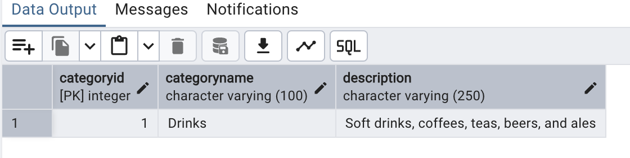2) Insert into shipper new record (give any values) Delete that new record from shippers table.

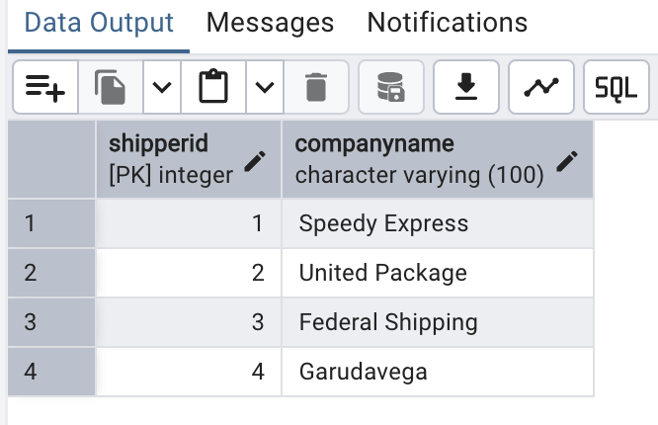

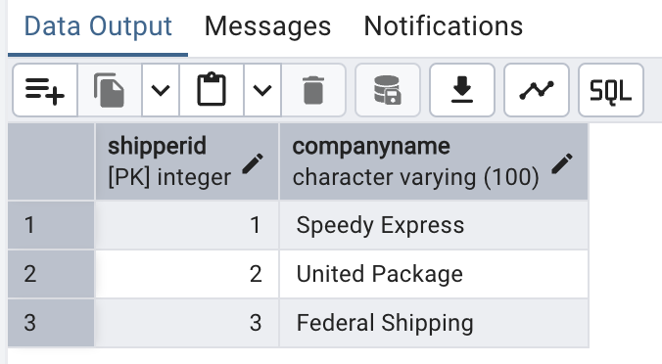

3) Update categoryID=1 to categoryID=1001. Make sure related products update their categoryID too. Display the both category and products table to show the cascade.

Delete the categoryID= “3” from categories. Verify that the corresponding records are deleted automatically from products. (HINT: Alter the foreign key on products(categoryID) to add ON UPDATE CASCADE, ON DELETE CASCADE, add ON DELETE CASCADE for order_details(productid) )

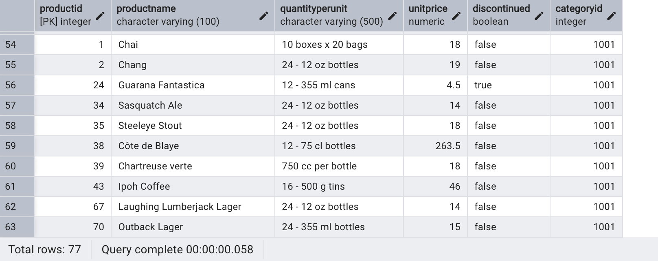

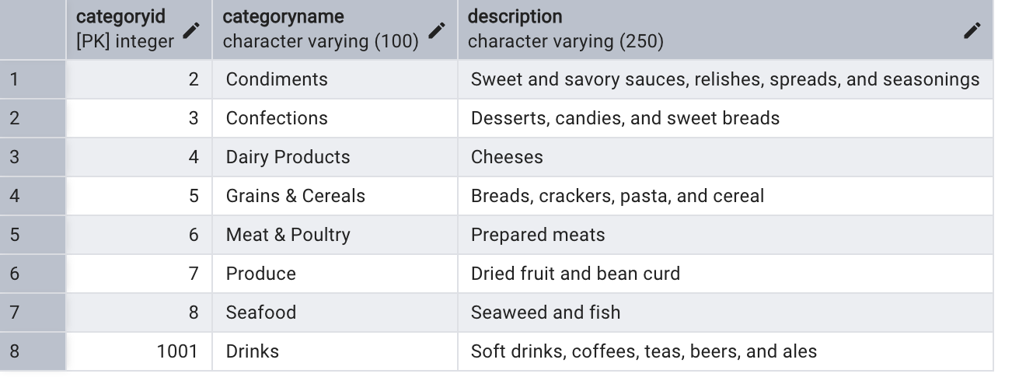

Delete the categoryID= “3” from categories. Verify that the corresponding records are deleted automatically from products.

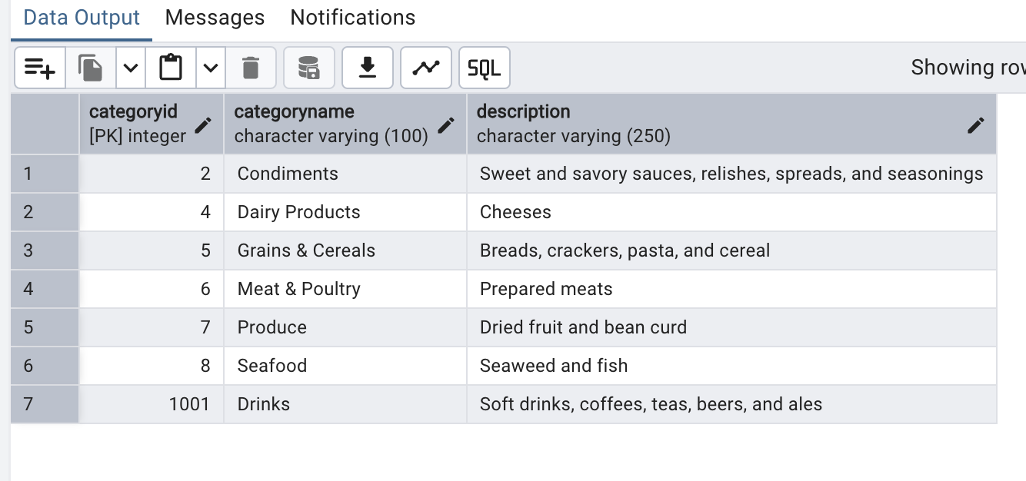

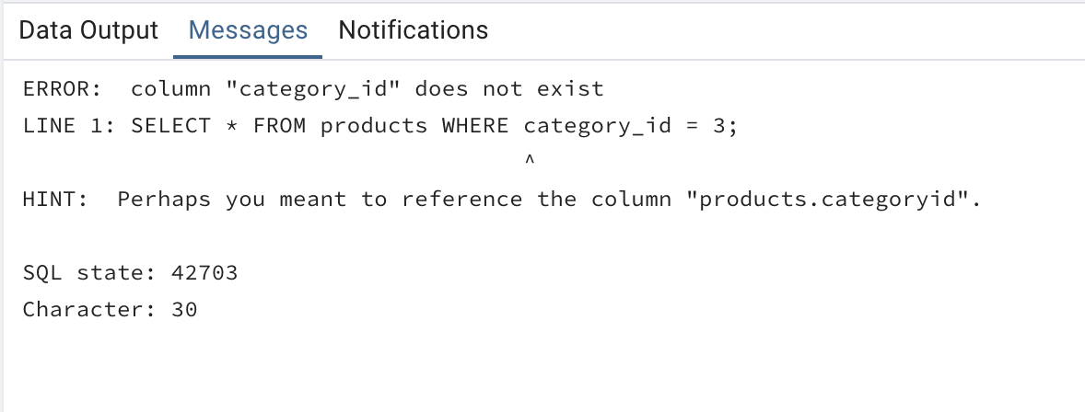

4) Delete the customer = “VINET” from customers. Corresponding customers in orders table should be set to null (HINT: Alter the foreign key on orders(customerID) to use ON DELETE SET NULL)

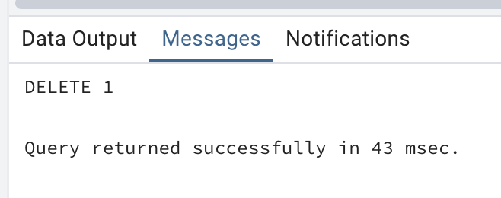

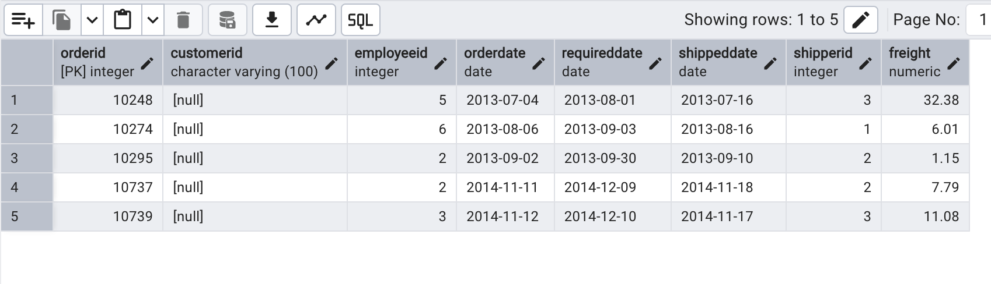5) Insert the following data to Products using UPSERT:

product_id = 100, product_name = Wheat bread, quantityperunit=1,unitprice = 13, discontinued = 0, categoryID=5

product_id = 101, product_name = White bread, quantityperunit=5 boxes,unitprice = 13, discontinued = 0, categoryID=5

product_id = 100, product_name = Wheat bread, quantityperunit=10 boxes,unitprice = 13, discontinued = 0, categoryID=5

(this should update the quantityperunit for product_id = 100)

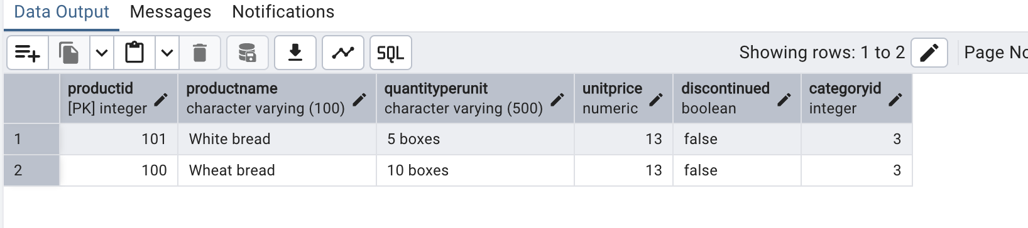

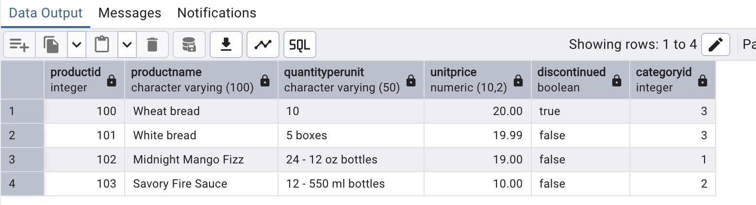

6) Write a **MERGE query**:Create **temp table with name:**  ‘updated_products’ and insert values as below:

* Update the price and discontinued status for from below table ‘updated_products’ only if there are matching products and updated_products .discontinued =0
* If there are matching products and updated_products .discontinued =1 then delete
* Insert any new products from updated_products that don’t exist in products only if updated_products .discontinued =0.

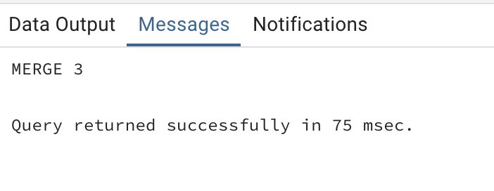

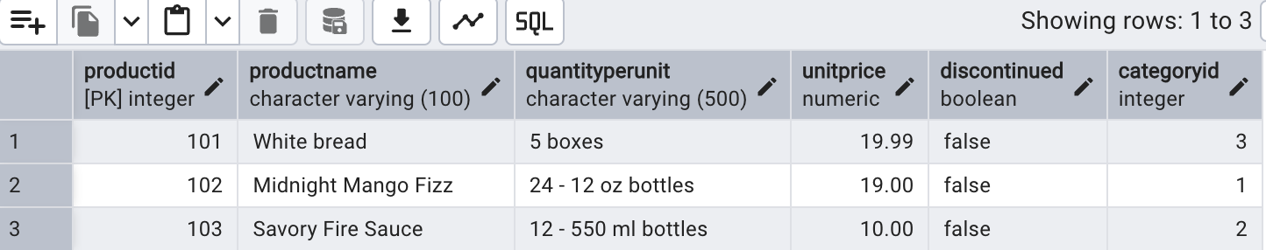



7) List all orders with employee full names. (Inner join)

