**Assignment DAY 4**

1. List all customers and the products they ordered with the order date. (Inner join)**Tables used:** customers, orders, order_details, products**Output should have below columns:**companyname AS customer,orderid,productname,orderdate,quantity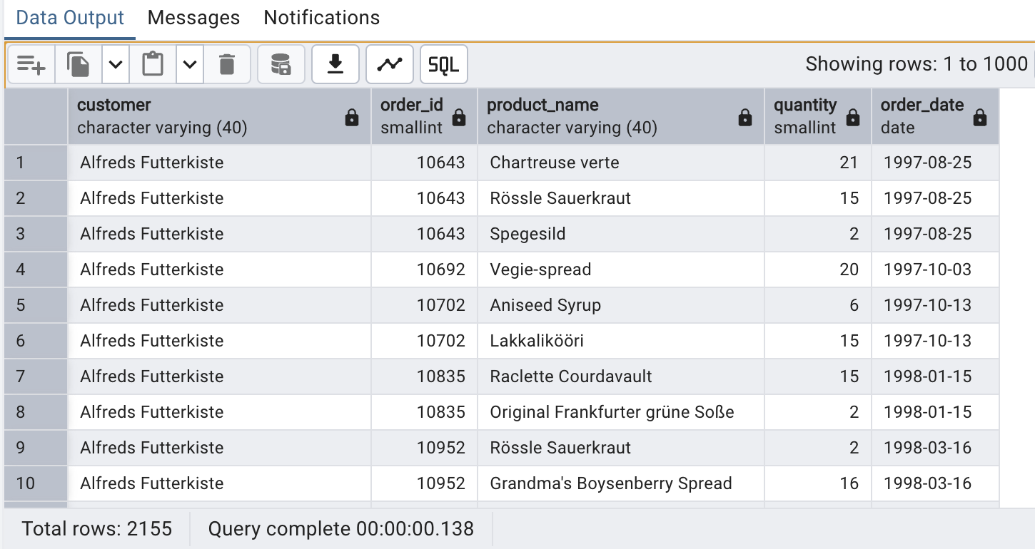2. Show each order with customer, employee, shipper, and product info — even if some parts are missing. (Left Join)Tables used: orders, customers, employees, shippers, order_details, products

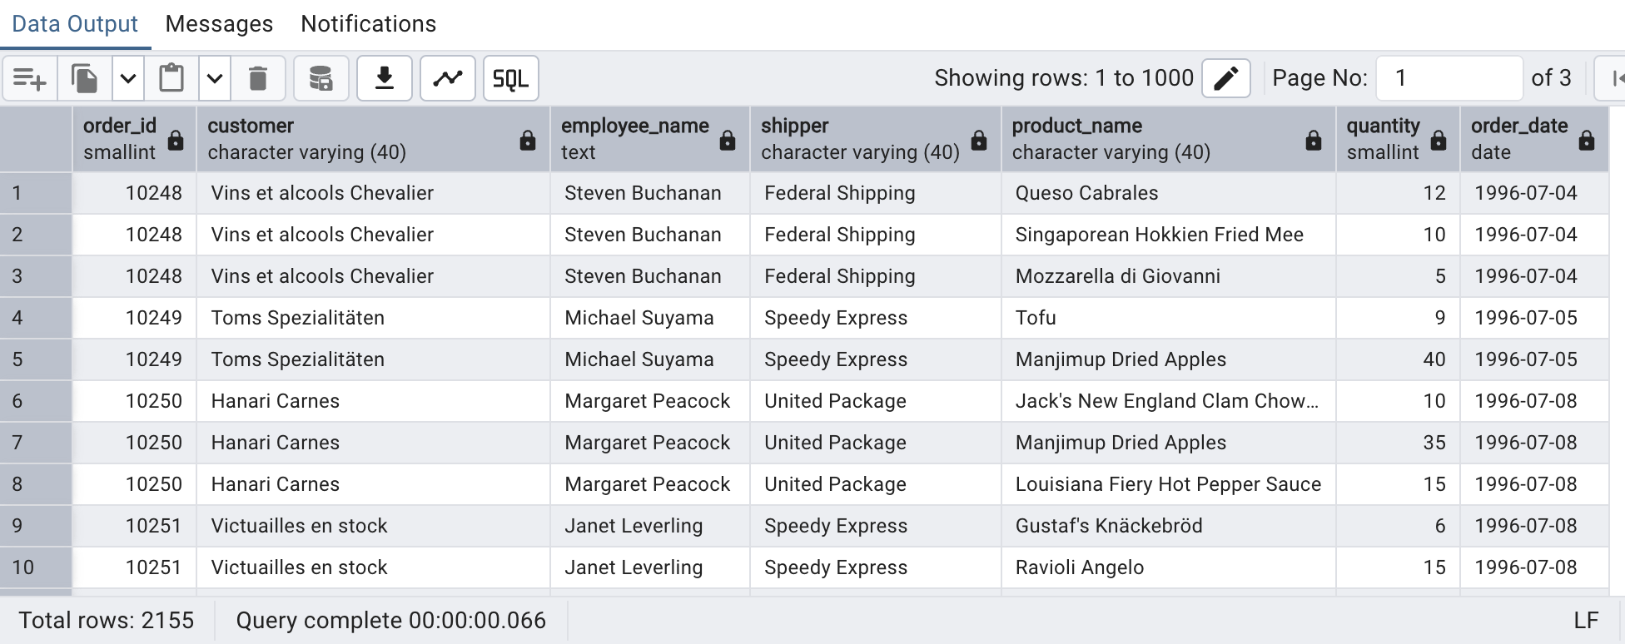

3) Show all order details and products (include all products even if they were never ordered). (Right Join)Tables used: order_details, products Output should have below columns:orderid,productid,quantity,productname

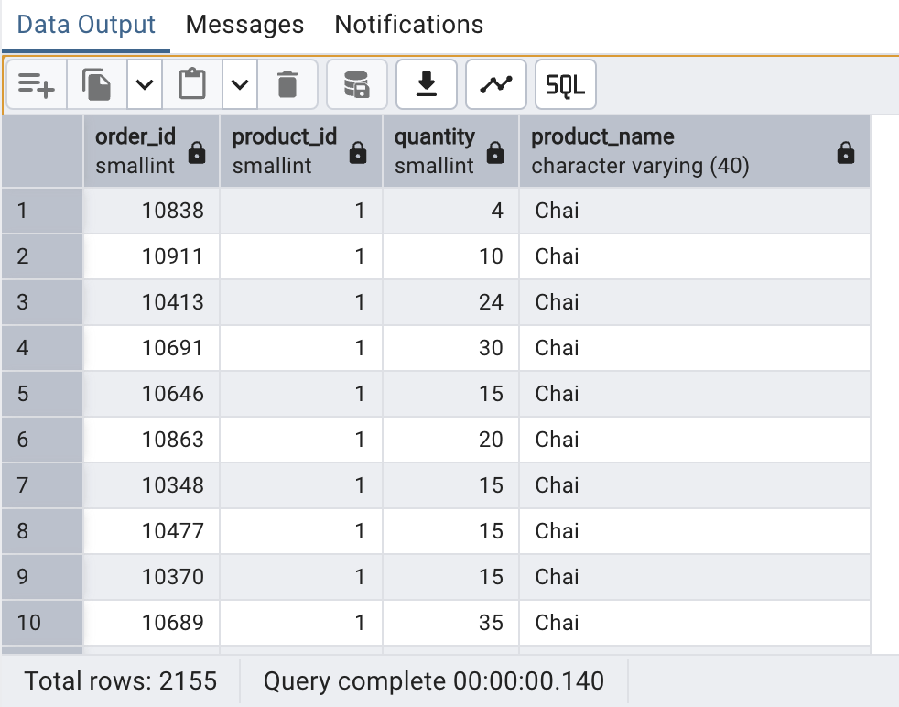

4)List all product categories and their products — including categories that have no products, and products that are not assigned ------to any category.(Outer Join) Tables used: categories, products

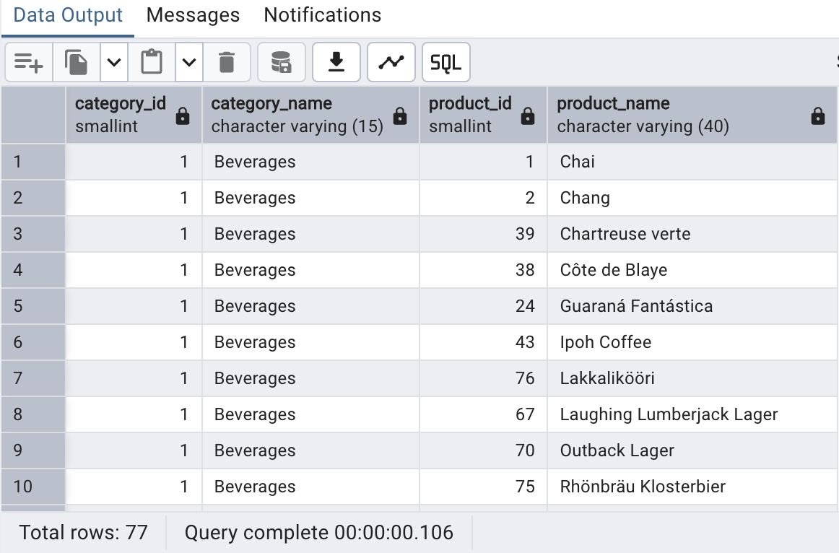

5)Show all possible product and category combinations (Cross join).

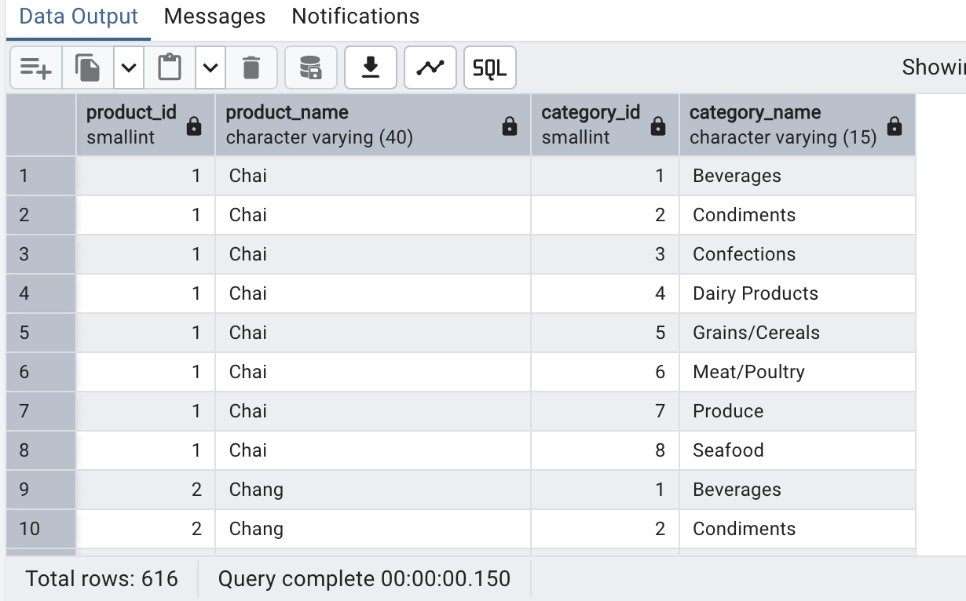

6)Show all employees and their manager(Self join(left join))

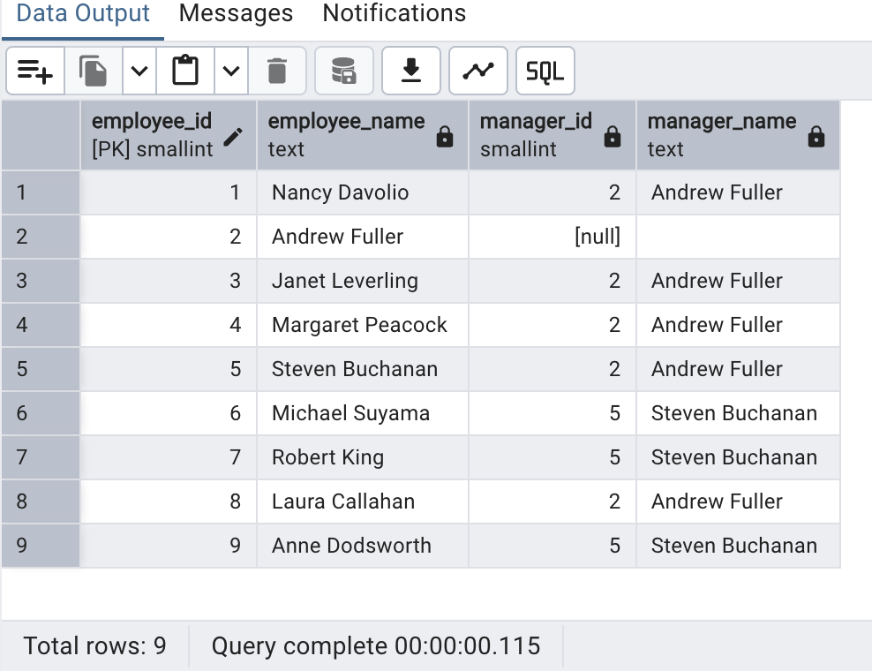

7)List all customers who have not selected a shipping method.Tables used: customers, orders(Left Join, WHERE o.shipvia IS NULL)

