# Assignment Day 8

1. Create view vw_updatable_products (use same query whatever I used in the training)Try updating view with below query and see if the product table also gets updated.Update query:UPDATE updatable_products SET unit_price = unit_price * 1.1 WHERE units_in_stock < 10;

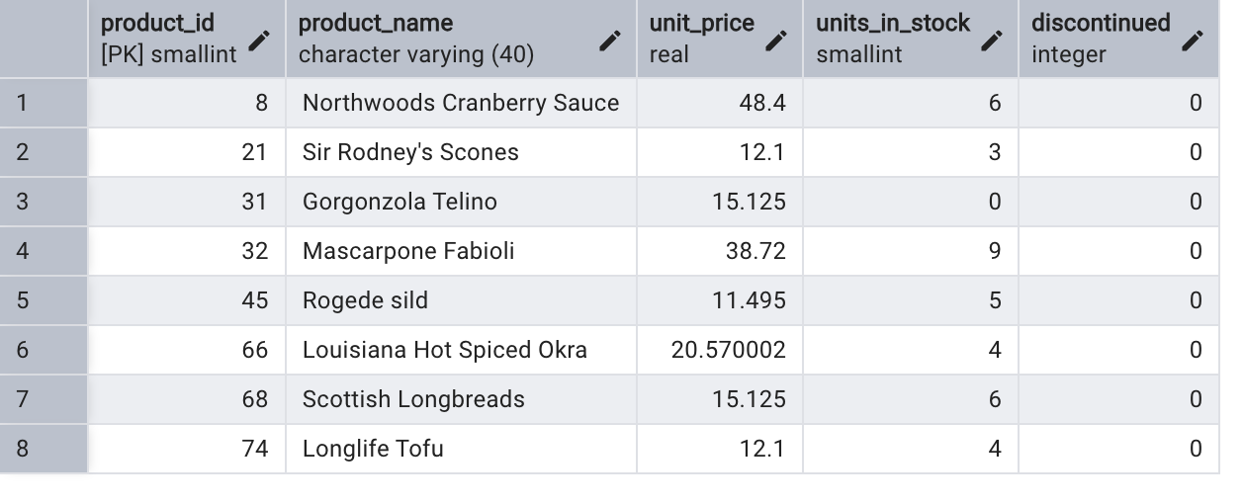

2. Transaction:Update the product price for products by 10% in category id=1Try COMMIT and ROLLBACK and observe what happens. 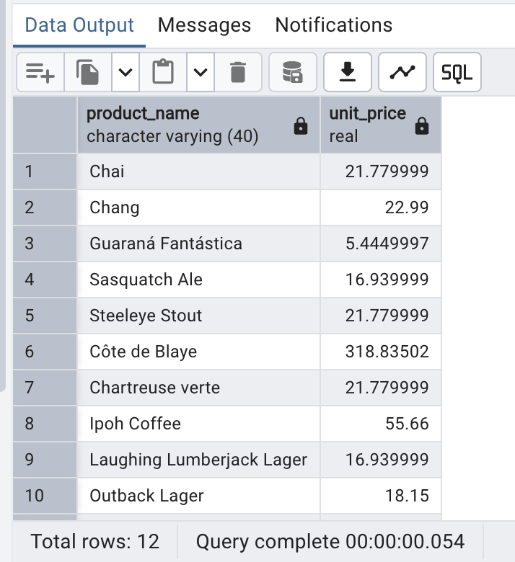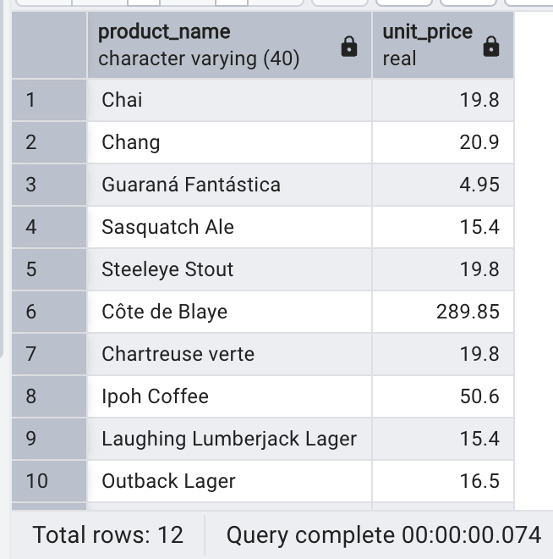

3. Create a regular view which will have below details (Need to do joins):Employee_id,Employee_full_name,Title,Territory_id,territory_description,region_description

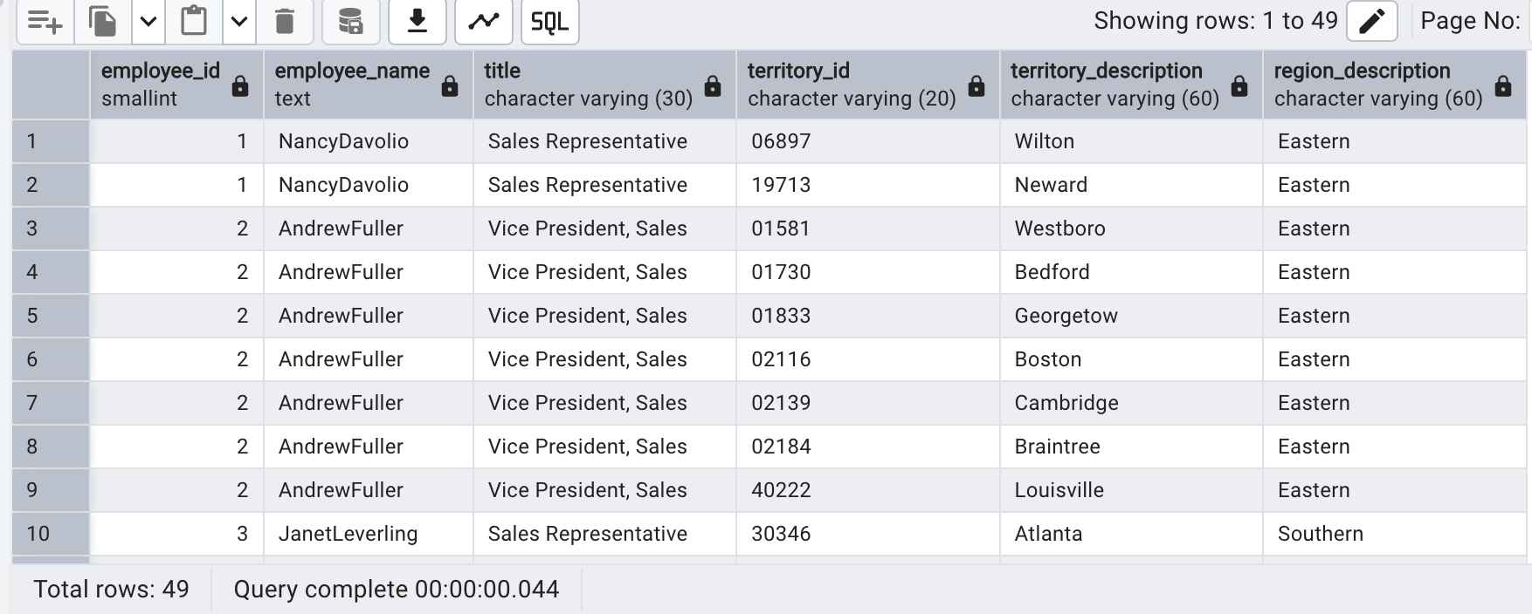4. Create a recursive CTE based on Employee Hierarchy

