1. **Data Visualization Using Word Cloud:**

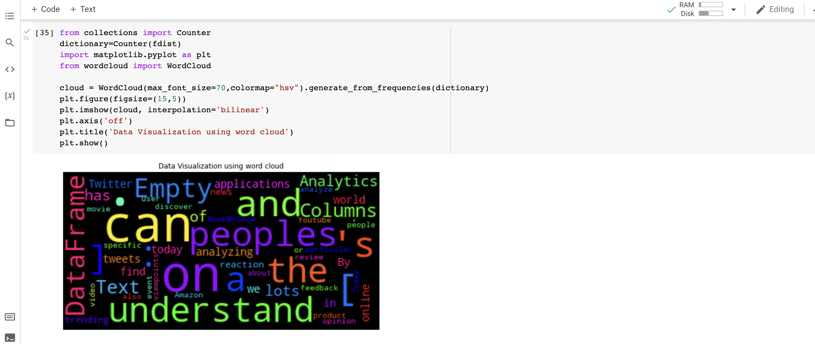

**2.Frequency Distribution of First 10 words using Pie Chart**

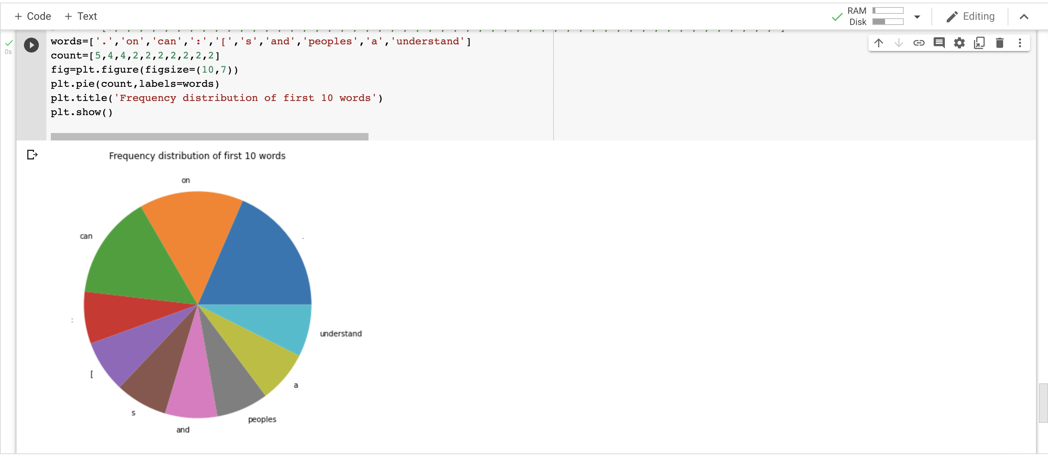

1. **Frequency Distribution of 10 words using Bar Graph**

