# **Week-1**

* Install the power BI.
* After Installation:

The page as shown below is the welcome page for the power BI.

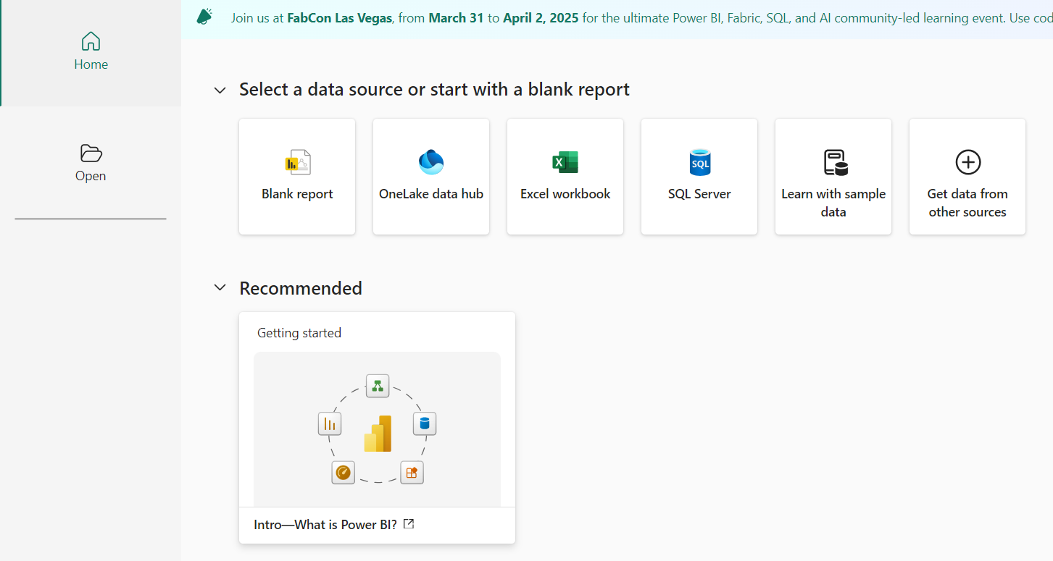

* Select the blank document and it will get into the page as shown below.

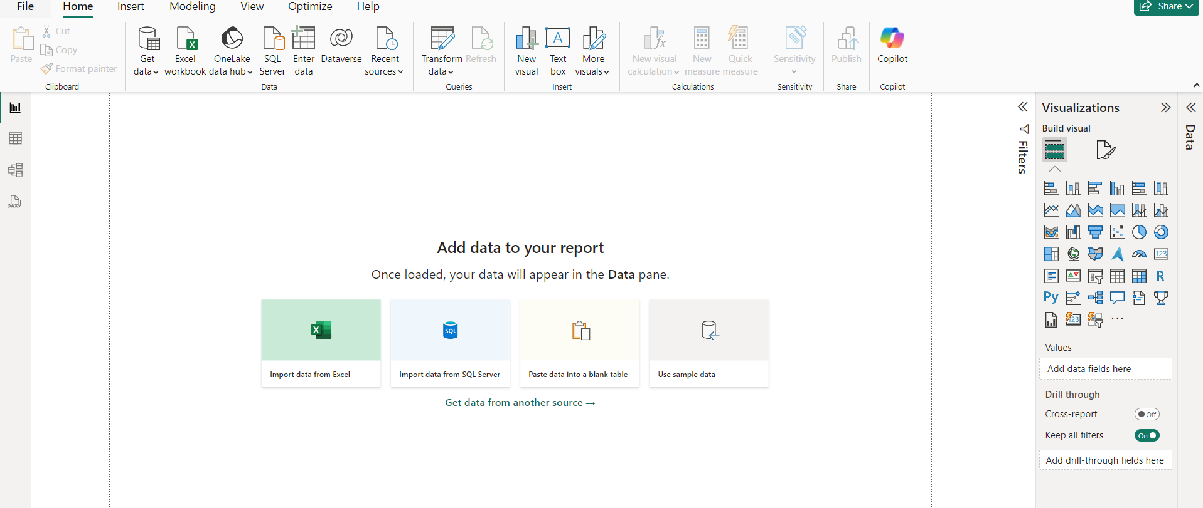

* The above page contain three icons in left corner they are given as follows:

1. Report view
2. Table view
3. Model view

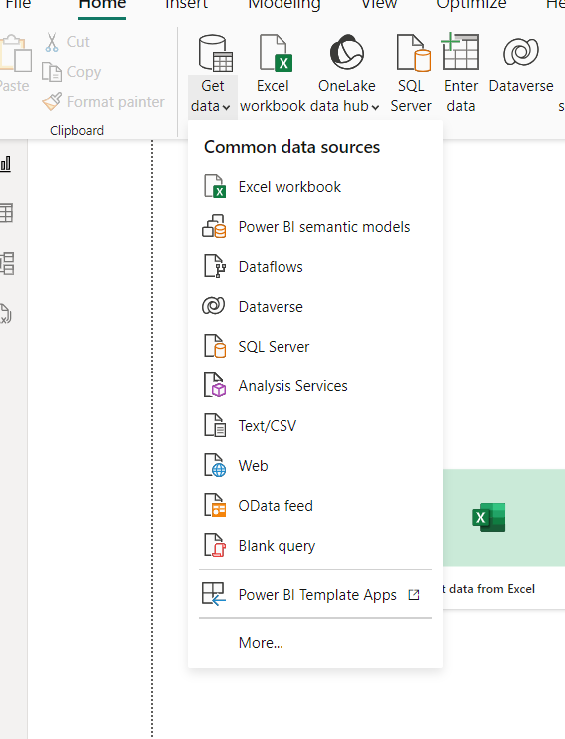

* To add the data from the file just click on “Get data” which is shown in the figure. We can acces any type of data.
* Click on Text/CSV to add the CSV type of data.

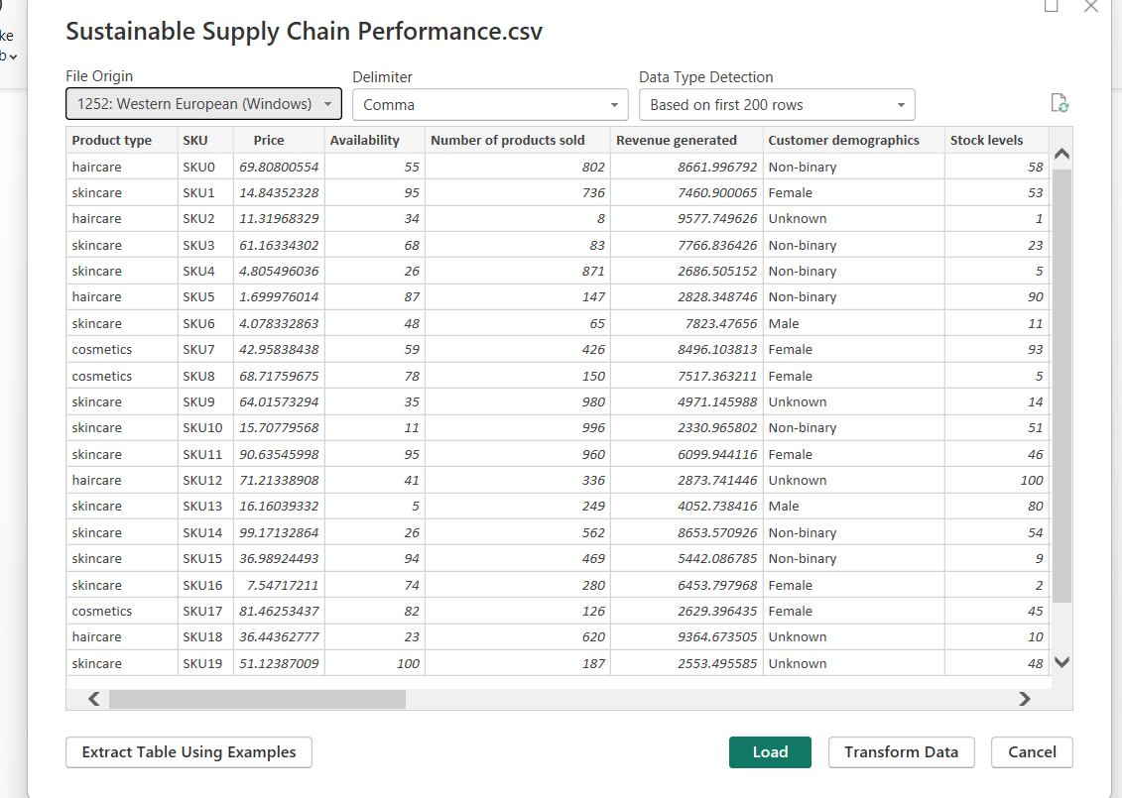

After getting the data from the particular we can see the data as shown in above figure.

Further we can “load” the data.

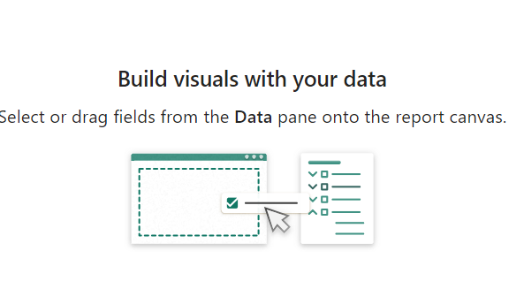

We can get above page after completion of loading the data.

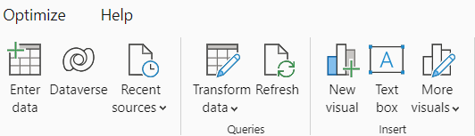

We can also Transform the data by using the “Transform data” which is shown in the figure.

* **After Transforming**:

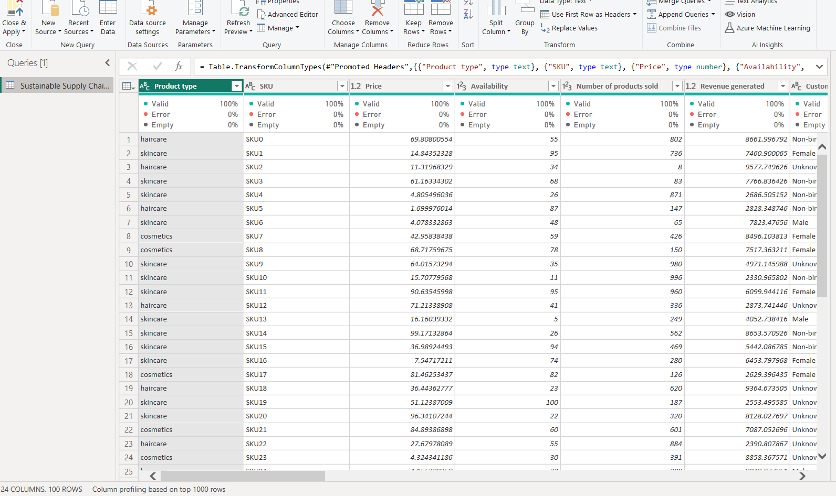

After completion of Transformation we can add duplicates as shown below

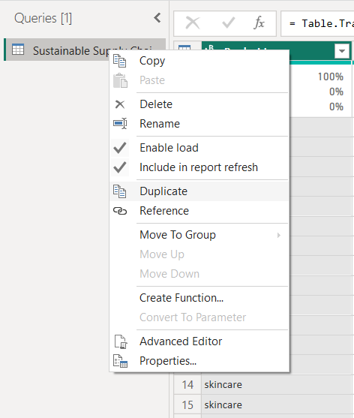

* We made duplicates for the given data set as:

1.Inventory table

2.Manafacturing Table

3.Supplier Table

4.Supply chain Table

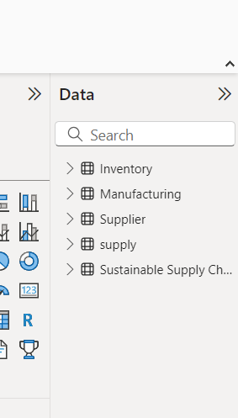

After completion we can find all the duplicates as shown in the above figure.