**Activity 1:**

1. Log into the system.
2. Execute system utilities: date, cal, who, man, etc...

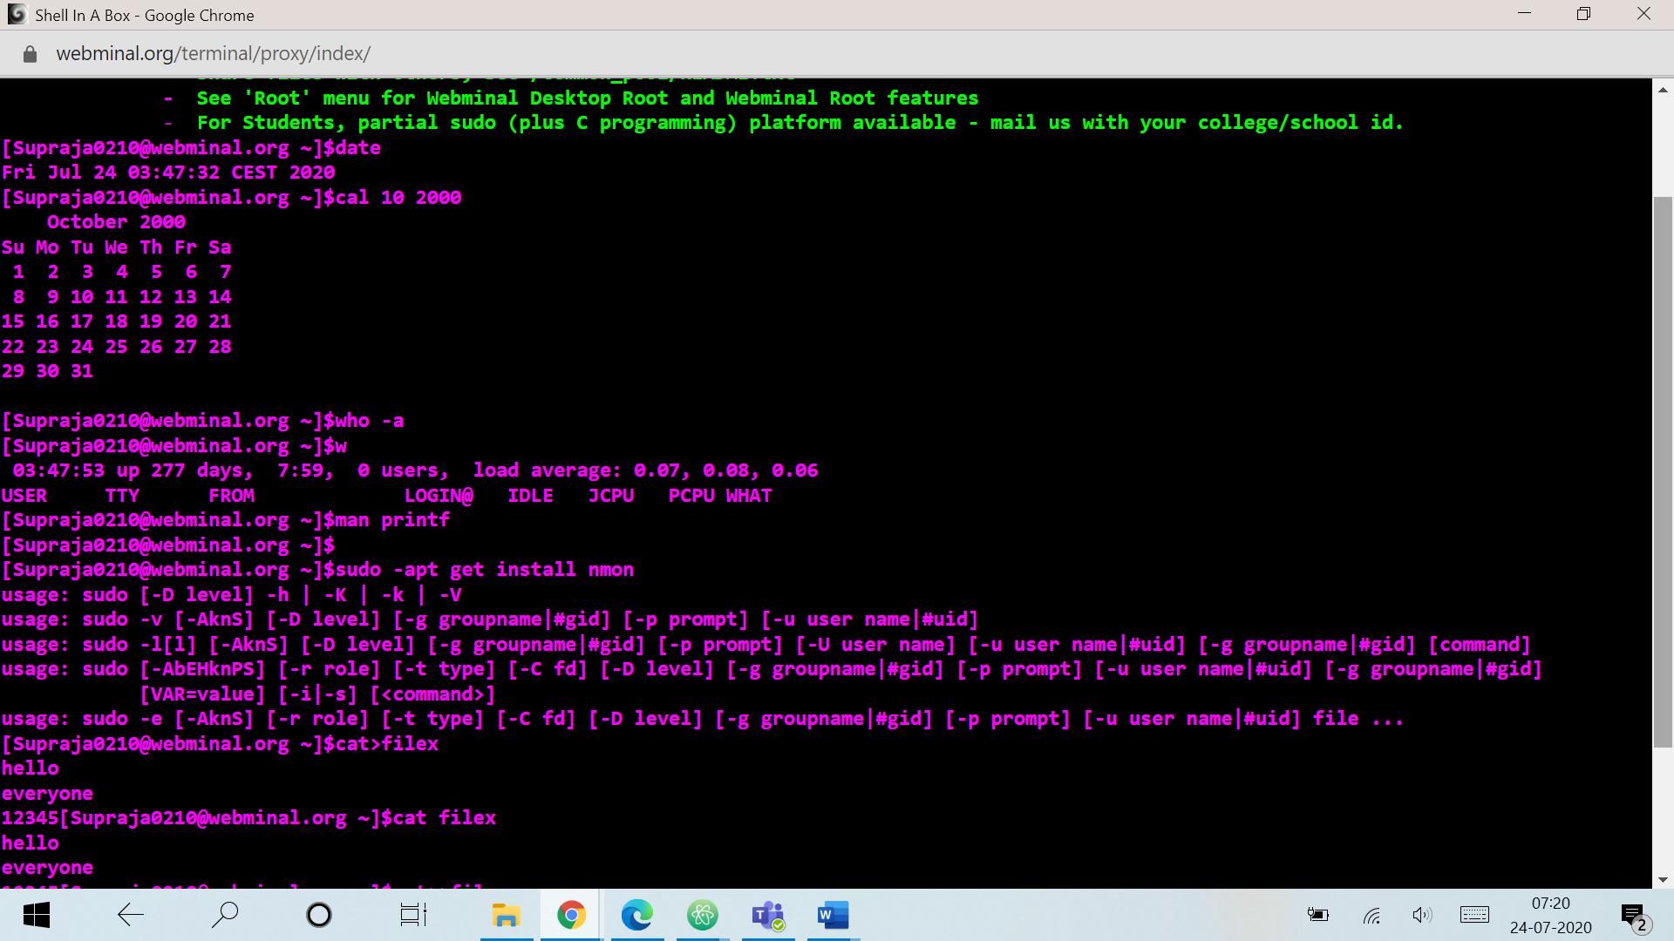

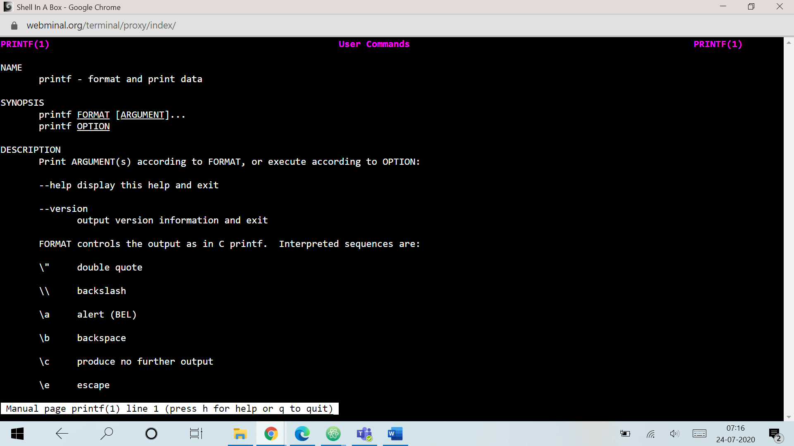

1. File handling utilities: cat, more, touch

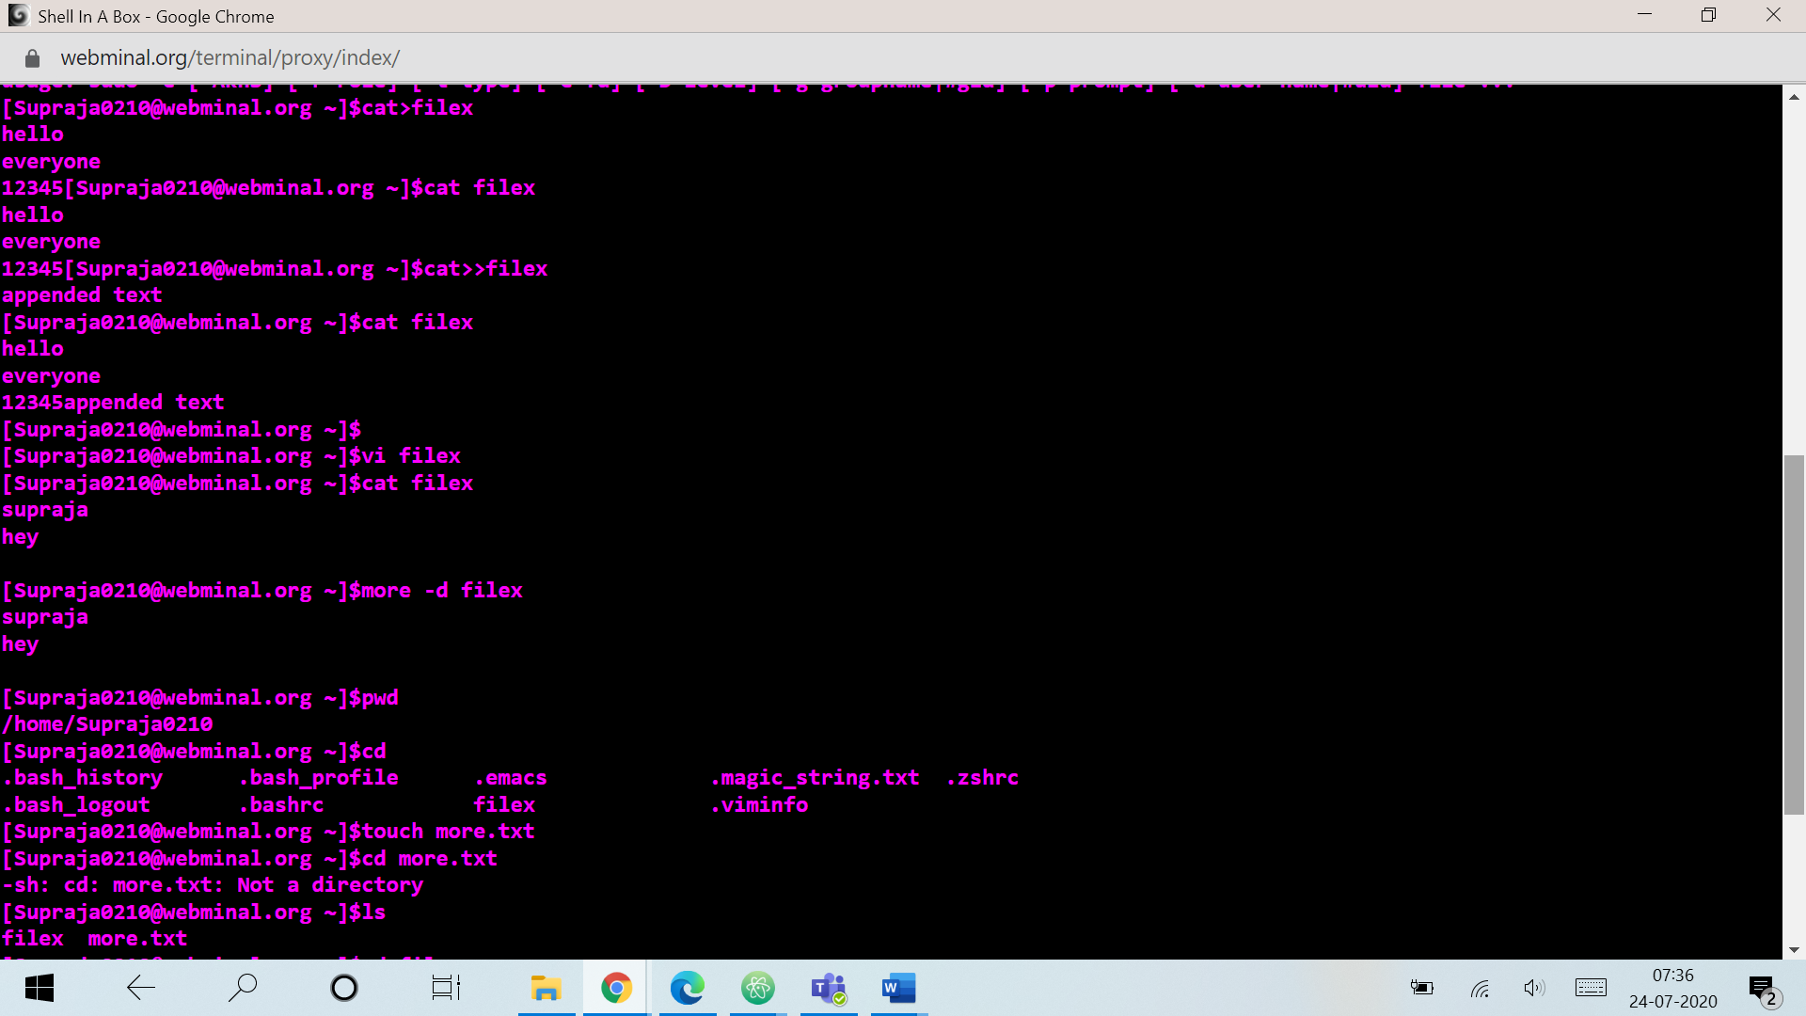

1. Directory handling utilities: mkdir, rmdir, cd, ls, pwd etc.

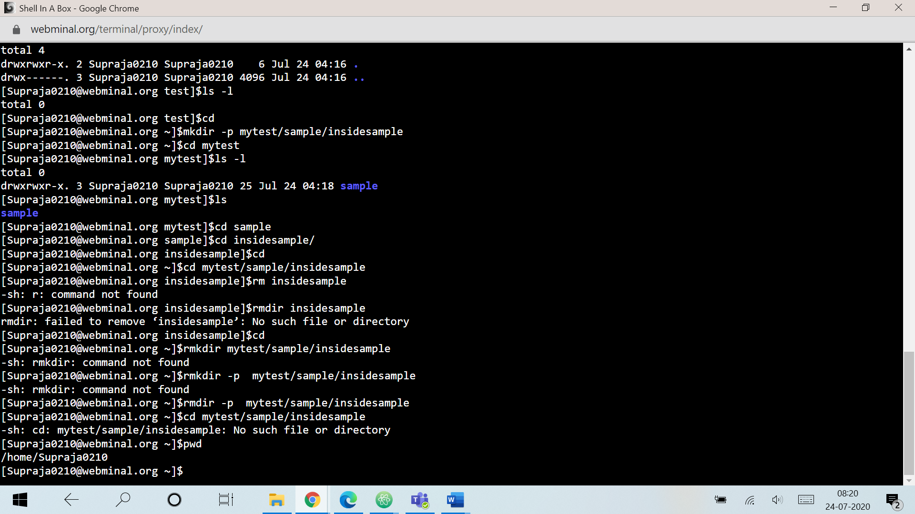

**Activity 2:**

1. Create a file called **student.txt** which contains individual student details i.e. roll number, name, branch, section, mail_id, phone number each column separated by pipe (|) delimiter.

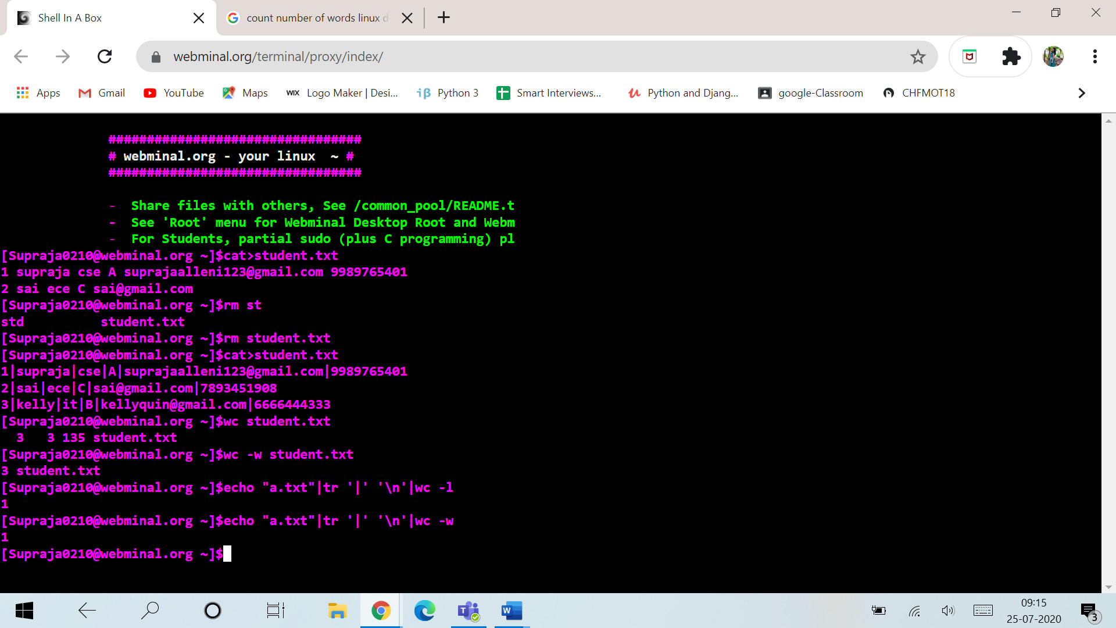

1. Count number of characters, words and lines in **student.txt**
2. Copy the student.txt content to another file **sample.txt**

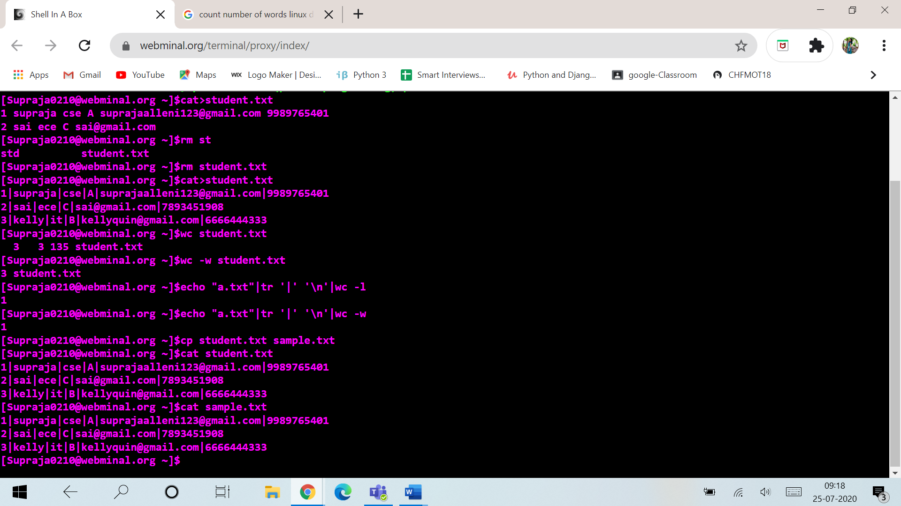

4. Move the file sample.txt content to another file **sample1.txt**

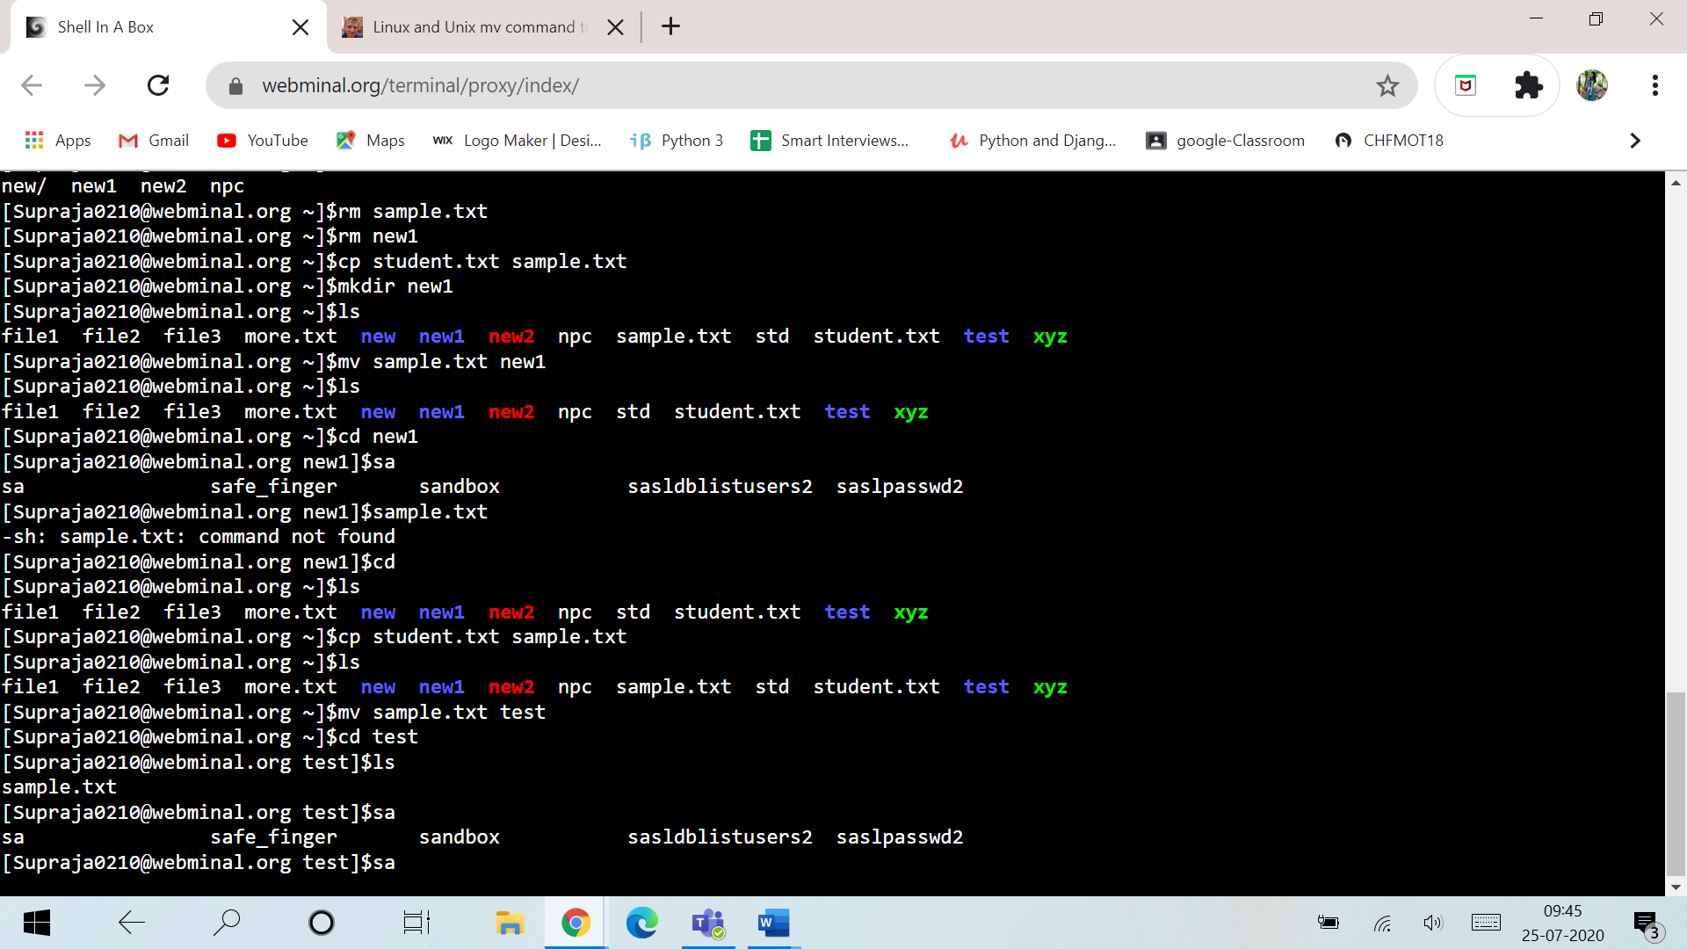

5.Give only owners read permission to **sample1.txt** and try to copy or move or delete that file to another file

6. Give only owners write permission to **sample1.txt** and try to open it

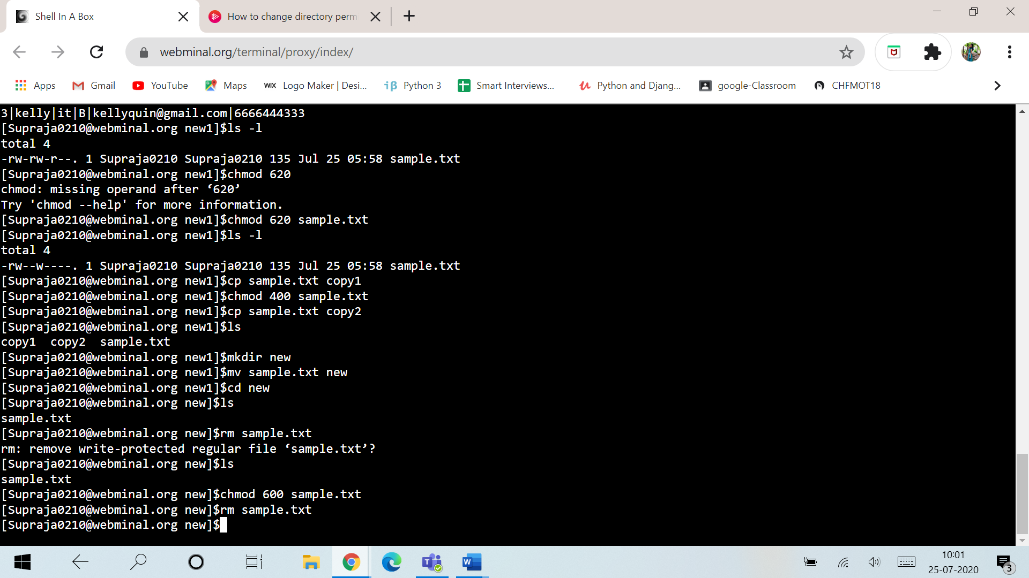

7. Apply soft and hard links to **student.txt** with other new or existing files and write your reflections.

