**In class Programming Assignment - 4**

**GitHub Link:** [**https://github.com/AkhilaBollepalli/ICP4**](https://github.com/AkhilaBollepalli/ICP4)

**Video Explanation:** [**clickhere**](https://drive.google.com/file/d/15Kt46l6W_KPXsfLxvwu-J4ytStBLEUQZ/view?usp=sharing)

**Problem 1:** Predict the first 4 images of the test data using the above model. Then, compare with the actual label for those 4 images to check whether or not the model has predicted correctly.

**Solution:**



OUTPUT:

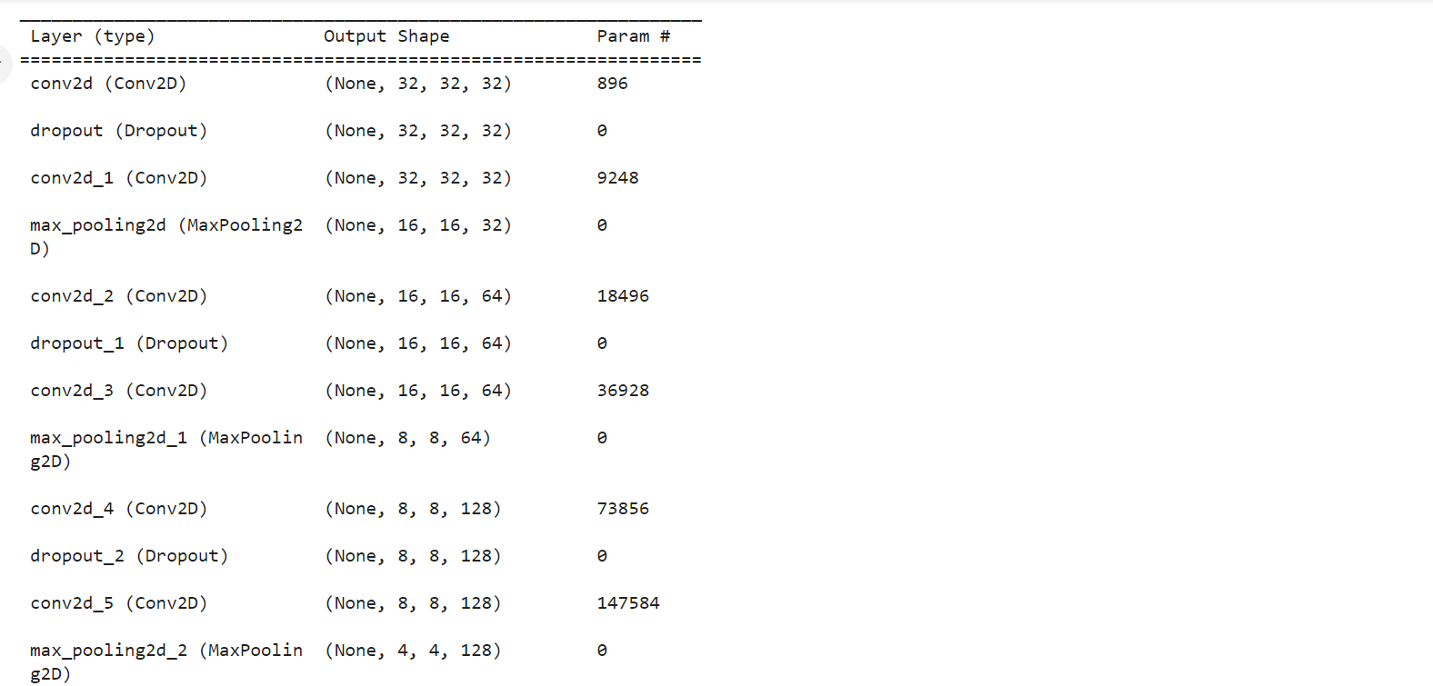

**Problem 2:** . Visualize Loss and Accuracy using the history object

**Solution:**

OUTPUT:

