SLE-3: Architectural Design (Full C4 Model)
Course: 02AML204 – Introduction to Artificial Intelligence
PRN - 25UAM098
Name – Akhila Kiran Dhutre
Division - B
Date - 05/10/2026
GitHub – https://github.com/AkhilaDhutre-coder25/SLE3.git

- System Title

BFS and DFS Graph Search Performance Analysis System
The system performs graph traversal using Breadth-First Search (BFS) and Depth-First Search (DFS). Different graph structures are generated for best-case, average-case, and worst-case experiments. BFS uses a queue, while DFS uses a stack for traversing the graph. The system measures the execution time of both algorithms using time.perf_counter(). The same BFS/DFS system was used for performance analysis and profiling in SLE-2.

2. Context Diagram (C4 Level 1)
The user provides the graph/search configuration to the BFS/DFS Graph Search System. The system generates the required graph structure and performs BFS or DFS traversal from the starting node. After the traversal is completed, the system provides the traversal result and execution-time information to the user.
Figure 1: Context view of the BFS/DFS Graph Search System
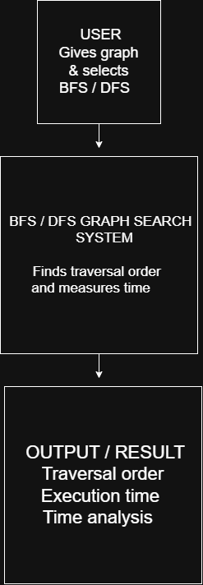

3. Container Diagram (C4 Level 2)
Container | Responsibility
Input / Graph Module | Creates and provides the graph structure for the experiment.
Search Engine | Runs the selected BFS or DFS traversal algorithm.
Visited / Memory Module | Keeps track of visited nodes during traversal.
Performance Measurement Module | Measures the execution time of BFS and DFS.
Output Module | Displays the traversal and execution-time results.
Figure 2: Main containers of the BFS/DFS Graph Search System

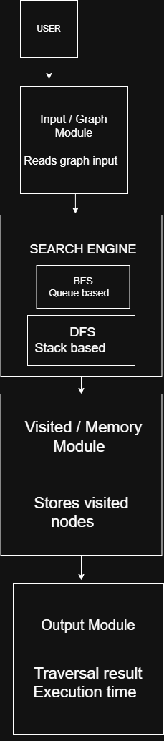

4. Component Diagram (C4 Level 3)
structure to keep track of already visited nodes. This view focuses only on the internal components of the Search Engine container. The Search Engine contains the two main search strategies, BFS and DFS. BFS uses a queue to manage the order of node exploration, while DFS uses a stack. Both algorithms use a visited
Figure 3: Components inside the Search Engine

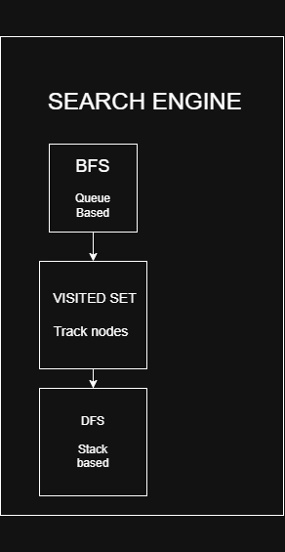

5. Code Level Overview (C4 Level 4)
File / Function | Responsibility
bfs_dfs.py – bfs() | Performs Breadth-First Search using a queue.
bfs_dfs.py – dfs() | Performs iterative Depth-First Search using a stack.
bfs_dfs.py – best_case() | Creates a linear graph structure for the best-case experiment.
bfs_dfs.py – average_case() | Creates a moderately connected graph structure for the average-case experiment.
bfs_dfs.py – worst_case() | Creates a densely connected graph structure for the worst-case experiment.
bfs_dfs.py – measure() | Measures the execution time of a selected algorithm using time.perf_counter().
profile.py | Runs the BFS/DFS program for performance profiling using py-spy.

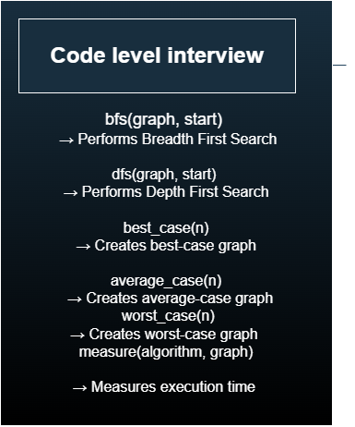

6. Design Decisions
The design uses separate responsibilities for constructing test graphs, executing searches, tracking traversal state, and collecting timing results. This arrangement allows BFS and DFS to be evaluated under the same conditions without coupling their implementations. A queue is selected for BFS because it preserves level-based processing, while a stack supports DFS’s depth-oriented behavior. The visited collection prevents cycles and redundant work. Multiple graph patterns make the comparison more meaningful, and profile.py provides an additional way to identify runtime behavior during execution.

7. AI Contribution Note
AI Tool Used: ChatGPT
What AI helped with:
- Clarifying the purpose and organization of the C4 model.
- Suggesting a suitable separation of system responsibilities.
- Rephrasing the architecture of the graph-search application.
- Helping arrange the sections of the SLE-3 documentation.
What I did:
- Developed and validated the BFS and DFS implementations.
- Constructed the graph configurations used in the experiments.
- Collected runtime results and carried out py-spy profiling.
- Designed the C4 diagrams using draw.io.
- Reviewed the architecture and documented the reasoning behind the design choices.

8. Conclusion
This SLE demonstrated how the BFS/DFS application can be described from a broad system view down to individual functions through the C4 model. The work distinguished the external system context, major containers, internal traversal components, and implementation-level responsibilities. Using the same application from SLE-2 made it possible to connect algorithm implementation with timing evaluation, profiling, and architectural documentation.

