**Tableau graphs and mappings based on dataset of proportion unemployed (per 1000) for persons of age 15-59 years according to usual status**

**by**

**G.Akhila Mtech CSE, gotteakhila11@gmail.com**

1. First i took a data set of unemployment.
2. Import to tableau data source.
3. created a horizontal bar graph based on rule , urban male and female to prepresent hight count of unemployment of perticular area base on gender. See the below figure1.

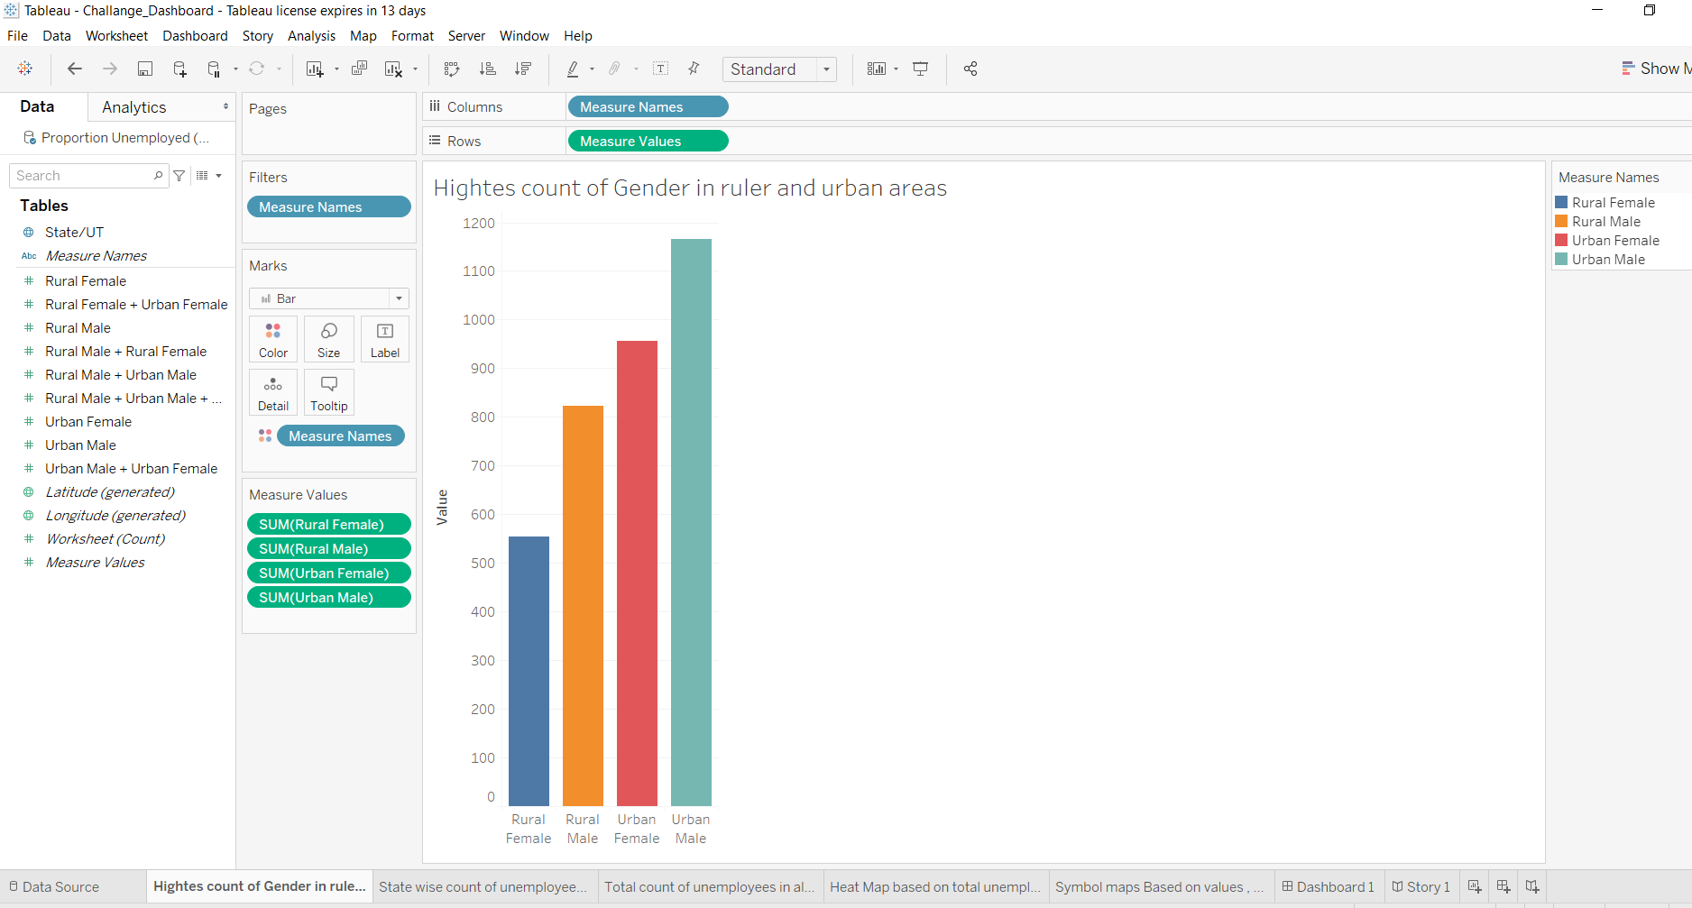

Figure 1

1. Another graph represents about state wise count of unemployees in ruarl and urban areas, see the below figure 2.

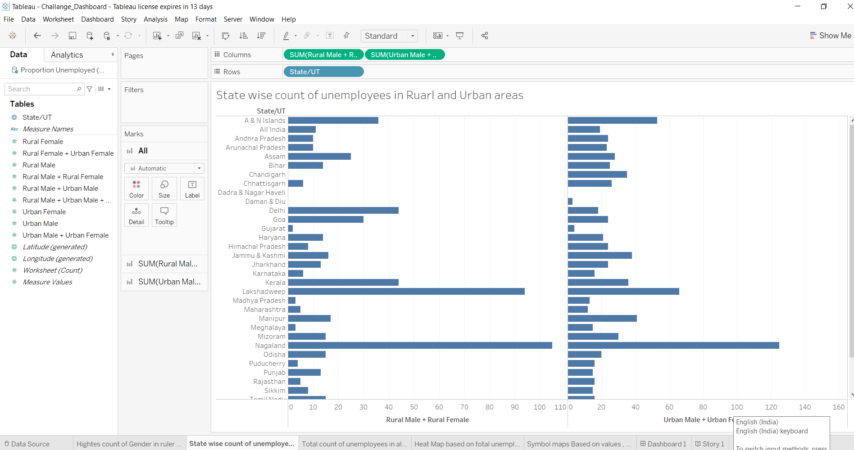

Figure 2

1. Next 3rd graph is about total count of unemployees in all states, see the below figure 3.

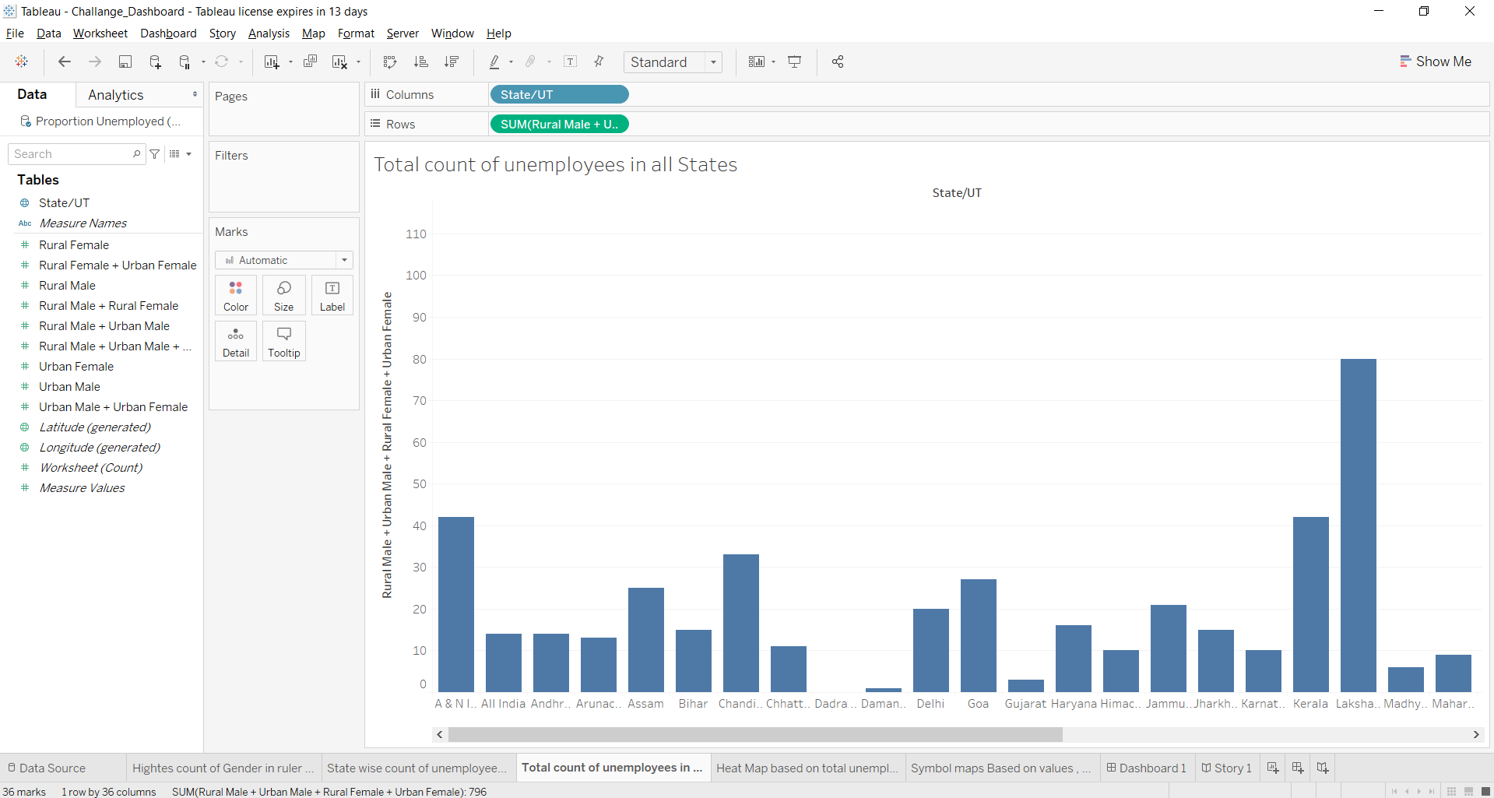

Figure 3

1. Next created a heat map based on total unemployes on all states, see the below figure 4.

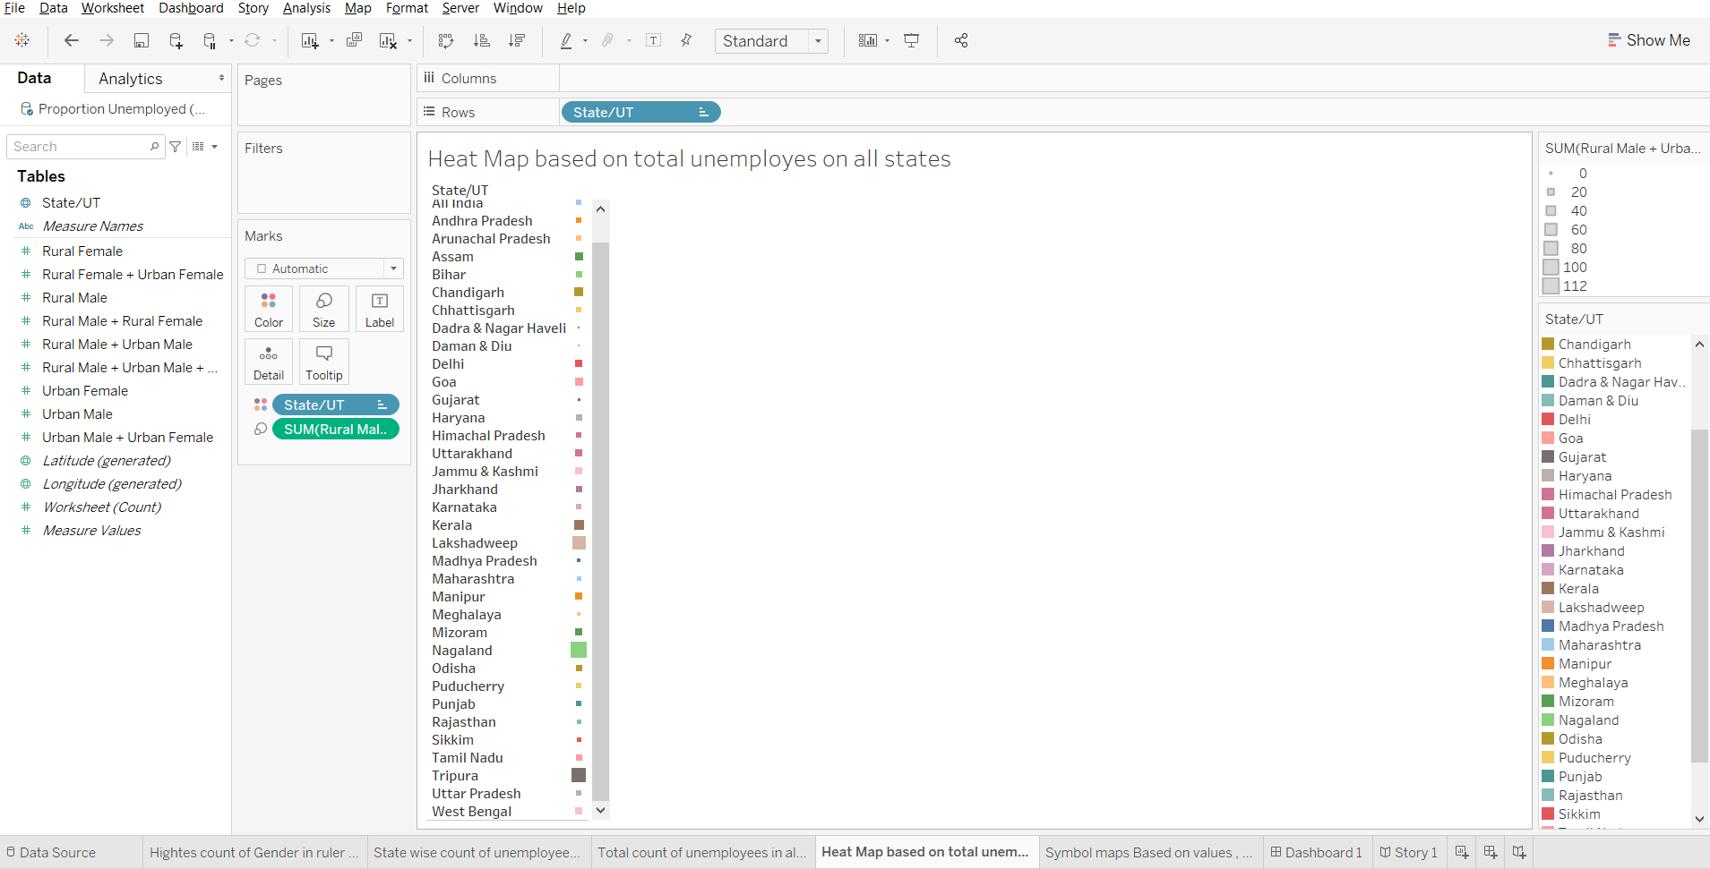

Figure 4

1. Next created a symbol map which says about total unemployments based on values , names, see the below figure 5.

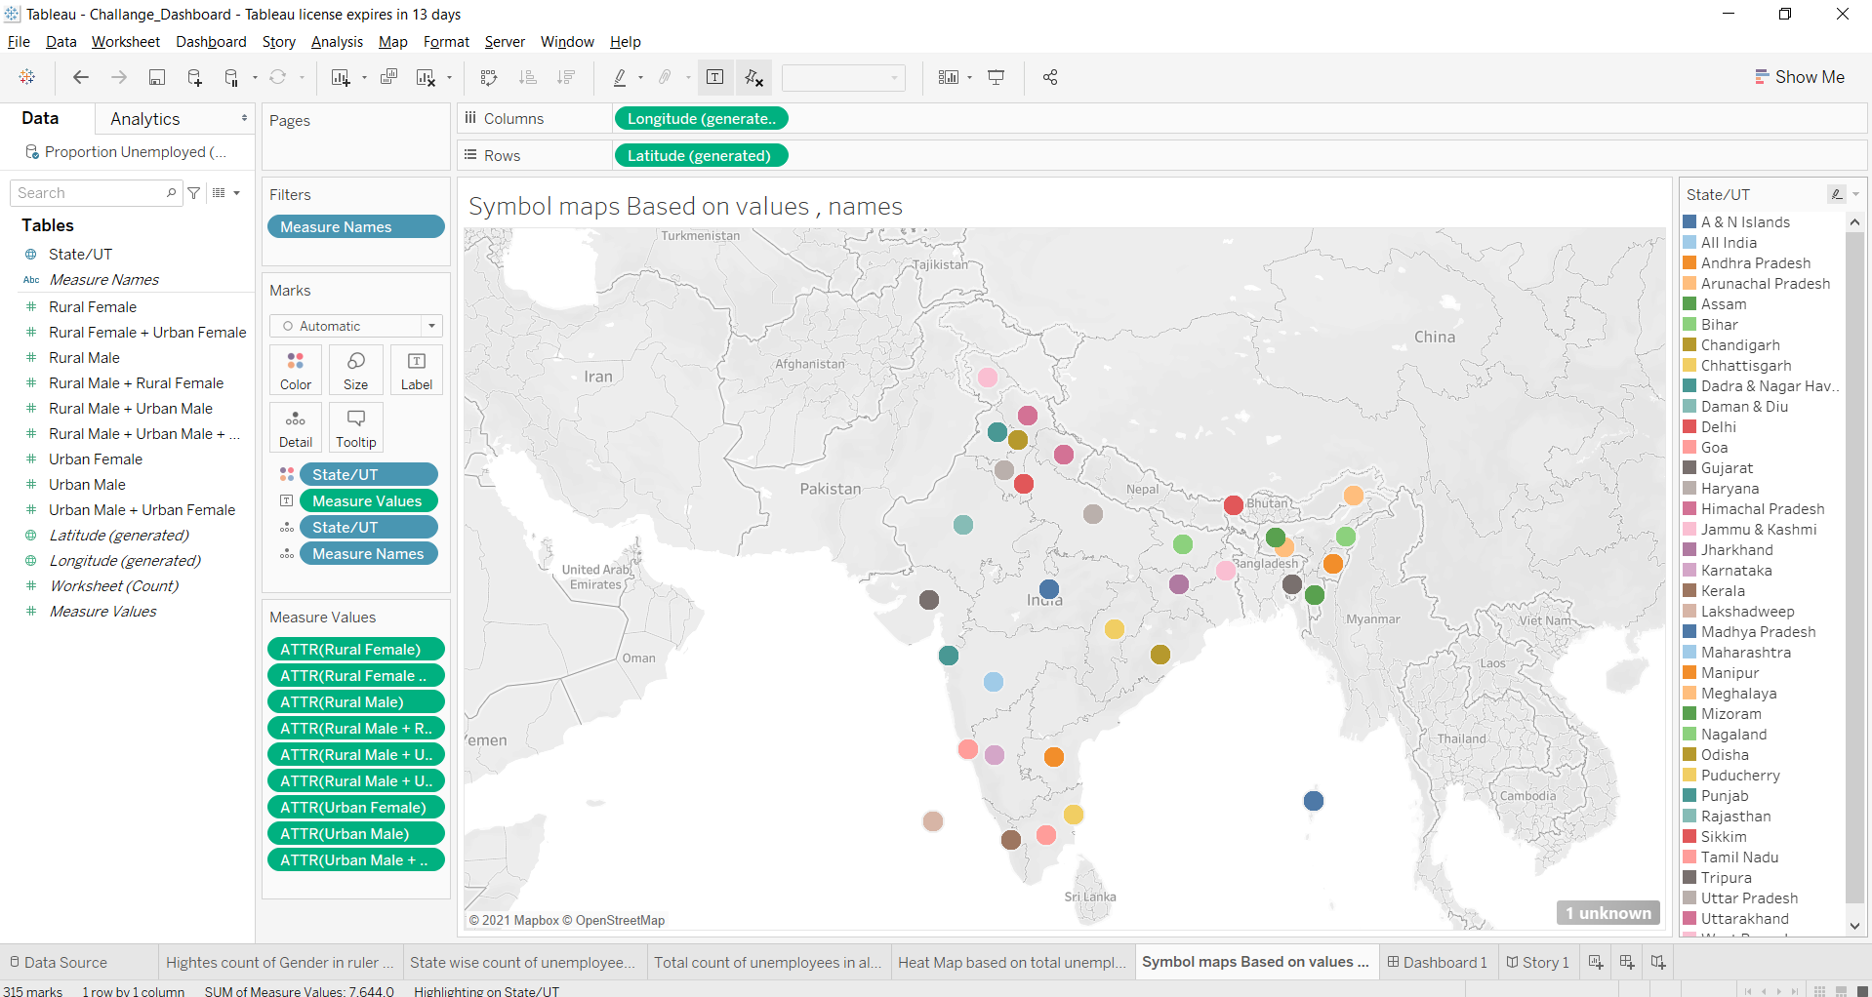

Figure 5

1. Next created a dashboard of all graphs and maps. see below figure 6

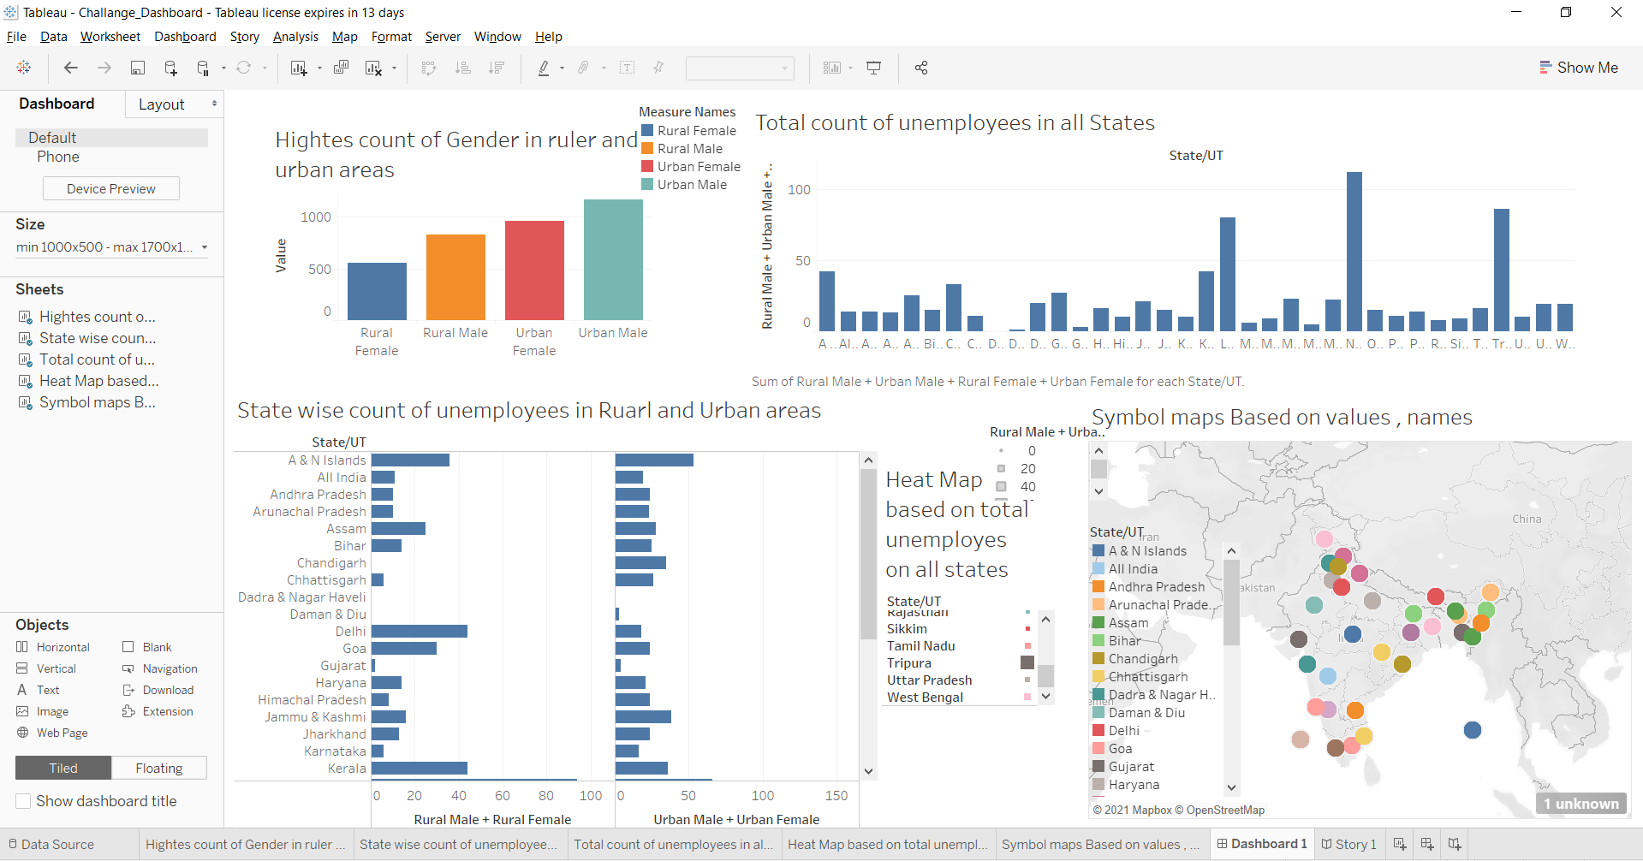

Figure 6

1. Next created a story of all graphs and maps. see below figure 7

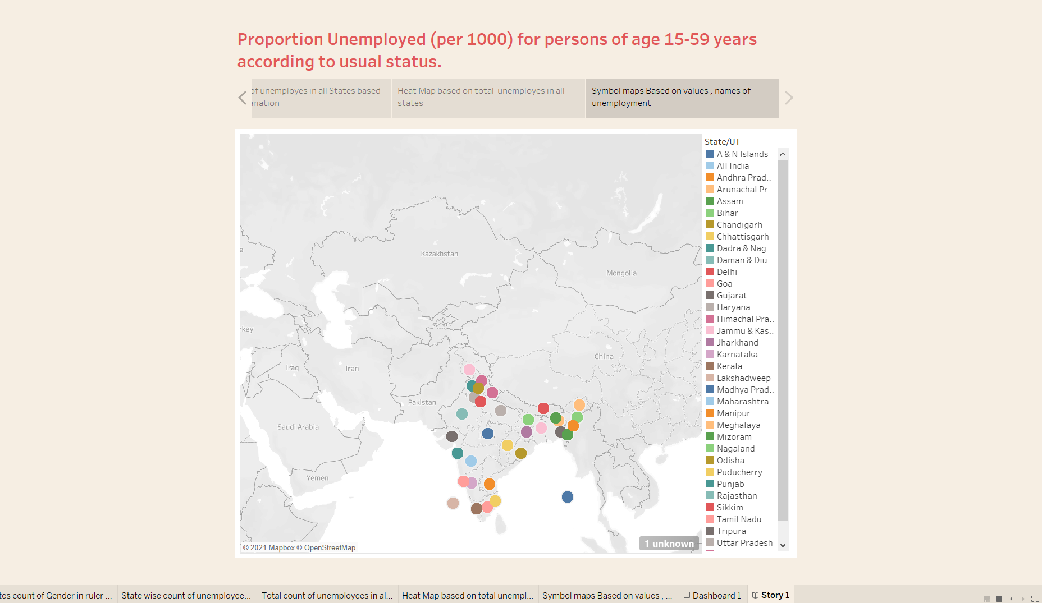

Figure 7

10. This project is all about the unemployment allover the states in india.