# 1.0 Validation

**Case 1:**

1. Go to any container which has a role OBSERVERLITE /OBSERVER and user mapped to it. Login as that user.

2. Pick an EPMDocument which is already published and not in OBSOLETE state. Navigate to the details page. Click on the PDF Viewable icon/Primary contents/Open viewable in Creo view.

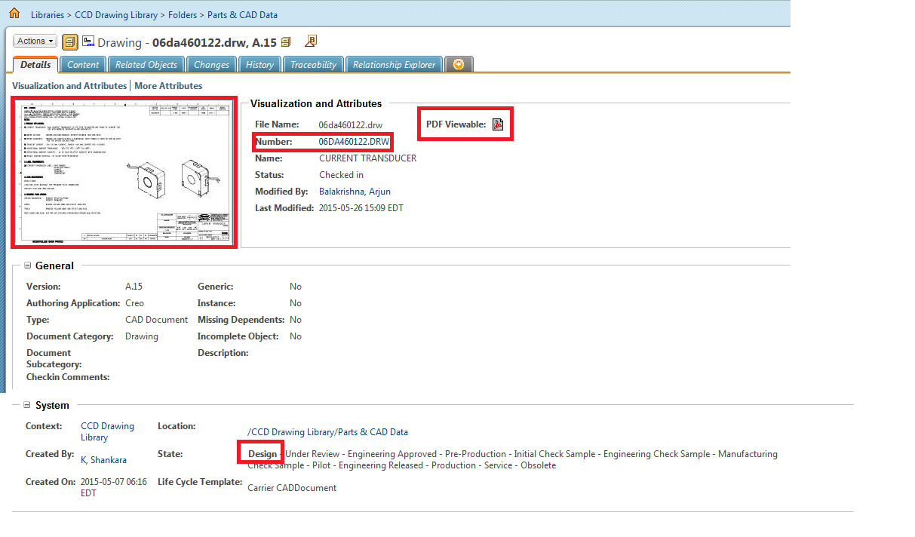

3. User should be able to download PDF Viewable/Primary Contents/open viewables in Creo View.

**Case 2:**

1. Go to any container which has a role OBSERVERLITE /OBSERVER and user mapped to it. Login as that user.

2. Pick an EPMDocument which is already published and is in OBSOLETE state. Navigate to the details page. Click on the PDF Viewable icon/Primary contents/Creo view.

3. User should not be able to download the PDF Viewable/Primary Contents/Open viewable in Creo view.

**Case 3:**

1. Login as any user not mapped to OBSERVERLITE/OBSOLETE role.

2. Pick an EPMDocument which is already published and is in OBSOLETE state. Navigate to the details page. Click on the PDF Viewable icon/Primary contents/Open viewable in Creo view.

3. User should be able to download the PDF Viewable /Primary contents/Open viewable in Creo view.