# Purpose

This release note covers the changes to Carrier servers to fix ESR mentioned in below table

| ESR | Description | PTC TS # (if any) |
| --- | --- | --- |
| ESR 35588 | **PDF Viewable on EPMDocuments** | NA |

# Revision History

Document revision history is controlled by [http://windchill.carrier.utc.com](http://windchill.carrier.utc.com/) (Carrier’s Production Server).

Carrier: http://windchill.carrier.utc.com/Windchill/app/#ptc1/tcomp/infoPage?ContainerOid=OR%3Awt.projmgmt.admin.Project2%3A8297123&oid=VR%3Awt.doc.WTDocument%3A2414386090&u8=1

# Change History

| Date | Revision | Technician | Description of change and a link to affected section |
| --- | --- | --- | --- |
| 10/07/15 | -.1 | Akhila V Mani | Do not Provide a download access on PDF Viewable/Primary contents/open viewable in Creo view to OBSERVERLITE/OBSERVER role at OBSOLETE state |

# Issue Summary

Restrict the User to download the PDF viewable/Primary Contents/Open viewable in Creo view if he is mapped to OBSERVERLITE/OBSERVER role at OBSOLETE state.

# Deployment Status

Below table contains current status of these changes, this tables will be updated by Infrastructure Team

|  |  |  |  |
| --- | --- | --- | --- |
| **Servers** | **Development** | **Staging** | **Production** |
| **Deployed by** |  |  |  |
| **Deployed Date** |  |  |  |
| **Validated by** |  |  |  |
| **Validated date** |  |  |  |

# Check List

Below are the lists of items that need to be verified before scheduling deployment on test and production server.

|  |  |  |  |
| --- | --- | --- | --- |
| **Check-list** | **Development** | **Staging** | **Production** |
| **Files updated to SVN** |  |  |  |
| **Included manual recovery steps** |  |  |  |
| **Included validation Steps** |  |  |  |
| **Validation Confirmation from User** |  |  |  |
| **Database Export required** |  |  |  |
| **LDAP Export required?** |  |  |  |
| **Windchill codebase Backup?** |  |  |  |
| **Selected Files Backup** |  |  |  |
| **Change Control** |  |  |  |
| **Windchill Start/Stop required?** |  |  |  |

# Resolution

Below are the different steps involved during deployment.

## Specify the SVN Location

All modified/updated files downloaded from [WCDEV](http://cusnwa5d.carrier.utc.com/wc/wcsvn/branch/WCDEV/) SVN branch

## List of all OOTB & Custom files modified to resolve this issue

Below are the lists of files that are modified to resolve this ESR.

|  |
| --- |
| **File Name** |
| **/apps/ptc/Windchill/** **src/ext/carrier/wc/datautility/****PDFLinkDataUtility.java** |
| **/apps/ptc/Windchill/** **codebase/ext/carrier/wc/****wc.xconf** |

## List of all OOTB and Custom files added to resolve this issue

Below are the lists of files that are added to resolve this ESR.

|  |
| --- |
| **File Name** |
| **/apps/ptc/Windchill/** **loadFiles/ext/carrier/wc/acls/****ACL_WTObjects_ESR_35588.xml** |

## Revision Table

|  |  |  |
| --- | --- | --- |
| **Filename** | **Revision for Change** | **Revision to Restore** |
| **PDFLinkDataUtility.java** | **908** | **18** |
| **wc.xconf** | **941** | **NA** |
| **ACL_WTObjects_ESR_35588.xml** | **942** | **NA** |

## Manual changes before deploying changes

1. Go to Organization “Carrier”->Utilities->Policy administration->Default->Update->Access Control -> Delete the highlighted ACLs.



## Deployment procedure

1. Download the file mentioned above to their corresponding folders.
2. Compile the Java file using the following commands from Windchill Shell

CLASSPATH=$CLASSPATH\:/apps/ptc/Windchill/srclib/jmxcore/WtLogR.jar:/apps/ptc/Windchill/srclib/wnc/CommonCore.jar:/apps/ptc/Windchill/srclib/install/InstallUtil.jar:/apps/ptc/Windchill/srclib/tool/Annotations.jar:/apps/ptc/Windchill/srclib/commons-collections.jar:/apps/ptc/Windchill/srclib/log4j.jar:/apps/ptc/Windchill/srclib/esi/Esi.jar:/apps/ptc/Windchill/srclib/esi/Esi-upgrade.jar:/apps/ptc/Windchill/srclib/*.jar; export CLASSPATH

**javac PDFLinkDataUtility.java –d /apps/ptc/Windchill/codebase/ext/carrier/wc/datautility**

3. Copy the properties from the wc.xconf file and update the wc.xconf file on the server.

**xconfmanager -p**

4. Load ACLs using below command.

windchill wt.load.LoadFromFile -d /apps/ptc/Windchill/loadFiles/ext/carrier/wc/acls/ACL_WTObjects_ESR_35588.xml -u *username* -p *password* -CONT_PATH \"/wt.inf.container.OrgContainer=Carrier\"

5. Clear Cache and Restart Windchill.

# 8.0 Validation

**Case 1:**

1. Go to any container which has a role OBSERVERLITE /OBSERVER and user mapped to it. And login as that user.

2. Pick a EPMDocument which is already published and not in OBSOLETE state. Navigate to the details page. Click on the PDF Viewable icon/Primary contents/Open viewable in Creo view.

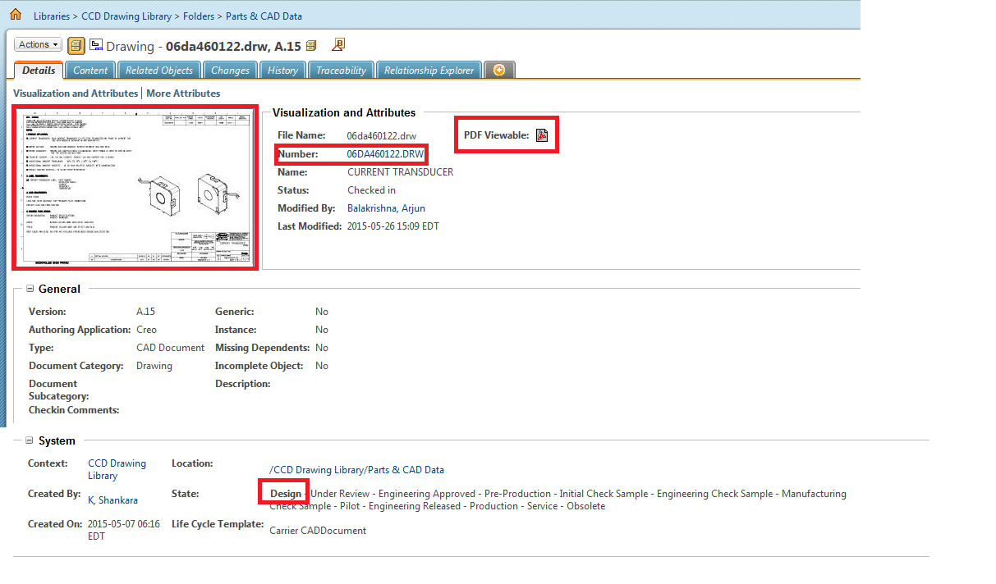

3. User should be able to download all the three.(PDF Viewable/Primary Contents/Creo view).

**Case 2:**

1. Go to any container which has a role OBSERVERLITE /OBSERVER and user mapped to it. And login as that user.

2. Pick an EPMDocument which is already published and is in OBSOLETE state. Navigate to the details page. Click on the PDF Viewable icon/Primary contents/Creo view.

3. User should not be able to download the PDF Viewable/Primary Contents/Open viewable in Creo view.

**No error message displayed**. But User should not be allowed to download PDF Viewable /Primary contents/Open viewable in Creo view.

**Case 3:**

1. Login as any user not mapped to OBSERVERLITE/OBSOLETE role.

2. Pick a EPMDocument which is already published and is in OBSOLETE state. Navigate to the details page. Click on the PDF Viewable icon/Primary contents/Open viewable in Creo view.

3. User should be able to download the PDF Viewable /Primary contents/Open viewable in Creo view.

**9.0 Steps to Restore (On Failure/if Needed)**

1. Delete all the class file added during this deployment.

2. Compile the Java file (Revision to Restore) using the following commands from Windchill Shell

**javac PDFLinkDataUtility.java –d /apps/ptc/Windchill/codebase/ext/carrier/wc/datautility**

3. Remove the updated properties from wc.xconf file and propagate the properties.

**xconfmanager –p**

4. Go to Organization “Carrier”->Utilities->Policy administration->Default->Update->Access Control -> Create the highlighted ACLs.



5. Restart Windchill.

# 10.0 Issues encounter during deployments (If any)

Details of any issues faced during deployment should be captured over here.

# 11.0 Server Administration procedures

The detailed steps of different server administration procedures are captured and available in Production server administration document available at PDS Site (link) and Carrier site (link).This includes procedures on taking different component backups, stopping and starting different components, steps to clear caches and server restore procedures.

# 12.0 Contacts

Details of all the contacts who are involved in different phases of deployments will be listed over here.