|  |
| --- |
| ESR 41652 - Functional Description Document |
|  |
| Carrier |
| Someshwar Sharvirala  ssharvirala@ptc.com |
|  |

Document Properties

|  |  |
| --- | --- |
| **File Name** | **Status** |
| ESR_41652_ FunctionalDescriptionDocument.doc | INWORK |

Change History

|  |  |  |  |
| --- | --- | --- | --- |
| **Date** | **Author** | **Version** | **Description** |
| FEB/2/2011 | Someshwar Sharvirala | A.1 | Initial Draft created from the specs given by June |
| OCT/09/2015 | Akhila V Mani | A.2 | * Modified to implement changes for ESR 41652 |
|  |  |  |  |
|  |  |  |  |
|  |  |  |  |
|  |  |  |  |
|  |  |  |  |
|  |  |  |  |
|  |  |  |  |
|  |  |  |  |
|  |  |  |  |

Approval History

|  |  |  |
| --- | --- | --- |
| **Approver** | **Approval Date** | **Comments** |
|  |  |  |
|  |  |  |
|  |  |  |

Table of Contents

Table of Definitions 5

Overview 6

1. Objective 6

Reference Documents 6

2. Functional Decisions 7

3. Assumptions 7

4. Functional Specification 8

4.1. General 8

4.2. ECN Summary Report 8

5. External References 9

APPENDIX - A 10

APPENDIX - B 11

Table Index

Table 1 : Terminology 5

Table 2 : Reference Documents 6

Table 3 : Functional Decisions 7

Table 4 : Assumptions 7

Table 5 : General Function Descriptions 8

Table 6 : Report Function Descriptions 8

Table of Definitions

Table : Terminology

|  |  |
| --- | --- |
| **Term Used** | **Definition** |
| RLCS | Residential & Light Commercial Systems. A business unit of Carrier |
| Cognos | A Windchill Business Reporting Module |
| Windchill | An integrated suite of Product Lifecycle Management application from PTC. |

Overview

This Functional Description Document describes the user requirements of a BOM Data Management Cognos report for Carrier PartsLister users without specifying system design, except when a particular design is an explicit user requirement from a user’s point of view.

# Objective

The principle objective of this ESR is to build a report that will enable the presentation of data for an ECN object in a user requested form. This is a report to be created using Windchill Cognos framework.

## Reference Documents

Table : Reference Documents

|  |  |  |
| --- | --- | --- |
| **Name** | **Reference link** | **Dependency** |
| Initial Requirements captured by June Dolan | <http://windchill.carrier.utc.com/Windchill/servlet/TypeBasedIncludeServlet?ContainerOid=OR%3Awt.projmgmt.admin.Project2%3A6387612&oid=VR%3Awt.doc.WTDocument%3A971579495&u8=1> | Input for this spec document |
| Carrier ESR | <http://esr.carrier.utc.com/WorkOrder.do?woMode=viewWO&woID=8588&> | Formal request initiation |

# Functional Decisions

This section provides a reference to key decisions that impact report creation, scope or functional behavior. Any decision that creates or resolves a risk or issue is captured here and as well as those that affect requirements for product capabilities or those that could impact user adoption.

Table : Functional Decisions

|  |  |
| --- | --- |
| **No.** | **Decision** |
|  | This requirement initially came from RLCS Raptor but later presented to all PartsLister users for gathering the specifications |
|  |  |
|  |  |
|  |  |
|  |  |
|  |  |
|  |  |
|  |  |

# Assumptions

This section provides a list of Assumptions that impact solution design and development.

Table : Assumptions

|  |  |
| --- | --- |
| **No.** | **Assumption** |
|  | Name of the Report is ‘ECN Summary Report’ |
|  |  |
|  |  |
|  |  |
|  |  |
|  |  |
|  |  |
|  |  |

# Functional Specification

## General

The following are the list of general functions described that are required to be enabled during the implantation:

Table : General Function Descriptions

|  |  |  |
| --- | --- | --- |
| **#** | **Function Category** | **Description** |
|  | General | The report should provide a summary of the changes being made on an ECN |
|  | General | The objects included on the report should be WTParts, EPMDocuments (Pro/E Drawings) ,CAD Models(.prt,.asm) and structured WTParts (BOMs). |
|  | General | The information is to be presented in an easy to understand format with optional report sections |

## ECN Summary Report

The following are the list of requirements identified for the proposed Report development:

Table 6 : Report Function Descriptions

|  |  |  |
| --- | --- | --- |
| **#** | **Function Category** | **Description** |
|  | Report | **Header Information to be shown on the Report:**  ECN Number  ECN Lifecycle State  ECR Number(s) – Should be a csv list with links  Creation Date  Release Date  Resolve Date  CAIII Signature  CAIV Signature  Section Name (i.e. Obsolete Parts, New Parts etc. See below requirement) |
|  | Report | There should be different report sections – each section should have the ability to be included / excluded when the report is run. Different sections are:   * Obsolete Parts * New Parts * Revised Parts – List of all WTParts on resulting items that have attribute changes only (no structure changes). * Revised drawings – List of all drawings on resulting items. * CAD Models –List of all cad models (.prt,.asm) on resulting items. * Bill of Materials Revision summary: List of all product structure adds/deletes/changes. |
|  | Report | Information common to all report sections except for Revised BOM Section:   * Part Number (Labeled “Drawing No.” in Revised Drawings section) * Revision * Part Name * Part Qualifier * LC State of the object |
|  | Report | Obsolete Parts section additional information:   * Any unresolved ECNs that has a WTPart that exists on the resulting items of this ECN included on it |
|  | Report | New Parts section additional information:   * Any unresolved ECN that has a WTPart that exists on the resulting items of this ECN included on it |
|  | Report | Revised Drawings section additional information: (Note this is not currently available in Parts Lister)   * New/Revised * Any unresolved ECN that has a Drawing(.DRW or DD Drawing) that exists on the resulting items of this ECN included on it |
|  | Report | CAD Model section additional information: (Note this is not currently available in Parts Lister)   * New/Revised * Any unresolved ECN that has a CAD Mode(.prt,.asm) that exists on the resulting items of this ECN included on it |
|  | Report | Revised Bill of Materials – A summary of the changes to each BOM. For each component add/delete/change:   * Parent Number * Parent Rev * Parent Name * Assembly Disposition * For Each Parent Component relation   + Component Disposition   + Line/Item Number   + Component Number   + Quantity   + Units of Measure   + Source of the component   + Component Name   + Status – like DEL-Delete, ADD – Add & CHG – Change (Change of Item Number or Quantity)   Special Requirements:   * Disposition information is not available on the ECN. It is usually written on the hard copy of the revision summary from Parts Lister. * If it is determined that disposition information is a requirement for this report, having it added goes beyond just adding a field with a 2/3 space characters with a underline to the report. This is for the user to enter it manually when printed. |
|  |  |  |

# Future Enhancements

## Future

The following are the list of functions described that are identified to be implemented in the future as required.

Table : General Function Descriptions

|  |  |  |
| --- | --- | --- |
| **#** | **Function Category** | **Description** |
|  | Future | Incorporating Windchill disposition on parents into the report |
|  | Future | Adding manufacturing plants into the new & revised sections |

# External References

|  |  |
| --- | --- |
| **Reference** | **Description** |
|  |  |

# APPENDIX - A

Currently Windchill has a similar Report in place with name ‘Revision Summary Report’

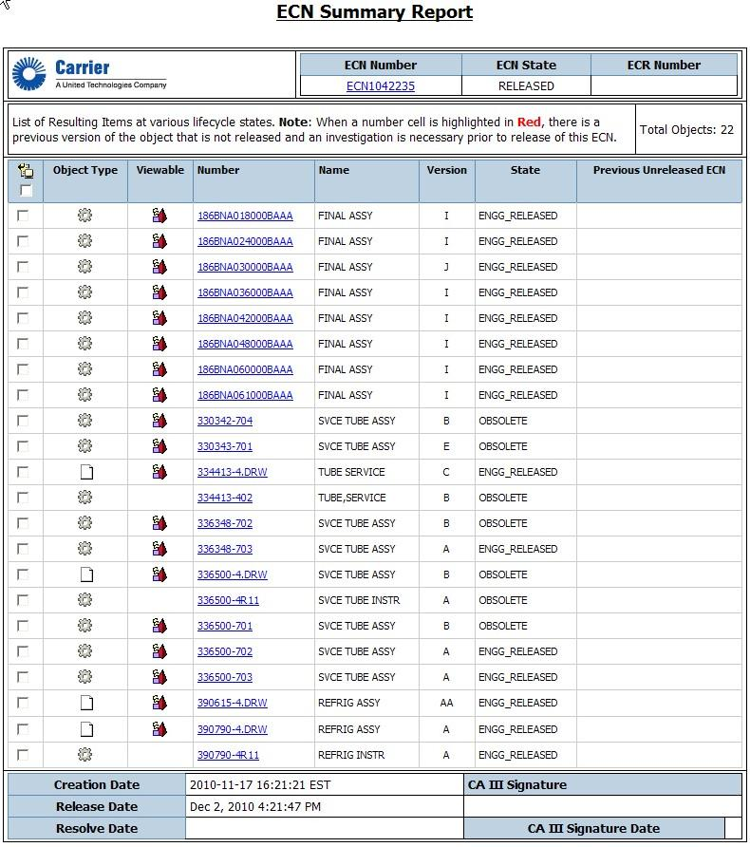

Add a column with Drawing # and Drawing Rev #

# APPENDIX - B

There is a similar report in PartsLister where this requirement has conceptually originated from. Providing some screens of this report for reference here:

**Obsolete Parts Report**

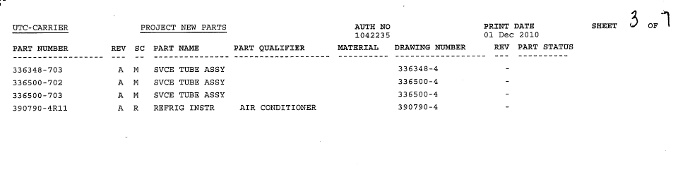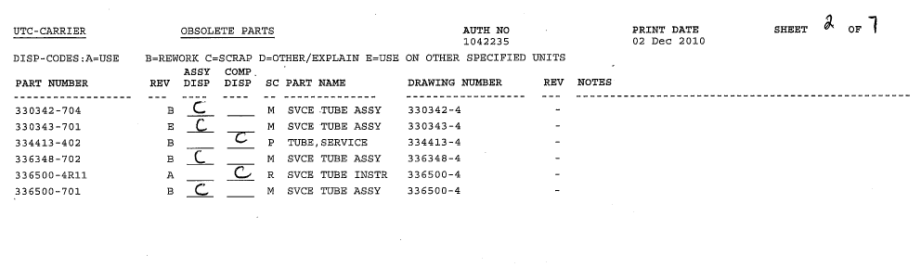

**New Parts Report**

Indicate the plant affected by these new parts.

**Revision Summary Report**

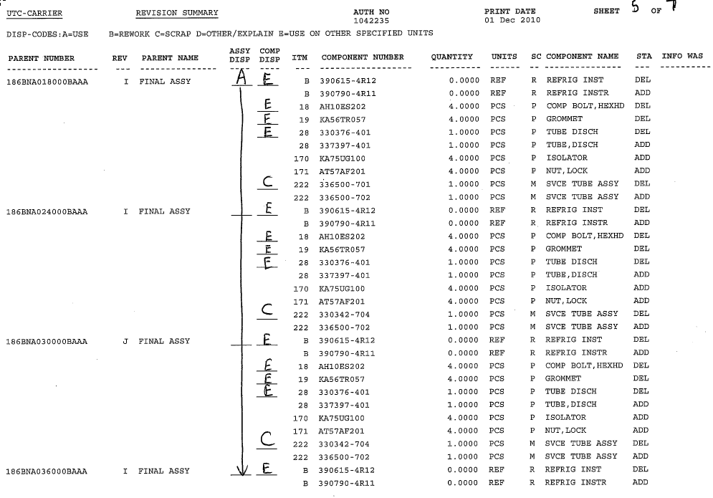

**Revised Drawings**

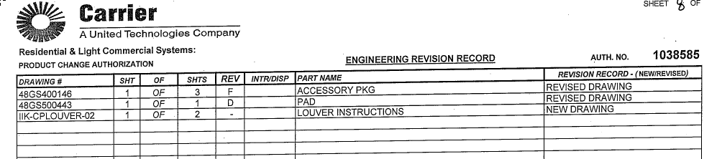

**Similar Report in Excel**

