# Purpose

This release note covers the changes to Carrier servers to fix ESR mentioned in below table

| ESR | Description | PTC TS # (if any) |
| --- | --- | --- |
| ESR 41652 | Enhance the ECN release report | NA |
| ESR 44231 | [Add ECN number to all pages of ECN Release Report](http://esr.carrier.utc.com/WorkOrder.do?woMode=viewWO&woID=44231&&fromListView=true) | NA |
| ESR 36848 | ECN release report - Download for all objects doesn't work | NA |

# Revision History

Document revision history is controlled by [http://windchill.carrier.utc.com](http://windchill.carrier.utc.com/) (Carrier’s Production Server).

Carrier: http://windchill.carrier.utc.com/Windchill/app/#ptc1/tcomp/infoPage?ContainerOid=OR%3Awt.projmgmt.admin.Project2%3A8297123&oid=VR%3Awt.doc.WTDocument%3A2417813241&u8=1

# Change History

| Date | Revision | Technician | Description of change and a link to affected section |
| --- | --- | --- | --- |
| 01/09/15 | -.1 | Akhila V Mani | Add a section in the report that includes CAD models being released on the ECN and display the ECN Number in all the pages of ECN Release report and open the viewable in PDF Format. |

# Issue Summary

Adding a CAD Model section in the ECN Release Report to list all the CAD Models being released and adding ECN Number to all the pages of the ECN Release Report and open the viewable in PDF Format.

# Deployment Status

Below table contains current status of these changes, this tables will be updated by Infrastructure Team

|  |  |  |  |
| --- | --- | --- | --- |
| **Servers** | **Development** | **Staging** | **Production** |
| **Deployed by** |  |  |  |
| **Deployed Date** |  |  |  |
| **Validated by** |  |  |  |
| **Validated date** |  |  |  |

# Check List

Below are the lists of items that need to be verified before scheduling deployment on test and production server.

|  |  |  |  |
| --- | --- | --- | --- |
| **Check-list** | **Development** | **Staging** | **Production** |
| **Files updated to SVN** |  |  |  |
| **Included manual recovery steps** |  |  |  |
| **Included validation Steps** |  |  |  |
| **Validation Confirmation from User** |  |  |  |
| **Database Export required** |  |  |  |
| **LDAP Export required?** |  |  |  |
| **Windchill codebase Backup?** |  |  |  |
| **Selected Files Backup** |  |  |  |
| **Change Control** |  |  |  |
| **Windchill Start/Stop required?** |  |  |  |

# Resolution

Below are the different steps involved during deployment.

## Specify the SVN Location

All modified/updated files downloaded from [WCDEV](http://cusnwa5d.carrier.utc.com/wc/wcsvn/branch/WCDEV/) SVN branch

## List of all OOTB & Custom files modified to resolve this issue

Below are the lists of files that are modified to resolve this ESR.

|  |
| --- |
| **File Name** |
| **/apps/ptc/Windchill/src/ext/carrier/wc/cognos/CognosReportHelper.java** |
| **/apps/ptc/Windchill/src/ext/carrier/wc/cognos/CognosReportRB.java** |
| **/apps/ptc/Windchill/codebase/netmarkets/jsp/ext/carrier/wc/cognos/report/ecnReleaseReportInputPage.jsp** |
| **/apps/ptc/Windchill/loadFiles/ext/carrier/wc/cognos/reports/ECNReleaseReport.xml** |
| **/apps/ptc/Windchill**/**tasks/ext/carrier/wc/cognos/reports/ECNReleaseResultingBOMQuery.xml** |
| **/apps/ptc/Windchill/tasks/ext/carrier/wc/cognos/reports/ECNReleaseResultingNewPartsQuery.xml** |
| **/apps/ptc/Windchill/tasks/ext/carrier/wc/cognos/reports/ECNReleaseResultingObjectsQuery.xml** |
| **/apps/ptc/Windchill/tasks/ext/carrier/wc/cognos/reports/ECNReleaseResultingObsoleteQuery.xml** |
| **/apps/ptc/Windchill/tasks/ext/carrier/wc/cognos/reports/ECNReleaseResultingRevisedDrwQuery.xml** |
| **/apps/ptc/Windchill/loadFiles/ext/carrier/wc/cognos/reports/ECNReleaseResultingRevisedPartQuery.xml** |
| **/apps/ptc/Windchill/** **codebase/ext/carrier/wc/****wc.xconf** |

## List of all OOTB and Custom files added to resolve this issue

Below are the lists of files that are added to resolve this ESR.

|  |  |  |
| --- | --- | --- |
| **Filename** | **Revision for Change** | **Revision to Restore** |
| **/apps/ptc/Windchill/loadFiles/ext/carrier/wc/cognos/reports/ECNReleaseReportCADModel.ldif** | **947** | **NA** |
| **/apps/ptc/Windchill/tasks/ext/carrier/wc/cognos/reports/ECNReleaseResultingCADModelQuery.xml** | **918** | **NA** |

## 7.4 Revision Table

|  |  |  |
| --- | --- | --- |
| **Filename** | **Revision for Change** | **Revision to Restore** |
| **/apps/ptc/Windchill/src/ext/carrier/wc/cognos/CognosReportHelper.java** | **1034** | **18** |
| **/apps/ptc/Windchill/src/ext/carrier/wc/cognos/CognosReportRB.java** | **1032** | **NA** |
| **/apps/ptc/Windchill/codebase/netmarkets/jsp/ext/carrier/wc/cognos/report/ecnReleaseReportInputPage.jsp** | **927** | **NA** |
| **/apps/ptc/Windchill/loadFiles/ext/carrier/wc/cognos/reports/ECNReleaseReport.xml** | **1020** | **NA** |
| **/apps/ptc/Windchill/tasks/ext/carrier/wc/cognos/reports/ECNReleaseResultingBOMQuery.xml** | **917** | **18** |
| **/apps/ptc/Windchill/tasks/ext/carrier/wc/cognos/reports/ECNReleaseResultingNewPartsQuery.xml** | **920** | **18** |
| **/apps/ptc/Windchill/tasks/ext/carrier/wc/cognos/reports/ECNReleaseResultingObjectsQuery.xml** | **937** | **18** |
| **/apps/ptc/Windchill/tasks/ext/carrier/wc/cognos/reports/ECNReleaseResultingObsoleteQuery.xml** | **922** | **18** |
| **/apps/ptc/Windchill/tasks/ext/carrier/wc/cognos/reports/ECNReleaseResultingRevisedDrwQuery.xml** | **923** | **18** |
| **/apps/ptc/Windchill/tasks/ext/carrier/wc/cognos/reports/ECNReleaseResultingRevisedPartQuery.xml** | **924** | **18** |
| **/apps/ptc/Windchill/loadFiles/ext/carrier/wc/cognos/reports/ECNReleaseReportCADModel.ldif** | **947** | **NA** |
| **/apps/ptc/Windchill/tasks/ext/carrier/wc/cognos/reports/ECNReleaseResultingCADModelQuery.xml** | **918** | **NA** |
| **/apps/ptc/Windchill/** **codebase/ext/carrier/wc/wc.xconf** | **1035** | **NA** |

## Manual changes before deploying changes

1. Go to site->Utilities->Task Delegate Administration->Login as LDAP Administrator.

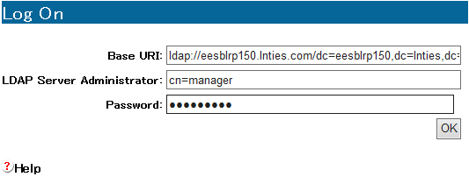

2. Import Delegate. Choose the file mentioned below.

**/apps/ptc/Windchill/loadFiles/ext/carrier/wc/cognos/reports/ECNReleaseReportCADModel.ldif**

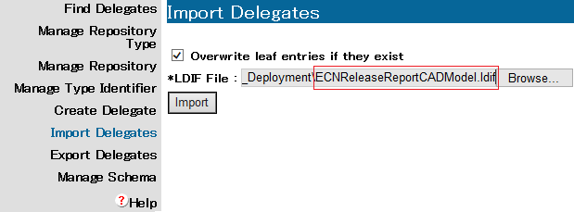

## Deployment procedure

1. Download the file mentioned above to their corresponding folders.

2. Copy the properties from the wc.xconf file and update the wc.xconf file on the server.

**xconfmanager -p**

3. Compile the Java file using the following commands from Windchill Shell

**javac CognosReportHelper.java –d /apps/ptc/Windchill/src/ext/carrier/wc/cognos**

**javac CognosReportRB.java –d /apps/ptc/Windchill/src/ext/carrier/wc/cognos**

4. Run the below command in the shell.

**windchill com.ptc.windchill.cognos.CognosProxy loadReports /apps/ptc/Windchill/loadFiles/ext/carrier/wc/cognos/reports**

**windchill com.ptc.windchill.enterprise.report.ReportHelper updatemodel**

5. Clear Cache and Restart Windchill.

# 8.0 Validation

**Case 1:**

1. Go Home->Reports->Select ECNRelease Report as shown below.

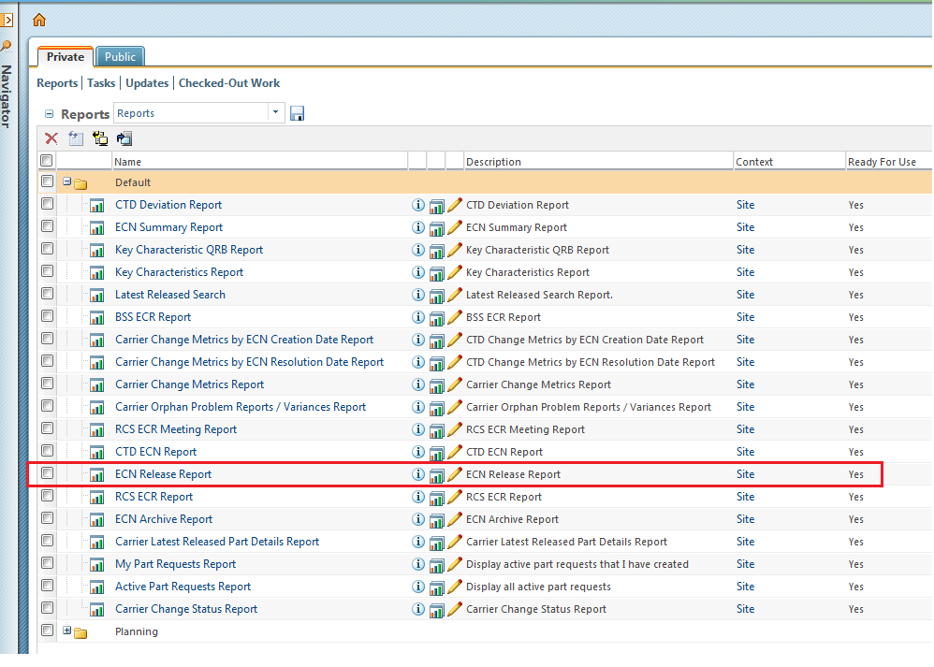

2. Enter any ECN Number as shown below.

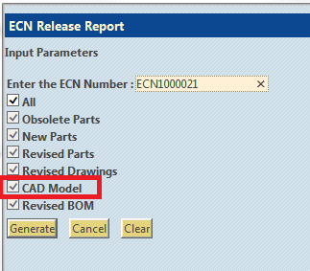

3. CADModel section is displayed as below with ECN Number on the tittle.

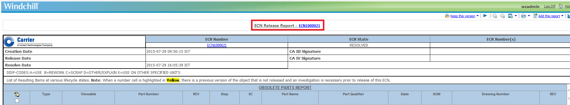

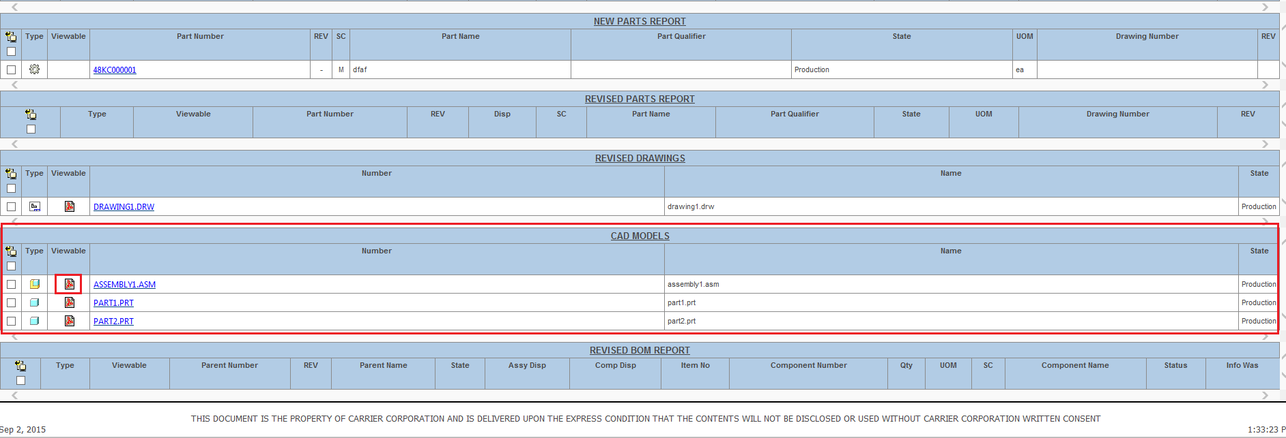

**9.0 Steps to Restore (On Failure/if Needed)**

1. Delete the task registered.

Go to site->Utilities->Task Delegate Administration->Login as LDAP Administrator.

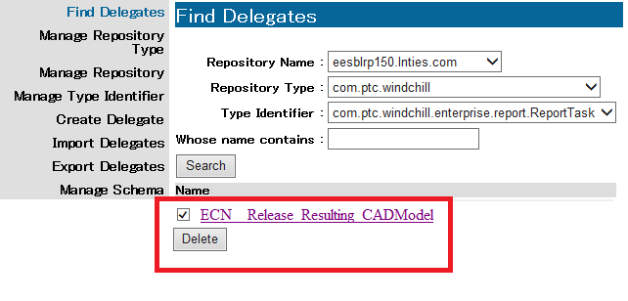

2. Delete all the class file added during this deployment.

3. Compile the Java file (Revision to Restore) using the following commands from Windchill Shell

**javac CognosReportHelper.java –d /apps/ptc/Windchill/src/ext/carrier/wc/cognos**

**javac CognosReportRB.java –d /apps/ptc/Windchill/src/ext/carrier/wc/cognos**

4. Remove the xml files and jsp file (Revision to Restore).

5. Run the below command in the shell.

**windchill com.ptc.windchill.cognos.CognosProxy loadReports /apps/ptc/Windchill/loadFiles/ext/carrier/wc/cognos/reports**

**windchill com.ptc.windchill.enterprise.report.ReportHelper updatemodel**

6. Restart Windchill.

# 10.0 Issues encounter during deployments (If any)

Details of any issues faced during deployment should be captured over here.

# 11.0 Server Administration procedures

The detailed steps of different server administration procedures are captured and available in Production server administration document available at PDS Site (link) and Carrier site (link).This includes procedures on taking different component backups, stopping and starting different components, steps to clear caches and server restore procedures.

# 12.0 Contacts

Details of all the contacts who are involved in different phases of deployments will be listed over here.