# CoverPage

|  |
| --- |
| **Requirement Document :** Save As wizard customization |
| **Submitted to:** |
| **Attention:** |
| **Reference:** |

|  |  |  |
| --- | --- | --- |
| Title | Document No. | Rev. & Date (DD-Mon-YYYY) |
| Save As Customization Analysis |  |  |

Larsen & Toubro Limited,

Technology Services

www.lnttechservices.com

The contents of this document are the sole and exclusive property of Larsen & Toubro Limited Unit: L&T Integrated Engineering Services. They may not be disclosed to any third party, copied or reproduced in any form or used for any purpose, other than the purpose for which they were provided, without the permission of Larsen & Toubro Limited.

**Document History:**

|  |  |  |  |  |  |  |
| --- | --- | --- | --- | --- | --- | --- |
| **Rev No.** | **Release Date** | **Prepared. By Prepared. Dt.** | **Reviewed By Reviewed Dt.** | **Reviewed By Reviewed Dt.** | **Authorized By Authorized Dt.** | **Remarks/Revision Details** |
| Draft 1.1 |  |  |  |  |  |  |
|  |  |  |  |

|  |  |  |
| --- | --- | --- |
| **Req.ID** | **Requirement Summary** | **Requirement Description** |
| ER001 | Allow user to modify Subtype attribute during save as of Part | Based on the Subtype attribute value AutoNumber will be generated for Part. During Save As of the existing Part, subtype attribute should be editable as dropdown.  Reference **ESR41809**  <http://esr.carrier.utc.com/WorkOrder.do?woMode=viewWO&woID=41809&&fromListView=true> |

**Functional Analysis**

Create part wizard:

* The Subtype attribute is displayed from Type and Attribute configuration
* The dropdown values are coming from Enumerated value list

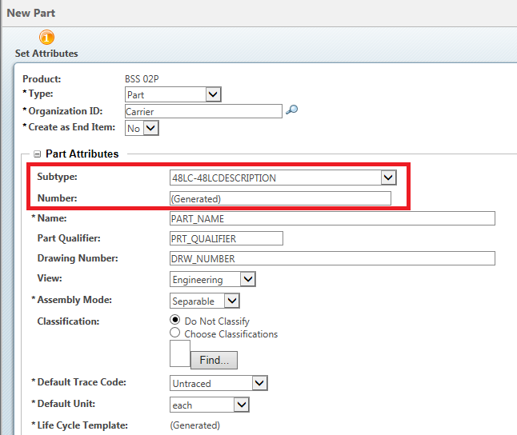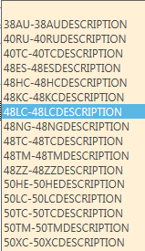

Values coming from type and attribute Enumeration

Part information:

* Part Number is an Auto generated Number based on the subtype attribute value
* Selected subtype attribute value will be saved and displayed.

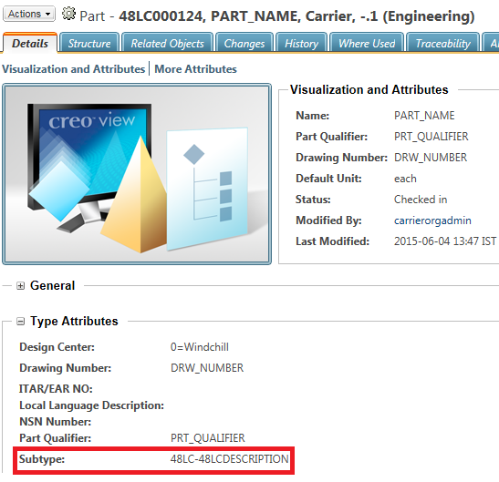

Save as Functionality:

* Save as functionality is tightly coupled and it is not using Windchill jca-Mvc framework
* EPMDocument Save as is also using the same wizard and modifying the table will affect the existing functionalities
* Functionalities like collect related parts, collect related family objects , collect CAD Documents , collect related Drawings are directly linked with the save as table
* Save as table subtype column is displaying the original part string value.
* As per ptc product specification editing the soft attributes on Save As action wizard UI is not recommendable.

Part Save as:

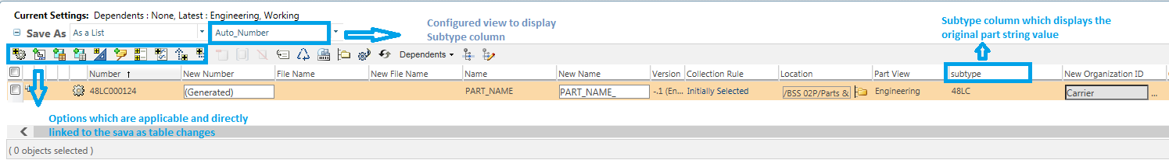

EPMDocument Save as:

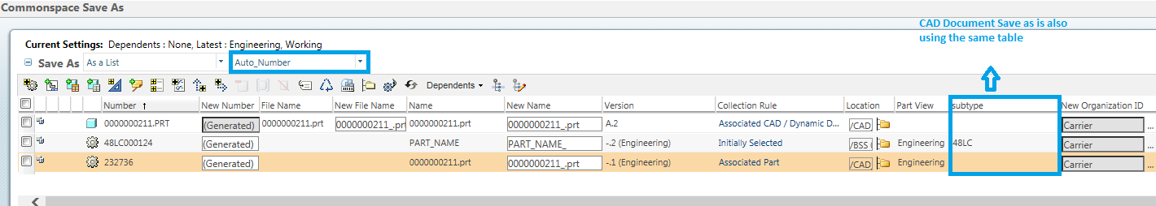

References:

1. <https://support.ptc.com/appserver/cs/view/solution.jsp?n=CS62867&art_lang=en&posno=1&q=CS62867>

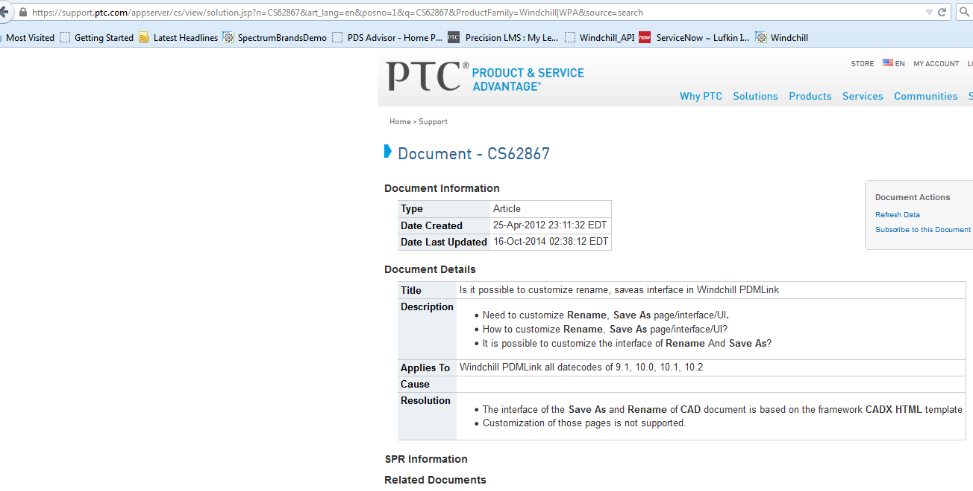

1. <https://support.ptc.com/apps/case_logger_viewer/auth/ssl/case=12563858>

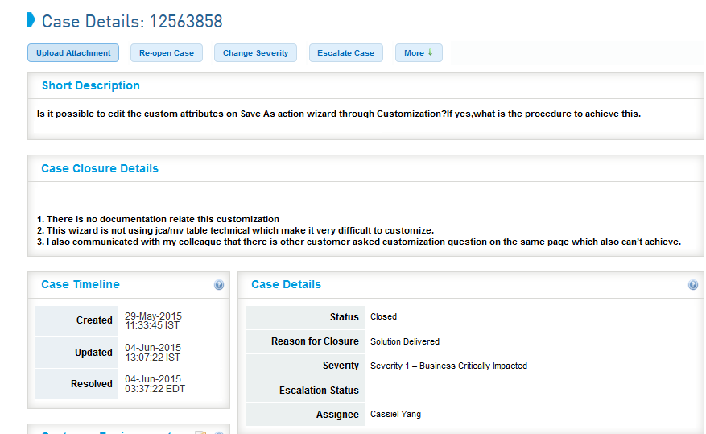

1. <https://support.ptc.com/apps/case_logger_viewer/auth/ssl/case=12562661>

