# Purpose

This release note covers the changes to Carrier servers to fix ESR mentioned in below table

| ESR | Description | PTC TS # (if any) |
| --- | --- | --- |
| ESR 40414 | New report needed in WC-RCS PMP ECR Meeting Report | NA |

# Revision History

Document revision history is controlled by [http://windchill.carrier.utc.com](http://windchill.carrier.utc.com/) (Carrier’s Production Server).

Carrier: http://windchill.carrier.utc.com/Windchill/app/#ptc1/tcomp/infoPage?oid=VR%3Awt.doc.WTDocument%3A2465759906

# Change History

| Date | Revision | Technician | Description of change and a link to affected section |
| --- | --- | --- | --- |
| 24/09/15 | -.1 | Akhila V Mani | [CMU ECR Meeting Report](javascript:launchWindow2('http://eesblrp150.lnties.com/Windchill/wtcore/jsp/report/runReport.jsp?actionOid=wt.org.WTUser%3A107&oid=com.ptc.windchill.enterprise.report.Report%3A311547&u8=1','reportExecute','width=1000,height=600,directories=no,location=no,menubar=no,scrollbars=yes,status=yes,toolbar=no,resizable=yes')) similar to [RCS ECR Meeting Report](javascript:launchWindow2('http://eesblrp150.lnties.com/Windchill/wtcore/jsp/report/runReport.jsp?actionOid=wt.org.WTUser%3A107&oid=com.ptc.windchill.enterprise.report.Report%3A228926&u8=1','reportExecute','width=1000,height=600,directories=no,location=no,menubar=no,scrollbars=yes,status=yes,toolbar=no,resizable=yes')) for specific containers. |

# Issue Summary

Creating a new cognos report similar to [RCS ECR Meeting Report](javascript:launchWindow2('http://eesblrp150.lnties.com/Windchill/wtcore/jsp/report/runReport.jsp?actionOid=wt.org.WTUser%3A107&oid=com.ptc.windchill.enterprise.report.Report%3A228926&u8=1','reportExecute','width=1000,height=600,directories=no,location=no,menubar=no,scrollbars=yes,status=yes,toolbar=no,resizable=yes')) but specific to [Split and Fan Coils] and [SRT] Containers.

# Deployment Status

Below table contains current status of these changes, this tables will be updated by Infrastructure Team

|  |  |  |  |
| --- | --- | --- | --- |
| **Servers** | **Development** | **Staging** | **Production** |
| **Deployed by** |  |  |  |
| **Deployed Date** |  |  |  |
| **Validated by** |  |  |  |
| **Validated date** |  |  |  |

# Check List

Below are the lists of items that need to be verified before scheduling deployment on test and production server.

|  |  |  |  |
| --- | --- | --- | --- |
| **Check-list** | **Development** | **Staging** | **Production** |
| **Files updated to SVN** |  |  |  |
| **Included manual recovery steps** |  |  |  |
| **Included validation Steps** |  |  |  |
| **Validation Confirmation from User** |  |  |  |
| **Database Export required** |  |  |  |
| **LDAP Export required?** |  |  |  |
| **Windchill codebase Backup?** |  |  |  |
| **Selected Files Backup** |  |  |  |
| **Change Control** |  |  |  |
| **Windchill Start/Stop required?** |  |  |  |

# Resolution

Below are the different steps involved during deployment.

## Specify the SVN Location

All modified/updated files downloaded from [WCDEV](http://cusnwa5d.carrier.utc.com/wc/wcsvn/branch/WCDEV/) SVN branch

## List of all OOTB & Custom files modified to resolve this issue

Below are the lists of files that are modified to resolve this ESR.

|  |
| --- |
| **File Name** |
| **/apps/ptc/Windchill/** **codebase/ext/carrier/wc/****wc.xconf** |

## List of all OOTB and Custom files added to resolve this issue

Below are the lists of files that are added to resolve this ESR.

|  |
| --- |
| **Filename** |
| **/apps/ptc/Windchill/loadFiles/ext/carrier/wc/cognos/reports/CMU_ECR_Meeting_Agenda_Report.ldif** |
| **/apps/ptc/Windchill/tasks/ext/carrier/wc/cognos/reports/cmuECRmtgAgendaQuery.xml** |
| **/apps/ptc/Windchill/loadFiles/ext/carrier/wc/cognos/reports/CMUECRMtgReport.xml** |
| **/apps/ptc/Windchill/loadFiles/ext/carrier/wc/cognos/reports/CMUECRMtgReportLoad.xml** |

## 7.4 Revision Table

|  |  |  |
| --- | --- | --- |
| **Filename** | **Revision for Change** | **Revision to Restore** |
| **/apps/ptc/Windchill/loadFiles/ext/carrier/wc/cognos/reports/CMU_ECR_Meeting_Agenda_Report.ldif** | **1048** | **NA** |
| **/apps/ptc/Windchill/tasks/ext/carrier/wc/cognos/reports/cmuECRmtgAgendaQuery.xml** | **1064** | **NA** |
| **/apps/ptc/Windchill/loadFiles/ext/carrier/wc/cognos/reports/CMUECRMtgReport.xml** | **1048** | **NA** |
| **/apps/ptc/Windchill/loadFiles/ext/carrier/wc/cognos/reports/CMUECRMtgReportLoad.xml** | **1048** | **NA** |
| **/apps/ptc/Windchill/** **codebase/ext/carrier/wc/wc.xconf** | **1063** | **NA** |

## Manual changes before deploying changes

1. Go to site->Utilities->Task Delegate Administration->Login as LDAP Administrator.

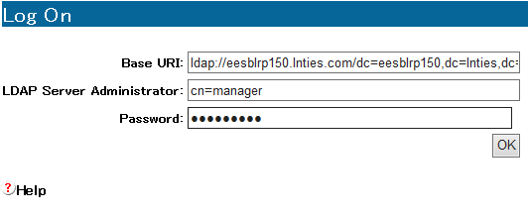

2. Import Delegate. Choose the file mentioned below.

**/apps/ptc/Windchill/loadFiles/ext/carrier/wc/cognos/reports/CMU_ECR_Meeting_Agenda_Re port.ldif**

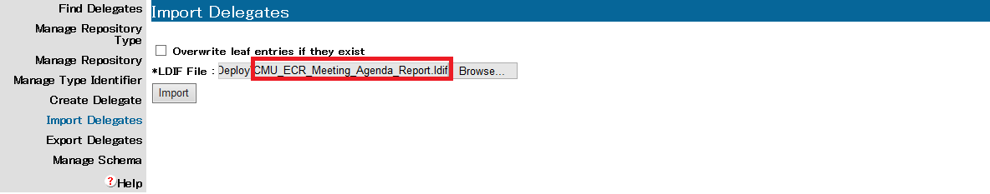

## Deployment procedure

1. Download the file mentioned above to their corresponding folders.

2. Copy the properties from the wc.xconf file and update the wc.xconf file on the server.

**xconfmanager -p**

3. Run the below command in the shell.

**windchill wt.load.LoadFromFile -d /apps/ptc/Windchill/loadFiles/ext/carrier/wc/cognos/reports/CMUECRMtgReportLoad.xml**

**windchill com.ptc.windchill.cognos.CognosProxy loadReports /apps/ptc/Windchill/loadFiles/ext/carrier/wc/cognos/reports**

**windchill com.ptc.windchill.enterprise.report.ReportHelper updatemodel**

4. Clear Cache and Restart Windchill.

5. Go to site->Reports and refresh as shown below.

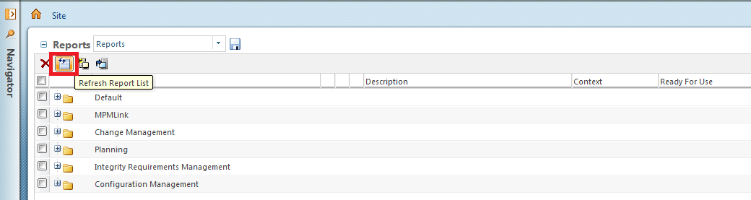

6. Goto Site-> Reports ->Default and select edit option as shown below.

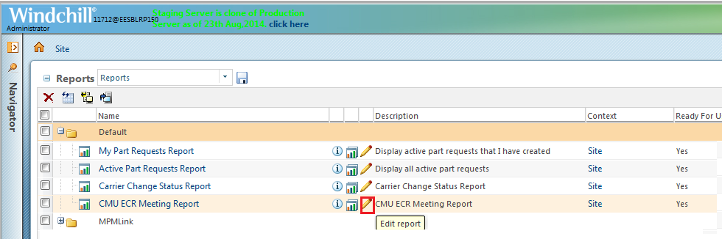

# 7. Selected the highlighted options and click on ok.

# 8.0 Validation

1. Go Home->Reports->Default Folder->Select [CMU ECR Meeting Report](javascript:launchWindow2('http://eesblrp150.lnties.com/Windchill/wtcore/jsp/report/runReport.jsp?actionOid=wt.org.WTUser%3A107&oid=com.ptc.windchill.enterprise.report.Report%3A311547&u8=1','reportExecute','width=1000,height=600,directories=no,location=no,menubar=no,scrollbars=yes,status=yes,toolbar=no,resizable=yes')) as shown below.

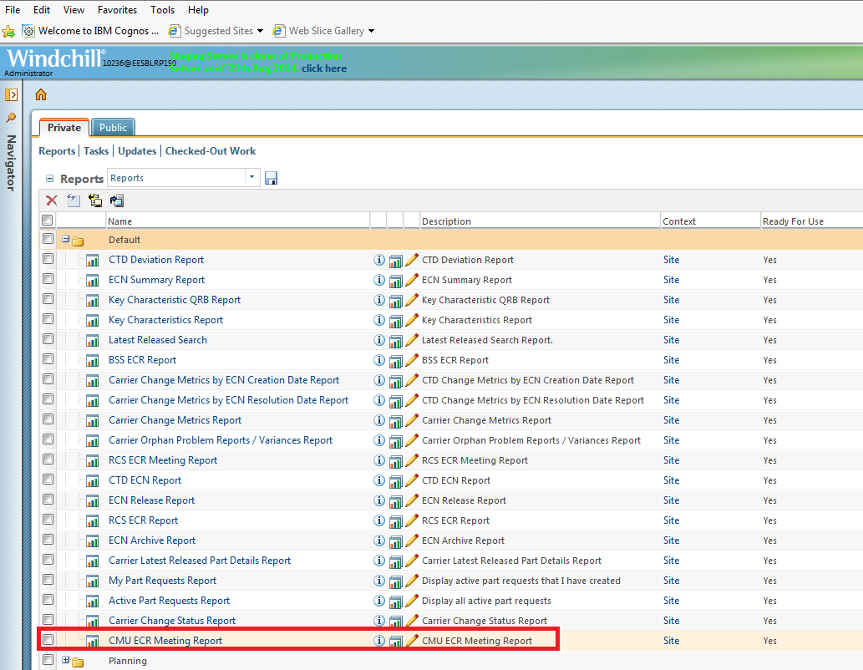

2. You should be able to see the ECRs which are in PENDING APPROVAL or ON HOLD state for Split and Fan Coils or SRT containers only.

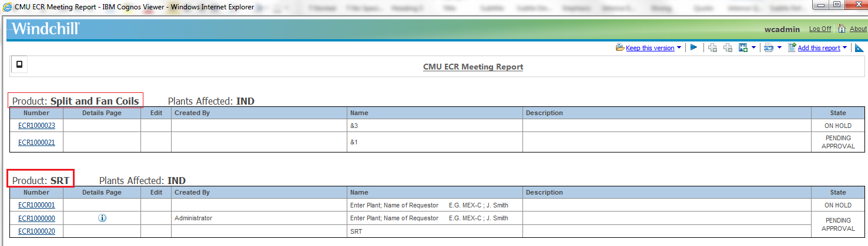

**9.0 Steps to Restore (On Failure/if Needed)**

1. Delete the task registered.

Go to site->Utilities->Task Delegate Administration->Login as LDAP Administrator.

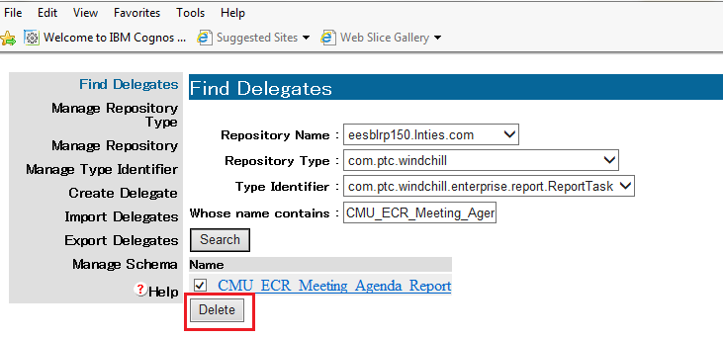

2. Remove the xml files.

3. Run the below command in the shell.

**windchill com.ptc.windchill.cognos.CognosProxy loadReports /apps/ptc/Windchill/loadFiles/ext/carrier/wc/cognos/reports**

**windchill com.ptc.windchill.enterprise.report.ReportHelper updatemodel**

4. Remove the updated properties from wc.xconf file. Run the below command.

**xconfmanager -p**

5. Restart Windchill.

# 10.0 Issues encounter during deployments (If any)

Details of any issues faced during deployment should be captured over here.

# 11.0 Server Administration procedures

The detailed steps of different server administration procedures are captured and available in Production server administration document available at PDS Site (link) and Carrier site (link).This includes procedures on taking different component backups, stopping and starting different components, steps to clear caches and server restore procedures.

# 12.0 Contacts

Details of all the contacts who are involved in different phases of deployments will be listed over here.