Component Design Document for ‘ECN Release Report’ Cognos Report


Carrier

Author: Sathya

Reviewer:

Document Properties
File Name | Status
ComponentDesignDocument_ECNReleaseReport.doc | In Work
Change History
Date | Author | Version | Description
March 18, 2011 | Sathya C | V1 | Initiated
October 09,2015 | Akhila V Mani | V2 | Modified
Approvers
Approver | Approval Date | Comments
Table of Content
1. Overview 4
1.1 Purpose 4
1.2 Scope 4
2. Component Overview 5
Pictorial Overview of the Design 5
3. Design Considerations 5
3.1 Key Report Logic Considerations: 5
3.2 Performance Considerations 5
3.3 Input and Output UIs 6
3.3.1 Report Input Page Layout 6
3.3.2 Report Results Layout 6
4. Design 7
4.1 Source code 7
4.2 Soft Attribute Definitions 7
4.3 Algorithms 7
4.3.1 JSP Input Page 7
4.3.2 Business Logic to fetch the Objects 8
4.3.3 Key Cognos Side Javascripting Logic 10
5. Unit Tests 10
6. Maintenance and Upgrade Considerations 10
7. Risks 10
7.1 Technical Risks 10
7.2 Volatile Areas 10
7.3 Open Issues 10
8. External References 10

- Overview

Purpose
This document describes the low-level design for “ECN Release Report using cognos framework”, This Design document covers the technical details for how this Report shall be/is designed. In this report, the users can search by ECN number and section Name (Obsolete Parts, New Parts, Revised Parts, Revised Drawings, CAD Models, and Revised BOM etc) and generate a Report that contains the selected sections with list of objects with links to the viewable for each object. From the report results output, the users can also select rows and request a zip file of the objects Viewable/Primary content, BOM document’s primary content and EPM Document’s viewable. This report will serve as a replacement for the “ECN Summary Report” Cognos Report with new added functionalities.
To have a complete and detailed understanding of the code, it is expected that the user also open sections of the code to support this documentation.

Scope
The scope of this document is limited to low-level design of the component. Use cases, requirements, process descriptions, project plans, and other documents listed under internal and external references may be referenced, paraphrased, or interpreted to help develop, explain, or evaluate the domain model; however, this document is not the authoritative reference for such information. Accordingly, creating or modifying use cases, requirements, process descriptions, etc. are out of the scope of this document.
Technically, the design for this whole report can be broken down into 2 portions.
- ECN Report Input and Results
- ZIP Download-the same functionality of ECN Summary report is reused.
The scope of this document is limited to the ‘Report Input and Results’ only. However, we have briefly mentioned how to invoke the ZIP Download component. The technical design for the ZIP download portion is explained here.

Component Overview

Pictorial Overview of the Design

Cognos calls the IE Task for processing the input parameters

IE Task processes the input and sends the result as a ‘Group Element’ to Cognos

Cognos processes the Group Element and displays the output parameters.
Sends the user Entered input (ECN No and Selected sections) as hidden value to cognos
JSP Input Page
Forwards the input parameters
Sends the output parameters

Design Considerations

Key Report Logic Considerations:
  - A key consideration is that the IE Task collects the OID’s of all filtered objects and sends that to Cognos. Concatenated string of OIDs for each row shall be designed as the checkbox ‘name’ by Cognos.
  - When the user clicks on the ZIP icon in report results, javascript should collect all the checkbox names (separated by a ‘*’ sign) and send it to the ‘Zip download component’, details for which are explained here.
  - Only the sections selected by User in the input JSP should be shown in the report generated. If user selects ALL , all reports sections show be generated. Accordingly, logic to control section display must be done in Cognos.
  - Report must open up correctly in PDF and Excel formats. Accordingly, logic to control table format for PDF and Excel must be done in Cognos.

Performance Considerations
- The Report Generation logic should hit the database not more than 6 times for each report.
- Generation of Viewable URL needs a database hit for each object. To avoid a database hit for each object, we shall only send the oid to the results. On click of the viewable url, the jsp that opens should calculate the proper viewable url and open the same (ProductView window)
- Report should display the results for 100 or more objects at least.

Input and Output UIs

Report Input Page Layout
a) ECN Release Report Input jsp.
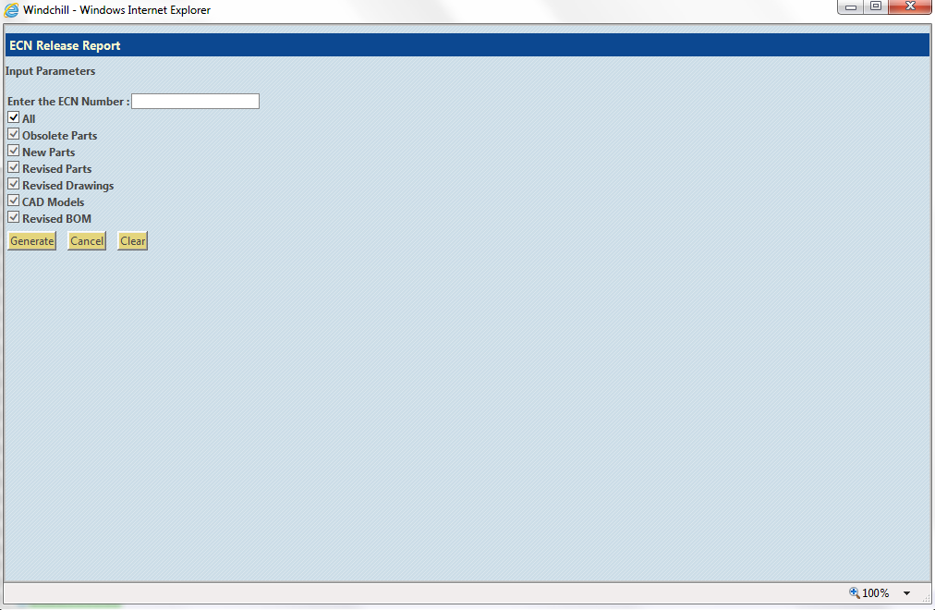

b) ECN Release Report Layout in Report studio

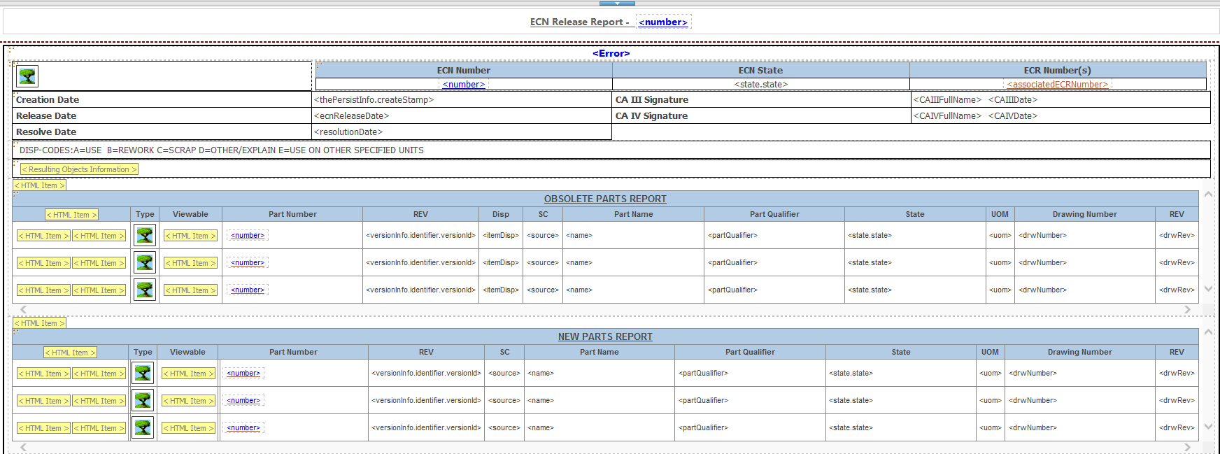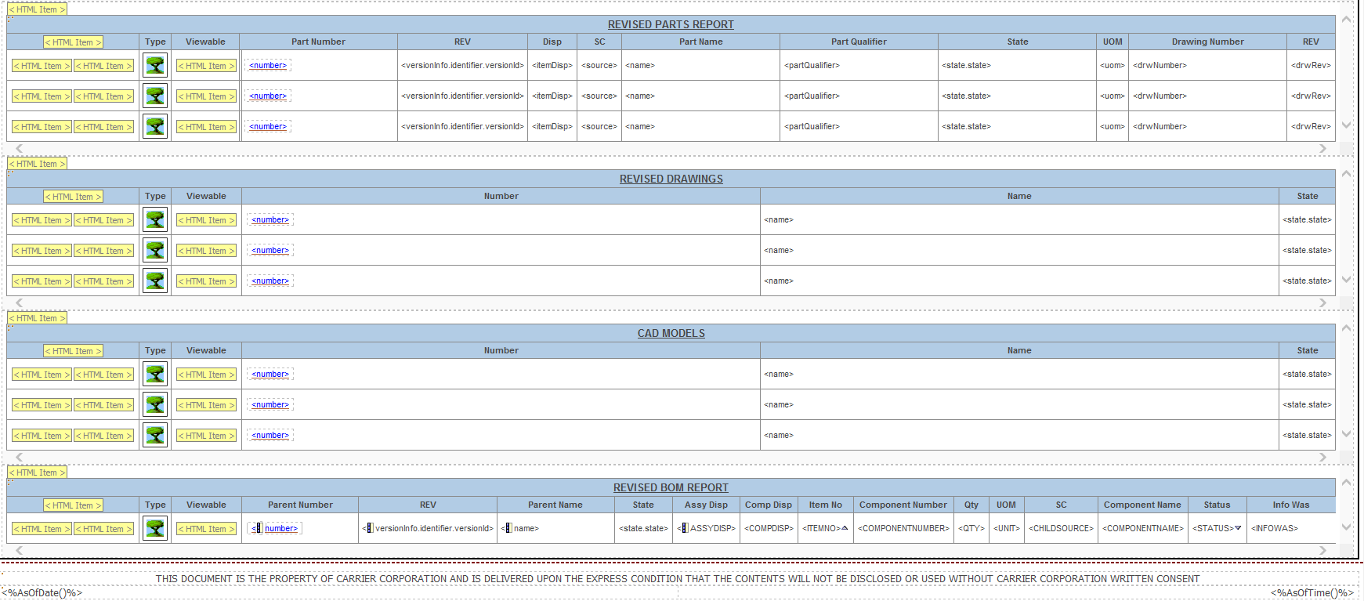

Report Results Layout

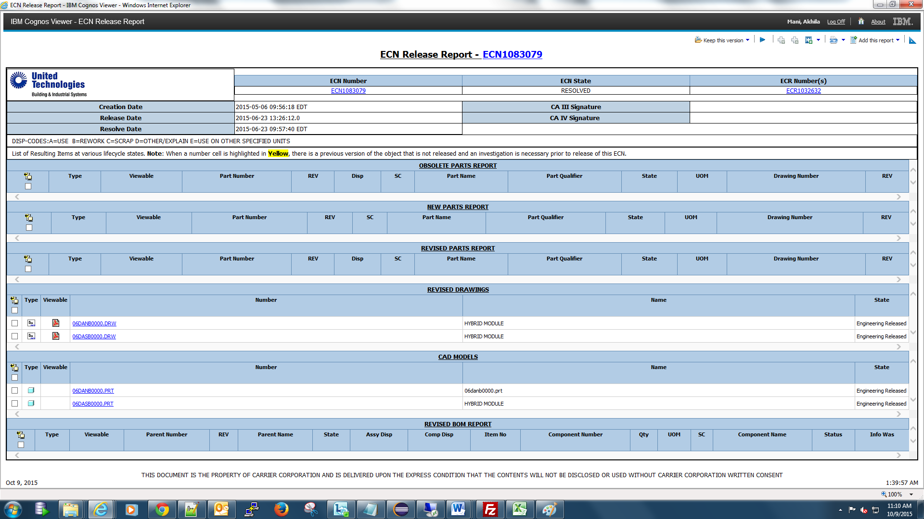

Design

Source code
Note: Some of the files below belong to the component ‘ZIP Download component’ (in blue font). But the source code for the same is mentioned below, for the sake of totality

New Files
<wt_home>/ loadFiles/ext/carrier/wc/cognos/reports/ECNReleaseReport.xml
<wt_home>/ loadFiles/ext/carrier/wc/cognos/reports/ECNReleaseReportLoad.xml
<wt_home> /loadFiles/ext/carrier/wc/cognos/reports/ECNReleaseReport.xml
<wt_home>/ loadFiles/ext/carrier/wc/cognos/reports/ECNReleaseReport.ldif
<wt_home>/tasks/ext/carrier/wc/cognos/reports/ECNReleaseResultingCADModelQuery.xml
<wt_home>//loadFiles/ext/carrier/wc/cognos/reports/ECNReleaseReportCADModel.ldif
<wt_home>/ tasks/ext/carrier/wc/cognos/reports/ECNReleaseResultingObjectsQuery.xml
<wt_home>/ tasks/ext/carrier/wc/cognos/reports/ECNReleaseSummaryReportQuery.xml
<wt_home>//codebase/netmarkets/jsp/ext/carrier/wc/cognos/report/ecnReleaseReportInputPage.jsp <wt_home>/codebase/netmarkets/jsp/ext/carrier/wc/cognos/report/downloadViewable.jsp
<wt_home>/src/ext/carrier/wc/cognos/DownloadViewableUtility.java
<wt_home>/src/ext/carrier/wc/cognos/PrimaryContentToFile.java
<wt_home>/src/ext/carrier/wc/cognos/ZipUtil.java
Changed Files
- <wt_home>/ src/ext/carrier/wc/cognos/CognosReportRB.rbInfo
- <wt_home>/ src/ext/carrier/wc/cognos/CognosReportHelper.java

Soft Attribute Definitions
No new soft type attributes required for this report.

Algorithms
The key business logics for the various pages are explained below.

JSP Input Page
a. Data Entry:
The user should input an ECN Number and select at least one check box for report generation. (He can select all checkbox to generated all report sections)

b. Validation:
- ECN Number field must be populated. If ECN Number field is not populated an alert message will be displayed to user to reenter ECN Number.
- At least one Section checkbox must be selected. If no checkbox is selected alert message to select at least one check box will be displayed.
- ‘All’ checkbox should be enabled by default. When All is checked all other check boxes should be checked and be disabled. If All checkbox is unchecked all other checkboxes should be enabled.

Business Logic to fetch the Objects

  - Display only the Object Types WTPart, WTDocument(DD document) , EPMDocument(.drw) and CAD Models(.prt,.asm).
  - The webject to collect data for ECN attributes has been reused from ECN summary report.
  - XML Task will contain report results attributes as well as obid.
  - Code should all fetch the url to the Images for Object type.
  - Utilize I*E to query all information. After brainstorming and RnD, we have decided to use the following webjects in the following sequence.
- Query-Objects
Key Webject that does all the searching in a single hit to the database.
Key part is constructing the Where clause, such that it Searches for change order Number.This webject is capable of returning the change order attributes
- Query-Links
This webject takes the input of the Query object webjects outgroup( i.e change Orders) and collects associated change activities.
Query webject above has a limitation. We cannot fetch the Representation of the object in this webject. We need the obid of the Representation. Hence, we send in the group returned by Search Objects to the ‘Query-Links’ webject to traverse the 'RepresentableLink' class. The webject will return the Representation objects. However, in order to combine this group with the Search objects, we need to join them on something that is common to Search objects too.. That is Number..Hence, in the attribute retrieval section of the webject, we navigate to the number via the Master Reference. This is done via... 'theRepresentableReference^number'

- Subset-Group
Above retuns ALL representations for that object. We need just the default representation. Hence, this filter webject is used. Filter is (name="FILTER" data="defaultRepresentation='true'")

- Change-Group
Before we do the eventual Join, we need to Rename one of the elements returned by Subset-Group, which is the obid element. We need to do this so that the final group can contain obid’s of both object(under ‘obid’ tag) and its default representation( under ‘representabledoid’ tag)

- Join-Groups
Enlarges the Search Results output Group, by adding the representation obid to it too. After the above IE webject is done, we also need to do a little manipulation to get rid of Drawing Document objects returned from the final group, if the user had not selected Documents of type Drawing(Softtype’s logical id is com.ptc.DD)

Business Logic for different sections in Report
- Obsolete Parts
This section will display the WTParts in the ECN which have been marked for Promote to Obsolete and all other WTParts in ECN which are in the lifecycle state PRODUCTION, ENGINEERING RELEASED, SERVICE or OBSOLETE.Also the EPMDocument(.drw) or DD document associated to the WTParts will also be displayed.
- New Parts
This section will display the WTParts in the ECN which do not have any previous revision. Also the EPMDocument(.drw) or DD document associated to the WTParts will also be displayed.

- Revised Parts
This section will display the WTParts in the ECN which do not have any attribute or structural changes but are being revised. Also the EPMDocument(.drw) or DD document associated to the WTParts will also be displayed.

- Revised Drawings
This section will display all the EPMDocuments (.drw only) and DD Documents which are new or revised in the ECN.

- CAD Models

This section will display all the EPMDocuments (.prt,.asm only) and DD Documents which are new or revised in the ECN.

- Revised BOM
This section will display all the WTParts and its first level children which have Attribute and/or structural changes.

Key Cognos Side Javascripting Logic
  - Viewable Opening Logic:
Write the javascript onclick event on the Viewable Image, to open the ‘openPDF.jsp’. Pass the representation obid in the query string.
  - Invoking the Zip Download component.
Construct the javascript onclick event for the Zip Image. Onlick, you must concatenate all the obids selected on page in the format of ‘obid=id1*id2*id3….’. The jsp to be invoked is the ‘downloadViewable.jsp’. Pass the representation obid in the query string to this jsp.

Unit Tests
Refer to ECN Release Report Unit Test Case.

Maintenance and Upgrade Considerations
No OOTB Source Code was changed. Hence, the only consideration to be noted is to make sure all the source code is properly deployed according to the release note.

Risks

Technical Risks
None.

Volatile Areas
Since the report takes an ECN number as input, stability of the Report for ECN that will return a large number of results is not yet known. Design may be impacted, if the performance on Beta testing yields slow/bad performance.

Open Issues
None.

External References
Reference | Description
Section R.1.1 in Req. Matrix
Use Case Document
Unit Test Case
Release Note

