Created backlog and sprint 14 days
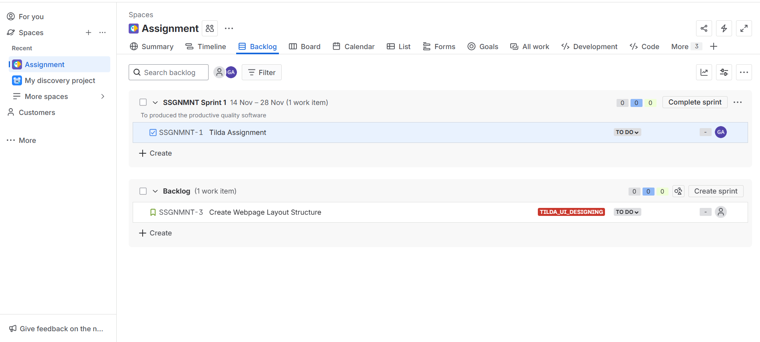
then created epic https://gadipalliakhila00.atlassian.net/browse/SSGNMNT-2

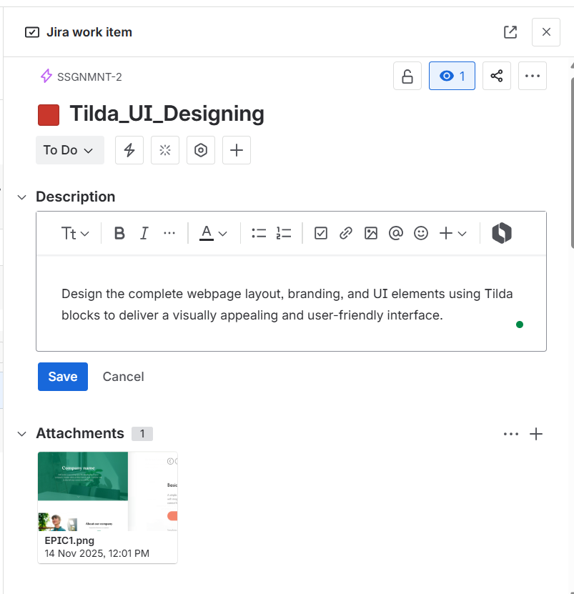

Created story:-https://gadipalliakhila00.atlassian.net/browse/SSGNMNT-3

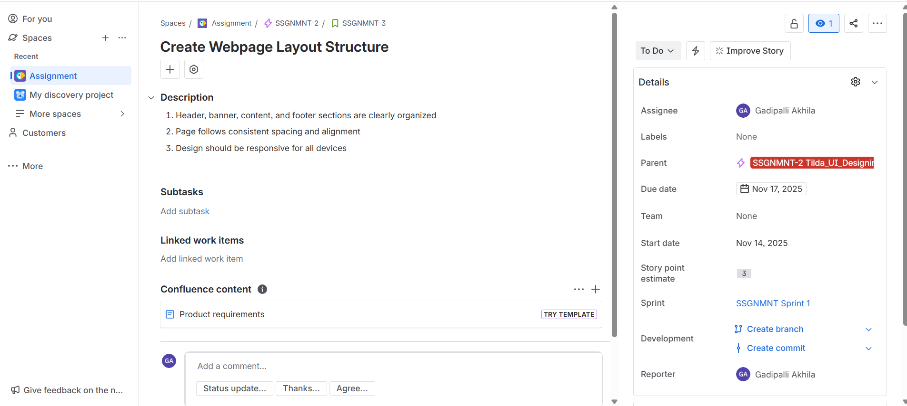

Created Task:-https://gadipalliakhila00.atlassian.net/browse/SSGNMNT-4

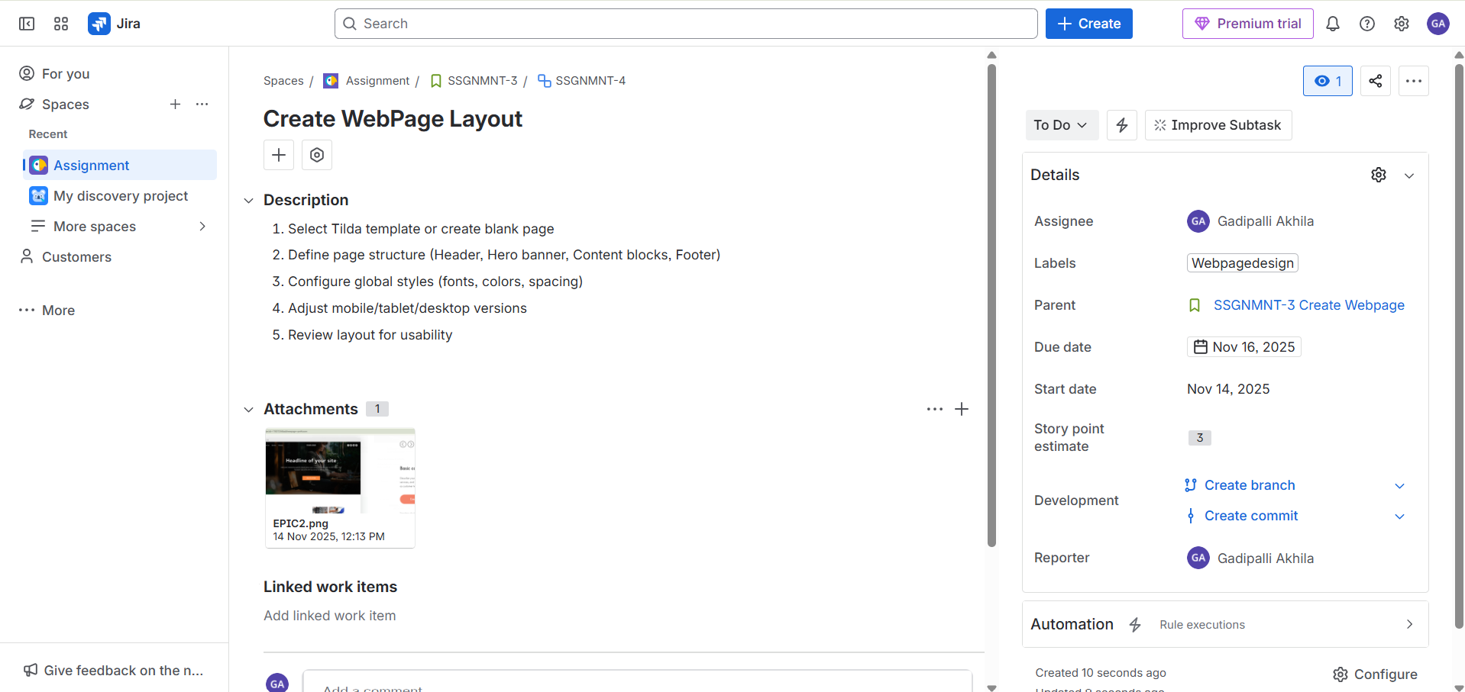

Created 1 more user story and sub task:-

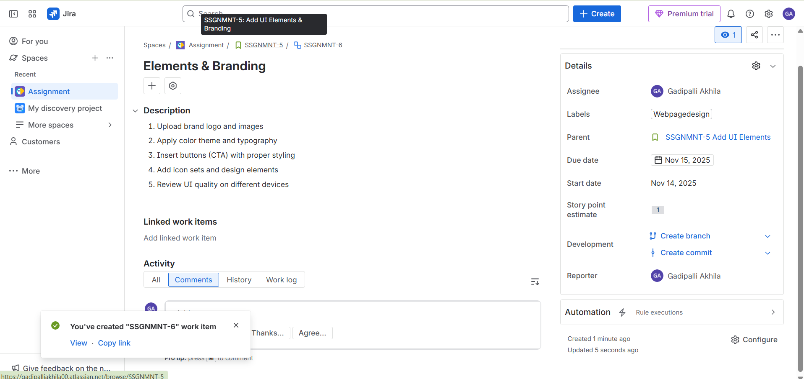

created the development epic :-https://gadipalliakhila00.atlassian.net/browse/SSGNMNT-7

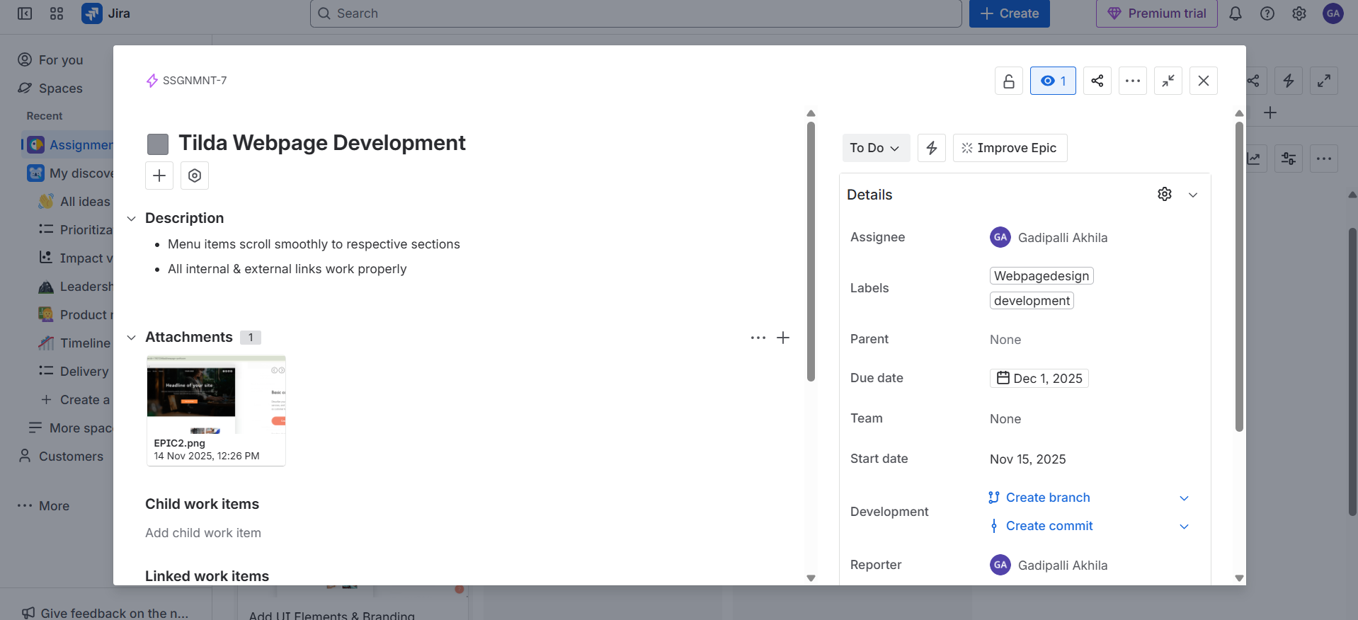

created story and task:-https://gadipalliakhila00.atlassian.net/browse/SSGNMNT-9
https://gadipalliakhila00.atlassian.net/browse/SSGNMNT-8

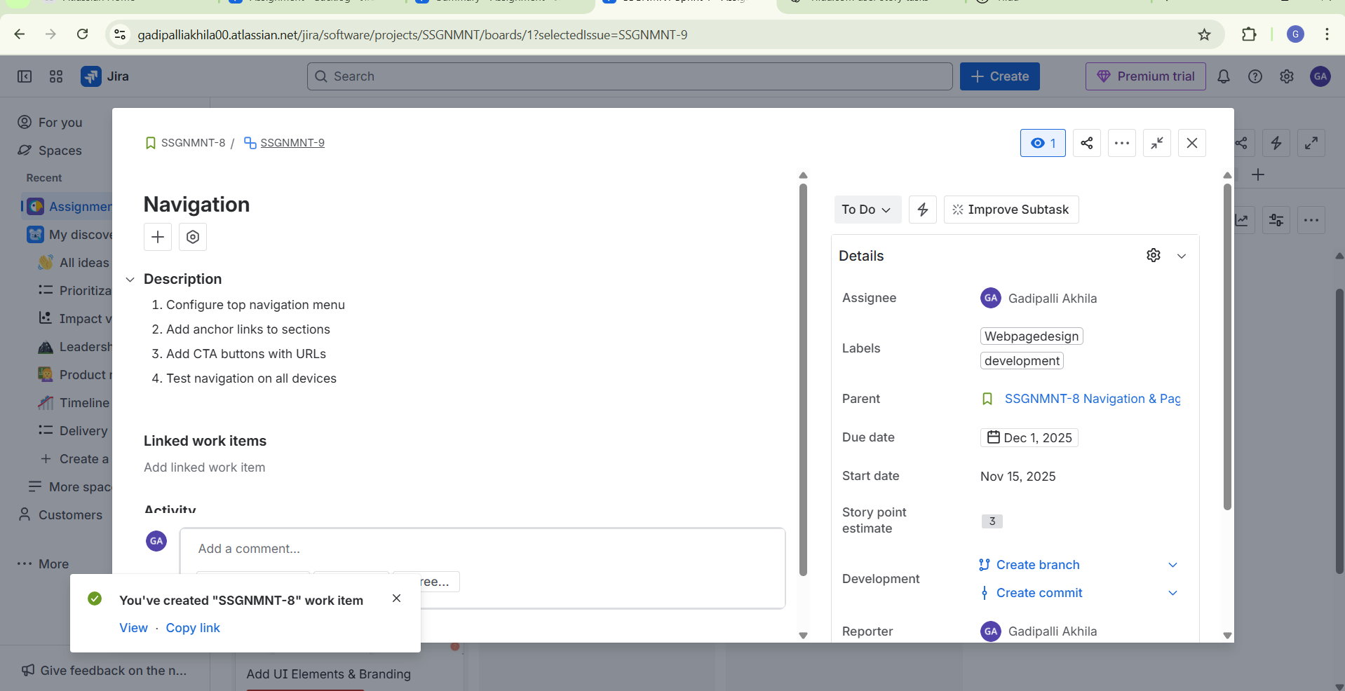

all tasks done like this:-

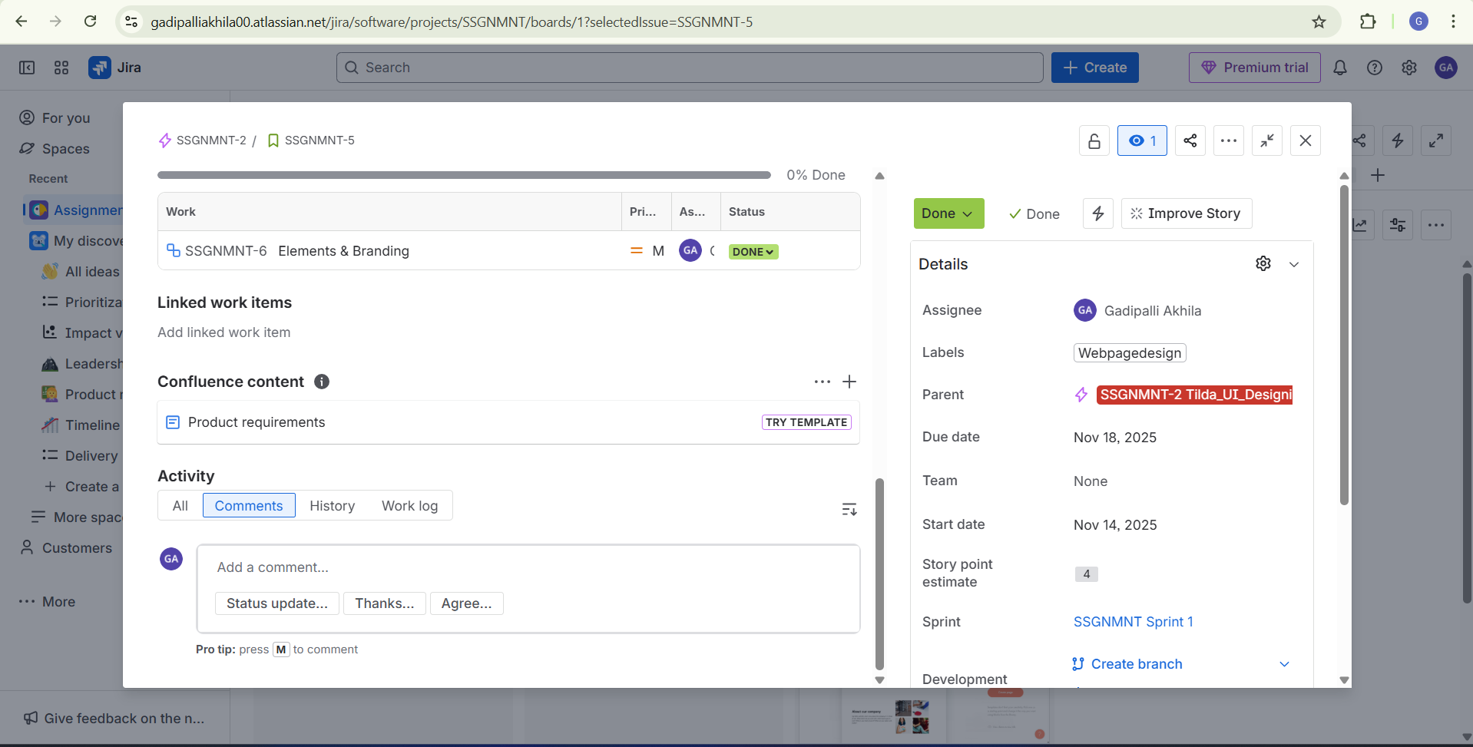

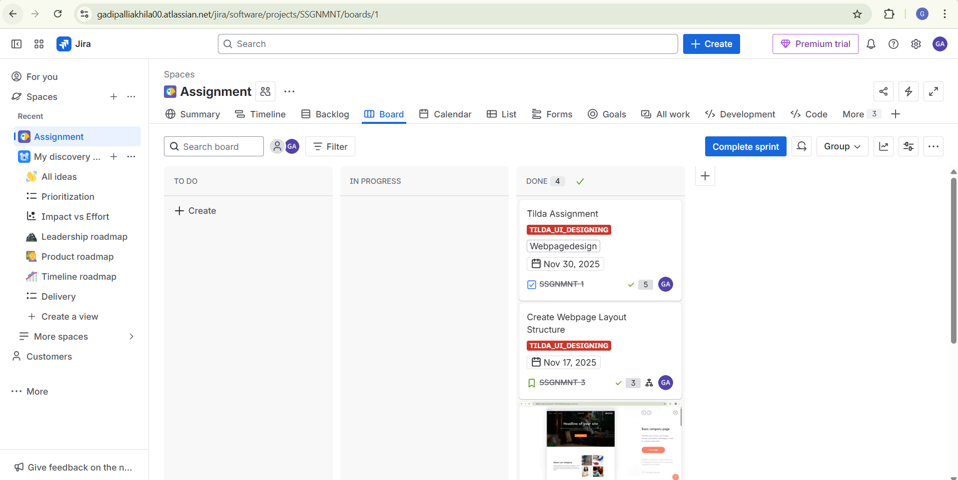

completed the sprint:-

