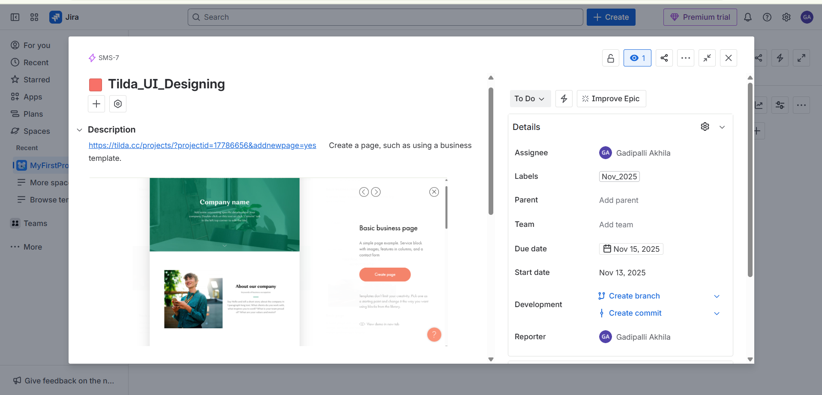
Design epic:- https://gadipalliakhila00-1763020661296.atlassian.net/browse/SMS-7

Design Story:-https://gadipalliakhila00-1763020661296.atlassian.net/browse/SMS-8

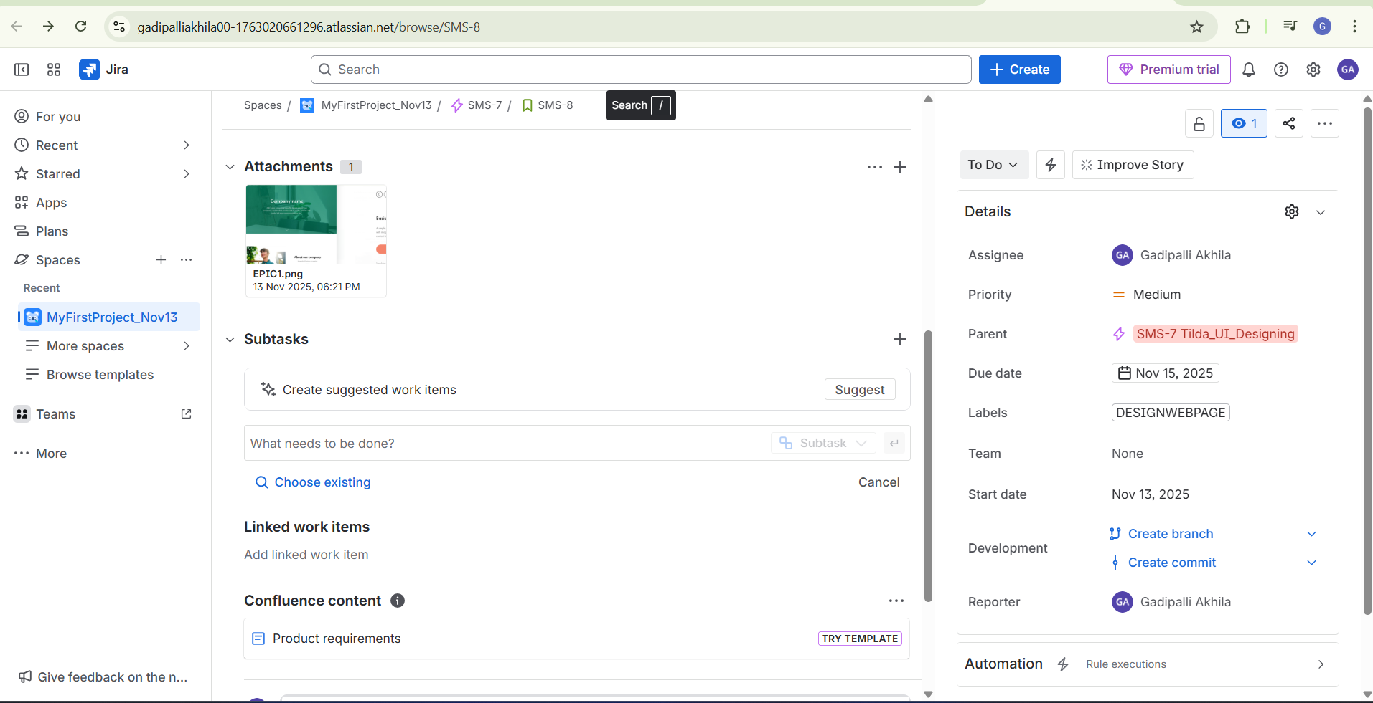

SUB Task: https://gadipalliakhila00-1763020661296.atlassian.net/browse/SMS-9

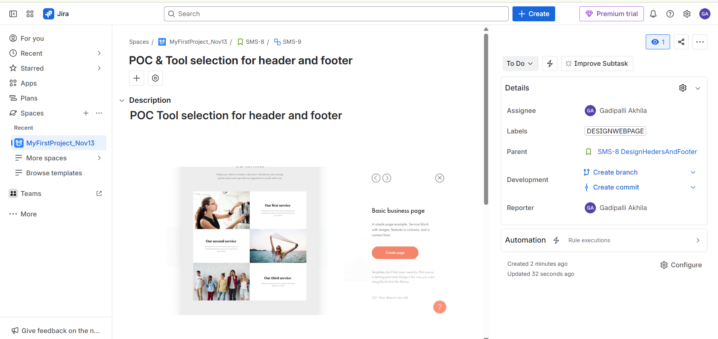

Development EPIC:-https://gadipalliakhila00-1763020661296.atlassian.net/browse/SMS-10

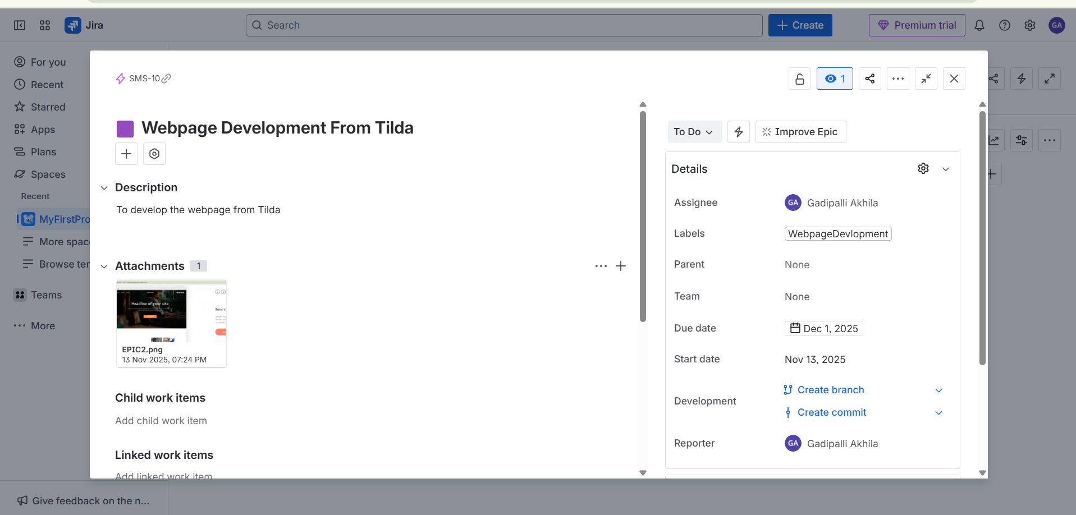

user story:-https://gadipalliakhila00-1763020661296.atlassian.net/browse/SMS-11

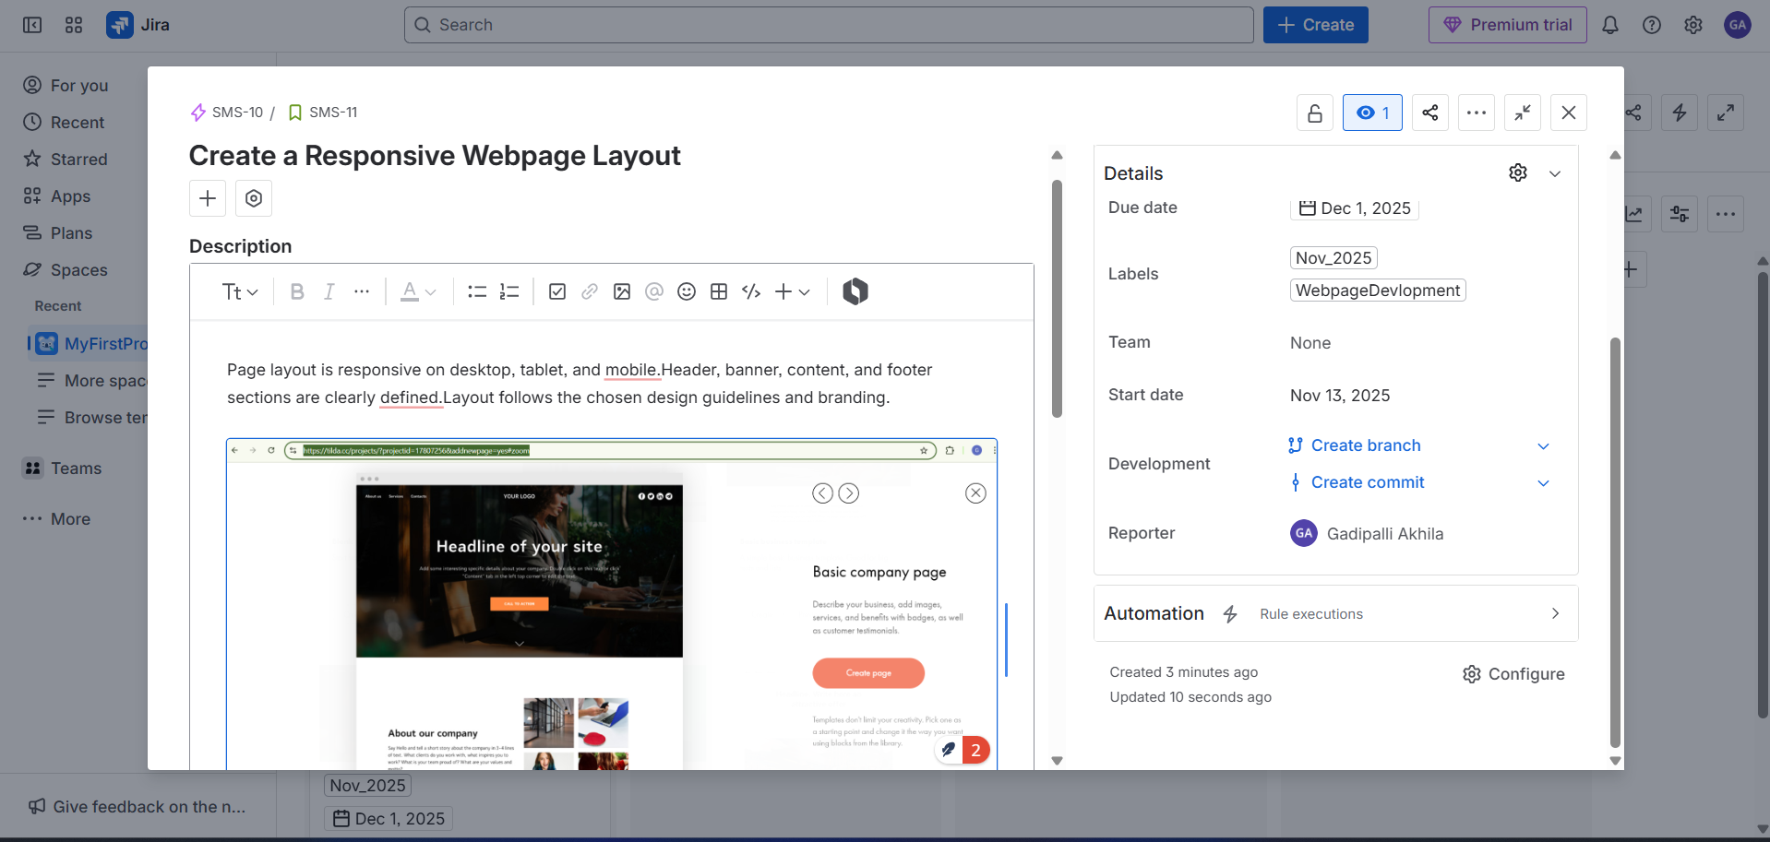

Sub Task:-https://gadipalliakhila00-1763020661296.atlassian.net/browse/SMS-12

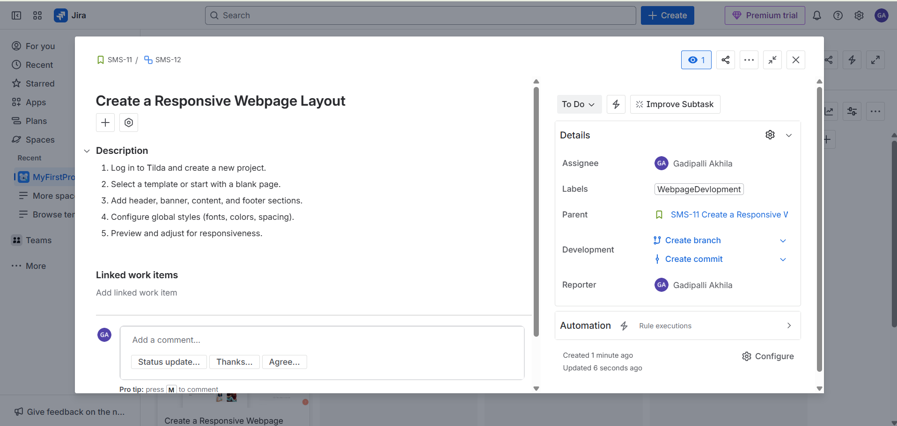

created design and development epic

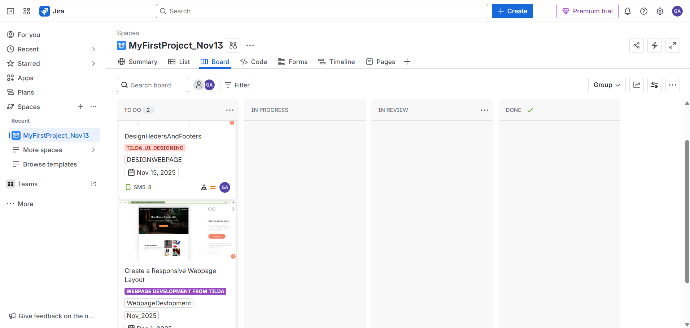

designing is there in in progress

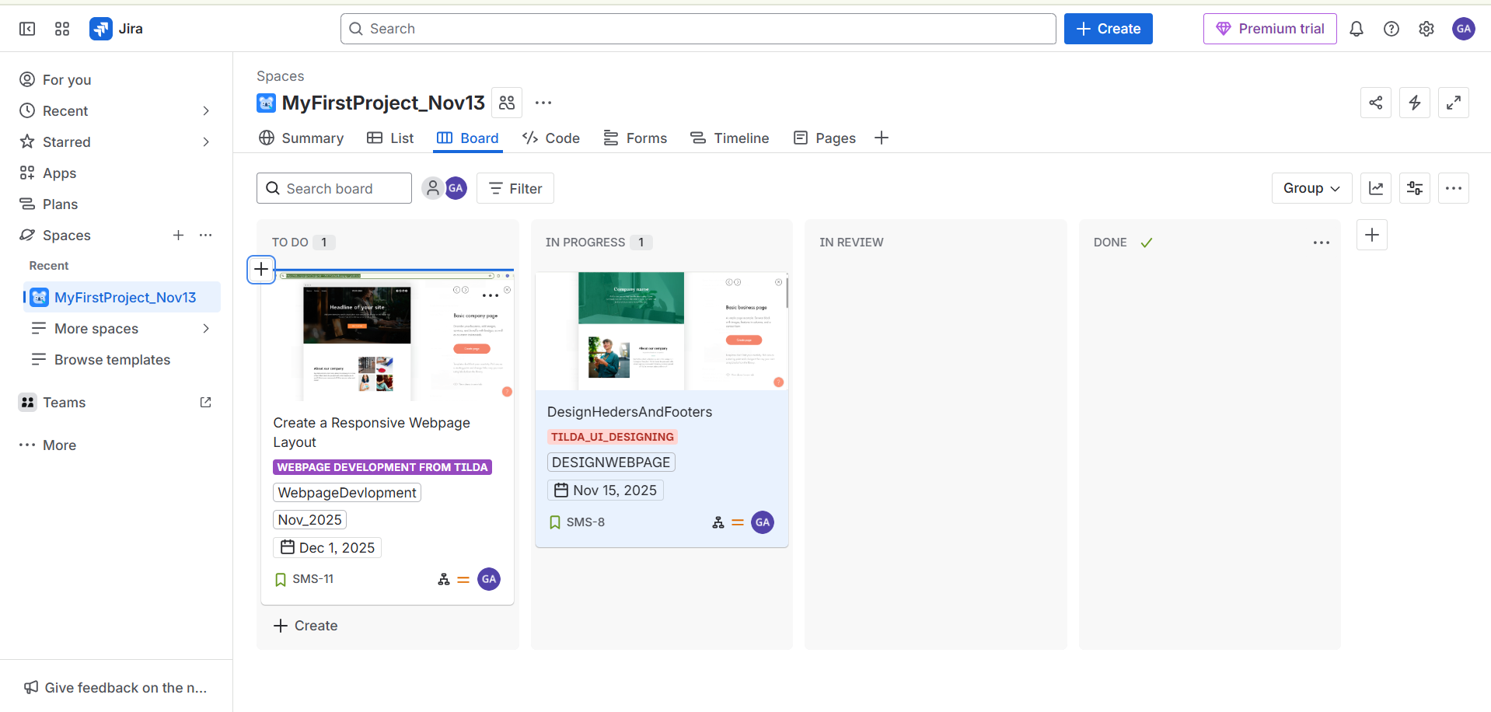

task also there in progress

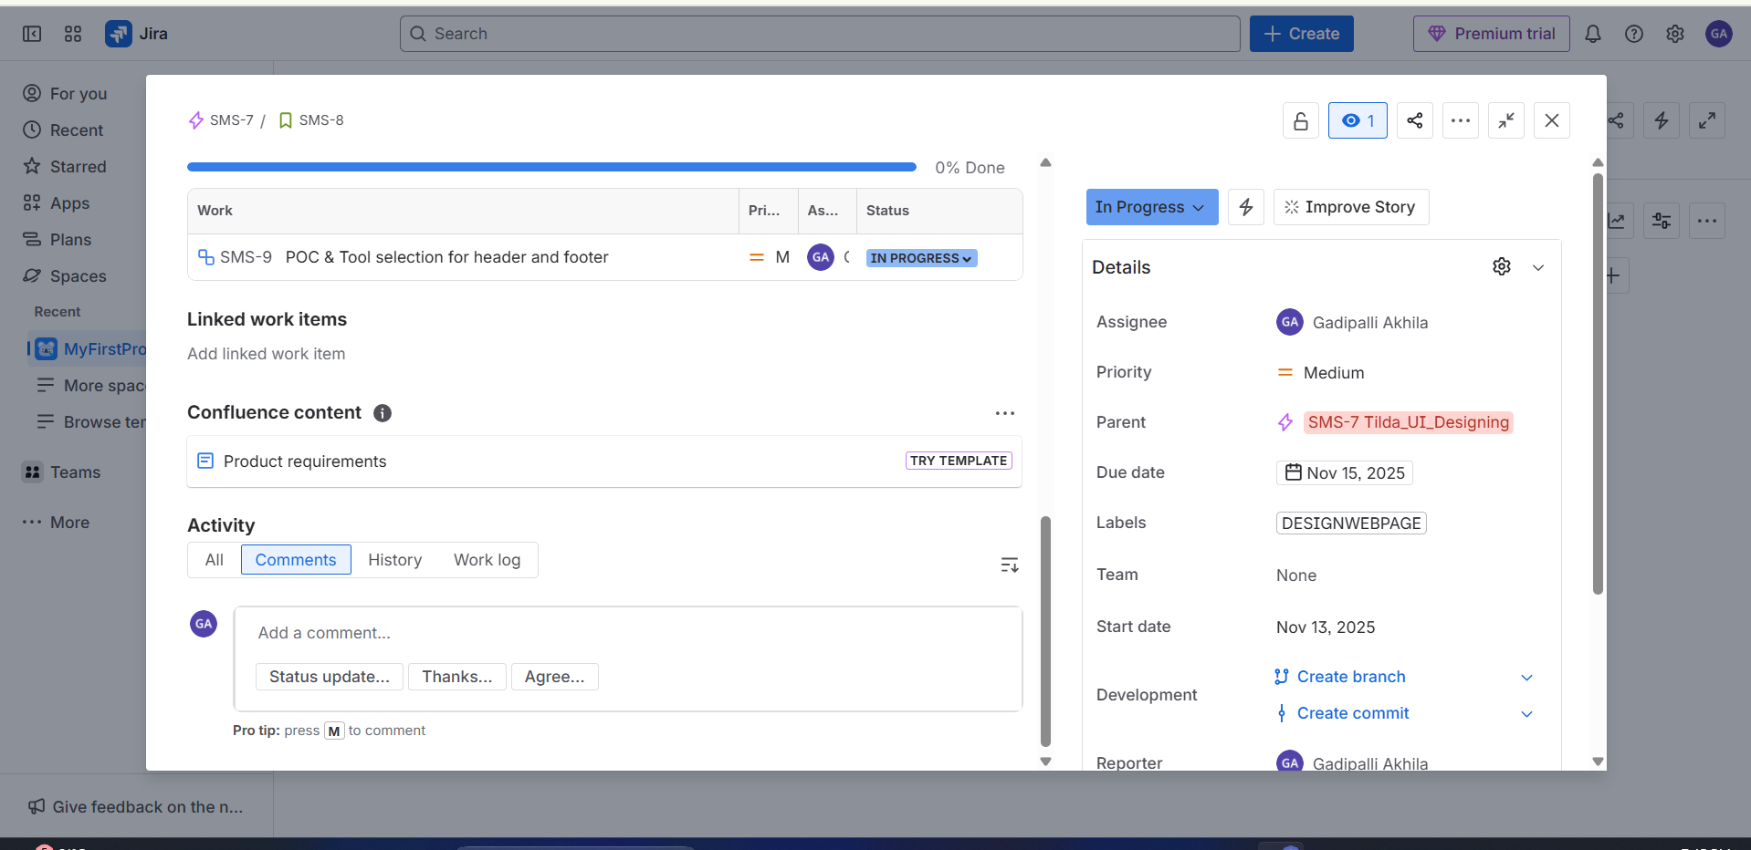

Task is in review

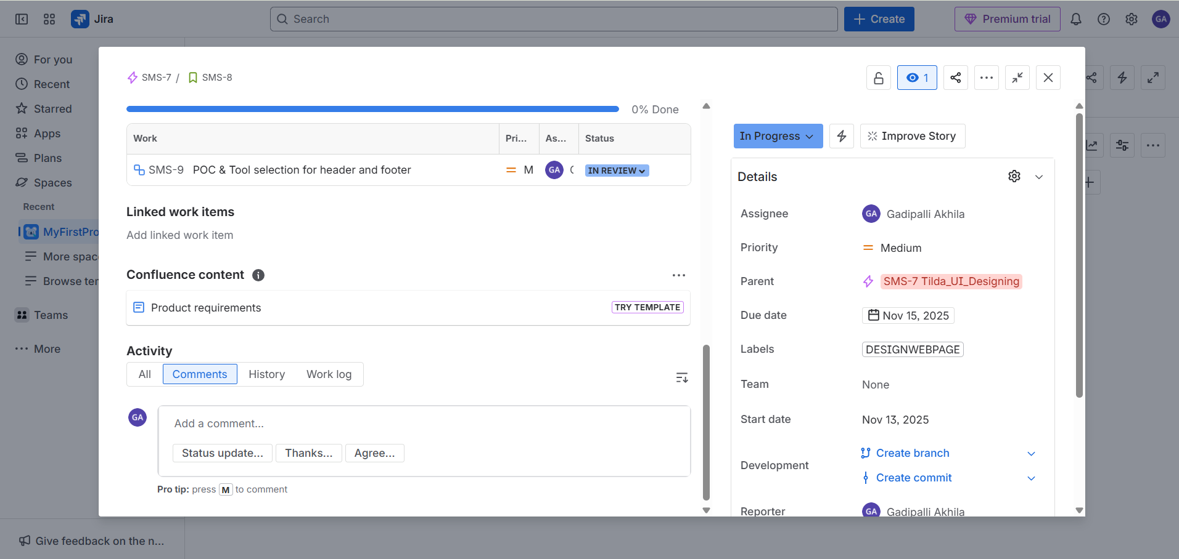

Task is done.

