**LINUX DIRECTORY STRUCTURE**

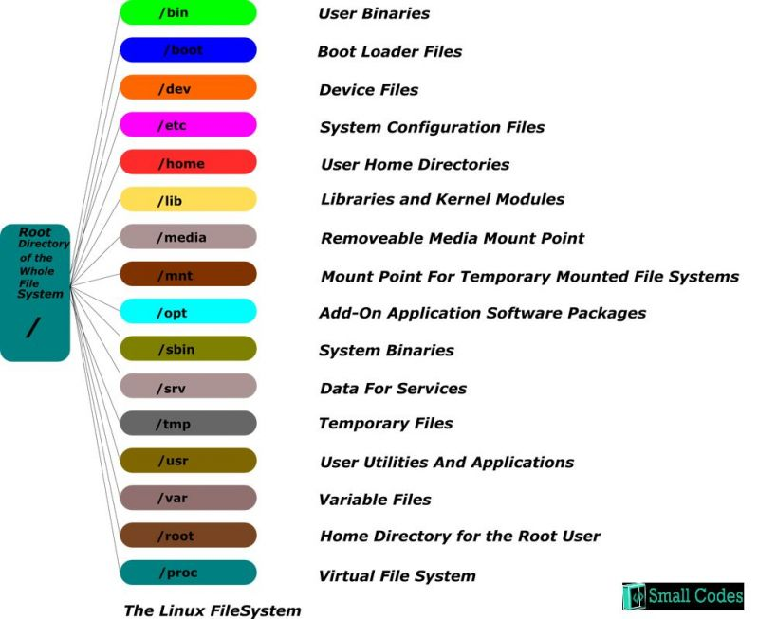

* Root – Root account’s home directory. It is the administrator window, it has all the privileges like r, w, x.
* tmp – Contains all the temporary data. Items/contents in this directory will be erased when you reboot your system.
* var – Files & Folders where the system must be able to write during the operations.

**Basic Commands**

**Account**

$ - indicates that you are logged in as normal user.

# - indicates that you are logged in as root user.

su(Switch User) -when you enter su command, it will prompt you a root password, if you enter root password, it will take you to the root account.

su [login name] – It will prompt you to enter a password of that particular login, it will take you to that account. Used to switch to a different user.

sudo – Executes only that command with super/root user privileges.

whoami – To check whether you are a root user / which user you are logged in as.

passwd – Command used to change the account’s password.

**pwd** – Displays the current working directory of the terminal.

**echo** – Command that writes its arguments to standard output.

**locate filename** – Searches entire computer & locates where that file is located/stored.

**cd**

Changing directory with relative path concept

$pwd

/home/kt

$cd abc

$pwd

/home/kt/abc

Changing directory with absolute path concept

$pwd

/home/kt

$cd /home/kt/abc

$pwd

/home/kt/abc

cd .. – moves one level up

$pwd

/home/kt/abc

$cd ..

$pwd

/home/kt

cd ../.. – moves two level up

$pwd

/home

cd ./ - changes to current directory

cd ~ - Changes the directory to home directory.

cd / - Changes the directory to root directory.

cd .. – Changes the directory to its parent directory.

cd [dir name] – change to particular directory.

**ls – lists all files**

ls -l - lists files along with parameters

ls -a - lists files along with hidden files.

ls -laS > Filename – Output of the command gets stored in the specified file.

**mkdir**

**Package Manager in ubuntu** (How to manage the package that we have installed or we need to install in ubuntu)

apt-get – To install the applications.

apt-get install -y <packagename> - To install the particular package from repository.

apt-get remove -y <packagename> - To uninstall the particular package from repository.

apt-cache search <packagename>* - To search for the particular package which is already installed.

sudo dpkg -i google-chrome-stable_current_amd64.deb – To install the downloaded package.

sudo apt-get upgrade – This upgrades the older versions of the packages to the newer versions.

sudo chown user:group <Filename>– To change ownership of a file.

sudo chmod 777 <Filename> - To change the permissions of a file.

nano <Filename> - To provide input to the File.