**Assignment 1.1**

**Imported acadgild vm using Oracle vm:**

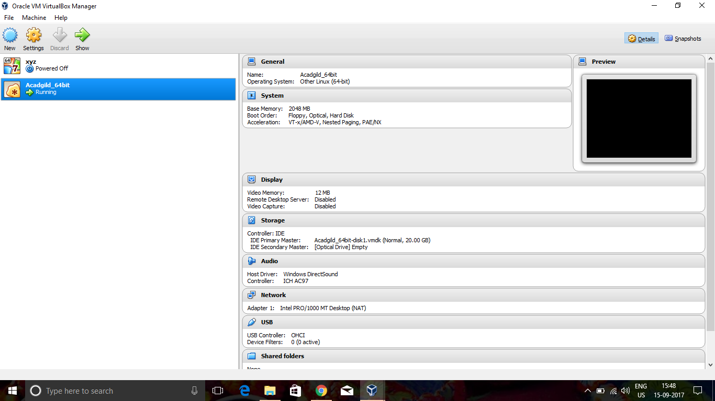

**Command jps to check the list of daemons:**

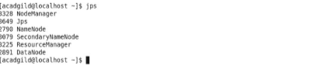

**Start the ssh server:**

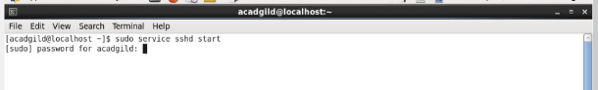

**Start all the daemons:**

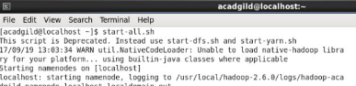

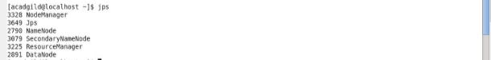

**Start the historyserver:**

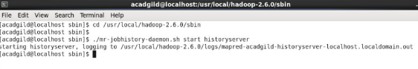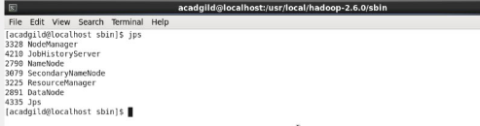

**Start Pig in hdfs mode:**

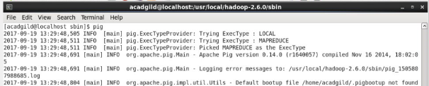

C:\Users\skm\Pictures\snap\Snapshot(6).png

**Start mysql service,hive:**

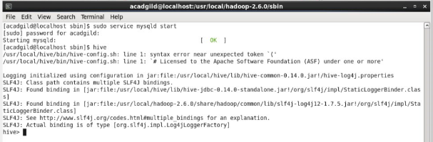

**Start hbase:**

