**ASSIGNMENT 1.4**

* **Create a file max-temp.txt in local FS.**

**Put some 10-15 records of date and temperature**

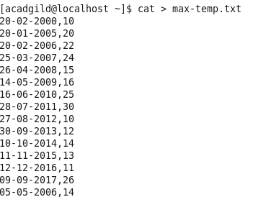

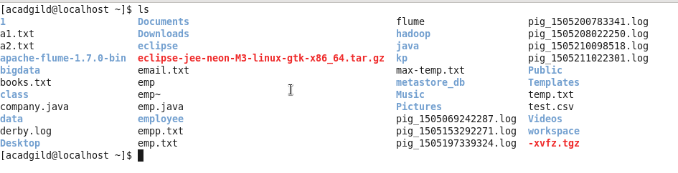

* **Move this file to HDFS at /user/acadgild/hadoop.**

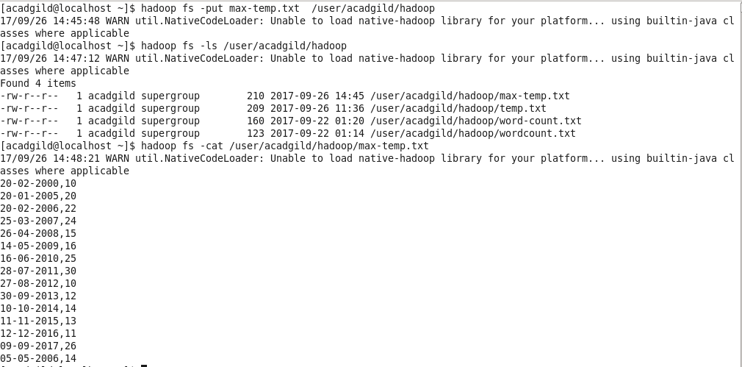

* **Change the permission of the file /user/acadgild/hadoop/max-temp.txt, such that**

**only the owner and the group members have full control over the file.**

**Others do not have any control over it.**

