**ASSIGNMENT-3**

**Task 1:**

* Check whether /user/acadgild directory exists or not in the HDFS.
* If it doesn't exist, then Create a directory /user/acadgild/hadoop.

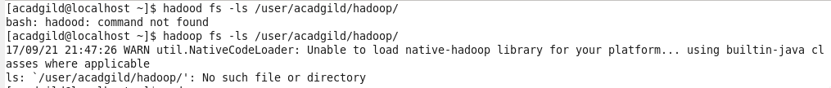

**using mkdir**

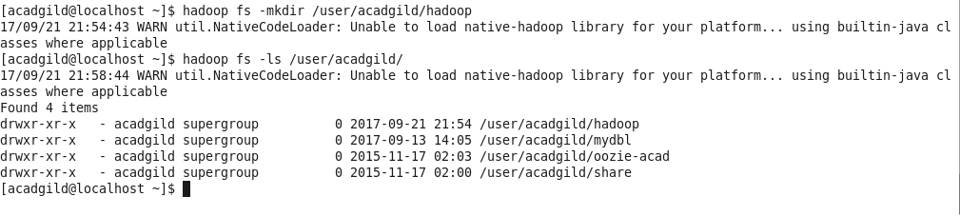

**Task 2:**

Create a file in HDFS under directory /user/acadgild/hadoop, with name word-count.txt.

* Command Used **–touchz** for creating zero byte file in HDFS

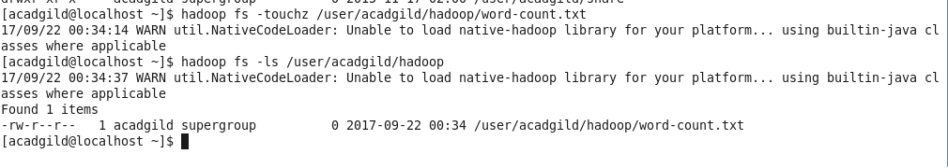

Whatever we type on screen should get appended to file

* Command **–appendToFile**

