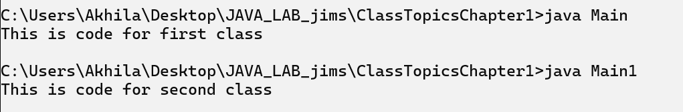

**Qn 3 “: Write a Java program to overload the main,try to invoke overloaded  main(), in the main method, from where program execution started.**

**CODE::**

public class OverloadMain {

public static void main(String[] args) {

System.out.println("Main method with String array args.");

main(5);

}

public static void main(int x) {

System.out.println("Overloaded main method with int: " + x);

}

}

**OUTPUT::**



**Qn 14:: Write a java program using variable length multidimensional arrays to create output like:**

**\***

**\*\***

**\*\*\***

**\*\*\*\***

**\*\*\*\*\***

**\*\*\*\*\*\***

**\*\*\*\*\*\*\***

**Code::**

public class StarPattern {

    public static void main(String[] args) {

          int numRows = 7;

        char[][] stars = new char[numRows][];

        for (int i = 0; i < numRows; i++) {

            stars[i] = new char[i + 1];

            for (int j = 0; j <= i; j++) {

                stars[i][j] = '*';

            }

        } for (int i = 0; i < numRows; i++) {

            for (int j = 0; j < stars[i].length; j++) {

                System.out.print(stars[i][j]);

            }        System.out.println();

        } }

}

**Output::**

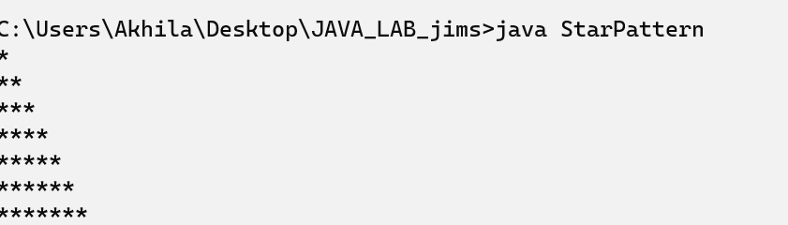

**Qn 15:: Write  a java program to print following  output program using variable length multidimensional arrays:**

**Code::**

 public class PatternArr {

    public static void main(String[] args) {

        int[] upperPart = {1, 3, 5, 7};

        int[] lowerPart = {5, 3, 1};

        for (int i = 0; i < upperPart.length; i++) {

            for (int j = 0; j < upperPart[i]; j++) {

                System.out.print("*");

            }

            System.out.println();

        }

        for (int i = 0; i < lowerPart.length; i++) {

            for (int j = 0; j < lowerPart[i]; j++) {

                System.out.print("*");

            }

            System.out.println();

        }

    }

}

**Output::**

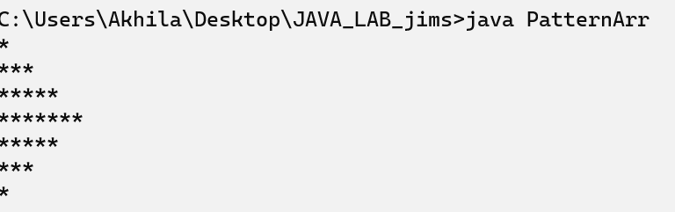

**Qn 29 :: Create GUI environment using  AWT, create a students registration form.Generate required user interactions on both form.**

**CODE::**

import java.awt.*\**;

import java.awt.event.*\**;

public class qn29 extends Frame implements ActionListener {

    Label nameLabel, ageLabel, genderLabel, courseLabel;

    TextField nameField, ageField;

    Choice genderChoice, courseChoice;

    Button submitButton, resetButton;

    public qn29() {

        setTitle("Student Registration Form");

        setLayout(new GridLayout(5, 2));

        nameLabel = new Label("Name:");

        ageLabel = new Label("Age:");

        genderLabel = new Label("Gender:");

        courseLabel = new Label("Course:");

        nameField = new TextField();

        ageField = new TextField();

        genderChoice = new Choice();

        genderChoice.add("Male");

        genderChoice.add("Female");

        genderChoice.add("Other");

        courseChoice = new Choice();

        courseChoice.add("Computer Science");

        courseChoice.add("Information Technology");

        courseChoice.add("Electronics");

        courseChoice.add("Mechanical Engineering");

        submitButton = new Button("Submit");

        resetButton = new Button("Reset");

        add(nameLabel);

        add(nameField);

        add(ageLabel);

        add(ageField);

        add(genderLabel);

        add(genderChoice);

        add(courseLabel);

        add(courseChoice);

        add(submitButton);

        add(resetButton);

        submitButton.addActionListener(*this*);

        resetButton.addActionListener(*this*);

        setSize(400, 300);

        setVisible(true);

        addWindowListener(new WindowAdapter() {

            public void windowClosing(WindowEvent we) {

                System.exit(0);

            }

        });  }

    public void actionPerformed(ActionEvent e) {

        if (e.getSource() == submitButton) {

            String name = nameField.getText();

            String age = ageField.getText();

            String gender = genderChoice.getSelectedItem();

            String course = courseChoice.getSelectedItem();

            System.out.println("Name: " + name);

            System.out.println("Age: " + age);

            System.out.println("Gender: " + gender);

            System.out.println("Course: " + course);

        } else if (e.getSource() == resetButton) {

            nameField.setText("");

            ageField.setText("");

            genderChoice.select(0);

            courseChoice.select(0);

            }

    }

    public static void main(String[] args) {

        new qn29();}

}

**Output::**

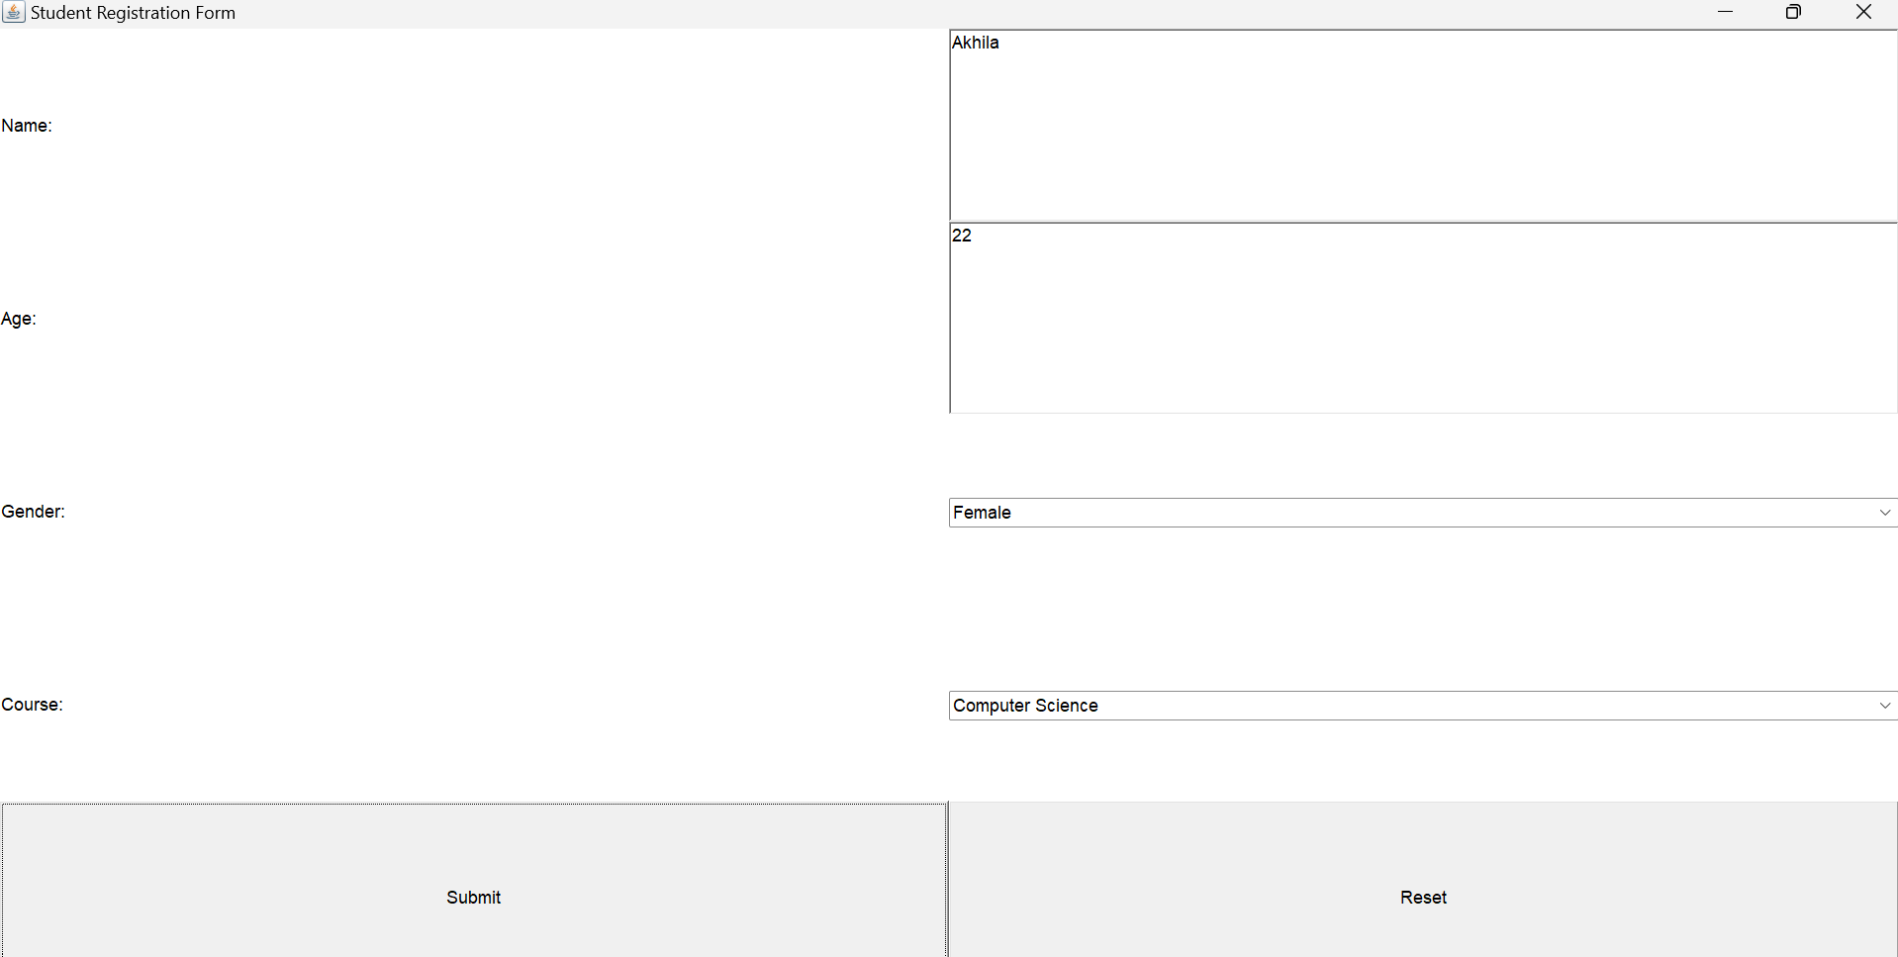

**Qn 30 :: Write a java program read data (byte and character) from buffer.**

**CODE::**

import java.io.*\**;

class File_Reading {

  FileInputStream in;

  File f1;

  File dir;

  File_Reading() throws IOException {

    dir = new File("C:\\Users\\Akhila\\Desktop\\JAVA_LAB_jims\\ClassTopicsChapter1");

   f1 = new File(dir, "file1.txt");

    in = new FileInputStream(f1);

  }

  void read_byte_data() throws IOException {

    int byteRead;

    System.out.println("Reading byte data from file:");

    while ((byteRead = in.read()) != -1) {

      System.out.print((char) byteRead); *// Convert byte to char for readable output*

    }

  }

  void read_char_data() throws IOException {

    FileReader fileReader = new FileReader(f1);

    BufferedReader bufferedReader = new BufferedReader(fileReader);

    System.out.println();

    System.out.println("Reading character data from file:");

    int charRead;

    while ((charRead = bufferedReader.read()) != -1) {

      System.out.print((char) charRead);

    }

    bufferedReader.close();

  }

  public static void main(String args[]) throws IOException {

    File_Reading fileHandler = new File_Reading();

    fileHandler.read_byte_data();

    fileHandler.read_char_data();

  }

}

**OUTPUT::**

