# Social Media Sentiment Analytics - Visual Results

## Overall Sentiment Distribution

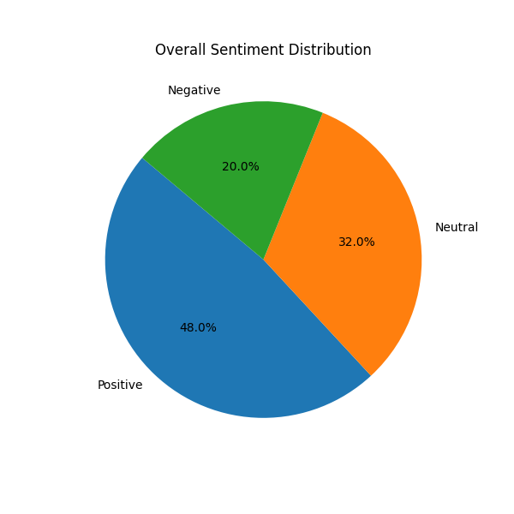

## Sentiment by Campaign

