Predicting Network Service Degradation Using Telecom Operational Data
Akhil Anand Thazhaniyil Muralidharan
Bellevue University
DSC680-T301 Applied Data Science (2271-1)
Professor: Xu Ashton
Sep 27, 2026
Week 3/Milestone 2 – Draft of White Paper

Index
​
Index 2
Project Topic 4
Predicting Network Service Degradation Using Telecom Operational Data 4
Business Problem 4
Research Questions 4
Hypotheses 4
Appendix A: Supporting Documentation 5
Data Inventory 5
Preparation and Reproducibility Notes 5
Predicting Network Service Degradation Using Telecom Operational Data 7
Executive Summary 7
Business Problem and Objective 7
Data and Preparation 8
Exploratory Findings 9
Baseline Model and Interpretation 13
Risks, Limitations, and Ethical Considerations 15
Recommendations and Implementation Plan 16
Audience Questions 16
Conclusion 17
References 17

​

Project Topic

Predicting Network Service Degradation Using Telecom Operational Data
This project aims to predict potential network service degradation events before they impact customers by analyzing network performance metrics, ticket data, and operational logs.

Business Problem
Telecommunication providers collect massive amounts of operational data from network devices, monitoring systems, and support platforms. Despite proactive monitoring, network degradation often affects customer experience before engineering teams can intervene.

Research Questions
- Can historical network performance metrics predict service degradation events?
- Which network indicators contribute most significantly to service disruptions?
- Can machine learning models help identify high-risk network segments before failures occur?
- How accurately can future service degradation events be predicted using historical operational data?

Hypotheses
H1: Changes in network performance indicators such as latency, packet loss, and throughput can predict service degradation.
H2: Machine learning models can identify patterns associated with degradation events before customer impact occurs.

Appendix A: Supporting Documentation
This appendix documents the source files, preparation rules, analytical definitions, and reproducibility controls used to create the evidence in this white paper. The three source groups were analyzed independently because they represent different observations and cannot be reliably joined record by record.

Data Inventory
Source group | Primary files | Usable records | Purpose
Cellular performance | cellular-network-performance-data.csv | 462 | Signal, SNR, distance, environment
Mobile speed tests | April_MySpeed_2021.csv | 275,078 | Operator, upload/download, region
Telstra faults | train plus event, resource, severity, and log files | 7,381 | Fault severity and operational features

Preparation and Reproducibility Notes
- Numeric fields were explicitly converted, and invalid values were treated as missing.
- Telstra categorical labels were converted to numeric codes and one-to-many files were aggregated to one row per id before joining.
- Exact repeated speed-test rows were retained because the source does not provide a unique test identifier or timestamp that proves duplication.
- The exploratory degradation flag identifies records with signal strength below -100 dBm or SNR below 15. It is not an operator-approved service-level standard.
- The baseline model used an 80/20 stratified split, balanced class weights, 400 trees, a minimum leaf size of two, and random_state=42.
- Figures were exported at 300 dpi, and evidence tables were saved as CSV files for verification.

Predicting Network Service Degradation Using Telecom Operational Data

Executive Summary
Telecommunication services depend on stable signal quality, sufficient throughput, and rapid response to operational faults. This study evaluates whether historical performance and event data can support earlier identification of network degradation. Three public source groups were examined: cellular signal measurements, Indian mobile speed tests, and Telstra fault-severity records. The evidence shows meaningful variation in service quality by environment, provider, region, and fault class. A reproducible Random Forest baseline also demonstrates that aggregated operational features contain predictive information, although model performance remains insufficient for unattended production use.
The main recommendation is to develop a controlled early-warning workflow rather than an automated decision system. Risk scores should be paired with explainable indicators and reviewed by network engineers. Future development should replace exploratory thresholds with operator-approved definitions, validate results on time-ordered production data, and monitor precision and recall across regions and network technologies.

Business Problem and Objective
Network degradation often develops before a complete outage. Weak signal, declining throughput, increased alarm activity, and unusual log patterns can reduce customer experience while individual measurements remain below traditional alert thresholds. The business challenge is to combine these signals into an earlier and more consistent indication of risk. The Milestone 1 proposal therefore asked whether historical performance metrics can predict degradation, which indicators contribute most, whether high-risk segments can be identified early, and how accurately future events can be classified.
The objective of Milestone 2 is to prepare the data, create defensible illustrations, and test a baseline predictive model. The analysis is designed as decision support. Predictions indicate where engineers should investigate; they should not automatically change network configurations or restrict service.

Data and Preparation
The cellular dataset contains signal strength, SNR, call duration, attenuation, distance to tower, environment, tower, user, call type, and direction. After required fields were converted and incomplete analytical rows were excluded, 462 observations were available. The mobile speed-test file contains 275,078 records across operator, technology, direction, speed, signal strength, and service area. It includes 1,443 zero-speed records, 46,828 missing signal-strength values, and 709 missing regional labels. These limitations were preserved in the quality assessment rather than hidden through broad imputation.
The Telstra training set contains 7,381 labeled records across three fault-severity classes. Event, resource, severity, and log tables contain repeated identifiers, so each was aggregated before joining. Created features include counts of event, resource, severity, and log-feature types, along with total, maximum, and mean log volume. This approach avoids record multiplication and provides one modeling row per labeled incident.

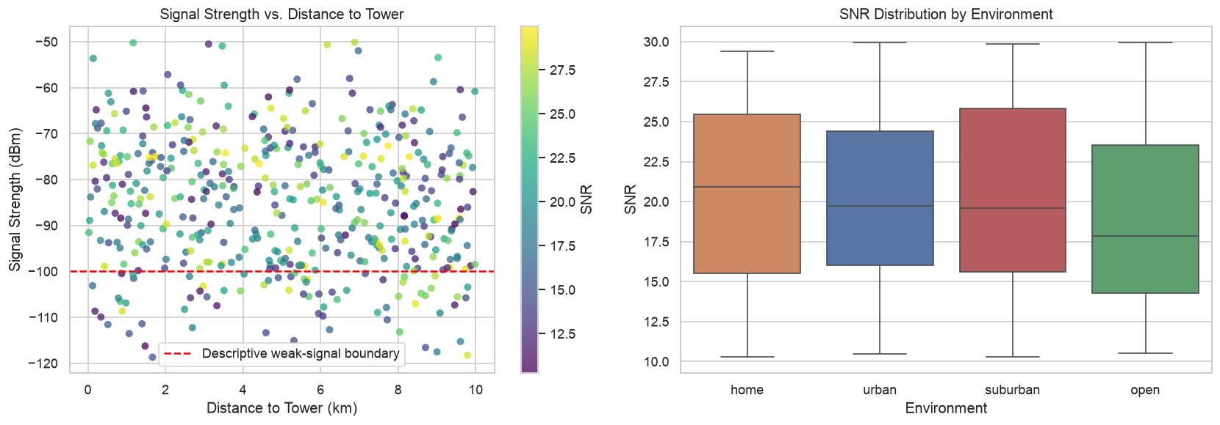
Figure 1. Cellular signal strength versus tower distance and SNR distribution by environment.

Exploratory Findings
The cellular analysis found a distance-to-signal correlation of -0.096, indicating that distance alone had only a weak linear relationship with signal strength in this sample. The median SNR was 20.90 at home, 19.75 in urban conditions, 19.60 in suburban conditions, and 17.84 in open environments. Using the transparent exploratory rule, potential degradation rates were 45.45% for open environments, 42.34% for urban environments, 31.82% for suburban environments, and 22.94% for home environments. These findings suggest that environment and other propagation conditions should be considered alongside distance.
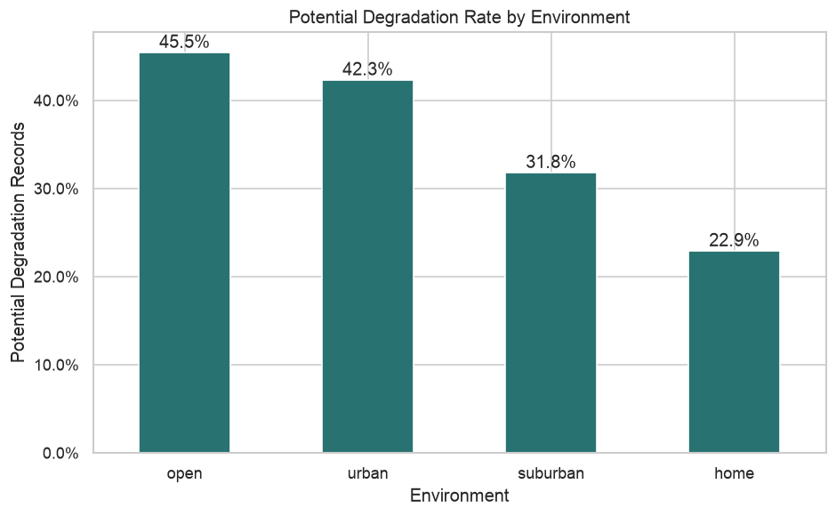
Figure 2. Exploratory potential-degradation rate by environment.

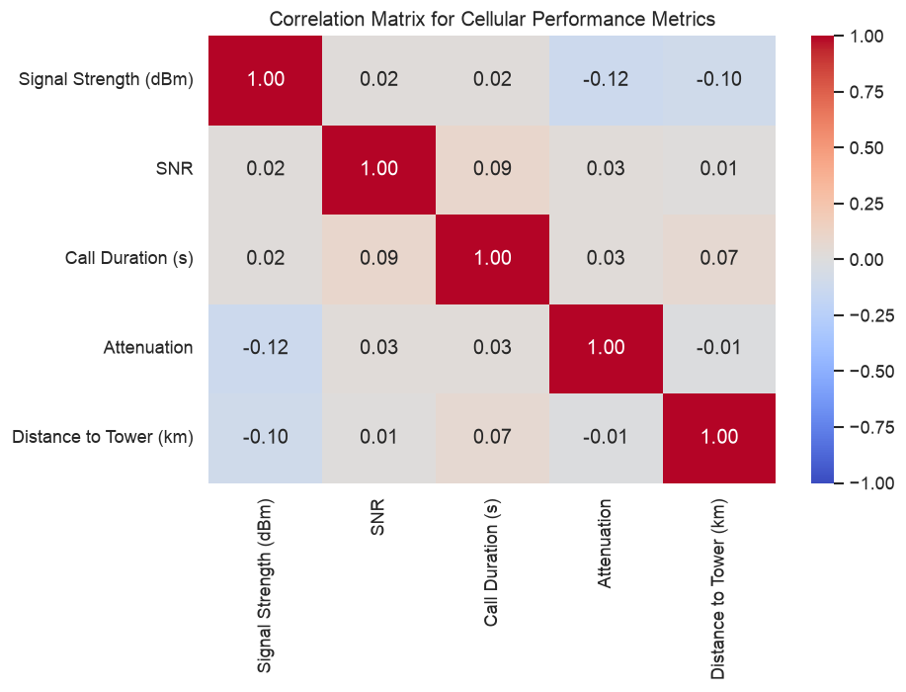
Figure 3. Correlation matrix for measured cellular performance variables.

Mobile results were strongly skewed, so medians were used. JIO had the highest median download value at 6,158 Kbps. Vodafone had the highest median upload value at 4,122 Kbps. Kolkata led the regional median download ranking at 12,276 Kbps. These comparisons are descriptive because unequal sample sizes, device mix, geography, and user self-selection may influence speed-test results.
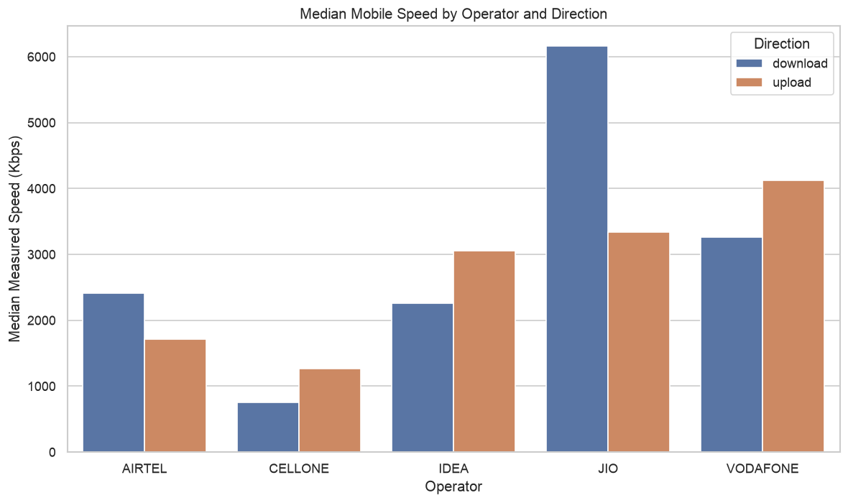
Figure 4. Median mobile speed by operator and direction.
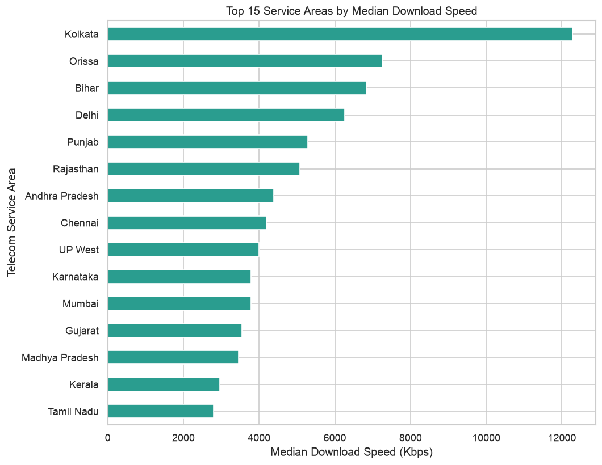
Figure 5. Top service areas ranked by median download speed.

The fault target was imbalanced: class 0 contained 4,784 records, or 64.8%; class 1 contained 1,871 records, or 25.3%; and class 2 contained 726 records, or 9.8%. Median total log volume was 8 for class 0, 6 for class 1, and 32 for class 2. The median number of log-feature types increased from two in classes 0 and 1 to three in class 2. The higher operational activity associated with class 2 supports including log-based variables in predictive modeling.
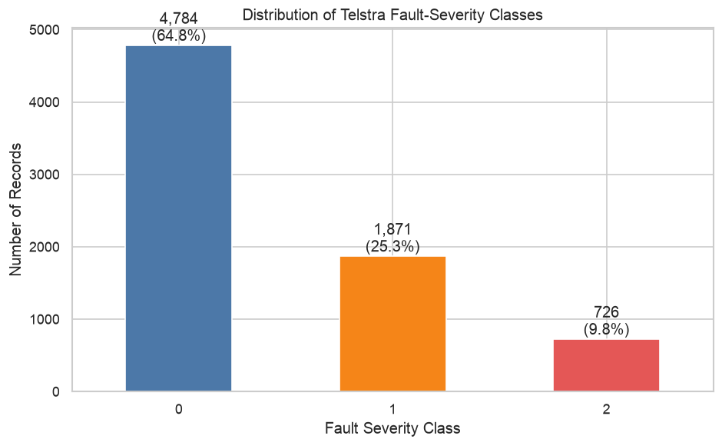
Figure 6. Distribution of Telstra fault-severity classes.
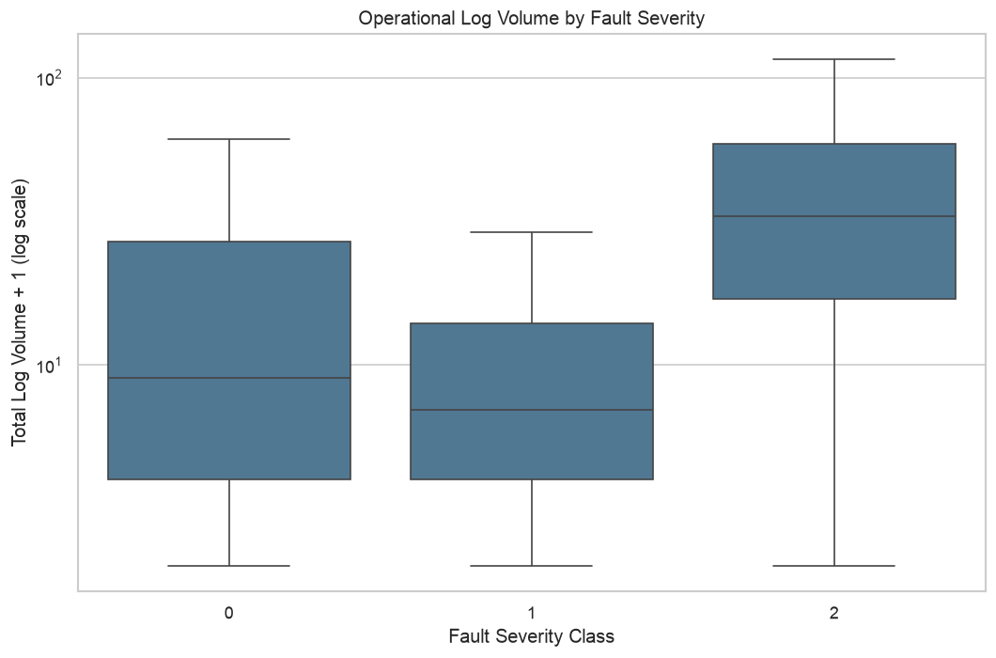
Figure 7. Operational log volume by fault-severity class.

Baseline Model and Interpretation
A Random Forest classifier was trained on aggregated Telstra features using a stratified 80/20 holdout split. Balanced class weights reduced majority-class dominance, and a fixed random seed supported reproducibility. The holdout accuracy was 0.640 and macro F1 was 0.587. Class 0 recall was 0.646, class 1 recall was 0.581, and class 2 recall was 0.759. Class 2 precision was only 0.385, showing that stronger detection of the rare class came with many false positives.
Location code was the strongest baseline feature with importance 0.354, followed by log-volume measures. Feature importance reflects predictive use within this specific model and does not establish causality. The baseline is useful because it confirms the existence of predictive signal, but the class-level errors show that additional feature engineering, threshold selection, cross-validation, and temporal testing are required.
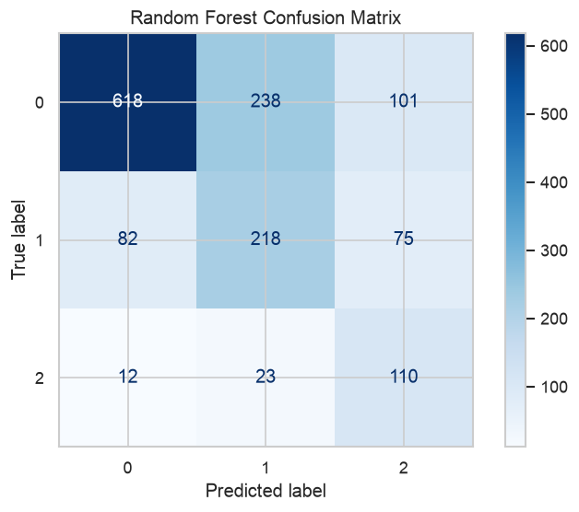
Figure 8. Holdout confusion matrix for the Random Forest baseline.
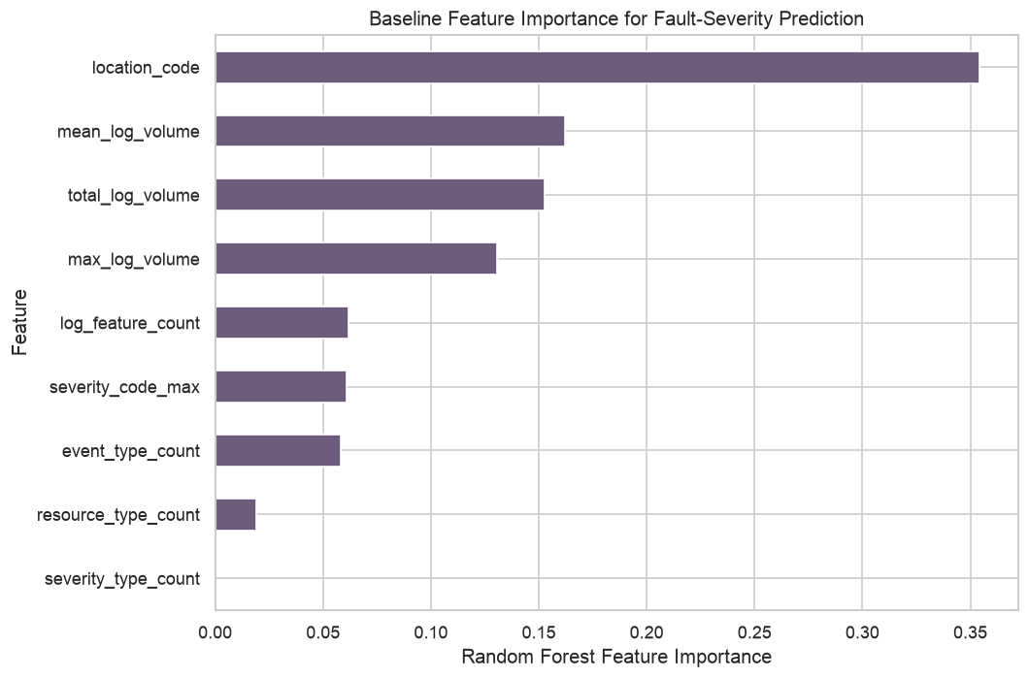
Figure 9. Baseline Random Forest feature importance.

Risks, Limitations, and Ethical Considerations
The source groups represent different populations, locations, and units of observation, so row-level integration would create unsupported relationships. The degradation rule is exploratory rather than contractual. The speed-test data lacks unique test identifiers and timestamps, and its missing signal values limit direct relationship analysis. The Telstra model uses location as a coded feature, which may capture site-specific history but may also reduce generalization to unseen locations.
Production use would require privacy-preserving aggregation, removal of customer identifiers, encryption, access controls, and documented retention limits. Fairness checks should compare error rates across regions and network technologies. Human review is necessary because false alerts create workload and missed events leave service risk undetected. Monitoring should include model drift, alert volume, feature availability, and changes in class-specific precision and recall.

Recommendations and Implementation Plan
First, the organization should establish an operational definition of degradation and a prediction window approved by network engineering. Second, future validation should use chronological splits to represent deployment more realistically. Third, feature engineering should add recent change, rolling variation, alarm sequences, and topology context. Fourth, model selection should balance class-specific recall with an acceptable false-positive rate. Fifth, every alert should include the strongest supporting measurements so that engineers can validate the recommendation.
Implementation should proceed through a limited pilot. Predictions should initially be displayed without triggering automated remediation. Engineers should record whether each alert was useful, which evidence supported investigation, and whether intervention prevented or reduced impact. These observations can guide threshold tuning, model retraining, and the design of a network-risk dashboard.

Audience Questions
- How is potential service degradation defined in this study?
- Why were the three source groups analyzed separately instead of merged?
- How representative are public datasets of production telecom networks?
- Why was median speed used instead of mean speed?
- How does class imbalance affect fault-severity evaluation?
- Which operational features contributed most to the baseline model?
- Why is accuracy not sufficient for judging the model?
- How would false-positive alerts affect network operations teams?
- What privacy and security controls would be required with production data?
- What additional testing is needed before operational deployment?

Conclusion
The Milestone 2 analysis supports the project hypothesis that operational data contains patterns associated with network quality and fault severity. Service quality differed across environments, operators, and regions, while severe Telstra faults showed greater log activity. The baseline model detected the rare severity class with relatively high recall but low precision, confirming both the opportunity and the risk of an early-warning approach. The project should continue as an explainable, human-reviewed decision-support system with stronger temporal validation and governance before any operational deployment.

References
Bicski, B., & Pekar, A. (2024). Early detection of network service degradation: An intra-flow approach. arXiv. https://arxiv.org/abs/2407.06637
Han, J., Pei, J., & Tong, H. (2022). Data mining: Concepts and techniques (4th ed.). Morgan Kaufmann.
Kaggle. (n.d.). Cellular network performance data. https://www.kaggle.com/datasets/suraj520/cellular-network-performance-data
Kaggle. (n.d.). Mobile internet speed India. https://www.kaggle.com/datasets/kishan305/mobile-internet-speed-india
Kaggle. (n.d.). Telstra recruiting network. https://www.kaggle.com/competitions/telstra-recruiting-network/data
Provost, F., & Fawcett, T. (2013). Data science for business. O’Reilly Media.

