Predicting Network Service Degradation Using Telecom Operational Data
Akhil Anand Thazhaniyil Muralidharan
Bellevue University
DSC680-T301 Applied Data Science (2271-1)
Professor: Xu Ashton
Oct 1, 2026
Week 4/Milestone 3 – Final White Paper

Table of Contents
​
​
Table of Contents 2
Executive Summary 4
Business Problem and Objective 4
Research Questions and Hypotheses 5
Data Sources and Preparation 5
Exploratory Findings 7
Baseline Model Results 10
Milestone 3 Code Enhancement 12
Risks, Ethics, and Limitations 13
Recommendations and Implementation Plan 14
Conclusion 14
Appendix A: Audience Questions and Answers 16
References 17

​

​

Executive Summary
Telecommunication services depend on stable signal quality, sufficient throughput, and timely response to operational faults. This project evaluates whether historical network performance and event data can support earlier identification of service degradation. Three public source groups were analyzed independently: cellular measurements, Indian mobile speed tests, and Telstra fault-severity records. The analysis found meaningful variation by environment, operator, region, and fault class. A reproducible Random Forest baseline achieved 0.640 holdout accuracy and 0.587 macro F1. Class 2 recall reached 0.759, but precision was 0.385, demonstrating that rare severe faults can be detected at the cost of false-positive alerts. The final recommendation is an explainable, human-reviewed early-warning workflow rather than unattended automated remediation.

Business Problem and Objective
Network degradation often develops gradually before a complete outage becomes visible to customers or operations teams. Weakening signal strength, declining throughput, lower signal-to-noise ratio, increased alarm activity, and unusual log patterns may appear independently and remain below conventional alert thresholds even though their combined behavior indicates rising risk. This creates an operational gap: teams may recognize the problem only after service quality has already declined and customer impact has begun. The primary objective of this study is therefore to determine whether historical telecom performance and event data contain patterns that can support earlier identification of degradation. The analysis examines which indicators are most informative, whether a reproducible machine-learning baseline can distinguish fault-severity classes, and how model outputs could be incorporated into a safe operational workflow. The project does not propose unattended remediation. Instead, it evaluates the feasibility of an explainable early-warning capability that gives network engineers additional evidence for prioritizing investigation and intervention.

Research Questions and Hypotheses
The analysis is guided by four related questions. First, it asks whether historical network performance metrics can predict service-degradation events before a complete failure occurs. Second, it evaluates which indicators—such as signal strength, SNR, throughput, event counts, resource activity, and log volume—contribute most to observed service disruption. Third, it considers whether machine-learning methods can identify high-risk network segments or incidents early enough to support operational action. Finally, it examines how accurately historical operational data can classify future fault severity, with particular attention to the rare severe class. Together, these questions connect descriptive analysis with predictive modeling and ensure that model performance is interpreted in terms of practical network-operations value rather than accuracy alone.
H1: proposes that changes in signal strength, SNR, throughput, and operational activity are associated with service degradation. This hypothesis is examined through environmental comparisons, operator and regional speed summaries, and fault-class differences in operational log volume.
H2: proposes that machine-learning models can identify patterns associated with higher fault severity before customer impact. This second hypothesis is evaluated through a reproducible Random Forest baseline using class-level precision and recall, macro F1, a confusion matrix, and feature importance. Because the available public datasets do not provide a live operational prediction window, the results are interpreted as evidence of predictive feasibility rather than proof of production readiness.

Data Sources and Preparation
Source | Usable records | Primary evidence | Role
Cellular performance | 462 | Signal, SNR, distance, environment | Quality patterns
Mobile speed tests | 275,078 | Operator, direction, speed, region | Performance variation
Telstra faults | 7,381 | Events, resources, severity, logs | Predictive modeling

Each source has a different observation unit, identifier structure, and collection context, so the datasets were analyzed as complementary evidence rather than merged row by row. The cellular dataset supports examination of signal strength, SNR, distance, and environment; the mobile speed-test dataset supports descriptive comparisons across operators, directions, and regions; and the Telstra records provide the labeled fault-severity outcome required for predictive modeling. Numeric fields were converted explicitly so invalid values could be detected, missingness remained visible instead of being silently hidden, and Telstra one-to-many event, resource, and log files were aggregated to one row per incident before joining to the severity label. This design avoids creating unsupported relationships across unrelated sources and establishes a reproducible modeling table. The baseline model used a stratified 80/20 train-test split to preserve class proportions, balanced class weights to reduce majority-class dominance, 400 trees, a minimum leaf size of two, and random_state=42 for repeatability. These choices provide a transparent starting point while leaving room for later temporal validation and tuning.
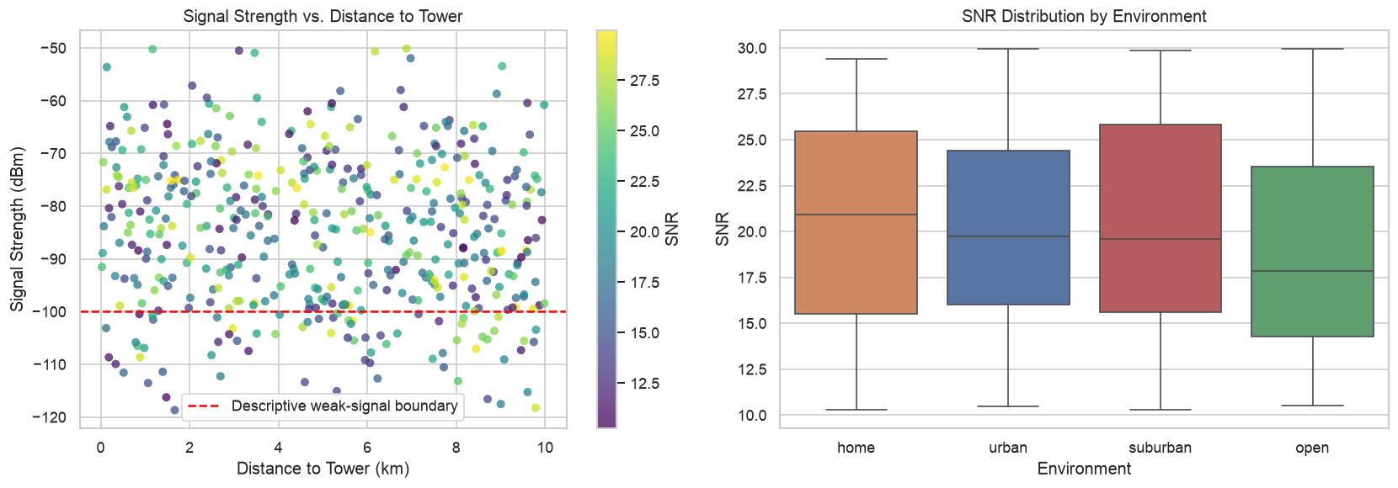
Figure 1. Signal strength versus tower distance and SNR by environment.

Exploratory Findings
The cellular analysis shows that tower distance alone does not adequately explain signal quality. Its correlation with signal strength was only -0.096, indicating a weak linear relationship in this sample and suggesting that environmental obstacles, network configuration, interference, and device conditions may also influence performance. Median SNR was highest in home environments at 20.90 and lowest in open environments at 17.84. Using the transparent exploratory definition of signal below -100 dBm or SNR below 15, potential-degradation rates were 45.45% in open, 42.34% in urban, 31.82% in suburban, and 22.94% in home environments. The contrast among environments demonstrates why a single measurement should not be interpreted without context. These thresholds are analytical rules rather than operator-approved service levels, so their main value is to support consistent comparison and identify patterns that warrant further investigation.
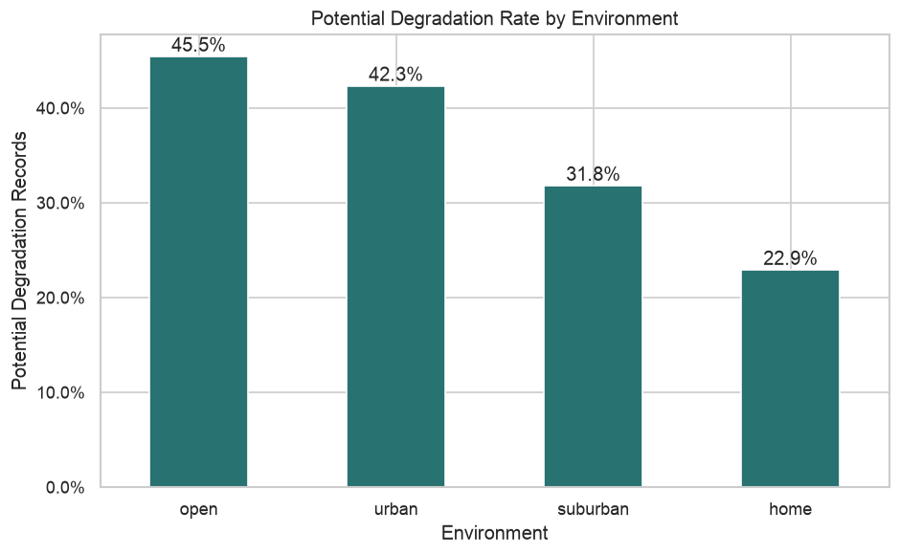
Figure 2. Exploratory potential-degradation rate by environment.
Mobile speed results were strongly skewed, so medians were emphasized because they are less affected by unusually high observations than means. JIO had the highest median download result at 6,158 Kbps, Vodafone had the highest median upload result at 4,122 Kbps, and Kolkata led the regional median download ranking at 12,276 Kbps. These results show that performance differs by operator, traffic direction, and geography, which supports using contextual features when evaluating service quality. However, the rankings should not be interpreted as definitive measures of operator quality. Sample size, device capability, test location, network technology, time of day, geography, and user self-selection may all influence the observed results. Accordingly, the speed-test evidence is used to demonstrate variation and analytical method rather than to make causal or contractual claims.
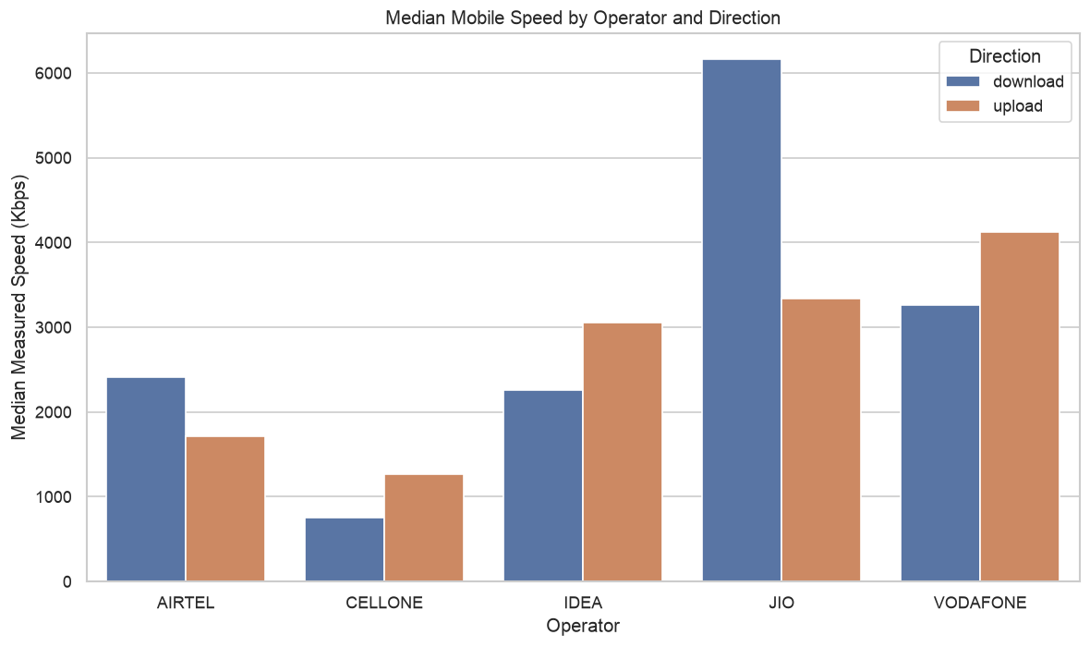
Figure 3. Median mobile speed by operator and direction.
The Telstra target was materially imbalanced: class 0 represented 64.8% of incidents, class 1 represented 25.3%, and class 2 represented only 9.8%. This distribution creates a modeling challenge because a classifier can appear effective while favoring the majority class and missing the incidents with the greatest operational importance. Median total log volume was 8 for class 0, 6 for class 1, and 32 for class 2. The substantially higher median for class 2 indicates that severe faults are associated with greater recorded operational activity in this dataset. This supports the inclusion of aggregated log-volume features in the model while also requiring caution: log volume may reflect the severity of an incident, the monitoring configuration at a location, or the amount of diagnostic activity generated after a problem begins. The relationship is therefore predictive evidence within the dataset, not proof that log activity causes severe faults.
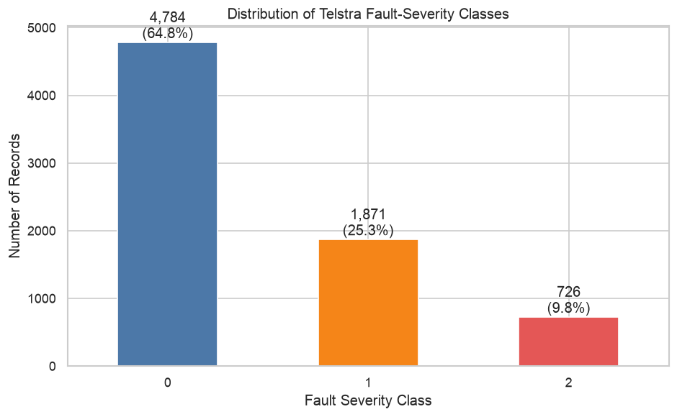
Figure 4. Distribution of Telstra fault-severity classes.

Baseline Model Results
The Random Forest baseline achieved 0.640 holdout accuracy and 0.587 macro F1. Class-level recall was 0.646 for class 0, 0.581 for class 1, and 0.759 for class 2. The relatively high class 2 recall is operationally encouraging because it shows that the model identified a large share of the rare severe incidents in the holdout sample. However, class 2 precision was only 0.385, meaning that many incidents predicted as severe were false positives. In a production environment, this tradeoff could increase investigation workload, create alert fatigue, and reduce engineer confidence if thresholds are not calibrated carefully. Location code was the strongest baseline feature with importance 0.354, followed by log-volume measures. This result suggests that site-specific history and operational activity contain useful predictive information, but it also raises a generalization concern because a model that depends heavily on known locations may perform less reliably at new or changed sites. Feature importance describes how the fitted model used variables; it does not establish causality or guarantee stability over time.
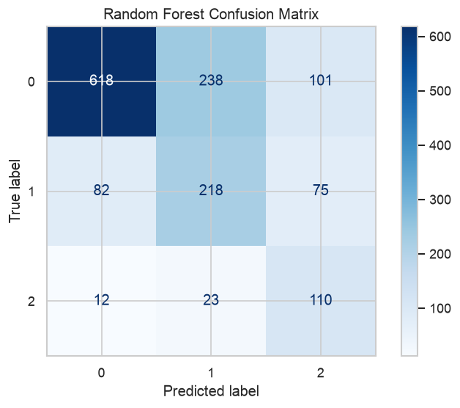
Figure 5. Holdout confusion matrix for the Random Forest baseline.
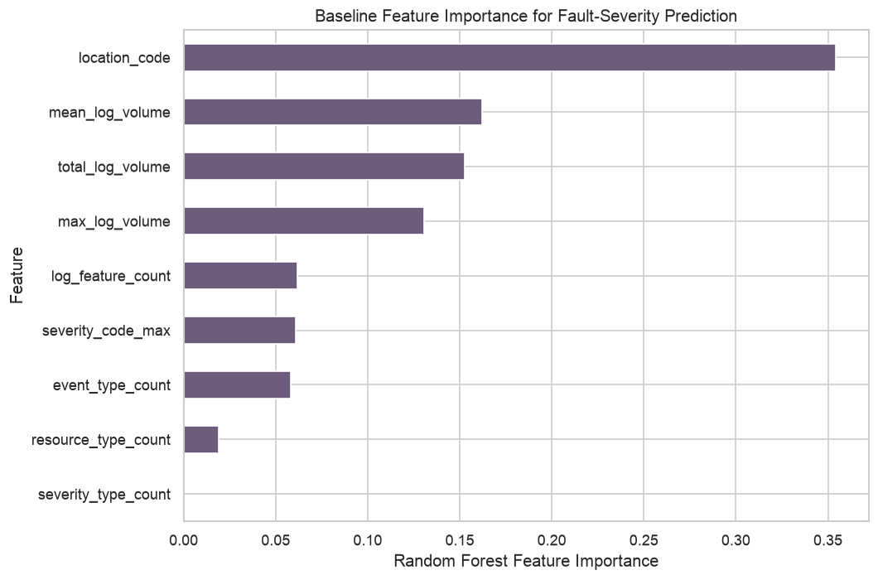
Figure 6. Baseline Random Forest feature importance.

Milestone 3 Code Enhancement
The final notebook strengthens the baseline by adding five-fold stratified cross-validation, RandomizedSearchCV hyperparameter tuning, a HistGradientBoosting comparison, probability-based multiclass precision-recall curves, permutation importance, and automatic export of evaluation tables and figures. Cross-validation provides a more stable estimate than a single split by measuring performance across multiple stratified folds. RandomizedSearchCV tests alternative parameter combinations efficiently, while the HistGradientBoosting model provides a meaningful comparison with a different learning approach. Precision-recall curves are especially useful for the imbalanced target because they show how severe-event detection changes as the decision threshold changes. Permutation importance complements built-in feature importance by measuring how model performance changes when each predictor is disrupted. Macro F1 remains the primary tuning measure because it gives equal consideration to all severity classes. The notebook intentionally reports enhanced model values only after execution against the supplied datasets; no unexecuted result is presented as fact. Final model selection should therefore consider cross-validation consistency, severe-class precision and recall, operational workload, and performance on temporally recent data rather than a single headline score.

Risks, Ethics, and Limitations
Several limitations constrain interpretation and operational use. The three source groups represent different populations and observation units, so they cannot support row-level integration or claims that a pattern in one dataset directly explains an outcome in another. The degradation threshold used for cellular analysis is an exploratory rule rather than a contractual service level. Speed-test comparisons may also be affected by missing values, device mix, geography, network technology, and user self-selection. Within the predictive model, location code may capture site-specific history that does not generalize to unseen or materially changed locations. The error tradeoff also has practical consequences: false positives increase engineering workload and may create alert fatigue, while false negatives can leave meaningful service risk undetected. Production deployment would introduce additional ethical and governance requirements, including privacy-preserving aggregation, minimization of customer identifiers, role-based access controls, encryption, retention limits, fairness and subgroup checks, drift monitoring, documented model ownership, and human oversight. These controls are necessary to ensure that the model supports responsible decision-making without exposing sensitive data or converting uncertain predictions into automatic corrective actions.

Recommendations and Implementation Plan
The recommended next step is a controlled pilot rather than immediate production automation. Network engineering and business stakeholders should first approve an operational definition of degradation, the prediction window, the acceptable balance between severe-event recall and false-positive workload, and the actions expected after an alert. The modeling workflow should then use chronological validation and compare performance across regions, technologies, and relevant operational subgroups. Additional features should capture rolling change, volatility, alarm sequence, topology, maintenance context, and recent configuration activity because deterioration is often defined by trends rather than isolated measurements. Decision thresholds should be calibrated with engineers so that alerts remain actionable within available investigation capacity. Each risk score should be accompanied by supporting measurements and a clear explanation of the factors that influenced it, with engineers retaining final judgment. The initial pilot should operate in shadow or advisory mode and record alert usefulness, investigation outcomes, false-positive burden, missed incidents, and any prevented customer impact. Advancement beyond the pilot should depend on stable performance, documented governance, and evidence that the workflow improves response without creating unacceptable operational or privacy risk.

Conclusion
This study supports the hypothesis that telecom operational data contains patterns associated with network quality and fault severity. The descriptive results showed meaningful variation by environment, operator, region, and operational log activity, while the predictive analysis demonstrated that aggregated incident features can distinguish severity classes with moderate effectiveness. The baseline model’s 0.640 accuracy and 0.587 macro F1 establish a reproducible starting point rather than a final production standard. Its class 2 recall of 0.759 demonstrates the potential to identify many severe incidents, but class 2 precision of 0.385 confirms that the same model would generate a substantial number of false-positive alerts. These findings illustrate both the opportunity and the operational risk of predictive degradation monitoring. The appropriate path forward is an explainable, human-reviewed pilot supported by chronological validation, threshold calibration, richer temporal and contextual features, privacy controls, drift monitoring, and clear ownership. Used in this manner, machine learning can strengthen engineering prioritization and early investigation without replacing professional judgment or overstating what public datasets can prove.

Appendix A: Audience Questions and Answers
- How is potential service degradation defined in this study?
For exploratory analysis, a cellular record is flagged when signal strength is below -100 dBm or SNR is below 15. The rule is transparent but is not an operator-approved service-level definition.
- Why were the three source groups analyzed separately instead of merged?
They represent different populations, identifiers, observation units, and collection contexts. A row-level merge would create unsupported relationships.
- How representative are public datasets of production telecom networks?
They are useful for demonstrating analytical methods and patterns, but they do not fully represent a specific operator’s topology, telemetry, devices, customers, or operating practices.
- Why was median speed used instead of mean speed?
The speed distribution is strongly right skewed and contains extreme observations. Median is less sensitive to those extremes and better represents a typical result.
- How does class imbalance affect fault-severity evaluation?
A model can achieve acceptable overall accuracy by favoring the majority class. Class-level precision and recall plus macro F1 provide a more balanced assessment.
- Which operational features contributed most to the baseline model?
Location code was the strongest baseline feature at 0.354 importance, followed by log-volume measures. Importance is model-specific and is not evidence of causality.
- Why is accuracy not sufficient for judging the model?
Accuracy hides different error rates across severity classes. For operations, missing a severe event and generating a false alert have different consequences.
- How would false-positive alerts affect network operations teams?
They can create alert fatigue, consume investigation capacity, and reduce trust. Thresholds should therefore be tuned with engineering feedback and workload limits.
- What privacy and security controls would be required with production data?
Production use should minimize customer identifiers, aggregate where possible, encrypt data, restrict access, document retention, and audit model and user activity.
- What additional testing is needed before operational deployment?
The model needs chronological validation, testing on recent production-like data, subgroup error analysis, drift monitoring, threshold calibration, and a human-reviewed pilot.

References
Bicski, B., & Pekar, A. (2024). Early detection of network service degradation: An intra-flow approach. arXiv. https://arxiv.org/abs/2407.06637
Kaggle. (n.d.). Cellular network performance data. https://www.kaggle.com/datasets/suraj520/cellular-network-performance-data
Kaggle. (n.d.). Mobile internet speed India. https://www.kaggle.com/datasets/kishan305/mobile-internet-speed-india
Kaggle. (n.d.). Telstra recruiting network. https://www.kaggle.com/competitions/telstra-recruiting-network/data

