Comparative Analysis of Machine Learning Algorithms for Human Activity Recognition Using the Daily and Sports Activities Dataset

Akhila Valsalakumari Sakthidharan (15979719)
College of Engineering, Environment and Science
Coventry University
Coventry, England
valsalakua@coventry.ac.uk

Abstract— Human activity recognition (HAR) using wearable sensors supports applications in fitness, healthcare, and ambient-assisted living. This study compares four classical machine-learning models—Support Vector Machines (SVM), k-nearest neighbors (KNN), linear discriminant analysis (LDA), and decision trees (DT)—on the DSADS dataset from the UCI Repository. DSADS provides multivariate inertial and magnetic signals sampled at 25 Hz from five body-worn units across 19 daily and sport activities, segmented into 5-second windows for a total of 9120 labeled samples. For each segment, we extracted basic statistical features (mean, standard deviation, minimum, maximum) from all 45 sensor channels, producing 180-dimensional feature vectors. Using standardized scikit-learn pipelines with optional PCA, stratified train–test splits, and five-fold cross-validated hyperparameter tuning, SVM with an RBF kernel achieved the best results: 99.34% accuracy and a macro F1-score of 0.993. KNN and LDA performed similarly, while DTs were slightly lower. The findings show that simple, well-designed feature engineering can yield near-perfect HAR performance and highlight model differences and ethical considerations in wearable HAR.
Key-words: Human activity recognition, wearable sensors, Daily and Sports Activities (DSADS), support vector machines, k-nearest neighbors, linear discriminant analysis, decision trees, principal component analysis.

GitHub repository link: https://github.com/Akhilavssree/7072CEM-Machine-Learning-coursework

- INTRODUCTION

Human Activity Recognition (HAR) through wearable sensors is among the key applications of ubiquitous computing such as fitness tracking, rehabilitation, workplace evaluation, and ambient-assisted living. Inference of human actions from inertial and magnetic sensor measurements forms the basis for long-term user behavior awareness, as well as personalized interventions for health and well-being of users. The Daily and Sports Activities dataset (DSADS) is one of the most popular benchmarks for sensor-based human activity recognition. It consists of triaxial accelerometer, gyroscope, and magnetometer recordings from five Xsens MTx units used on the torso, both arms, and both legs of eight healthy subjects performing 19 daily and sports activities. Each activity is performed for five minutes and sampled at the frequency of 25 Hz before being segmented into non-overlapping 5-second windows producing 60 segments per subject per activity and 9120 labelled segments in total: From this structure, DSADS is favorable for multiclass HAR evaluations under different subject variability and motion conditions. This study was carried out under the 7072CEM Machine Learning module, and it examines a rigorous comparison of classical supervised learning algorithms support vector machines (SVM), optimized K-nearest neighbors (KNN), linear discriminant analysis (LDA), and decision trees (DT) in regard to how standard methods coupled with relevant feature engineering and model selection can effectively approach a realistic multiclass HAR task.
This will include (1) setting up a full preprocessing and modeling pipeline in scikit-learn feature extraction, standardization, and possibly PCA; (2) investigating the four classifiers with five-fold cross-validated hyperparameter tuning and test-set performance measures of accuracy and macro F1-score; and (3) confusion patterns and per-class performance as well as ethical considerations for HAR in the real world. The subsequent portions of the paper are organized in the following manner: DSADS and problem formulation in Section II, methods in Section III, experimental setup in Section IV, results in Section V, and discussion and conclusions in Section VI.

II. PROBLEM AND DATA SET DESCRIPTION

This particular study deals with the classification of multiclass human activities, employing data collected through wearable sensors and recorded from five body positions within a 5-sec window of inertial and magnetic measurements. The most stimulating question, then, is how this instance can now classify a subject among 19 predefined daily or sport activities, thereby leading to a possible redefinition of how HAR is modeled for real-life activity scenarios in which the short sensor windows need to somehow be represented semantically and modeled for the variability in the ways in which people perform movements.
TABLE I
ACTIVITY LIST

- ACTIVITY_ID | - ACTIVITY DESCRIPTION
A1 | Sitting
A2 | Standing
A3 | Lying on back
A4 | Lying on right side
A5 | Ascending stairs
A6 | Descending stairs
A7 | Standing in an elevator
A8 | Standing in an elevator (moving)
A9 | Walking in a parking lot
A10 | Walking on a treadmill with a speed of 4 km/h
A11 | A10 in a 15-degree inclined position
A12 | Running on a treadmill with a speed of 8 km/h
A13 | Exercising on a stepper
A14 | Exercising on a cross trainer
A15 | Cycling on an exercise bike (horizontal position)
A16 | Cycling on an exercise bike (vertical position)
A17 | Rowing
A18 | Jumping
A19 | Playing basketball

The Daily and Sports Activities Dataset (DSADS) was obtained from the UCI Machine Learning Repository. Eight healthy adults (four males and four females, 20-30 years) performed 19 activities for five minutes each. Activities include sitting, standing, or lying postures, climbing and descending stairs and elevators, walking indoors and outdoors, treadmill walking and running, stepper and cross-training exercises, cycling in two positions, rowing, jumping, and playing basketball. Activities were recorded in several locations-from sports facilities to academic buildings to outdoors-in order to allow for possible variations in context.

Five Xsens MTX units were used in the study and were mounted on the torso, right arm, left arm, right leg, and left leg. Each unit consists of triaxial accelerometers, gyroscopes, and magnetometers-truly, a nine-channel unit for a total of 45 channels. The sampling frequency of the sensors was set to 25 Hz. For every single 5-minute recording, five non-overlapping 5-second windows are created giving 60 segments per subject per activity. This resulted in 9,120 segments (19 activities and 8 subjects) in the dataset. Each segment of an activity corresponds to a 125 × 45 times-series matrix. UCI flattened these segments to 5,625-dimension vectors (125 time steps × 45 channels); here we replace the raw segments with compact statistical descriptors summarized from each segment. We have now a total of 9,120 rows and 180 engineered features that become the tabular dataset where activity label is the supervised learning target.
DSADS as a dataset balance well with respect to the number of segments made per subject for a given activity scenario, but subjects do every activity in a natural manner, causing changes in the speed of movement and in the motor style. Thus, DSADS is a very realistic and hard benchmark in assessing machine learning approaches concerning HAR.

III. METHODS

This section is concerned with feature extraction and classification by supervised algorithms from the scikit-learn library: support vector machines (SVM), K-nearest neighbor (KNN), linear discriminant analysis (LDA), and decision tree (DT).

A. Feature Extraction

Each segment taken from DSADS is represented as a 125 × 45 matrix of the sensor readings corresponding to time samples of 5 seconds in the time epoch and 45 for the channels across all sensor units. Times-series modeling would call for temporal architectures with vastly greater amounts of data; thus, we resorted to classical handcrafted feature approaches appropriate to the statistical properties of the signals.

B. Support Vector Machine

Support vector classifiers are large-margin classifiers that given the dataset find an optimum separating hyperplane that maximizes the margin between classes. In the presence of non-linear separability of the data, the kernel functions will implicitly map the input-to-higher-dimensional space where linear separation becomes feasible. Implementing the RBF kernel involves two major hyperparameters: C-the regularization term, which tips the trade-off between margin size and misclassification, and γ-defines the range of influence of training points on decision boundaries. If either C or γ, is too large, then it would incur the risk of overfitting the data; hence, hyper-parameter tuning was done with cross-validation.

C. K-Nearest Neighborhoods (KNN)

KNN is an instance-based method that assigns labels to a test sample based on the k closest training samples under a chosen distance metric. Classification is determined by majority voting or distance-weighted voting. KNN is simple yet capable of modeling complex decision boundaries. Its performance depends strongly on the value of k, the distance metric, and proper feature scaling. We experiment with Euclidean and Manhattan distances, multiple k values, and uniform versus distance-weighted voting. All features are standardized beforehand to ensure comparable scale.

D. Linear Discriminant Analysis

Linear Discriminant Analysis (LDA) is a generative classifier, which assumes that each class follows a multivariate Gaussian distribution with a mean pertaining to that class and a common covariance matrix; this leads to linear decision boundaries. It works well in high-dimensional spaces when the Gaussian assumptions hold valid to some extent. In multiplot LDA within scikit-learn, cross-validation was used for choosing among several solvers.

E. Decision Tree

The decision tree divides the feature space into axis-parallel regions by binary splits, at each step ensuring maximal reduction in impurity (Gini or Entropy). Non-linear interactions are thereby captured with great interpretability yet left unchecked a decision tree will tend to overfit. Maximum depth and minimum samples per split or leaf were enforced on the trees for regularization, and these parameters were cross validated.

IV. EXPERIMENTAL SETUP
This section summarises the data preprocessing workflow, dataset partitioning strategy, model configuration, and evaluation metrics used in this study.
A. Data Preprocessing
The Daily and Sports Activities Dataset (DSADS) is organised hierarchically into activity folders (a01–a19), subject subfolders (p1–p8), and 60 segmented files per subject (s01–s60). Each file stores a 125 × 45 matrix of multivariate sensor readings, comprising accelerometer, gyroscope, and magnetometer data recorded at 25 Hz from five body-worn units. All files are iteratively loaded, validated for the expected dimensionality, and converted into a 180-dimensional statistical feature vector consisting of the mean, standard deviation, minimum, and maximum of each sensor channel. For each segment, metadata such as activity label, activity identifier, subject index, and segment number are also recorded.
The extracted feature records are combined into a Pandas DataFrame containing 9,120 samples and 180 features, along with four metadata fields. The feature matrix $X$is obtained by removing metadata columns, while the target vector $y$contains the nominal activity labels. Even though DSADS is complete and does not contain missing readings, mean imputation is applied defensively in the unlikely event of NaN values. Prior to classification, StandardScaler is used to normalise all features to zero mean and unit variance, a necessary step for distance-sensitive models such as KNN and beneficial for SVM and LDA. For models incorporating PCA, the dimensionality is further reduced while retaining 95% of the variance.
B. Train–Test Split and Cross-Validation
To ensure reliable generalisation estimates, there is an 80/20 stratified split of the dataset, resulting in 7,296 samples for training and 1,824 samples for testing, while stratification maintains the balanced distribution of the 19 activities. Hyperparameter tuning is performed solely on the training part via five-fold stratified cross-validation. Each fold evaluates model configurations using macro-averaged F1-score, guaranteeing equal weighting across all classes.
C. Model Configurations
All classifiers are implemented as scikit-learn pipelines. SVM, KNN, and LDA pipelines include both standardisation and PCA, whereas Decision Trees omit scaling and PCA due to their invariance to individual feature scaling. The SVM grid explores $\{C=0.1,1,10\}$and RBF kernel widths $\{γ=\text{scale},0.01,0.001\}$. KNN tuning spans neighbours $k∈\{3,5,7,11\}$, metrics (Euclidean, Manhattan), and weighting modes (uniform, distance). LDA is tested with SVD and LSQR solvers. Decision Trees vary maximum depth, impurity criteria, and minimum split sizes.
D. Evaluation Metrics
Model performance is assessed on the test set using overall accuracy and macro-averaged F1-score. Accuracy reflects the proportion of correct predictions, whereas macro F1 equally weights all activity classes in calculating harmonic means of precision and recall. Confusion matrices and class-wise classification reports are also generated to analyse error patterns and identify activities prone to misclassification.
V. RESULTS
This section describes the quantitative evaluation of the four classifiers on the DSADS dataset. The results pertain to the held-out test set of 1,824 segments (20% of the whole dataset). The evaluation result is with respect to the accuracy and macro-averaged F1 scores, wherein all of the 19 activity classes share equal footing since these are balanced.

The SVM is proved to be the best classifier. The model reached 99.34% accuracy and macro F1 of 0.993 with RBF kernel and best hyperparameter settings of C=10 and 𝛾=scale. Close behind was K-Nearest Neighbor, scoring competitively with the best configuration of k=3, using Euclidean distance and distance-based weighting, achieved 98.90% and a macro F1-score of 0.989. Linear Discriminant Analysis classifier with svd solver attained 98.63% accuracy and a macro F1-score of 0.986. The Decision Tree classifier, unrestricted depth using Gini criterion, provided impressive results with 98.08% accuracy and 0.981 macro F1-score.
Confusion matrices across all models show that for most activities, the performance is exemplary in near-perfect precision and recall, with the only place where misclassifications occur for activities that differentiate each other quite subtly from the movement characteristics. The decision tree seems to perform slightly poorer in these low-movement classes compared to SVM, KNN, and LDA.

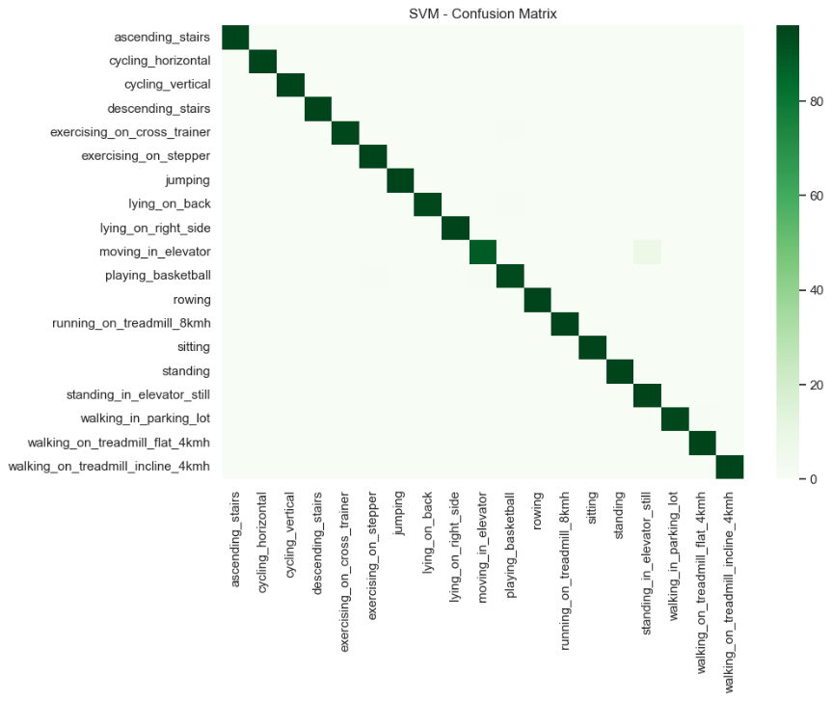
Fig: Confusion matrix for the SVM Model

All classifiers have almost achieved perfect recognition of dynamic activities played with high amplitudes, such as running, cycling, rowing, jumping and playing basketball since each can identify the discriminative movement signatures. The static activities of sitting, standing, and lying also availed of high classification performance, reflecting that the stock statistical features extracted from each 5s window were quite enough to differentiate among postures.
Table II summarizes all performance comparison for the four models.

TABLE II
Performance Comparison

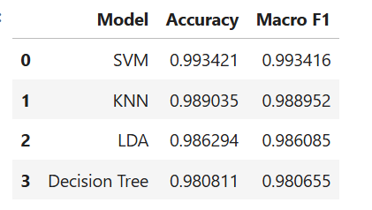

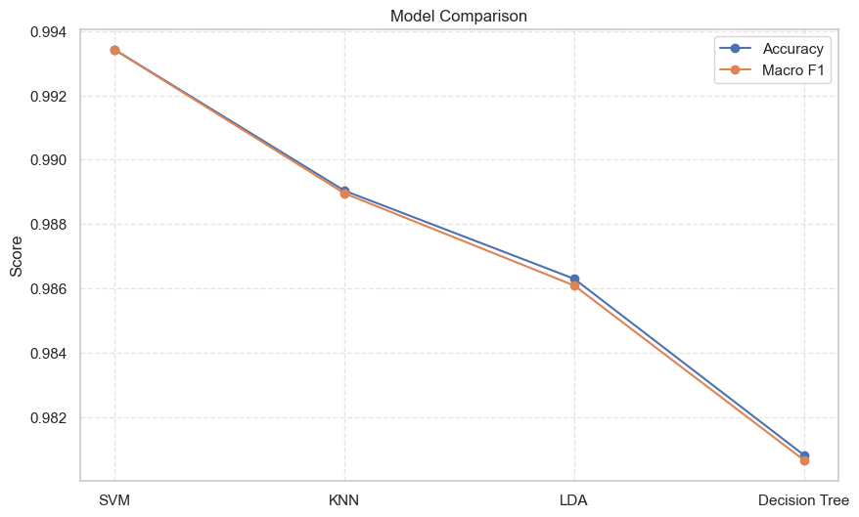
Fig: Model Comparison
VI. DISCUSSION AND CONCLUSION

The outcomes show that standard classical machine learning models combined with very simple but cleverly designed statistical attributes can feature human activity recognition for the DSADS dataset. Of the four classifiers tested, the highest accuracy and macro F1-score are achieved with the RBF-kernel SVM, although the distinctions in performance from KNN and LDA are rather minor. This means that the 180-dimensional statistical feature representation typically makes most activities easily separable, with LDA's excellent performance indicating that there is already much class structure captured by linear boundaries. The slight edge for SVM probably comes from the fact that it can model subtle non-linear deviations in activities such as elevator motions, where most movement of the body is rather still.
It does slightly worse than the rest because of the inability of partitioning the high-dimensional continuous feature space using axis-aligned splits, but then it touches 98% accuracy anyway. This proves that usage of even simple models with relevant features can solve the DSADS problem well.
There are, however, some limitations. The evaluation was done using stratified random splits rather than through subject-independent performance testing, which could introduce an optimistic estimate of the performance results. Moreover, DSADS encompasses a rather narrow demographic and controlled recording environment, leading to limited generalizability. In addition, ethical considerations, such as those related to privacy and informed consent as well as demographic biases, must also be matched with these real-world HAR applications.
In summary, the study points out that classical ML techniques are computationally efficient and provide an excellent performance measure for HAR, making a good benchmark for future work involving evaluations against unknown subjects and deep learning techniques.
VII. REFERENCES
[1] 7072CEM Machine Learning, "Machine learning algorithms for solving real-world challenges - Assignment Brief," Coventry University, 2025.
[2] B. Barshan and K. Altun, "Daily and Sports Activities," UCI Machine Learning Repository, Irvine, CA, USA, 2013.
[3] B. Barshan and M. C. Yüksek, "Recognizing daily and sports activities in two open-source machine learning environments using body-worn sensor units," Wiley Interdisciplinary Reviews: Data Mining and Knowledge Discovery, vol. 4, no. 6, pp. 534-549, 2014.
[4] F. Kuncan, "A new approach for physical human activity recognition using wearable sensors," Biomedical Signal Processing and Control, vol. 78, 2022. ScienceDirect
[5] S. R. Ramamurthy and N. Roy, "Recent trends in machine learning for human activity recognition - A survey," Wiley Interdisciplinary Reviews: Data Mining and Knowledge Discovery 8, no. 4, 2018.
[6] F. Pedregosa et al., "Scikit-learn: Machine learning in Python," Journal of Machine Learning Research 12:2825–2830, 2011.
Journal of Machine Learning Research
[7] S. Mekruksavanich and A. Jitpattanakul, "Recognition of sports and daily activities through deep learning techniques," Sensors 24, no. 2, 2024.
[8] J. Pabón et al., "A comprehensive dataset for the activity of daily living (ADL) recognition with wearable sensors," personalized Medicine 15, no. 5, 2025.

