**PROJECT REPORT**

on

# Your Personal Finance Companion

# Full Stack Development

Submitted in a partial fulfilment for the award of the degree

**BACHELOR OF TECHNOLOGY**

**In**

**COMPUTER SCIENCE AND ENGINEERING**

**Submitted by**

**CHINTHAGINJALA AKHIL**

**(202H1A0524)**

**Under the esteemed Guidance of**

**Mr. B. Hari Babu**

**Associate Professor**



**DEPARTMENT OF COMPUTER SCIENCE AND ENGINEERING AUDISANKARA INSTITUTE OF TECHNOLOGY**

(An Autonomous Institution)

Approved by AICTE, affiliated to JNTU, Anantapur

**GUDUR, ANDHRA PRADESH – 524101**

www.au[disankara.ac.in](http://www.audisankara.ac.in/) **2023– 2024**



**DEPARTMENT OF COMPUTER SCIENCE AND ENGINEERING**

**Audisankara Institute of Technology**



**CERTIFICATE**

This is to certify that the project report entitled **Your Personal Finance Companion - Full Stack Development** a bonafide record of the project work done and submitted by **CHINTHAGINJALA AKHIL** Regd. No**.: (202H1A0524)** for the partial fulfillment of the requirements for the award of B.Tech Degree in **COMPUTER SCIENCE AND ENGINEERING,** from Jawaharlal Nehru Technological University Anantapur, Anantapuramu, during the year 2023-2024.

**Project Guide Head of the Department**

**Mr. B. Hari Babu, Mr. G. Rajesh, M. Tech., (Ph.D.)**

Associate Professor Associate Professor

Department of CSE Department of CSE

**ASCET, GUDUR – TIRUPATI (DT). ASCET, GUDUR-TIRUPATI(DT).**

### Submitted for the viva-voce Examination held on:

**Internal Examiner External Examiner**

# DECLARATION

I am **CHINTHAGINJALA AKHIL** hereby declare that the project report entitled “**Your Personal Finance Companion - Full Stack Development**” done by us under the guidance of **Mr. B. Hari Babu**, and is submitted in partial fulfillment of the requirements for the award of the Bachelor’s degree in **Computer Science and Engineering**. This project is the result of our own effort and it has not been submitted to any other University or Institution for the award of any degree or diploma other than specified above.

Date:

Place:

Signature of the candidate

**CHINTHAGINJALA AKHIL**

**(202H1A0524)**

**DEPARTMENT OF COMPUTER SCIENCE AND ENGINEERING**

Audisankara Institute of Technology

**Full Semester Internship Report**

Submitted in accordance with the requirement for the degree of Bachelor of Technology

|  |  |
| --- | --- |
| Name Of the College | : Audisankara Institute of Technology |
| Department | : Computer Science & Engineering |
| Name of the supervisor | : Mr. B. Hari Babu |
| Duration of the FSI | : From 31-01-2024 to 15-04-2024 |
| Name of the Student | : CHINTHAGINJALA AKHIL |
| Course of Study | : Bachelor of Technology |
| Semester | : VIII Semester |
| Register Number | : 202H1A0524 |
| Date of Submission | : |

# STUDENT DECLARATION

I am CHINTHAGINJALA AKHIL a student of Full Semester Internship, Reg. No 202H1A0524 of Department of CSE, Audisankara Institute of Technology do hereby declare that I have completed the mandatory Full Semester Internship From 31-01-2024 to 15-04-2024 in IIDT under the Faculty supervisor of **Mr. B. Hari Babu, Associate Professor** in Department of Computer Science and Engineering in Audisankara Institute of Technology.

(Signature & Date)

Endorsements

Faculty Supervisor HOD Dean Academics Mr. B. Hari Babu Mr. G. Rajesh, M.Tech, (Ph.D.) Dr . M. Rajaiah, PhD Associate Professor Associate Professor, CSE Professor, CSE

# ACKNOWLEDGEMENT

The satisfaction and elation that accompany the successful completion of any task would be incomplete without the mention of the people who have made it a possibility. It is our great privilege to express our gratitude and respect to all those who have guided us and inspired us during the course of this project Working towards Industry/Research Internship has been a period of various challenges that have led to a great deal of learning and professional growth. Making it through would not have been possible without the help and **support of family and friends.**

First and foremost, I would like to express my heartful gratitude to our honourable chairman **Dr. VANKI PENCHALAIAH, M.A., M.L., Ph.D.,** who provided all facilities and necessary encouragement during the course of study.

I would like to thank **AUDISANKARA INSTITUTE OF TECHNOLOGY** for providing the extraordinary support in the completion of the project by utilizing the

laboratories, library and Software’s required for our project.

I extend my gratitude and sincere thanks to our beloved Director

**Dr. A. MOHAN BABU**, and Principal **Dr. T. VENUMADHAV, Ph.D**., for motivating and providing necessary infrastructure and permitting me to completion of the project.

I would like to express the sense of gratitude toward our Dean Academics **Dr. M. RAJAIAH, Ph.D**., and Head of the Department

**Mr**. **G. RAJESH**, **M. Tech, (Ph.D),** our external guide **Mr. B. Hari Babu, Associate Professor** in Computer Science and Engineering for their valuable inputs, able guidance, encouragement, whole-hearted cooperation and constructive criticism throughout the duration of our project.

Last, but not the least, I would like to thank my parents for supporting me in all the aspects for the completion of this internship.

**CHINTHAGINJALA AKHIL**

**(202H1A0524)**

# COMPANY PROFILE

Blackbucks Professional Studies, a prominent tech company launched in 2015, provides joboriented postgraduate programs in data science, AI, and full-stack development through universities like JNTU Hyderabad, emphasizing employability with small class sizes, personalized mentorship, and a claimed 100% placement record. Additionally, a partnership with IIDT Tirupati offers internship opportunities to bridge the gap between academic concepts and real-world tech experience.

**Founded: 2015 Specialties: ISO Certified, MSME, AICTE, EUAS, and IT Services**

## Mission and Vision

Mission: Revolutionize the logistics industry through technology, making transportation and freight services more efficient, reliable, and transparent for businesses and truckers alike.

Vision: To be the leading logistics platform not only in India but globally, by continuously innovating and improving the logistics ecosystem, making it environmentally sustainable and economically beneficial for all stakeholders.

## IT Services

BlackBuck's core IT services revolve around its logistics platform, offering utilizing algorithms to match loads with the best-suited trucks. Providing real-time GPS tracking for shipments and fleet management solutions.Data Analytics: Offering insights into operations to optimize routes, reduce costs, and improve efficiency.

## Education Services

Direct education services are not typically a focus for logistics companies. However, BlackBuck may offer training programs for its employees, truckers on its platform, and possibly workshops or seminars on logistics management, digital tools for transportation, and best practices in the industry to improve the overall ecosystem.

## Internship Opportunities

Tech-driven companies like BlackBuck often offer internship opportunities in areas such as software development, data analysis, business development, and operations. These opportunities can provide hands-on experience in a fast-paced startup environment, focusing on technology, logistics, and supply chain management.

**Website :** https:/[/www.thebla](http://www.theblackbucks.co/)c[kbucks.co](http://www.theblackbucks.co/)[m](https://shripriti.in/) **Industry :** Software Development

IIDT INTERNSHIP CERTIFICATE

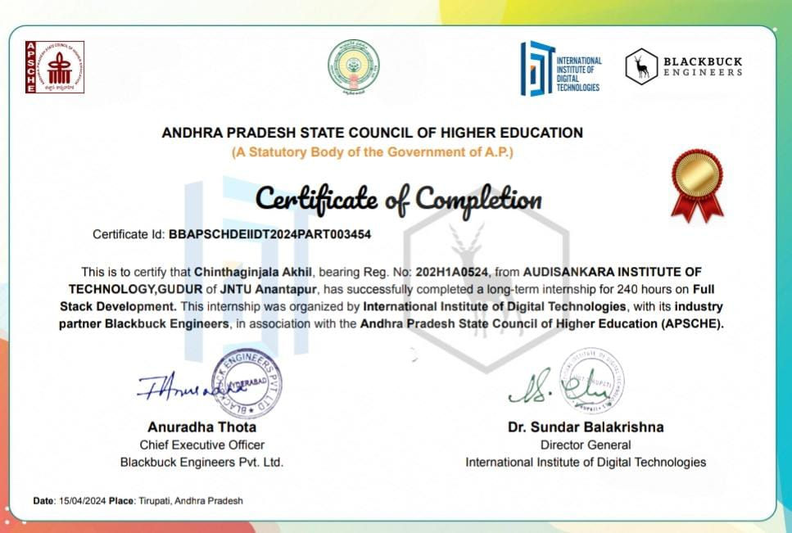

# ABSTRACT

In today's fast-paced world, effective management of personal finances is crucial for individuals striving for financial stability and security. Traditional methods of Personal Finance Companion often fall short, leading to inefficiencies and inaccuracies. To address this challenge, a modern Personal Finance Companion System has been developed using the MERN (MongoDB, Express.js, React.js, Node.js) stack. This system offers a comprehensive solution for individuals to monitor their finances in real-time, enabling them to make informed decisions and achieve their financial goals.

Existing Personal Finance Companion solutions often lack user-friendly interfaces and comprehensive analytical capabilities, hindering users' ability to manage their expenses effectively. The proposed Personal Finance Companion System seeks to bridge this gap by providing users with a user-centric platform that prioritizes ease of use and accessibility. Through secure authentication mechanisms such as JWT-based authentication and password hashing using Bcrypt, the system ensures data security and user privacy, instilling confidence in users to entrust their financial information.

In conclusion, the Personal Finance Companion System represents a significant advancement in personal finance management, offering users a modern and robust platform to take control of their financial futures. By leveraging cutting-edge technologies and user-centric design principles, the system empowers individuals to track expenses, manage income, and optimize savings with ease and confidence, ultimately leading to improved financial well-being and long-term financial success.

### Tick(✔) the fields: Online Offline Internship Members:

|  |  |  |
| --- | --- | --- |
| **Reg No** | **Name of the student** | **Signature of the student** |
| (202H1A0524) | CHINTHAGINJALA AKHIL |  |

**Project Guide: HOD:**