MySQL Tutorial

MySQL is a widely used relational database management system (RDBMS).

MySQL is free and open-source.

MySQL is ideal for both small and large applications.

Eg-

SELECT * FROM Customers; Introduction to MySQL

MySQL is a very popular open-source relational database management system (RDBMS).

**What is MySQL?**

* MySQL is a relational database management system
* MySQL is open-source
* MySQL is free
* MySQL is ideal for both small and large applications
* MySQL is very fast, reliable, scalable, and easy to use
* MySQL is cross-platform
* MySQL is compliant with the ANSI SQL standard
* MySQL was first released in 1995
* MySQL is developed, distributed, and supported by Oracle Corporation
* MySQL is named after co-founder Monty Widenius's daughter: My

**Who Uses MySQL?**

* Huge websites like Facebook, Twitter, Airbnb, Booking.com, Uber, GitHub, YouTube, etc.
* Content Management Systems like WordPress, Drupal, Joomla!, Contao, etc.
* A very large number of web developers around the world

**What is RDBMS?**

RDBMS stands for Relational Database Management System.

RDBMS is a program used to maintain a relational database.

RDBMS is the basis for all modern database systems such as MySQL, Microsoft SQL Server, Oracle, and Microsoft Access.

RDBMS uses SQL queries to access the data in the database.

**What is a Database Table?**

A table is a collection of related data entries, and it consists of columns and rows.

A column holds specific information about every record in the table.

A record (or row) is each individual entry that exists in a table.

Look at a selection from the Northwind "Customers" table:

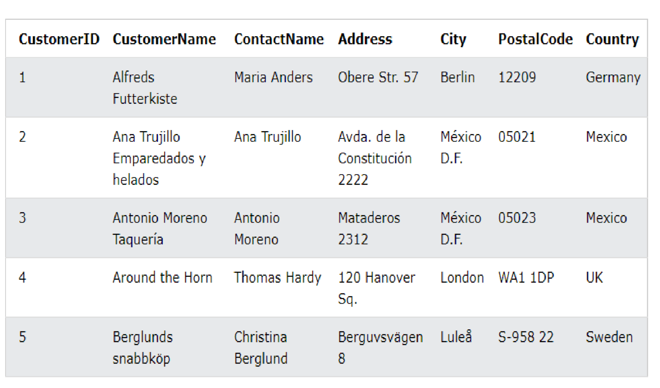

The columns in the "Customers" table above are: CustomerID,

CustomerName, ContactName, Address, City, PostalCode and Country. The table has 5 records (rows).

**What is a Relational Database?**

A relational database defines database relationships in the form of tables. The tables are related to each other - based on data common to each.

Look at the following three tables "Customers", "Orders", and "Shippers" from the Northwind database:

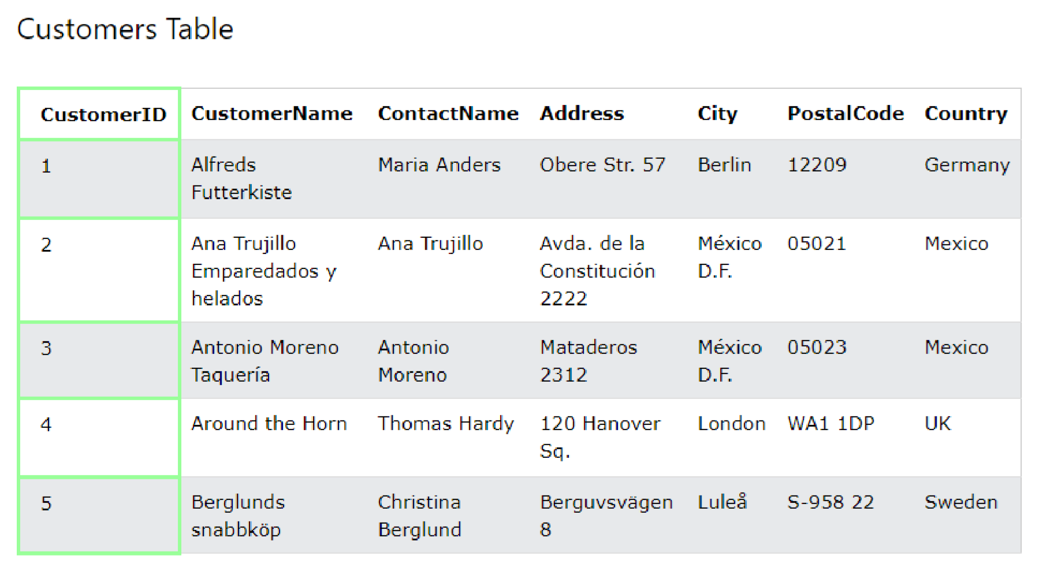

The relationship between the "Customers" table and the "Orders" table is the CustomerID column:

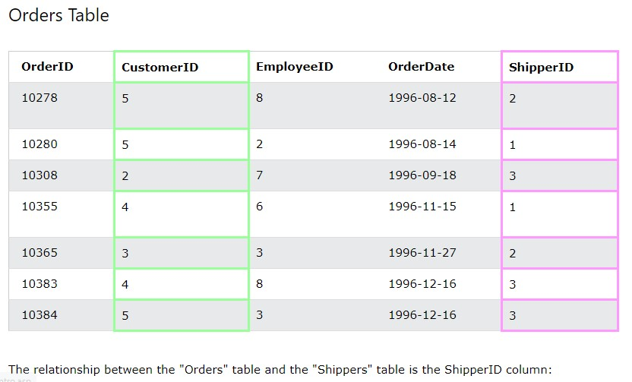

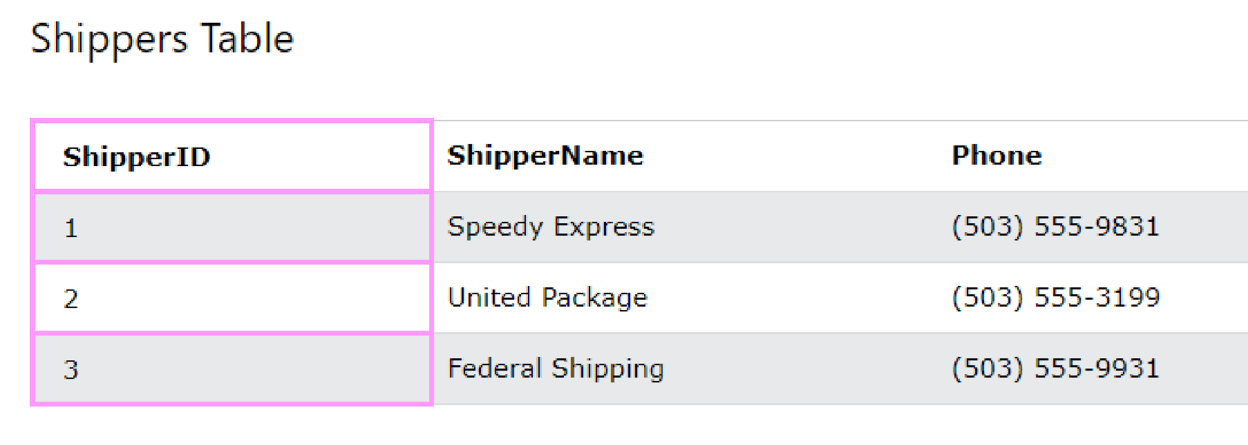

MySQL SQL

**What is SQL?**

SQL is the standard language for dealing with Relational Databases.

SQL is used to insert, search, update, and delete database records.

**How to Use SQL**

The following SQL statement selects all the records in the "Customers" table:

SELECT * FROM Customers;

**Keep in Mind That...**

* SQL keywords are NOT case sensitive: select is the same as SELECT

**Semicolon after SQL Statements?**

Some database systems require a semicolon at the end of each SQL statement.

Semicolon is the standard way to separate each SQL statement in database systems that allow more than one SQL statement to be executed in the same call to the server.

In this tutorial, we will use semicolon at the end of each SQL statement.

**Some of The Most Important SQL Commands**

* SELECT - extracts data from a database
* UPDATE - updates data in a database
* DELETE - deletes data from a database
* INSERT INTO - inserts new data into a database
* CREATE DATABASE - creates a new database
* ALTER DATABASE - modifies a database
* CREATE TABLE - creates a new table
* ALTER TABLE - modifies a table
* DROP TABLE - deletes a table
* CREATE INDEX - creates an index (search key)
* DROP INDEX - deletes an index

|  |
| --- |
| **The MySQL CREATE DATABASE**  **Statement** |
| The CREATE DATABASE statement is used to create a new SQL database. |

# Syntax

CREATE DATABASE *databasename*;

**CREATE DATABASE Example**

The following SQL statement creates a database called "testDB":

# Example

CREATE DATABASE testDB;

**Tip:** Make sure you have admin privilege before creating any database. Once a database is created, you can check it in the list of databases with the following SQL command: SHOW DATABASES;

**The MySQL DROP DATABASE Statement**

The DROP DATABASE statement is used to drop an existing SQL database.

# Syntax

DROP DATABASE *databasename*;

**Note:** Be careful before dropping a database. Deleting a database will result in loss of complete information stored in the database!

**DROP DATABASE Example**

The following SQL statement drops the existing database "testDB":

DROP DATABASE testDB;

**Tip:** Make sure you have admin privilege before dropping any database. Once a database is dropped, you can check it in the list of databases with the following SQL command: SHOW DATABASES;

|  |
| --- |
| **The MySQL CREATE TABLE Statement** |
| The CREATE TABLE statement is used to create a new table in a database. |

# Syntax

CREATE TABLE *table_name* (  *column1 datatype*,  *column2 datatype*,  *column3 datatype*, .... );

The column parameters specify the names of the columns of the table.

The datatype parameter specifies the type of data the column can hold (e.g. varchar, integer, date, etc.).

**MySQL CREATE TABLE Example**

The following example creates a table called "Persons" that contains five columns: PersonID, LastName, FirstName, Address, and City:

# Example

CREATE TABLE Persons (

PersonID int,

LastName varchar(255),

FirstName varchar(255),

Address varchar(255),

City varchar(255) );

The PersonID column is of type int and will hold an integer.

The LastName, FirstName, Address, and City columns are of type varchar and will hold characters, and the maximum length for these fields is 255 characters.

The empty "Persons" table will now look like this:

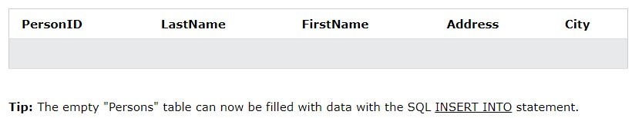

**The MySQL INSERT INTO Statement**

The INSERT INTO statement is used to insert new records in a table.

# INSERT INTO Syntax

It is possible to write the INSERT INTO statement in two ways:

1. Specify both the column names and the values to be inserted:

INSERT INTO *table_name* (*column1*, *column2*, *column3*, ...)

VALUES (*value1*, *value2*, *value3*, ...);

1. If you are adding values for all the columns of the table, you do not need to specify the column names in the SQL query. However, make sure the order of the values is in the same order as the columns in the table. Here, the INSERT INTO syntax would be as follows:

INSERT INTO *table_name*

VALUES (*value1*, *value2*, *value3*, ...);

**The MySQL SELECT Statement**

The SELECT statement is used to select data from a database.

The data returned is stored in a result table, called the result-set.

# SELECT Syntax

SELECT *column1*, *column2, ...*

FROM *table_name*;

Here, column1, column2, ... are the field names of the table you want to select data from. If you want to select all the fields available in the table, use the following syntax:

SELECT * FROM *table_name*;

**The MySQL DROP TABLE Statement**

The DROP TABLE statement is used to drop an existing table in a database.

# Syntax

DROP TABLE *table_name*;

**MySQL DROP TABLE Example**

The following SQL statement drops the existing table "Shippers":

DROP TABLE Shippers;

**MySQL TRUNCATE TABLE**

The TRUNCATE TABLE statement is used to delete the data inside a table, but not the table itself.

# Syntax

TRUNCATE TABLE *table_name*;