MySQL Operators

**MySQL Arithmetic Operators**

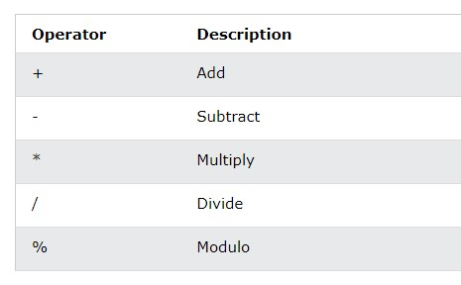

**MySQL Comparison Operators**

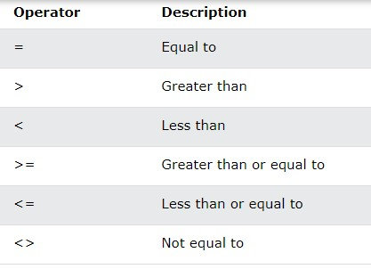

**MySQL Compound Operators**

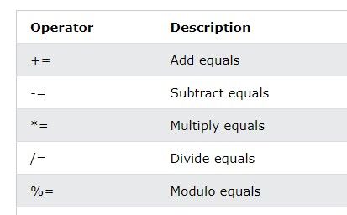

**MySQL Logical Operators**

**And:** TRUE if all the conditions separated by AND is TRUE

SELECT * FROM Customers

WHERE City = "London" AND Country = "UK";

**OR :** TRUE if any of the conditions separated by OR is TRUE

SELECT * FROM Customers

WHERE City = "London" OR Country = "UK";

**NOT** Displays a record if the condition(s) is NOT TRUE

SELECT * FROM Customers

WHERE City NOT LIKE 's%';

**BETWEEN** TRUE if the operand is within the range of comparisons SELECT * FROM Products

WHERE Price BETWEEN 50 AND 60;

**IN** TRUE if the operand is equal to one of a list of expressions

SELECT * FROM Customers

WHERE City IN ('Paris','London');

**LIKE** TRUE if the operand matches a pattern

SELECT * FROM Customers

WHERE City LIKE 's%';