Introduction To Databases

# Introduction

A database, in the most general sense, is an organized collection of data. More specifically, a database is an electronic system that allows data to be easily accessed, manipulated and updated.

# What are Databases?

A database is an organized collection of data, generally stored and accessed electronically from a computer system. It supports the storage and manipulation of data.

In other words, databasesare used by an organization as a method of storing, managing

and retrieving information.

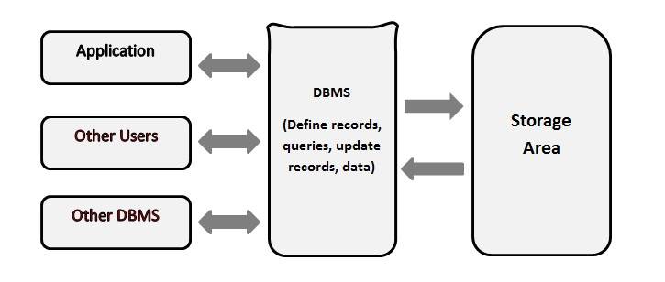

# Types of Databases

Depending upon the usage requirements, there are following types of databases available in the market:

* Centralized database
* Distributed database
* Personal database
* End-user database
* Commercial database
* NoSQL database
* Operational database
* Relational database
* Cloud database
* Object-oriented database
* Graph database

# Advantages of using Databases

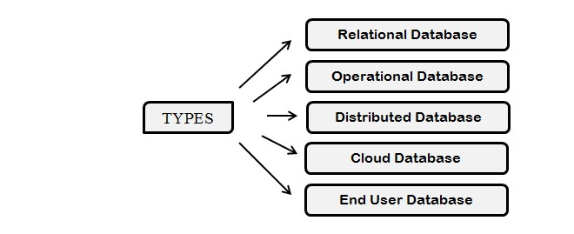

There are many advantages of databases

* Reduced data redundancy
* Reduced updating errors and increased consistency
* Greater data integrity and independence from application programs
* Improved data access to users through the use of host and query languages
* Improved data security
* Reduced data entry, storage, and retrieval costs

# Disadvantages of using Databases

There are many disadvantages of databases

* Although databases allow businesses to store and access data efficiently, they also have certain disadvantages
* Complexity
* Cost
* Security
* Compatibility

# Some examples of Databases

Some of the most popular databases are

1. Oracle Database
2. Sybase
3. MySQL
4. SQL Sever etc.

# Database Management System

A database management system (DBMS) is a software package designed to define, manipulate, retrieve and manage data in a database. A DBMSgenerally manipulates the data itself, the data format, field names, record structure, and file structure. It also defines rules to validate and manipulate this data.

In other words, a database management system is a combination of hardware and software that can be used to set up and monitor a database and can manage the updation and retrieval of the database that has been stored in it.

# Types of Databases

There are 4 major types of DBMS. Let's look into them in detail.

* **Hierarchical** - this type of DBMS employs the "parent-child" relationship of storing data. This type of DBMS is rarely used nowadays. Its structure is like a tree with nodes representing records and branches representing fields. The windows registry used in Windows XP is an example of a hierarchical database. Configuration settings are stored as tree structures with nodes.
* **Network DBMS** - this type of DBMS supports many-to-many relations. This usually results in complex database structures. RDM Server is an example of a database management system that implements the network model.
* **Relational DBMS** - this type of DBMS defines database relationships in the form of tables, also known as relations. Unlike network DBMS, RDBMS does not support many to many relationships. Relational DBMS usually have pre-defined data types that they can support. This is the most popular DBMS type in the market. Examples of relational database management systems include MySQL, Oracle, and Microsoft SQL Server database.
* **Object-Oriented DBMS** - this type supports the storage of new data types. The data to be stored is in the form of objects. The objects to be stored in the database have attributes (i.e. gender, ager) and methods that define what to do with the data. PostgreSQL is an example of an object-oriented relational DBMS.

# Relational DBMS

RDBMS stands for Relational Database Management Systems.

All modern database management systems like SQL, MS SQL Server, IBM DB2, ORACLE, My-SQL, and Microsoft Access are based on RDBMS.

It is called Relational Database Management System (RDBMS) because it is based on the relational model introduced by E.F. Codd.

Standard relational databases enable users to manage predefined data relationships across multiple databases.

Popular examples of relational databases include Microsoft SQL Server, Oracle Database, MySQL, and IBM DB2.