# The MySQL GROUP BY Statement

The GROUP BY statement groups rows that have the same values into summary rows, like "find the number of customers in each country".

The GROUP BY statement is often used with aggregate functions

(COUNT(), MAX(), MIN(), SUM(), AVG()) to group the result-set by one or more columns.

## GROUP BY Syntax

SELECT *column_name(s)*

FROM *table_name*

WHERE *condition*

GROUP BY *column_name(s)*

ORDER BY *column_name(s);*

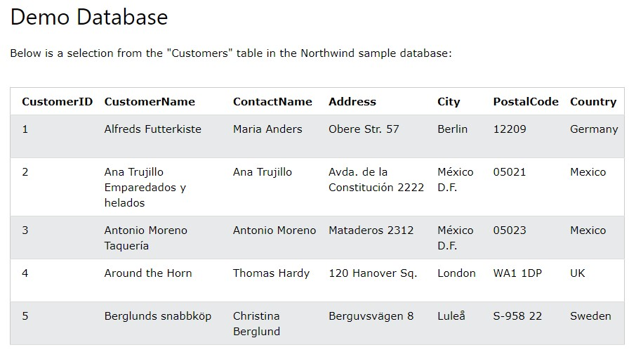

# MySQL GROUP BY Examples

The following SQL statement lists the number of customers in each country:

|  |
| --- |
| **Example** |
| SELECT COUNT(CustomerID), Country |

FROM Customers

GROUP BY Country;

The following SQL statement lists the number of customers in each country, sorted high to low:

## Example

SELECT COUNT(CustomerID), Country

FROM Customers

GROUP BY Country

ORDER BY COUNT(CustomerID) DESC;

# The MySQL HAVING Clause

The HAVING clause was added to SQL because the WHERE keyword cannot be used with aggregate functions.

## HAVING Syntax

SELECT *column_name(s)*

FROM *table_name*

WHERE *condition*

GROUP BY *column_name(s)*

HAVING *condition*

ORDER BY *column_name(s);*

# MySQL HAVING Examples

The following SQL statement lists the number of customers in each country.

Only include countries with more than 5 customers:

|  |
| --- |
| **Example** |
| SELECT COUNT(CustomerID), Country |

FROM Customers

GROUP BY Country

HAVING COUNT(CustomerID) > 5;

The following SQL statement lists the number of customers in each country, sorted high to low (Only include countries with more than 5 customers):

## Example

SELECT COUNT(CustomerID), Country

FROM Customers

GROUP BY Country

HAVING COUNT(CustomerID) > 5

ORDER BY COUNT(CustomerID) DESC;

# The MySQL EXISTS Operator

The EXISTS operator is used to test for the existence of any record in a subquery.

The EXISTS operator returns TRUE if the subquery returns one or more records.

## EXISTS Syntax

SELECT *column_name(s)*

FROM *table_name*

WHERE EXISTS

(SELECT *column_name* FROM *table_name* WHERE *condition*);

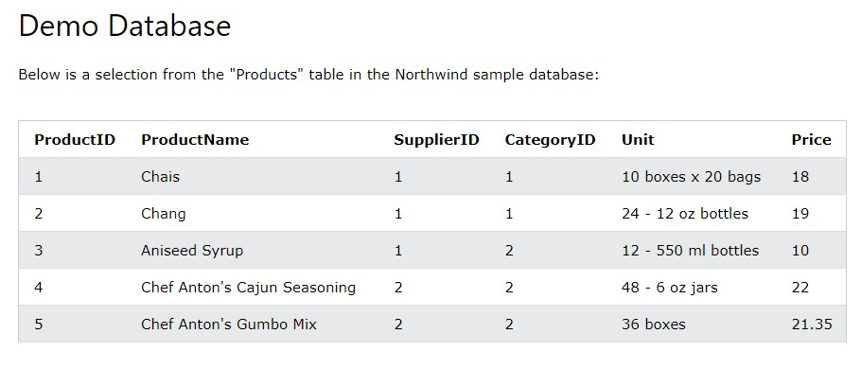

# MySQL EXISTS Examples

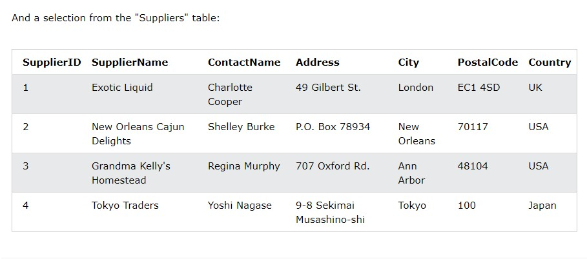

The following SQL statement returns TRUE and lists the suppliers with a product price less than 20:

## Example

SELECT SupplierName

FROM Suppliers

WHERE EXISTS (SELECT ProductName FROM Products WHERE Products.SupplierI D = Suppliers.supplierID AND Price < 20);

The following SQL statement returns TRUE and lists the suppliers with a product price equal to 22:

|  |
| --- |
| **Example** |
| SELECT SupplierName |

FROM Suppliers

WHERE EXISTS (SELECT ProductName FROM Products WHERE Products.SupplierI D = Suppliers.supplierID AND Price = 22);