Project Report: Co-op Loopy AI
1. Abstract
This project is an intelligent assistant for the "Slitherlink" logic puzzle. We modeled the game as a mathematical Planar Undirected Graph where the goal is to form one single, perfect loop that follows all the numerical clues on the board. We replaced older, slower methods with a highly optimized, multi-phase algorithmic architecture: Stack-based State Management, Custom Merge Sort for constraint organization, a deterministic Greedy engine for fast logic, and a Lookahead system to break deadlocks. Global correctness is enforced using Depth-First Search (DFS), and local rules are verified using a Recursive Divide & Conquer referee.
2. Why We Split the Problem
To keep the logic mathematically clean, we decoupled the board into two systems:
• The Topology Graph: Handles the dots (Nodes) and lines (Edges) to enforce the global shape and connectivity of the loop.
• The Constraint Grid: Handles the squares (Cells) and clues (0–3) to enforce local mathematical rules.
3. Why Normal Divide & Conquer (D&C) Fails for Global Loops
You can use D&C for localized data, but it cannot prove if your global loop is finished.
• The Reason: D&C works by partitioning a large problem into smaller halves. If you cut a Slitherlink grid in half, you physically sever the loop itself.
• The Result: The left recursive call sees a broken path, and the right recursive call sees a broken path. Neither side knows the whole loop is actually connected across the boundary.
• The Fix: We must use Graph Traversal (DFS) to walk the entire path in one continuous trace to mathematically verify the loop.
4. Algorithm 1: Stack-Based State Management (Undo Mechanism)
To allow the user and the AI to safely explore different moves, the system uses a Stack Data Structure for Last-In, First-Out (LIFO) state history.
FUNCTION SaveState(edges):
snapshot = CreateArray(edges.size)
FOR i = 0 to edges.size:
snapshot[i] = edges[i].state
HistoryStack.Push(snapshot)
FUNCTION UndoLastMove(edges):
IF HistoryStack is NOT Empty:
snapshot = HistoryStack.Pop()
FOR i = 0 to edges.size:
edges[i].setState(snapshot[i])
5. Algorithm 2: Custom Merge Sort (Divide & Conquer)
The AI must process the most restricted cells (like 3 and 0) first. We wrote a custom Merge Sort to organize these clues by priority before the constraint engine runs.
FUNCTION CustomMergeSort(list, left, right):
IF left < right:
mid = (left + right) / 2
CustomMergeSort(list, left, mid)
CustomMergeSort(list, mid + 1, right)
Merge(list, left, mid, right) // Sorts by highest restriction
6. Algorithm 3: Constraint Propagation (Greedy Approach)
The core logic engine evaluates local rules in linear passes. It acts eagerly (greedily) by immediately locking in moves that are 100% mathematically forced.
FUNCTION PropagateGreedy(cells, nodes):
FOR each Cell c:
IF (lines_needed == empty_spots): FILL all lines
IF (lines_needed == 0): CROSS out all spots
FOR each Node n:
IF (lines == 2): CROSS remaining spots
7. The Flaw: Why We Cannot Use a "Pure Textbook" Greedy Algorithm
A textbook Greedy Algorithm (like Kruskal's) works by assigning a numerical "Weight" or "Score" to every option and irrevocably picking the highest score to maximize an objective function.
• Lack of Optimal Substructure: Slitherlink does not possess "Optimal Substructure." Making the most attractive local move (e.g., guessing a line near a 3 because it has a high statistical probability) does not guarantee a globally correct solution.
• Poisoning the Board: Logic puzzles are binary and deterministic. If a pure greedy algorithm makes a highly probable heuristic guess that turns out to be wrong, the error permanently corrupts the board state. Therefore, our "Greedy approach" (Algorithm 3) is strictly a Constraint Propagator—it behaves greedily in its execution speed, but it refuses to guess, only acting on proven mathematical facts.
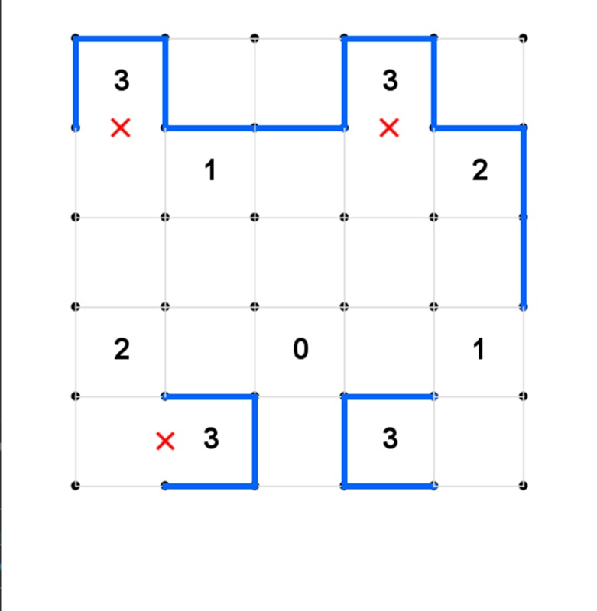ṁ
8. Algorithm 4: 1-Step Lookahead (Contradiction Proof)
When the puzzle lacks immediately forced moves, the AI prevents freezing by using Proof by Contradiction.
FUNCTION ApplyLookahead(edge):
Try placing a LINE
Run Greedy Propagation (Algorithm 3)
IF (math_breaks OR contradiction_found):
Fix as a CROSS // Proven false
ELSE:
Fix as a LINE // Proven false
9. Algorithm 5: DFS (Stopping Illegal Loops)
To ensure the board doesn't contain multiple disconnected circles, the AI uses Depth-First Search (DFS) to trace the lines.
FUNCTION DFSFindCycle(CurrentNode, PreviousNode, VisitedSet):
ADD CurrentNode TO VisitedSet
FOR EACH Edge connected to CurrentNode:
IF Edge is a LINE:
NextNode = the other end of the Edge
IF NextNode == PreviousNode: SKIP
IF NextNode is IN VisitedSet: RETURN True
IF DFSFindCycle(NextNode, CurrentNode, VisitedSet) == True:
RETURN True
RETURN False
If the DFS finds a closed loop, it counts the lines in that loop. If those lines are fewer than the total lines on the board, it mathematically proves there is a disjoint "Secondary Loop" elsewhere. The move is instantly flagged as illegal.
10. Algorithm 6: Recursive D&C (Checking the Win)
Instead of an iterative linear scan to check if the game is over, we use a Recursive Boolean Reduction algorithm.
FUNCTION CheckWin(cells, left, right):
IF (left == right):
RETURN (cell_is_satisfied)
mid = (left + right) / 2
RETURN CheckWin(left, mid) AND CheckWin(mid + 1, right)
11. Limitations
• Bounded Lookahead Depth: Because the AI only looks 1 step ahead to avoid exponential time complexity, it cannot automatically resolve extreme puzzles requiring nested, multi-step dependencies.
• Incompleteness: By avoiding global recursive backtracking, the solver sacrifices absolute completeness in favor of polynomial-time execution speed.
12. Comparison: Old vs. New Implementation
The system was fundamentally rebuilt to move from heuristic guessing to formal algorithmic proofs.
• Data Prioritization:
Old: Used Java's built-in Collections.sort() (TimSort) with basic ordering.
New: Implemented a strict Custom Merge Sort to deterministically push high-constraint cells to the front of the queue.
• State Management & Memory:
Old: Relied on dynamic recalculation sweeps to figure out the board state.
New: Uses an observer pattern to instantly cache constraints, backed by a LIFO Stack History algorithm for instantaneous undo operations.
• Logic Engine:
Old: Relied on random "Guess and Check" backtracking.
New: Utilizes a Greedy Constraint Propagator paired with 1-Step Lookahead to enforce mathematical proofs without exponential branching.
• Global Loop Control:
Old: Used Breadth-First Search (BFS) and passive Disjoint Set Union (DSU).
New: Uses Depth-First Search (DFS) paired with continuous global edge-count verification to proactively block secondary loops.
• Board Validation:
Old: Iterative for-loops scanning the board.
New: Recursive Boolean Divide & Conquer to structurally prove satisfaction.
13. Conclusion
This project elevates a simple puzzle script into a formal, highly optimized computational system. By integrating Custom Sorting, Stack-Based Memory, Greedy Deductive Logic, and strict Graph Theory (DFS), we created an interactive AI that provides rigorous mathematical guarantees for every move it makes while maintaining instant execution speeds.

