Effort Estimation Calculator – Project Plan

Summary
As part of the team plan, this small project builds an internal desktop tool that turns the CI effort estimate matrix into a consistent estimate in a few clicks and shares it in our standard e-mail format. The plan below covers how the team will build it, test it with a small pilot group and roll it out to the CI team.
Developers: Akhilesh Kumar and Ishita Garg

Objective and scope
The goal is that every CI estimate uses the same matrix, the same formula and the same output format, whoever prepares it.
In scope (this project) | Out of scope (possible later phase)
Data & KPIs estimate (CI 1.0 matrix) | Saving estimate history or reports
Power BI Dashboard estimate | User login and approval workflow
Hours and days at 8 h/day, activity breakdown | Web or mobile version
Share form: entity, delivery date, up to 3 CI resources, assumptions | Integration with timesheets or project tools
Copy for e-mail and Excel download in the standard 5-column format | Editing the matrix from inside the app
Single Windows EXE for the team

Proposed solution
A small Windows desktop app that applies the estimate matrix automatically and produces the standard e-mail table, so an estimate takes a few selections instead of manual working.
Feature | How it would work
Two estimators | Separate tabs for Data & KPIs (CI 1.0 matrix) and Power BI Dashboard
Selections | Dropdowns for files, KPIs, pages and sources; buttons for complexity levels
Instant result | Total hours, days at 8 h/day, and an activity-wise breakdown
Share form | Entity name, delivery date from a calendar, up to 3 CI resources, key assumptions
Outputs | Copy the table straight into an Outlook e-mail, or download it as Excel
Distribution | One EXE file; team members do not need to install anything
Maintenance | All hours and names kept in one settings file, updated by one owner

Proposed technology: Python with its built-in Tkinter UI library, packaged as a single EXE; no database or server needed.

Estimate matrix
Each activity's hours = base hours for the chosen level × the volume multiplier; the estimate is the sum of all activities, and days = hours ÷ 8.
Data & KPIs (CI 1.0) — base hours per 10 files or 10 KPIs
Activity | Level 1 | Level 2 | Level 3 | Multiplier from
Quality of the Data | Good – 1 h | Average – 2 h | Poor – 3 h | Number of files
Level of Data Cleansing | Basic – 2 h | Intermediate – 3 h | Advanced – 4 h | Number of files
Data Transformation for Ingestion | Basic – 1 h | Intermediate – 2 h | Advanced – 5 h | Number of files
Average complexity of KPIs | Basic – 4 h | Moderate – 8 h | Complex – 12 h | Number of KPIs

Volume multiplier (files and KPIs): Upto 10 = ×1, 11-20 = ×2, 21-30 = ×3, 31-40 = ×4, 41-50 = ×5. Bands above 10 follow the same per-10 rule and are to be confirmed.
Power BI Dashboard
Report pages | 1 | 2 | 3 | 4 | 5
Hours | 3 h | 5 h | 7 h | 9 h | 11 h

Activity | Level 1 | Level 2 | Level 3 | Multiplier from
Data Modelling & Power Query | Basic – 2 h | Intermediate – 4 h | Advanced – 8 h | Data sources, per 5
DAX Measures | Basic – 2 h | Intermediate – 5 h | Advanced – 10 h | Flat for 1-5 pages
Visual Design & Layout | Standard – 2 h | Custom – 4 h | Advanced – 6 h | Flat for 1-5 pages

Data sources multiplier: Upto 5 = ×1, 6-10 = ×2, 11-15 = ×3, 16-20 = ×4. Modelling, DAX and Visual hours are initial values, to be confirmed in Phase 1.
Example: Data & KPIs with 10 files, 10 KPIs, Good / Basic / Basic / Basic = 1 + 2 + 1 + 4 = 8 h = 1 day.

Plan
The work runs in four phases; each phase starts only when the gate before it is met, so no unverified numbers reach the team.
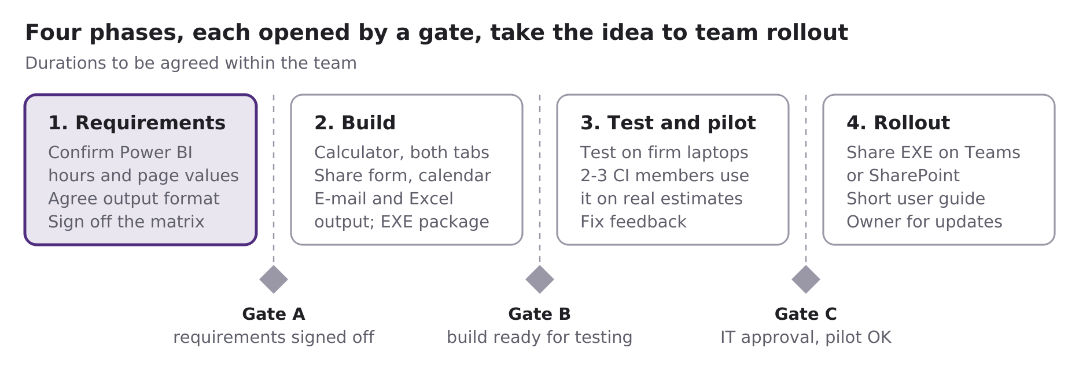
Phase 1 comes first and mainly needs the confirmed Power BI hours. Durations are not fixed yet and will be proposed once the matrix owner and pilot users are named.

