Effort Estimation Calculator – Technical Design Document
28 Sep 2026 ·

1. Overview
We plan to build the Effort Estimation Calculator as a small Windows desktop app: the user picks a few options, the app calculates hours and days, and the result can be shared by e-mail or Excel.
Item | Plan
Language | Python 3
Screen (UI) | Tkinter, Python's built-in UI library
Excel output | openpyxl library
Packaging | One EXE file made with PyInstaller; users install nothing
Data | All hours and names in one settings file (config.py)

2. How the app will work
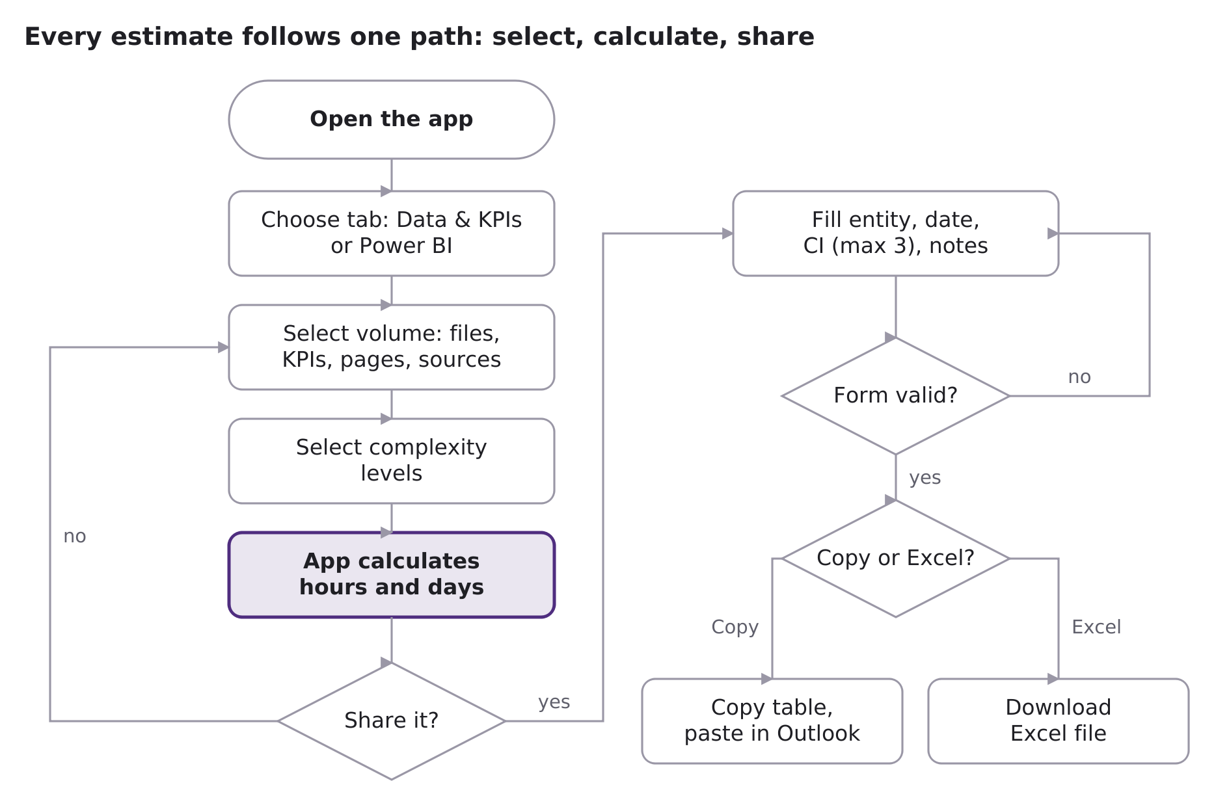
If the user does not share, they can change selections and see a new total at once; if the form has an error, they fix it and try again.

3. Architecture
The code will be split into small files by job: screen files only show things, one file does all the maths, and two files create the outputs. Changing a number will need an edit in one settings file only.
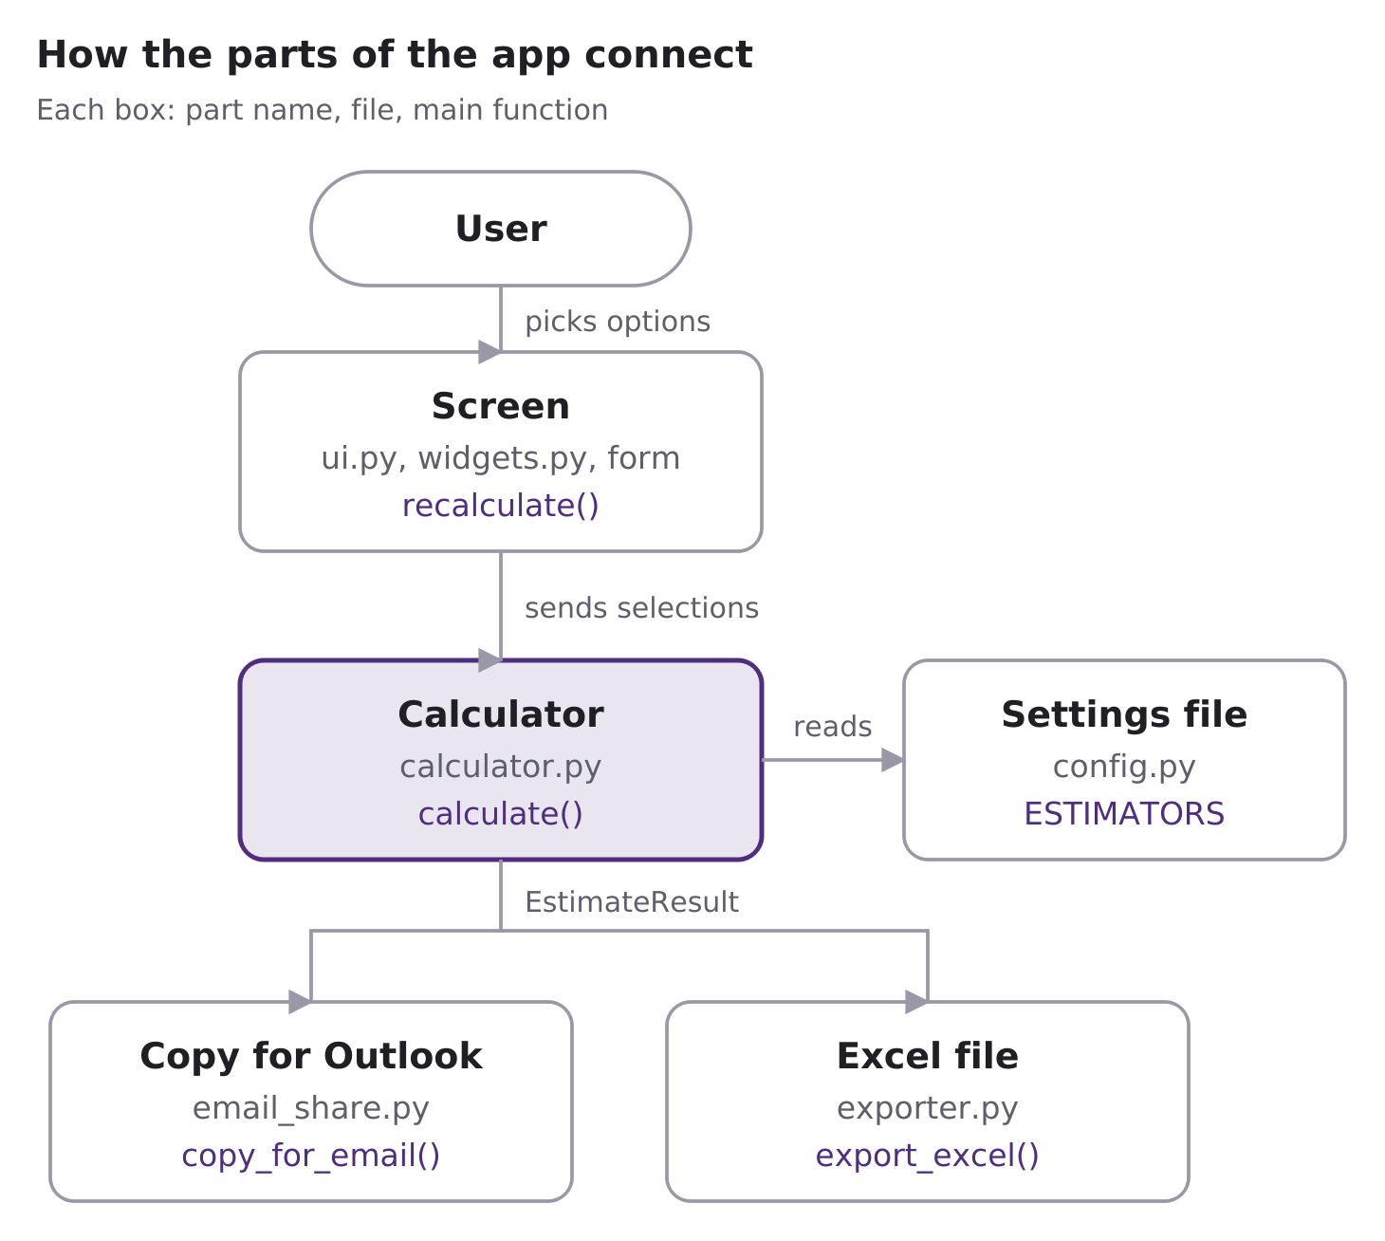
The user works only with the screen; the calculator reads the settings file and hands its result to the two outputs.

4. Class diagram
The design uses 6 main classes; one object, EstimateResult, will carry the calculated estimate to the screen, the e-mail table and the Excel file.
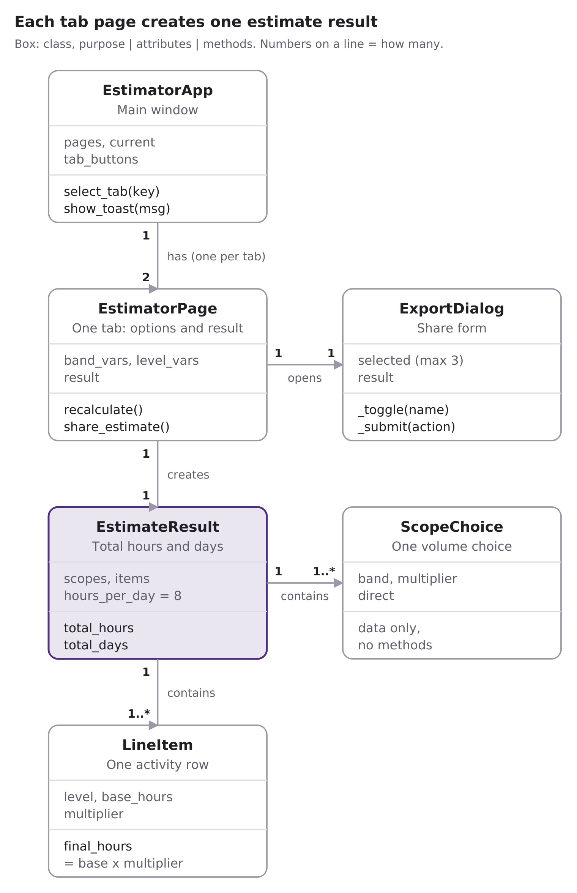
Class | File | Built on | What it will hold or do
EstimatorApp | ui.py | tk.Frame | The main window; holds one page per tab; Ctrl+1/2 switches tabs
EstimatorPage | ui.py | tk.Frame | One tab: reads selections, calls calculate(), shows the result
ExportDialog | export_dialog.py | tk.Toplevel (modal) | The share form; returns details and the chosen action (copy or Excel)
EstimateResult | calculator.py | frozen dataclass | The finished estimate; total_hours and total_days are computed properties
LineItem | calculator.py | frozen dataclass | One activity row; final_hours = base_hours × multiplier
ScopeChoice | calculator.py | frozen dataclass | One volume choice; direct = True means hours come straight from the band (Power BI pages)

Result classes are frozen (read-only), so the screen can show a number but never change it by mistake.

