Indian Premier League Analysis Report

# Dashboard

The following report provides an analysis of the Indian Premier League (IPL) from 2008 onwards. The data presented includes team performance, individual player achievements, and match statistics.

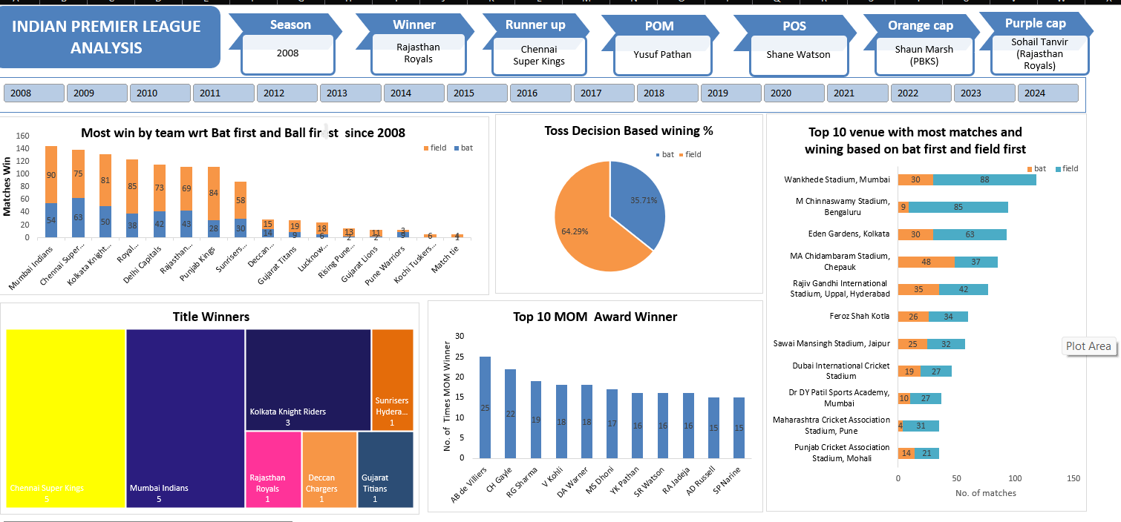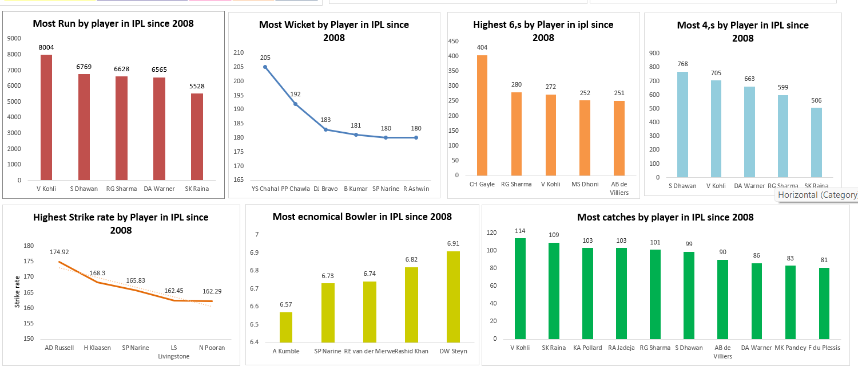

**Indian Premier League (IPL) Analysis Report**

**Title Winners**

* **Chennai Super Kings:** 5 titles
* **Mumbai Indians:** 5 titles
* **Kolkata Knight Riders:** 3 titles

**Insights:**

* Both Chennai Super Kings and Mumbai Indians have secured the most titles.
* Kolkata Knight Riders, while having fewer titles, are also a significant team in the league.

**Most Wins by Team**

* **Mumbai Indians:** 144 wins
* **Chennai Super Kings:** 138 wins
* **Kolkata Knight Riders:** 131 wins

**Insights:**

* Mumbai Indians top the list with the most victories.
* Chennai Super Kings follow closely, showing their consistent performance.
* Kolkata Knight Riders are competitive but have fewer wins compared to the top two teams.

**Toss Decision Based on Winning Percentage**

* **Bat First:** 35.71%
* **Field First:** 64.29%

**Insights:**

* Teams generally achieve higher success rates when opting to field first.

**Top Venues Based on Matches and Wins**

* **Wankhede Stadium, Mumbai:**
  + Matches: 30 (bat first) | 88 (field first)
* **M Chinnaswamy Stadium, Bengaluru:**
  + Matches: 9 (bat first) | 85 (field first)
* **Eden Gardens, Kolkata:**
  + Matches: 30 (bat first) | 63 (field first)

**Insights:**

* Choosing to bowl first usually leads to better results at these cricket grounds.

**Top MOM (Man of the Match) Award Winners**

* **AB de Villiers:** 25 awards
* **Chris Gayle:** 22 awards
* **Rohit Sharma:** 19 awards

**Insights:**

* AB de Villiers leads with the highest number of Man of the Match awards, reflecting his impactful performances.

**Top Run Scorers in IPL History**

* **Virat Kohli:** 8004 runs
* **Shikhar Dhawan:** 6769 runs
* **Rohit Sharma:** 6628 runs

**Insights:**

* Virat Kohli stands out with the highest run total, showing his dominance in batting.

**Top Wicket Takers in IPL History**

* **Yuzvendra Chahal:** 205 wickets
* **Piyush Chawla:** 192 wickets
* **Dwayne Bravo:** 183 wickets

**Insights:**

* Yuzvendra Chahal has the most wickets, underscoring his effectiveness as a bowler.

**Highest Strike Rates in IPL History**

* **Andre Russell:** 174.92
* **Heinrich Klaasen:** 168.3
* **Sunil Narine:** 165.83

**Insights:**

* Andre Russell boasts the highest strike rate, highlighting his aggressive batting style.

**Most Sixes by Players in IPL History**

* **Chris Gayle:** 404 sixes
* **Rohit Sharma:** 280 sixes
* **Virat Kohli:** 272 sixes

**Insights:**

* Chris Gayle leads with the most sixes, showcasing his power-hitting ability.

**Most Fours by Players in IPL History**

* **Shikhar Dhawan:** 768 fours
* **Virat Kohli:** 705 fours
* **David Warner:** 663 fours

**Insights:**

* Shikhar Dhawan has hit the most fours, reflecting his consistent boundary-scoring prowess.

**Most Economical Bowlers in IPL History**

* **Anil Kumble:** 6.57 economy rate
* **Sunil Narine:** 6.73 economy rate
* **Roelof van der Merwe:** 6.74 economy rate

**Insights:**

* Anil Kumble has the lowest economy rate, indicating his skill in containing runs.

**Top 3 Teams in Terms of Wins by Batting First and Fielding First**

**1. Mumbai Indians**

* **Batting First:** 54 wins
* **Fielding First:** 90 wins

**Total Wins:** 144

**2. Chennai Super Kings**

* **Batting First:** 63 wins
* **Fielding First:** 75 wins

**Total Wins:** 138

**3. Royal Challengers Bengaluru**

* **Batting First:** 38 wins
* **Fielding First:** 85 wins

**Total Wins:** 123

**Insights:**

* Mumbai Indians excel in both categories, particularly in fielding first.
* Chennai Super Kings show a stronger record when batting first.
* Royal Challengers Bengaluru perform notably well when fielding first, despite fewer wins when batting first.