**RESUME**

**Personal Information**

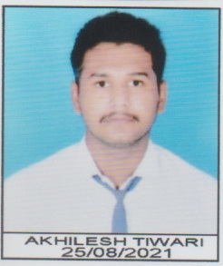**Name:**Akhilesh tiwari

**Mobile:**8120127454

**Date of Birth:**08/04/2005

**Gender:** Male

**Nationality:** Indian

**Marital Status:**Un Married

**Email Id:** [beturiyatiwari046@gmail.com](mailto:beturiyatiwari046@gmail.com)

**Career Objective:**

**Seeking a position in a dynamic organization where I can Launch My Carrer and work toward building a strong skill seT**

**EDUCATION**

**2021-2022 class 12th from MP BOARD**

**2019-20 CLASS 10TH from MP BOARD**

**KEY STRENGTH**

**~SELF CONFIDENCE**

**~LEADERSHIP QUALITY**

**~QUICK LEARNER**

**~OPTIMISTIC**

**~GOOD COMMUNICATION SKILL**