BDA LAB4
1BM19CS092
N.AKHILESH KUMAR DUTT

1. Create a key space by name Library

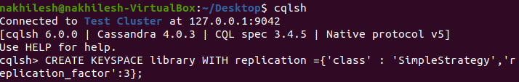

2. Create a column family by name Library-Info with attributes Stud_Id Primary Key,
Counter_value of type Counter,
Stud_Name, Book-Name, Book-Id, Date_of_issue
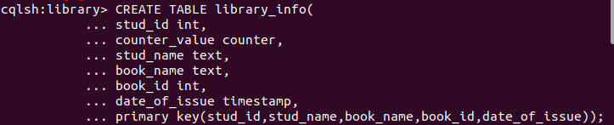

3. Insert the values into the table in batch
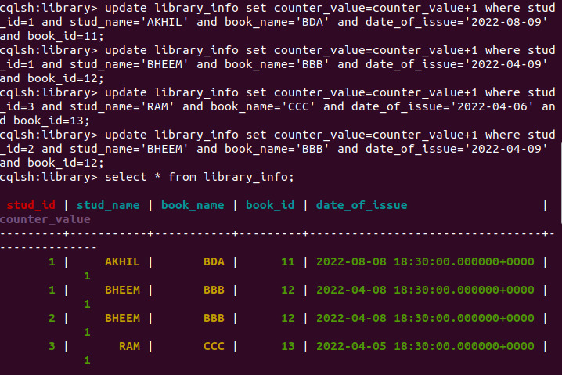

4.Display the details of the table created and increase the value of the counter
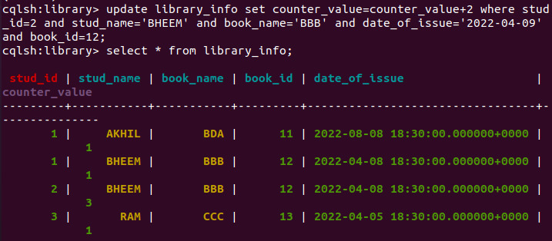

5. Write a query to show that a student with id 112 has taken a book “BDA” 2 times.

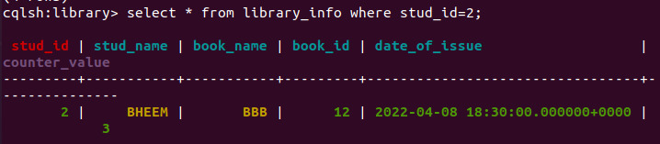
6. Export the created column to a csv file
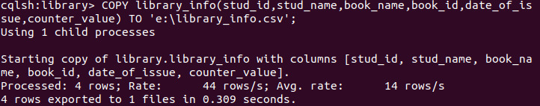

7. Import a given csv dataset from local file system into Cassandra column family

