**EVALUATION**

CIRCUIT DIAGRAM

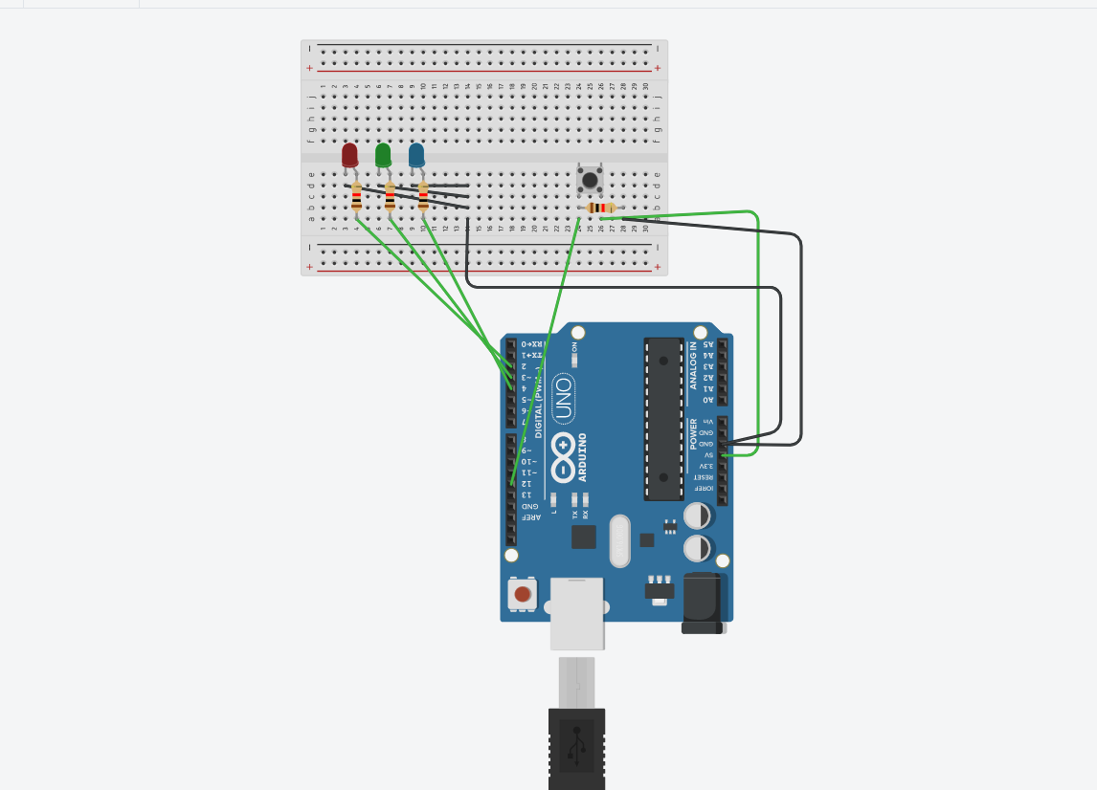

**THEORY**

CONCEPTS USED

1. Using LED with Arduino.
2. Using switch button in circuit board with Arduino.
3. Using random number.
4. Using one resistor or led

LEARNING AND OBSERVATION

1. I Learn how to use Arduino with switch button.
2. I learned how to use random number with Arduino.
3. I learned how to make led chaser code .

PRECAUTION

1.Connection should be tight and good.

2.check led n and p terminal.

3. The resistor used with the switch is value around 10k.

PROBLEMS AND TROUBLE SHOUTING

1.I faced problem in random number.

2.faced problem in switch button.

3.faced problem in using Tinker Cad.

4. faced problem in using Arduino.

LEARNING OUTCOMES

1. I learn how to make code for switch button.
2. I learned how make code for random number.
3. I learned how to make connection in breadboard
4. I learned how to run different code using switch.