**Project Deployment**

**Introduction:**

At times, people migrate to new locations and face difficulties to find people who can fix their household repairs, especially in the initial stages. They can be a plumber, an electrician, a carpenter etc. This problem is the motivation factor for us to build this new application. The primary goal of this application is to provide a one stop solution by finding the right person for corresponding problem, at nearby place, which can help to get their job done at times, people migrate to new locations and face difficulties to find people who can fix their household repairs, especially in the initial stages. They can be a plumber, an electrician, a carpenter etc. This problem is the motivation factor for us to build this new application. The primary goal of this application is to provide a one stop solution by finding the right person for corresponding problem, at nearby place, which can help to get their job done.

**How to use the system:**

|  |  |  |  |
| --- | --- | --- | --- |
| **Page Name** | **Usage** | **Screenshot** | **Comment** |
| User Sign in | A User can Sign in with the credentials with which he had registered | IMG_3059.JPG |  |
| User Registration | A User needs to be registered before signing in by clicking Signup button | IMG_3062.JPG |  |
| Home | The home page will automatically search your location and also provides a facility to enter the zip code to search the required Technician in that particular location along with the type technicians | WhatsApp-Image-20160511.jpg | Clicking on the particular technician type will redirect to the next step in the process |
| SubCategory Page | You have the flexibility of choosing what problem you have in order to estimate the cost of repair | IMG_3063.JPG | If you didn’t find the problem you have, in those options, you can describe your problem in the below description |
| Technicians list | The list of technicians near the location for the particular category are populated along with their base fare and experience | WhatsApp-Image-20160511 (1).jpg | You can choose the technician by both experience and rating then click on the particular tab to get the complete details |
| Technician details | This page will give you the whole information about the technician you have chosen so that you can contact him | IMG_3060.JPG | You have a call button beside the contact number which gives a facility to call him at that instance |
| Feedback | You have an opportunity to rate the technician after the required job done by clicking on the feedback button | IMG_3056.JPG | Apart from giving a rating out of 5, you can also comment on his work |
| Technician Registration  (Step 1) | This app provides an opportunity even for Technicians to register themselves and be a part of the list by clicking on ‘Are you a Technician’ link | IMG_3061.JPG | There is also another step in this process that appears by clicking Next button |
| Technician Registration  (Step 2) | At the time of Registration Technician needs to provide the cost that he charge per each problem | WhatsApp-Image-20160511 (2).jpg | The type of problems will automatically displayed based on the Technician Category chosen in the before step |
| Forgot Password | You have an option with link ‘forgot password’ on Signin page which by clicking on it asks to provide the username and the password is sent to the registered mobile number | IMG_3058.JPG | The user must remember his username in order to get the account password  (**Both Technician and User can get their password in the same way**) |
| Edit Profile | User can have the option of Editing his Profile details and can also change the password | WhatsApp-Image-20160511 (3).jpg | Username once set cannot be changed at any time |

**Project Management**

**Project Management Report:**

The **work is divided equally among the four members** and everyone in the team had satisfied their corresponding requirements division making sure that they have given their total effort in contributing to the project.

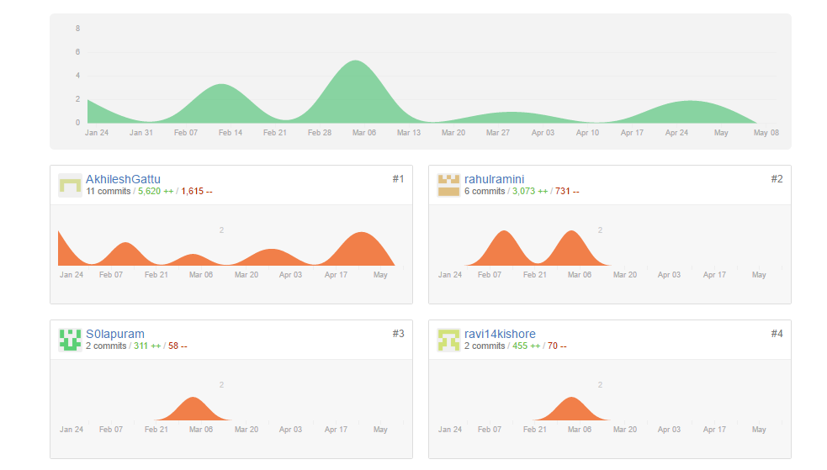

All the Increments are properly planned and the all the tasks are completed before the deadline of their corresponding Increment/Milestone.

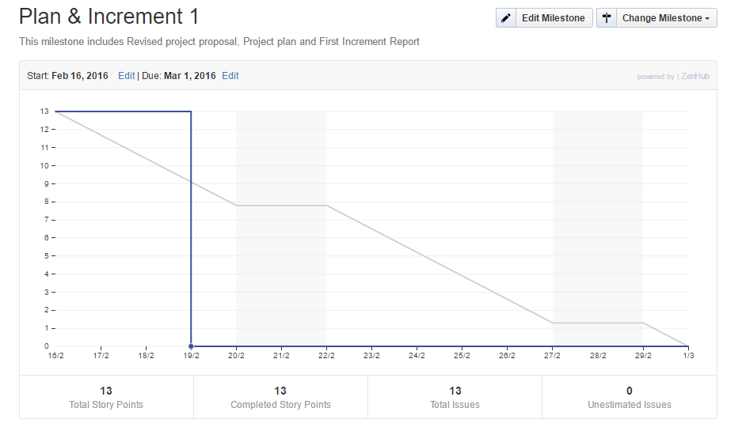

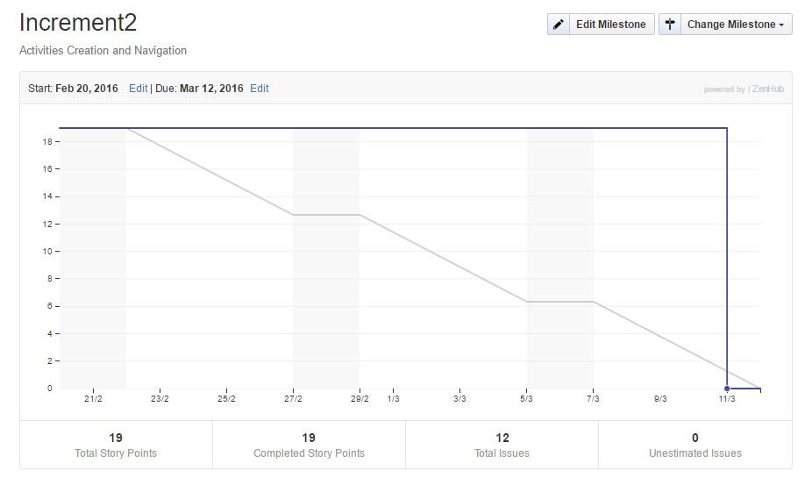

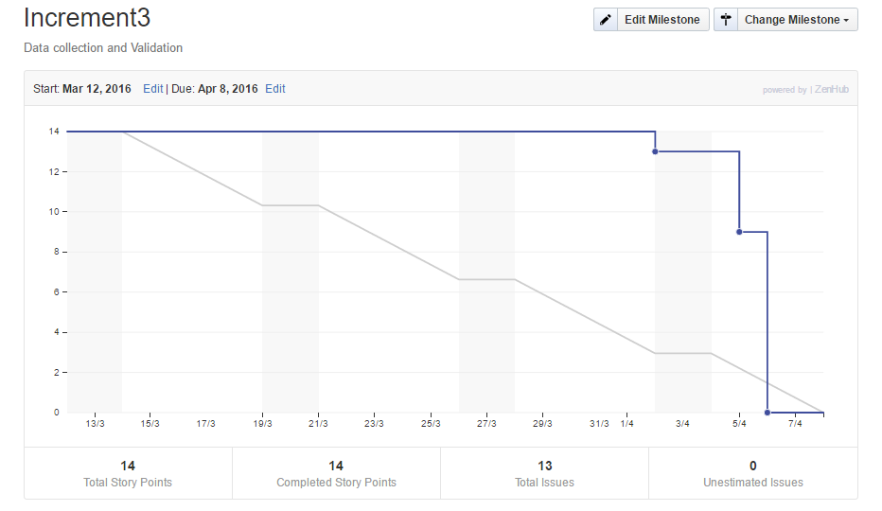

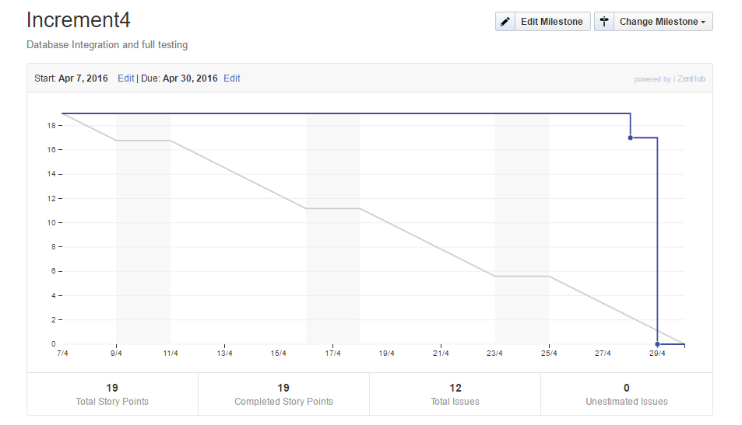

**Final Project Evaluation:**

At the time of Project Proposal, all the requirements those we needed to be implemented are successfully implemented and also gave us the satisfaction. At the time of implementation it also helped in implementing new ideas which gave the application much required uniqueness.

Though we were not sure enough at the time of designing, the agile process gave us the flexibility to implement the necessary changes at each and every step. There was a great coordination among the Team members which helped us to complete the project smoothly. There were no issues with the schedule of the course with respect to the project.

**Project Plan**

**Group Number: Team 6**

**Project Title: Find Your Technician**

**Group Members:**

* Akhilesh Gattu (13)
* Nagi Reddy Sollapuram (53)
* Rahul Ramini (50)
* Sree Ravi Kishore Lellapalli (23)

**Project Goal and Objectives:**

* **Motivation :**
* At times, people migrate to new locations and face difficulties to find people who can fix their household repairs, especially in the initial stages. They can be a plumber, an electrician, a carpenter etc. This problem is the motivation factor for us to build this new application. The primary goal of this application is to provide a one stop solution by finding the right person for corresponding problem, at nearby place, which can help to get their job done.
* **Significance/Uniqueness :**
* This application has its own significance as it provides a complete profile of the technician which includes his experience, cost estimation based on the subcategory of the problem selected. Technicians can register themselves through this application by creating their own profile even though the further process of updating their name to the search list is done after an offline verification.
* **Objectives :**
* The main objective of this application is to provide the details of the technicians nearby them, who can resolve the problem and give an opportunity of choosing the technician based on his experience and rating. This helps the user to overcome the difficulties in searching different people from various locations through number of contacts and reviews. User can select the type of problem to know the estimated cost of the repair. This application also provides an opportunity to the technicians to register themselves by creating a profile about their work and experience.
* **Specific Features**
* User Registration
* User Login
* Provides an option to Select Location
* Select Technician
* Plumber
* Carpenter
* Electrician
* Painter
* Mechanic
* Flexibility of providing unlisted subcategory of the problem
* Cost Estimation
* User can provide Feedback
* Technician Registration
* User Logout
* Technician Login

First Increment

**Detail Design of Features :**

* **Wireframes :**

Login Page Activity :

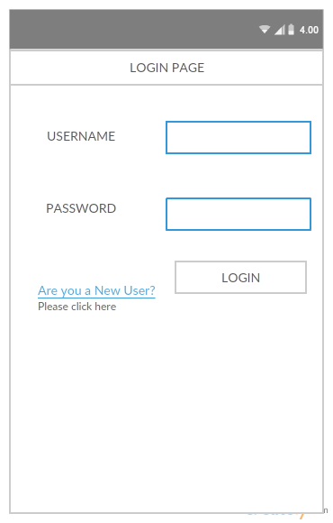

**User Registration Activity:**

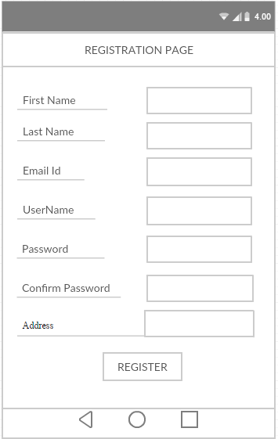

**Technician Registration Activity:**

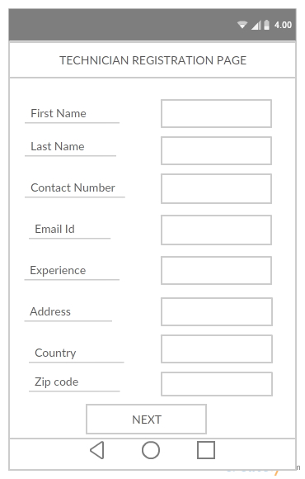

**Technician Experience Registration:**

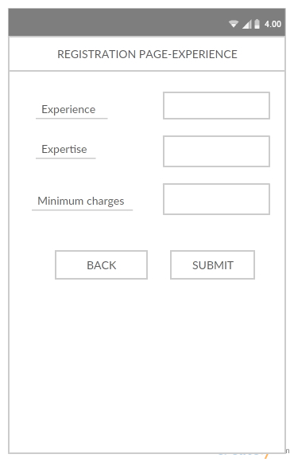

**Location and Category Search Activity:**

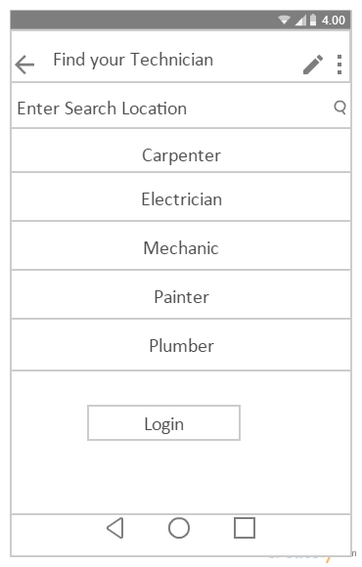

**Sub-Category search Activity:**

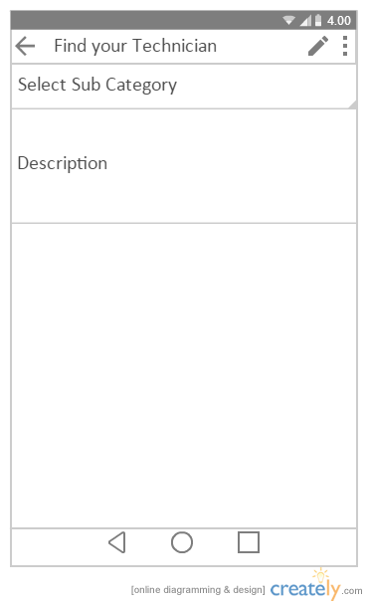

**Results Page Activity:**

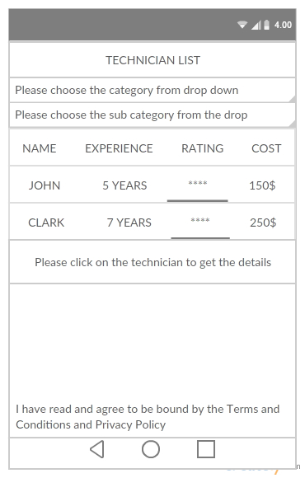

**Individual full details Page Activity:**

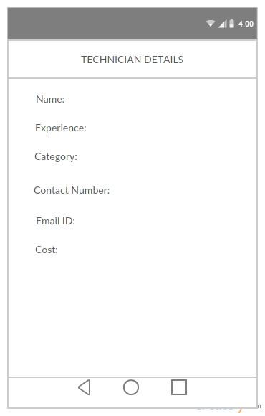

* **Architecture Diagram :**

Architecture Diagram (1).png

* **Sequence Diagram :**

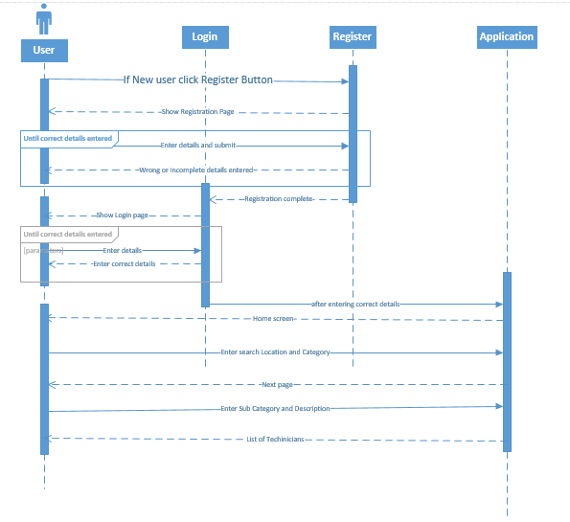

* **Class Diagram :**

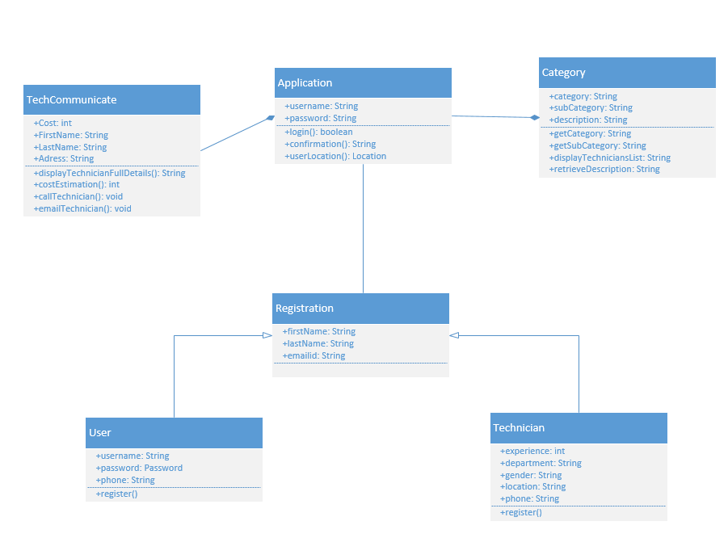

**Implementation:**

The Implementation of the design mentioned above would be processed using **Android Studio** as Mobile Client Implementation Method and the Source code has been included in the Source code folder attached with the Report

**User Registration Page:**

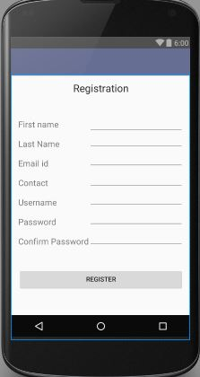

**User Login Page:**

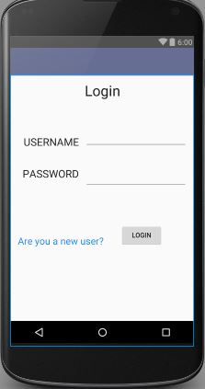

**Project Management:**

* **Work completed :**

Creation of Login Page Activity and User Registration Activity along with the wireframes and UML Diagrams.

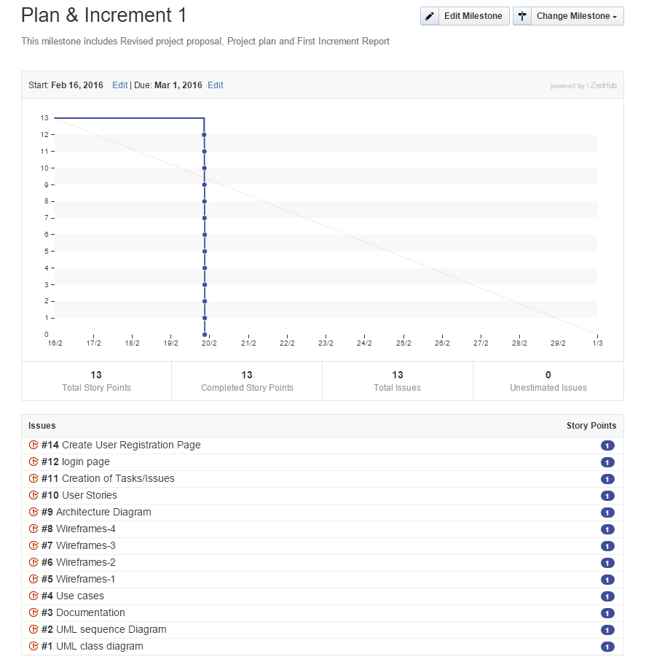

* **Work to be completed :**

`

**Bibliography :**

* <http://ziffi.com>
* <http://developer.android.com>

**Second Increment**

**Introduction:**

At times, people migrate to new locations and face difficulties to find people who can fix their household repairs, especially in the initial stages. They can be a plumber, an electrician, a carpenter etc. This problem is the motivation factor for us to build this new application. The primary goal of this application is to provide a one stop solution by finding the right person for corresponding problem, at nearby place, which can help to get their job done at times, people migrate to new locations and face difficulties to find people who can fix their household repairs, especially in the initial stages. They can be a plumber, an electrician, a carpenter etc. This problem is the motivation factor for us to build this new application. The primary goal of this application is to provide a one stop solution by finding the right person for corresponding problem, at nearby place, which can help to get their job done.

**Objective:**

The main objective of this application is to provide the details of the technicians nearby them, who can resolve the problem and give an opportunity of choosing the technician based on his experience and rating. This helps the user to overcome the difficulties in searching different people from various locations through number of contacts and reviews. User can select the type of problem to know the estimated cost of the repair. This application also provides an opportunity to the technicians to register themselves by creating a profile about their work and experience.

**Features:**

* User Registration
* User Login
* Provides an option to Select Location
* Select Technician
* Plumber
* Carpenter
* Electrician
* Painter
* Mechanic
* Flexibility of providing unlisted subcategory of the problem
* Cost Estimation
* User can provide Feedback
* Technician Registration
* User Logout

**Existing APIS:**

We are using Google API to get the current address of the user and display it on the home page regardless of whether the user is logged in or not.

**Detailed Design:**

* **Wire Frames:**

**Login Page:**

****

**User Registration:**

****

**Technician Registration:**

****

**Technician Experience Registration:**

****

**Home Page:**

****

**Sub Category and Description:**

****

**Technician Results:**

****

**Technician Details:**

****

**Architecture Diagram:**

**Architecture Diagram (1).png**

**Sequence Diagram:**

****

**Class Diagram:**

****

**Use Cases:**

* **Technician Profile Registration:** Check user is able to give the full details to register to the account
* **Technician Experience Registration:** Check user is able to give the full details to register to the account
* **Home Page:** Check user is able to search for the required technician
* **Sub Category Page:** Check user is able to select the subcategory page

**Implementation:**

The Implementation of the design mentioned above would be processed using **Android Studio** as Mobile Client Implementation Method and the Source code has been included in the Source code folder attached with the Report. Architecture, Class and Sequence diagrams are drawn using Microsoft Visual Studio. While wireframes are drawn in Creatly.com

**Deployment:**

**User Login:**

**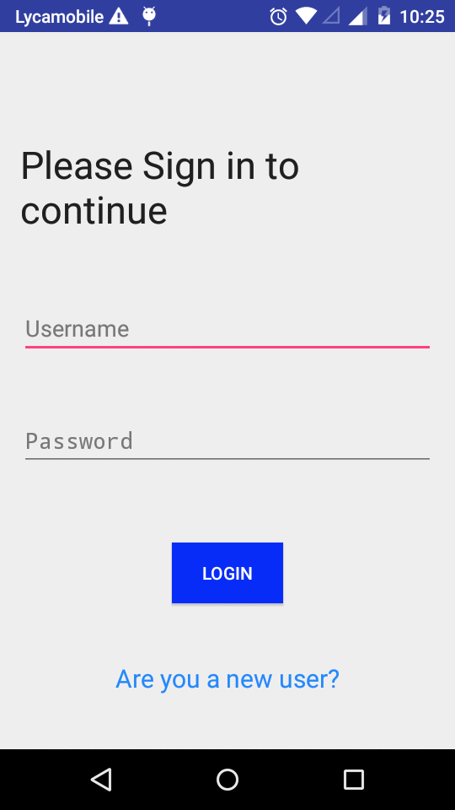**

**Home Page**

**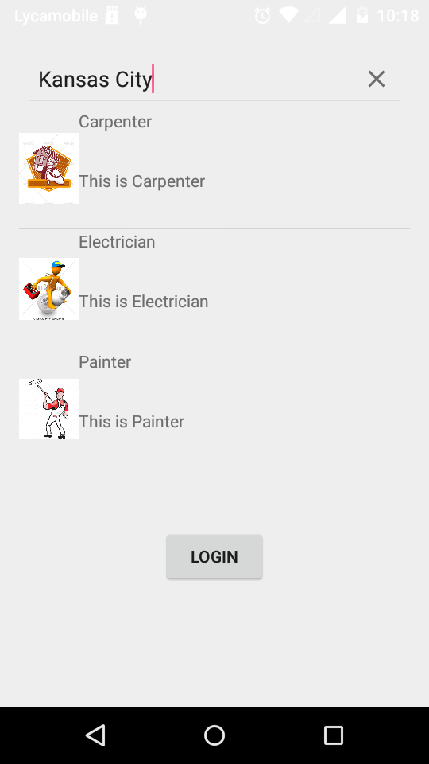**

**Technician Registration:**

**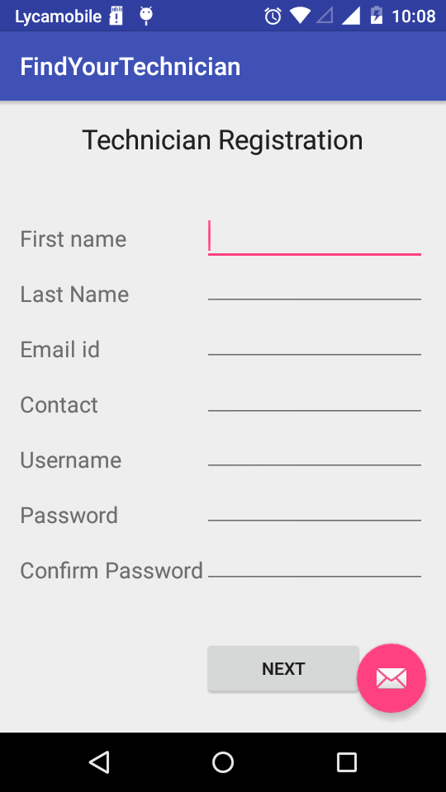**

**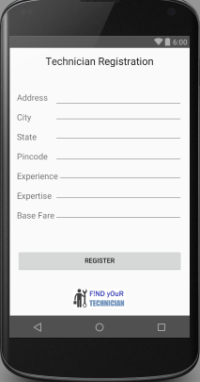**

**Sub Category:**

**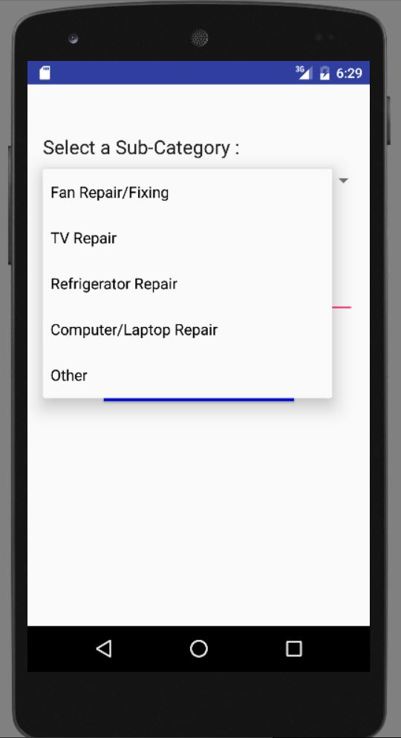**

**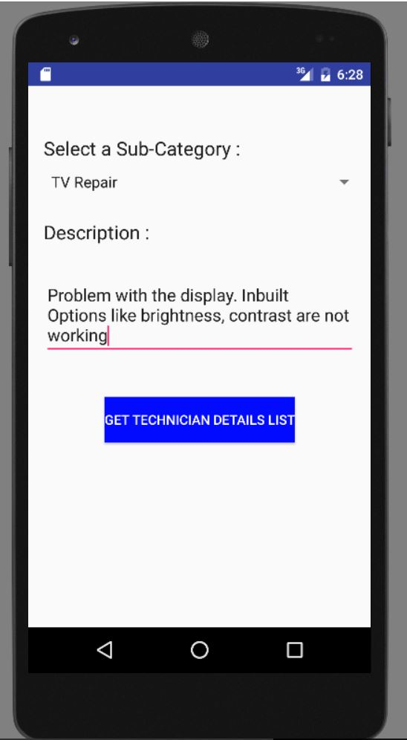**

**Technician Details Page:**

**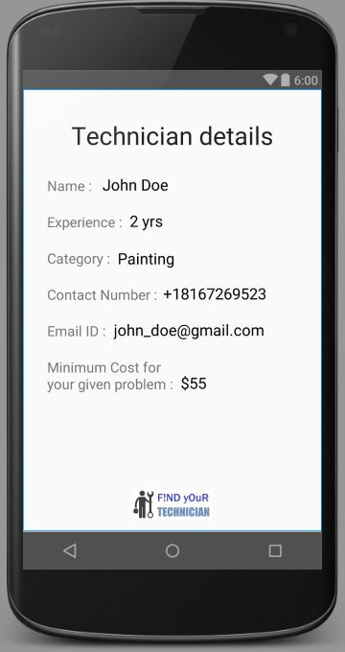**

**GitHub URL:** <https://github.com/AkhileshGattu/ASE-Spring2016-FindYourTechnician>

**Project Management:**

* **Work completed:**

Created Login Page, User Registration Page, Technician Registration, Home Page, Sub Category Page, and Technician Search Results Pages along with Architecture diagram, wireframes and UML Diagrams.

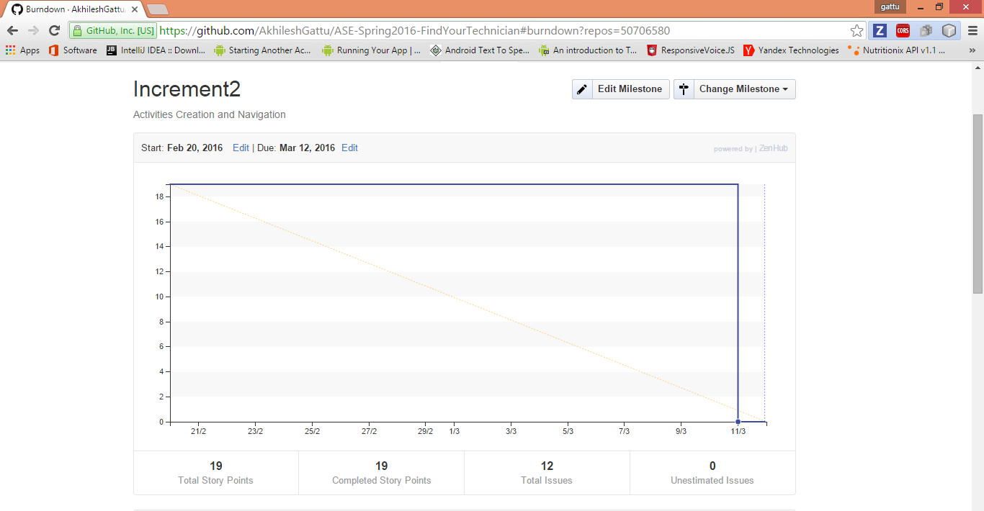

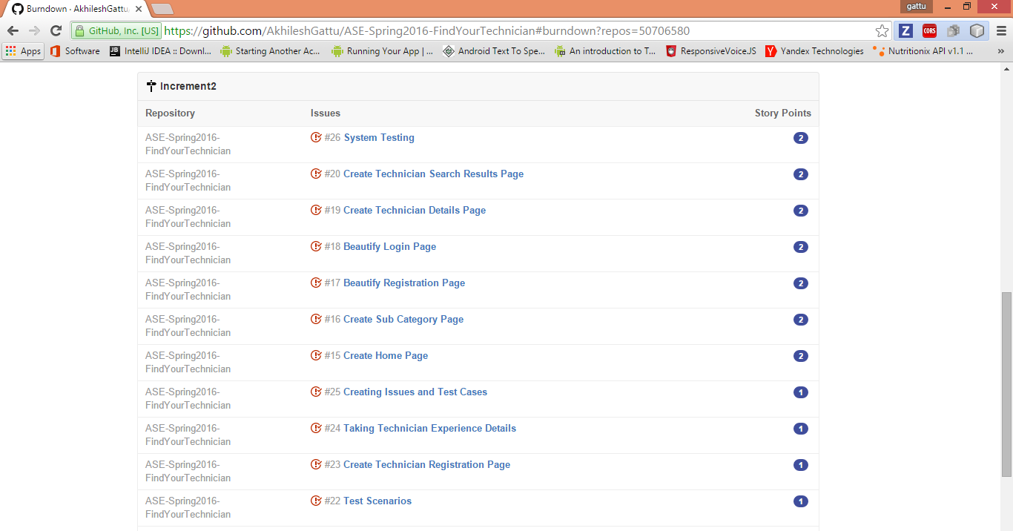

**Work to be completed:**

Collecting data and validating the user input data with proper conditions, Integrating application with the Database and complete System Testing.

**Bibliography:**

* <http://ziffi.com>
* <http://developer.android.com>
* <http://draw.io>
* <http://creatly.com>

**Third Increment**

**Introduction:**

At times, people migrate to new locations and face difficulties to find people who can fix their household repairs, especially in the initial stages. They can be a plumber, an electrician, a carpenter etc. This problem is the motivation factor for us to build this new application. The primary goal of this application is to provide a one stop solution by finding the right person for corresponding problem, at nearby place, which can help to get their job done at times, people migrate to new locations and face difficulties to find people who can fix their household repairs, especially in the initial stages. They can be a plumber, an electrician, a carpenter etc. This problem is the motivation factor for us to build this new application. The primary goal of this application is to provide a one stop solution by finding the right person for corresponding problem, at nearby place, which can help to get their job done.

**Objective:**

The main objective of this application is to provide the details of the technicians nearby them, who can resolve the problem and give an opportunity of choosing the technician based on his experience and rating. This helps the user to overcome the difficulties in searching different people from various locations through number of contacts and reviews. User can select the type of problem to know the estimated cost of the repair. This application also provides an opportunity to the technicians to register themselves by creating a profile about their work and experience.

**Features:**

* User Registration
* User Login
* Provides an option to Select Location
* Select Technician
* Plumber
* Carpenter
* Electrician
* Painter
* Mechanic
* Flexibility of providing unlisted subcategory of the problem
* Cost Estimation
* User can provide Feedback
* Technician Registration
* User Logout

**Existing APIS:**

We are using Google API to get the current address of the user and display it on the home page regardless of whether the user is logged in or not.

**Detailed Design:**

* **Wire Frames:**

**User Login Page:**

**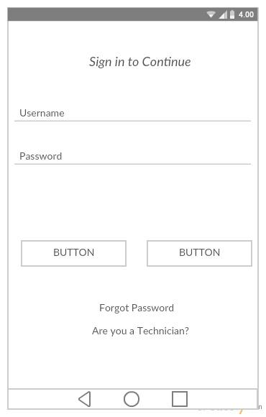**

**User Registration:**

****

**Technician Registration:**

****

**Technician Registration Completion:**

**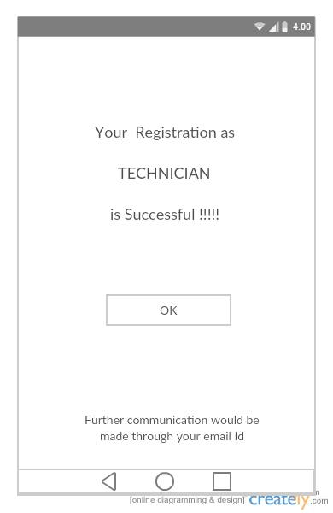**

**Home Page:**

****

**Sub Category and Description:**

****

**Technician Results:**

****

**Technician Details:**

****

**Forgot Password Page:**

**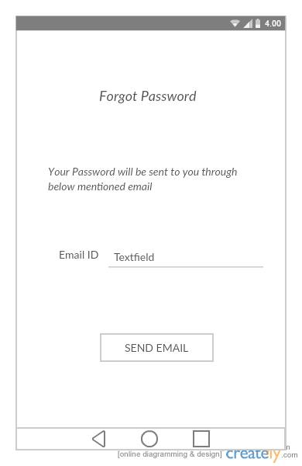**

**Confirm Password:**

**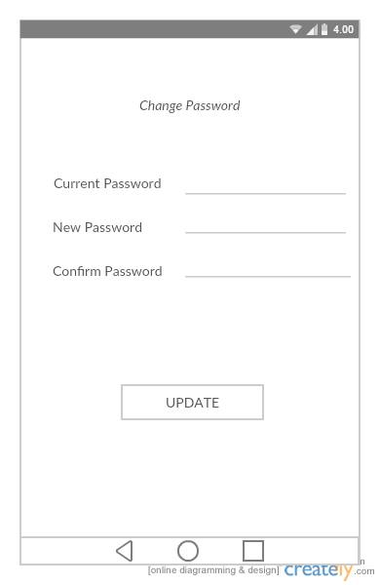**

**Edit Profile Page:**

**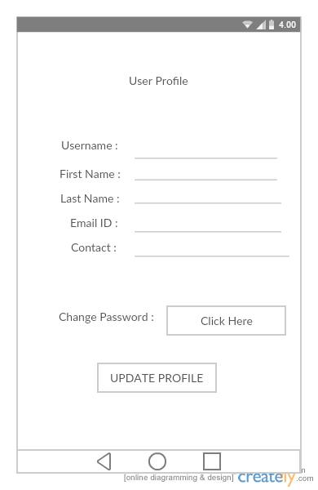**

**Architecture Diagram:**

**Architecture Diagram (1).png**

**Sequence Diagram:**

****

**Class Diagram:**

****

**Use Cases:**

* **Technician Profile Registration:** Checks for the user input details and validates with the existing User names. If exists through errors else registration will be done successfully.
* **Home Page:** Validates user details with the details present in the data base.If the details are correct then the user will be taken to the Home page.
* **Sub Category Page:** Validates the description that is entered.

**Implementation:**

The Implementation of the design mentioned above would be processed using **Android Studio** as Mobile Client Implementation Method and the Source code has been included in the Source code folder attached with the Report. Architecture, Class and Sequence diagrams are drawn using Microsoft Visual Studio. While wireframes are drawn in Creatly.com

**Deployment:**

**User Login:**

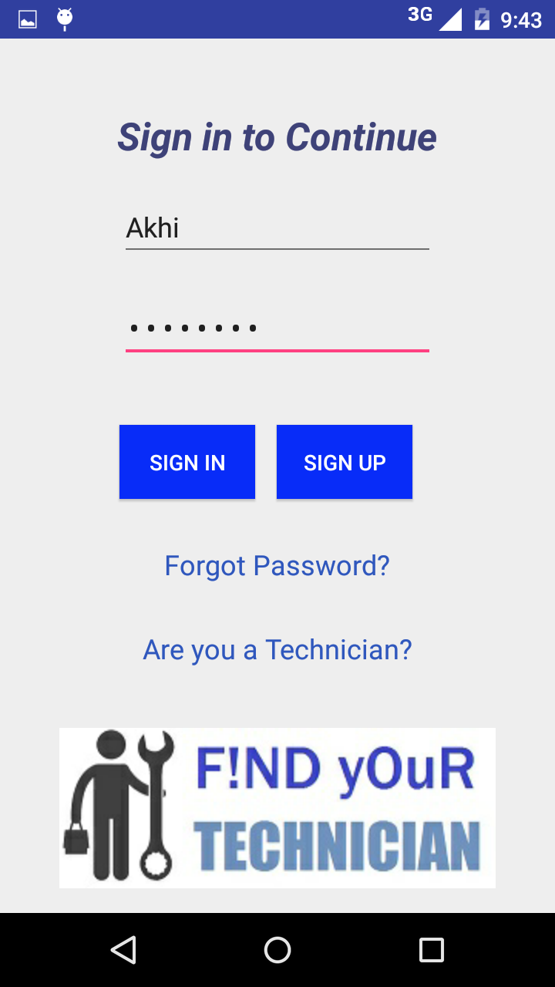

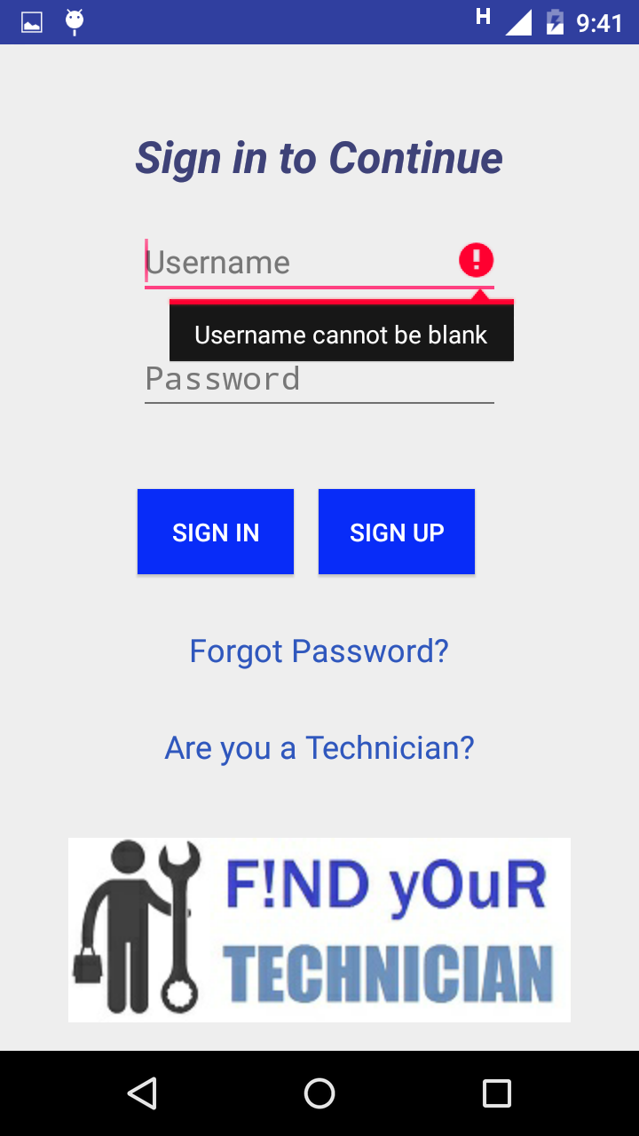

**Home Page:**

**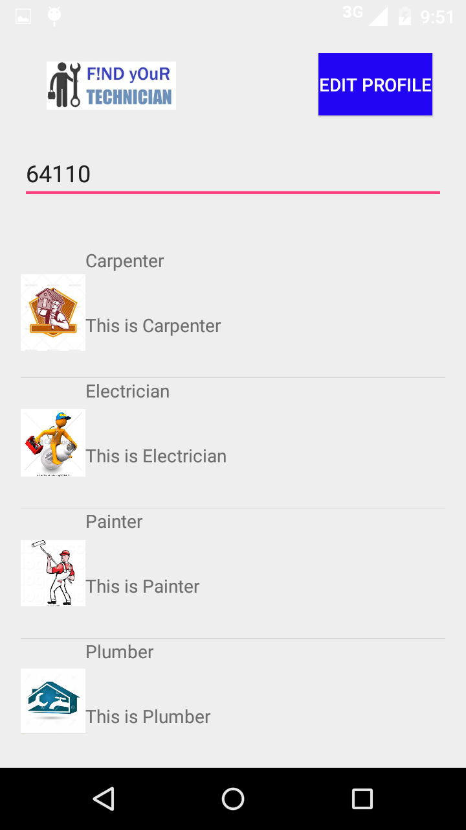**

**Sub Category Page:**

**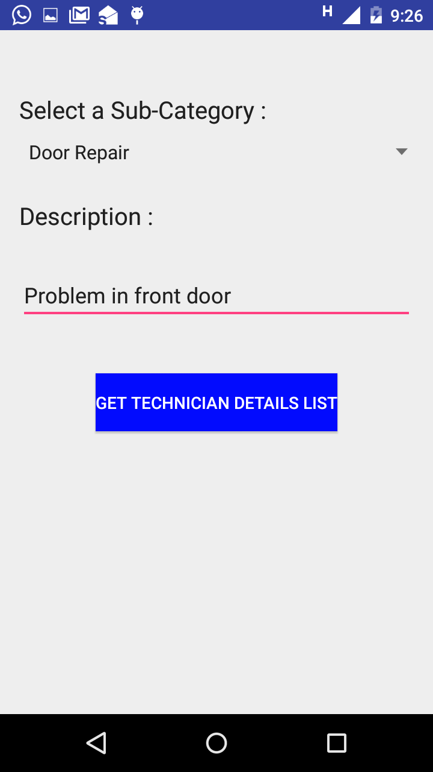**

**Forgot Password Page:**

**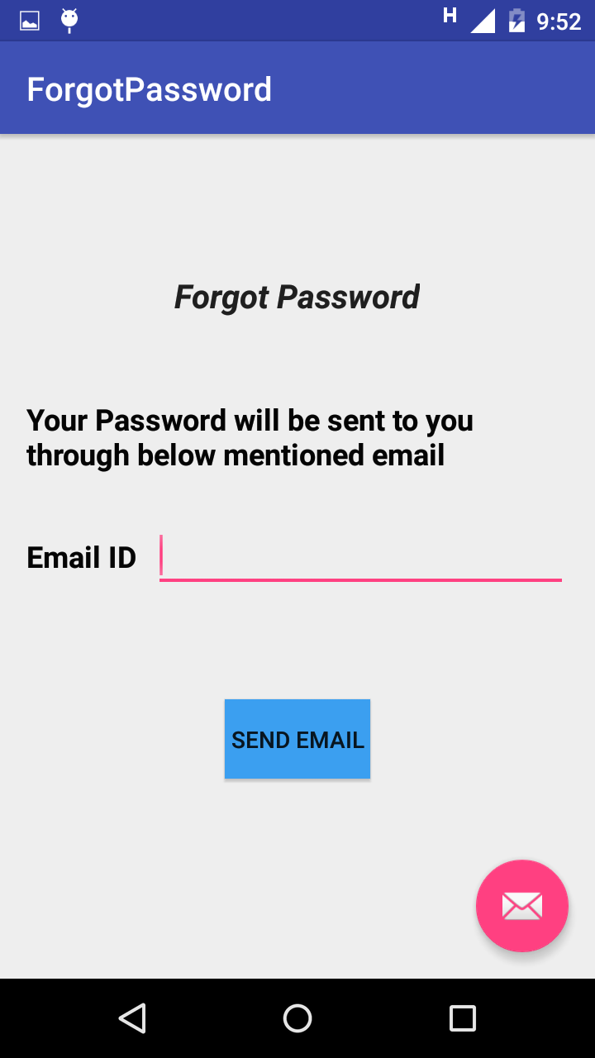**

**User Registration Page:**

**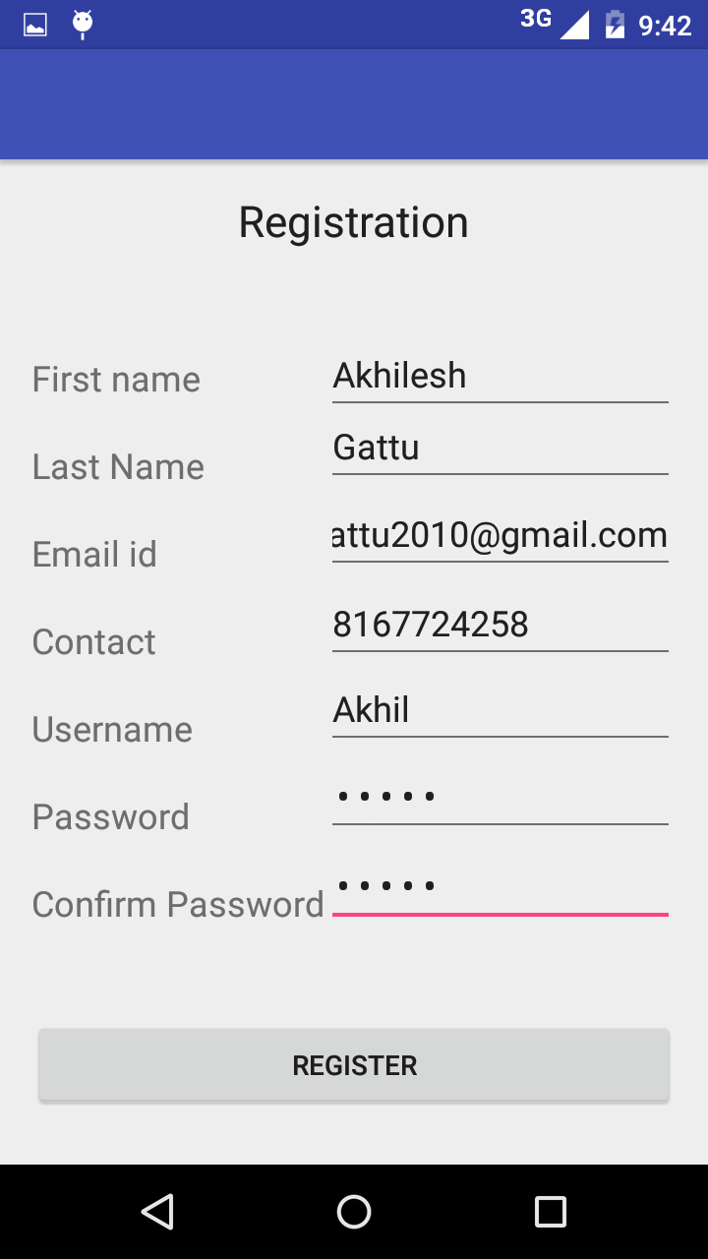**

**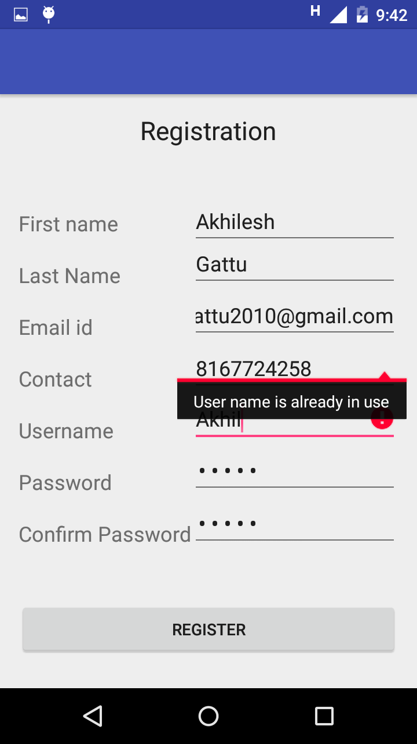**

**Technician Registration Page:**

**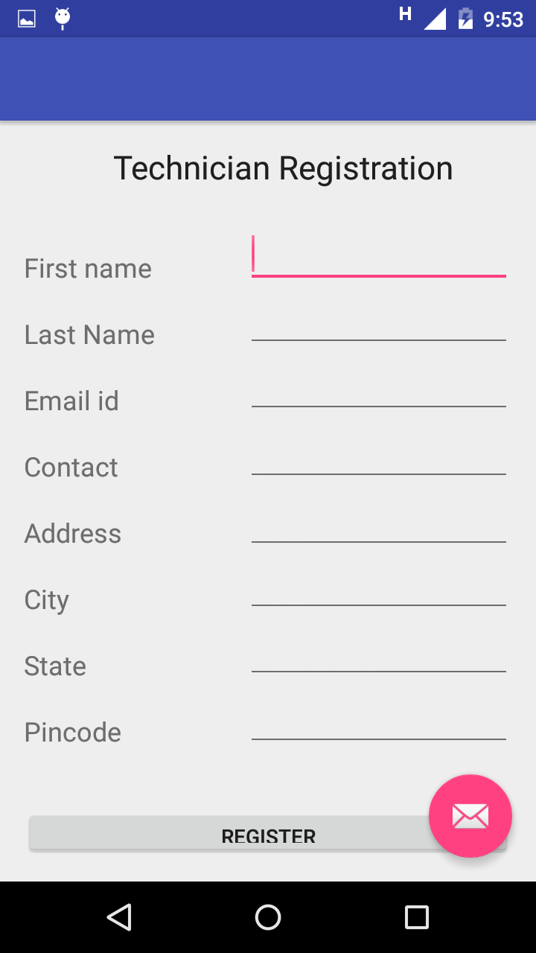**

**GitHub URL:** <https://github.com/AkhileshGattu/ASE-Spring2016-FindYourTechnician>

**Project Management:**

* **Work completed:**

Created all the pages and navigation between the pages is also completed. Data base integration for User and Technician Registration is done. Validating the User Details while logging in also completed. Validating the user input data while User and Technician Registration is in place and working fine.

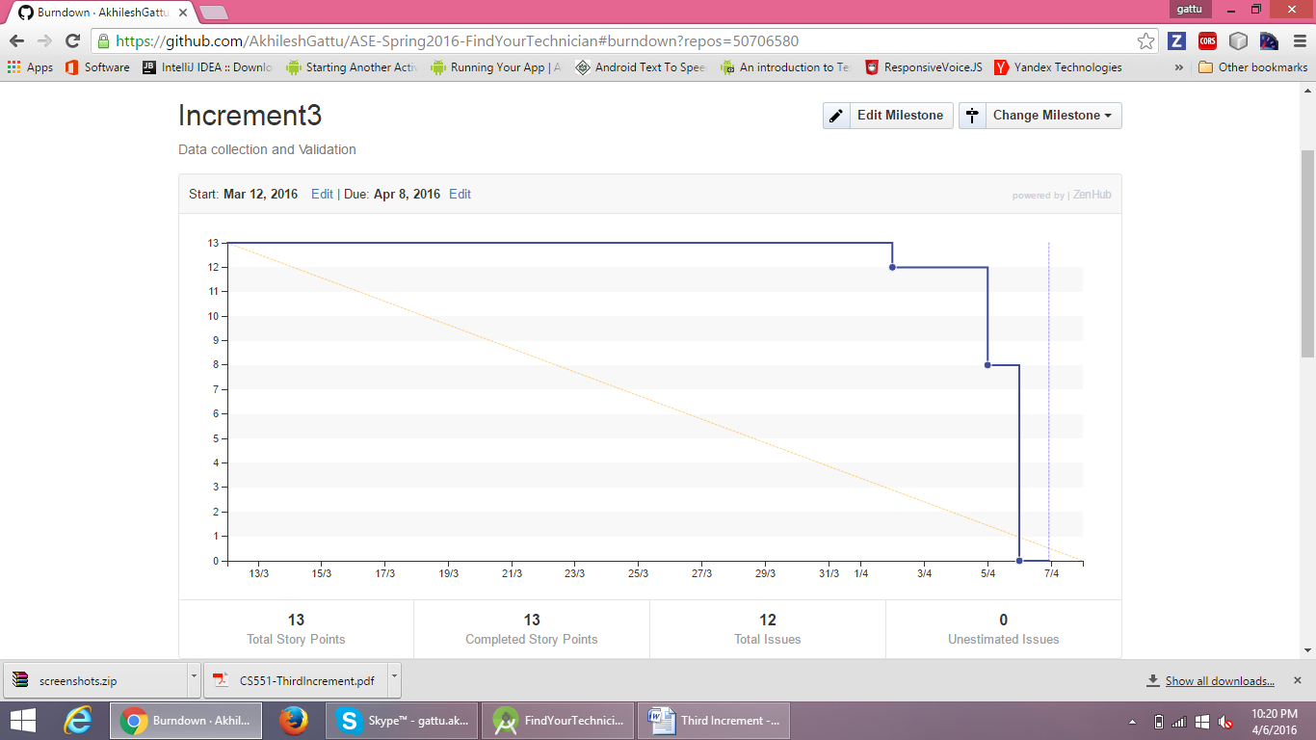

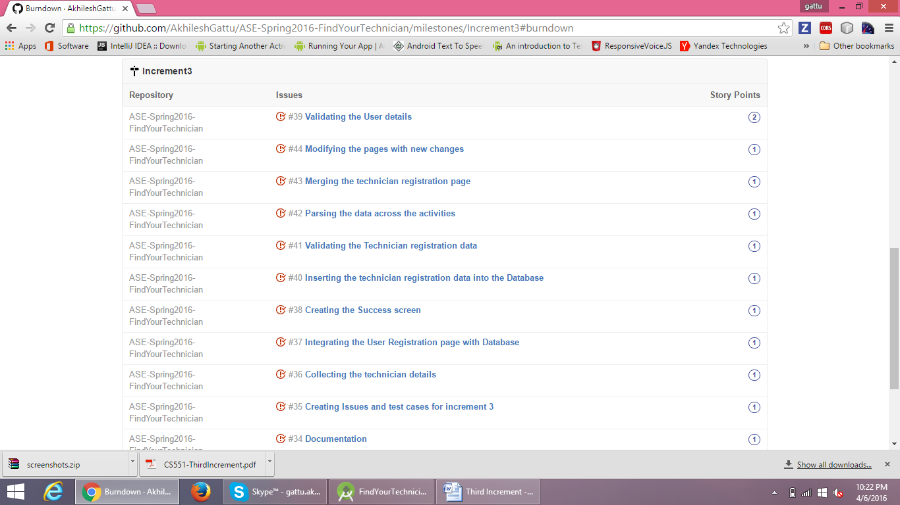

**Bibliography:**

* <http://ziffi.com>
* <http://developer.android.com>
* <http://draw.io>
* <http://creatly.com>

**Fourth Increment**

**Introduction:**

At times, people migrate to new locations and face difficulties to find people who can fix their household repairs, especially in the initial stages. They can be a plumber, an electrician, a carpenter etc. This problem is the motivation factor for us to build this new application. The primary goal of this application is to provide a one stop solution by finding the right person for corresponding problem, at nearby place, which can help to get their job done at times, people migrate to new locations and face difficulties to find people who can fix their household repairs, especially in the initial stages. They can be a plumber, an electrician, a carpenter etc. This problem is the motivation factor for us to build this new application. The primary goal of this application is to provide a one stop solution by finding the right person for corresponding problem, at nearby place, which can help to get their job done.

**Objective:**

The main objective of this application is to provide the details of the technicians nearby them, who can resolve the problem and give an opportunity of choosing the technician based on his experience and rating. This helps the user to overcome the difficulties in searching different people from various locations through number of contacts and reviews. User can select the type of problem to know the estimated cost of the repair. This application also provides an opportunity to the technicians to register themselves by creating a profile about their work and experience.

**Features:**

* User Registration
* User Login
* Provides an option to Select Location
* Select Technician
* Plumber
* Carpenter
* Electrician
* Painter
* Mechanic
* Flexibility of providing unlisted subcategory of the problem
* Cost Estimation
* User can provide Feedback
* Technician Registration
* User Logout

**Existing APIS:**

We are using Google API to get the current address of the user and display it on the home page regardless of whether the user is logged in or not.

**Detailed Design:**

* **Wire Frames:**

**User Login Page:**

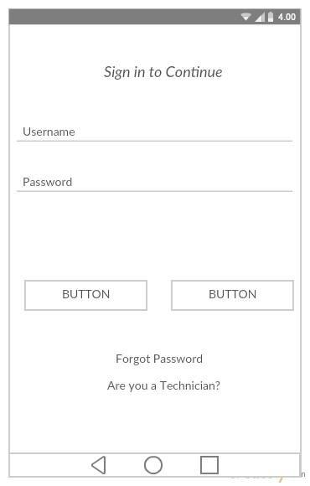

**User Registration:**

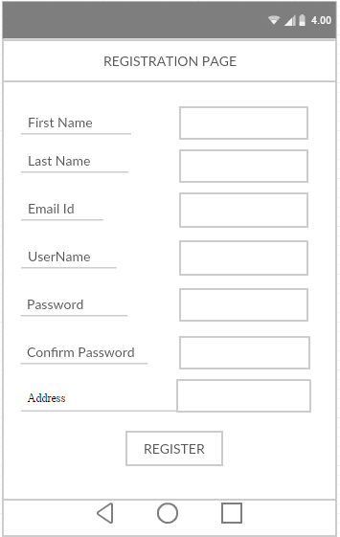

**Technician Registration:**

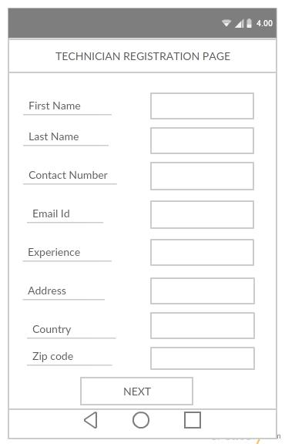

**Technician Registration Completion:**

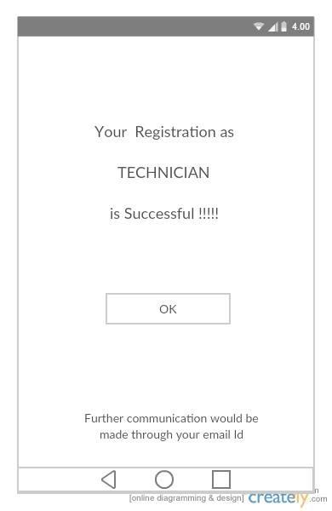

**Home Page:**

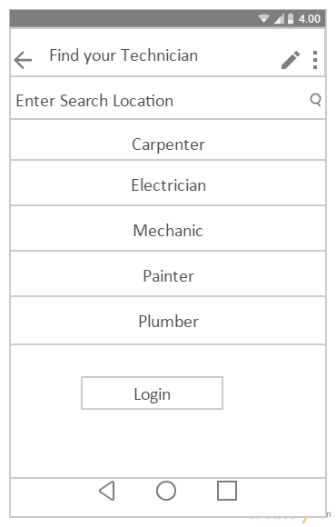

**Sub Category and Description:**

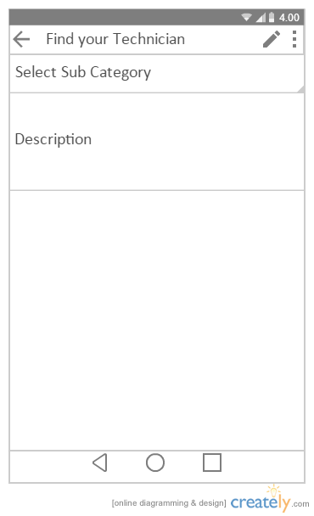

**Technician Results:**

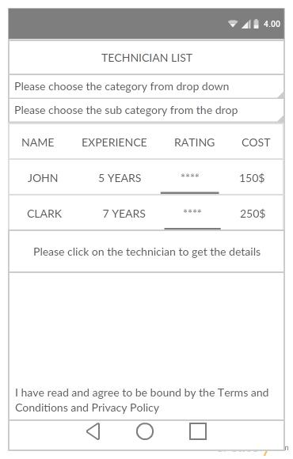

**Technician Details:**

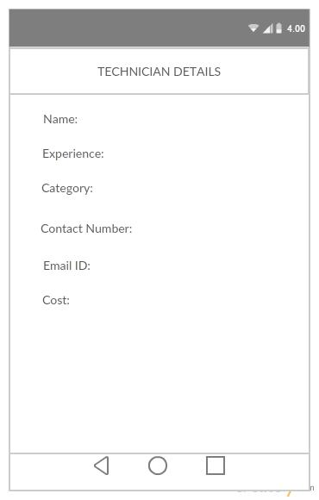

**Forgot Password Page:**

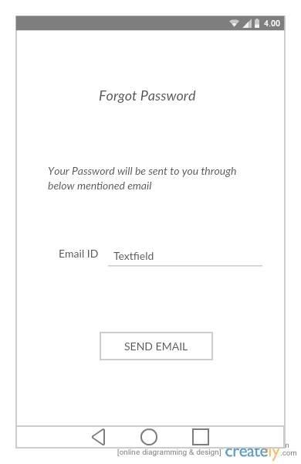

**Confirm Password:**

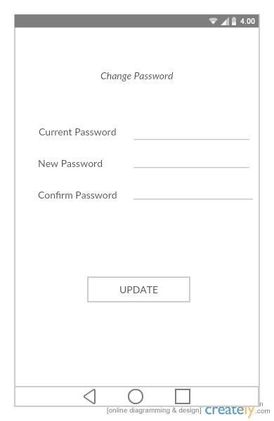

**Edit Profile Page:**

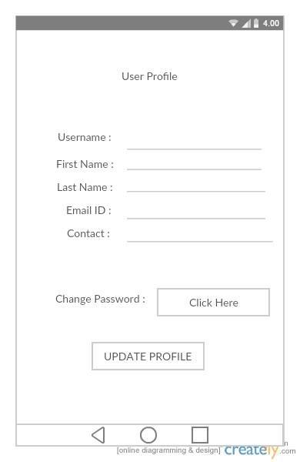

**Feedback Page:**

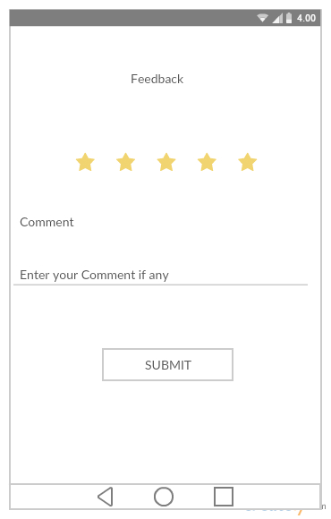

**Architecture Diagram:**

Architecture Diagram (1).png

**Sequence Diagram:**

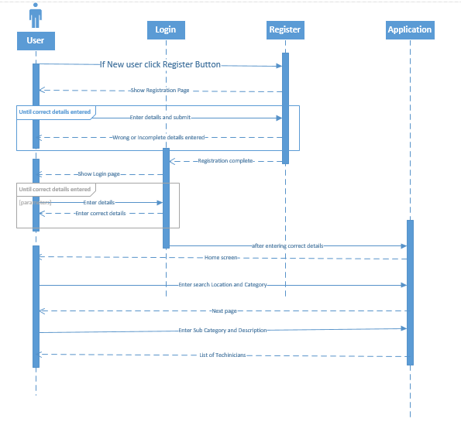

**Class Diagram:**

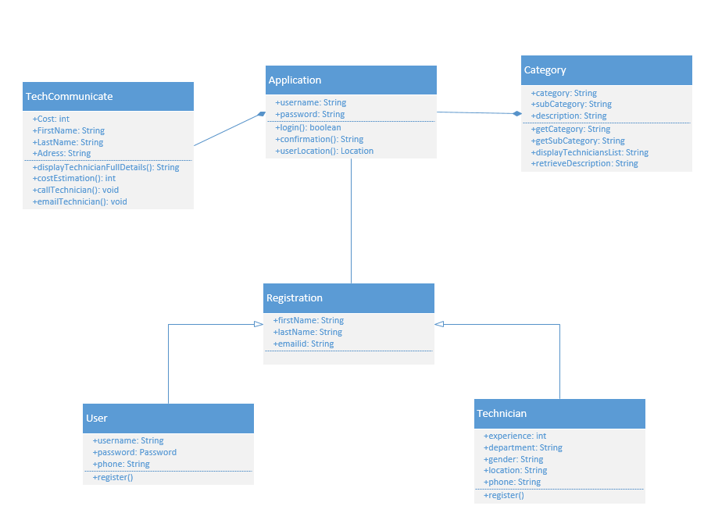

**Use Cases:**

* **Technician Profile Registration:** Checks for the user input details and validates with the existing User names. If exists through errors else registration will be done successfully.
* **Home Page:** Validates user details with the details present in the data base.If the details are correct then the user will be taken to the Home page.
* **Sub Category Page:** Validates the description that is entered.

**Implementation:**

The Implementation of the design mentioned above would be processed using **Android Studio** as Mobile Client Implementation Method and the Source code has been included in the Source code folder attached with the Report. Architecture, Class and Sequence diagrams are drawn using Microsoft Visual Studio. While wireframes are drawn in Creatly.com

**Deployment:**

**User Login:**

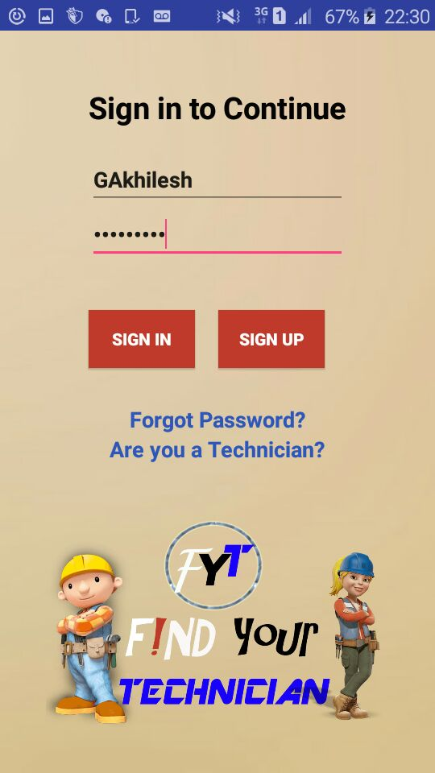

**Home Page:**

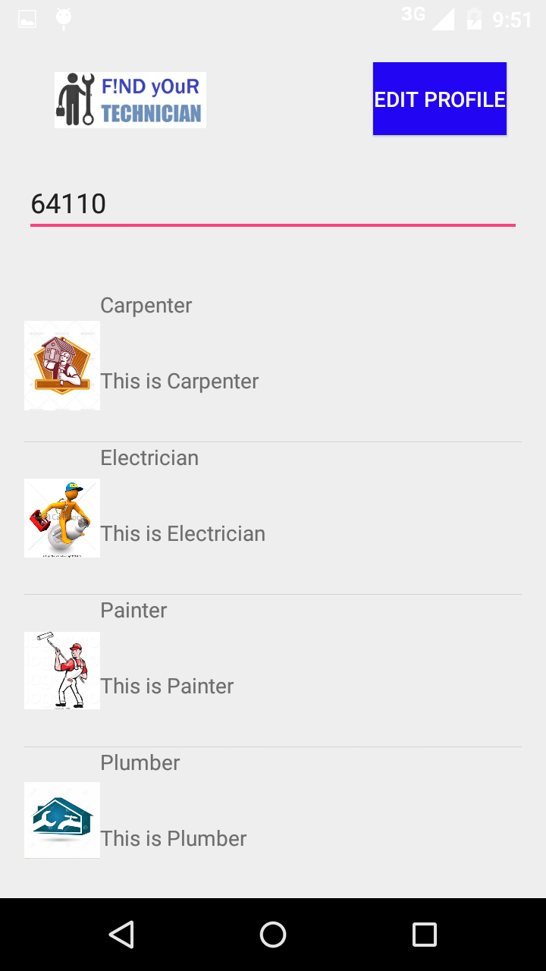

**Sub Category Page:**

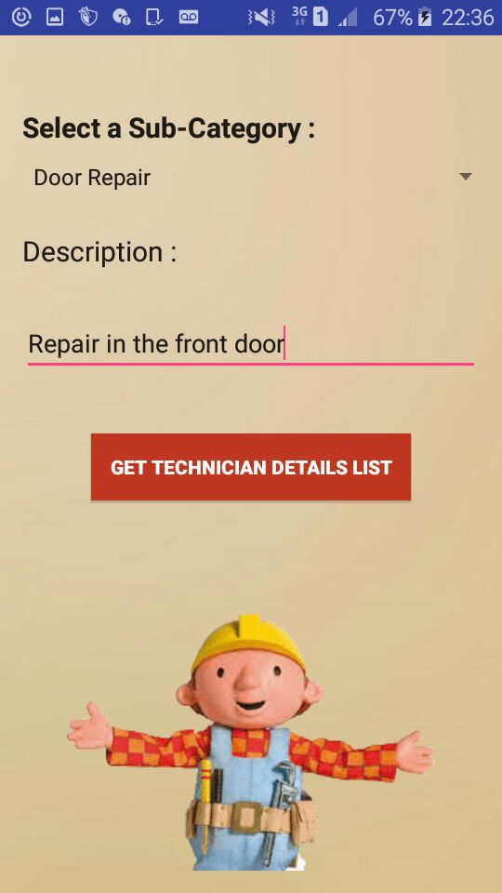

**Technicians List Page:**

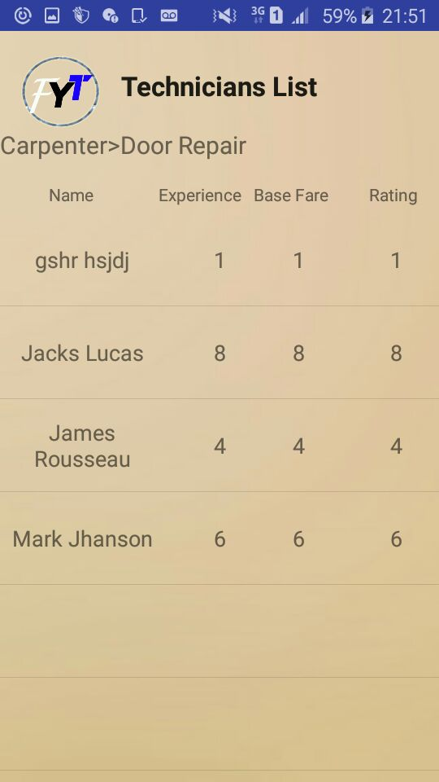

**Forgot Password Page:**

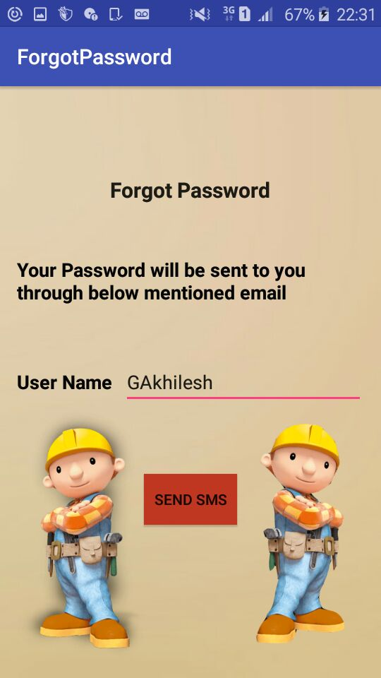

**User Registration Page:**

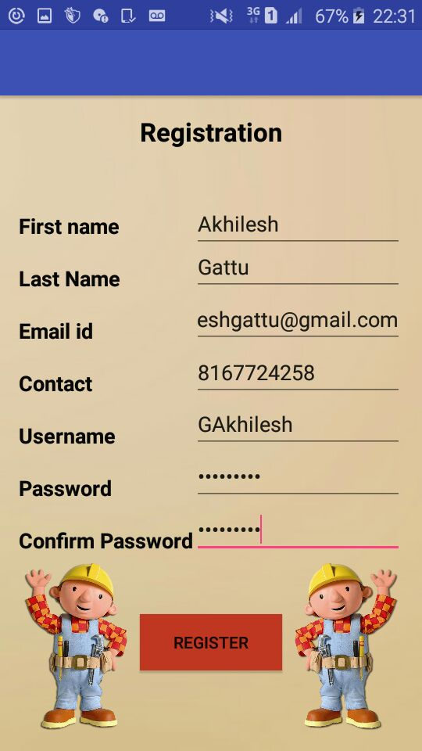

**Technician Registration Page:**

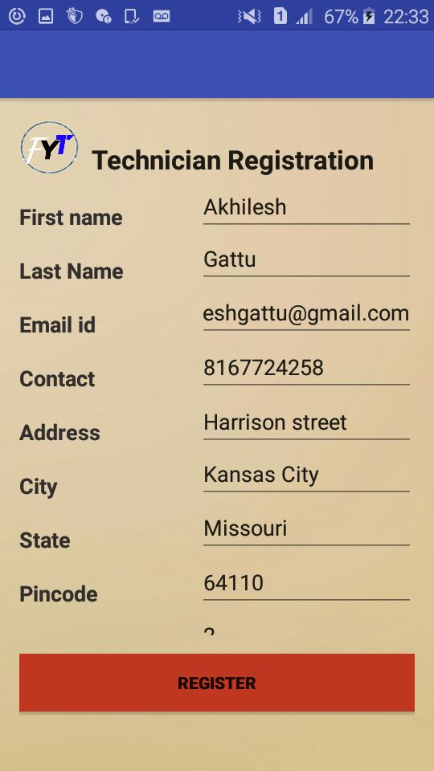

**Technician Details:**

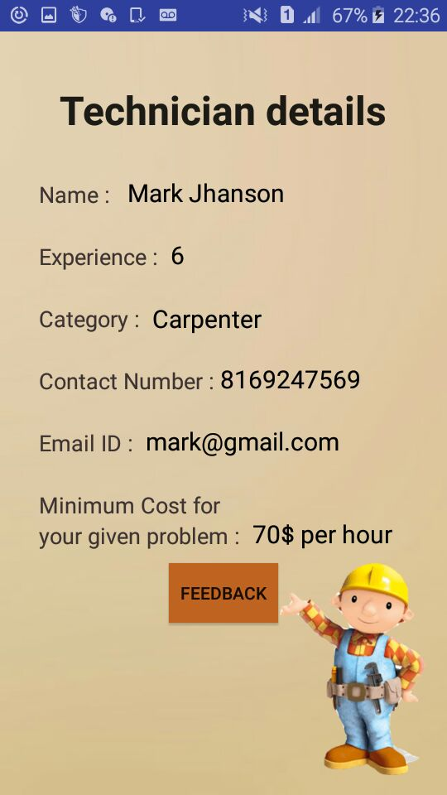

**Feedback Page:**

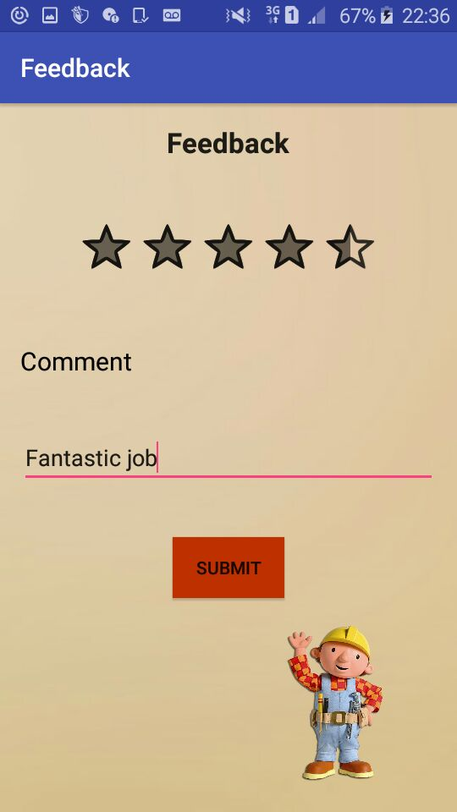

**GitHub URL:** <https://github.com/AkhileshGattu/ASE-Spring2016-FindYourTechnician>

**Project Management:**

* **Work completed:**

In this Increment, Feedback feature has been added to the application. When entered the username in the forgot password page, the password will be sent to the registered mobile number as a text message. UI of the whole application has been improved. Thus, all the required features those are mentioned at the start of the project are implemented which implies the output of this increment is the full fledged application with all the features functioning successfully.

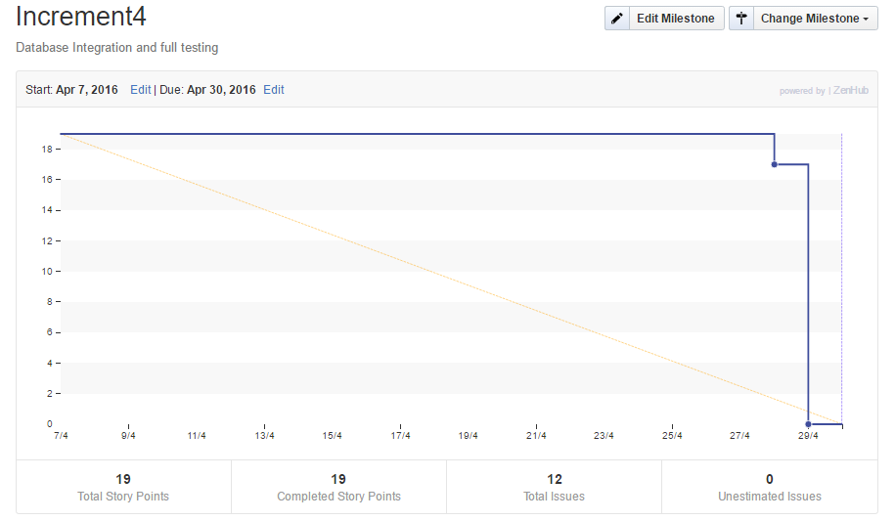

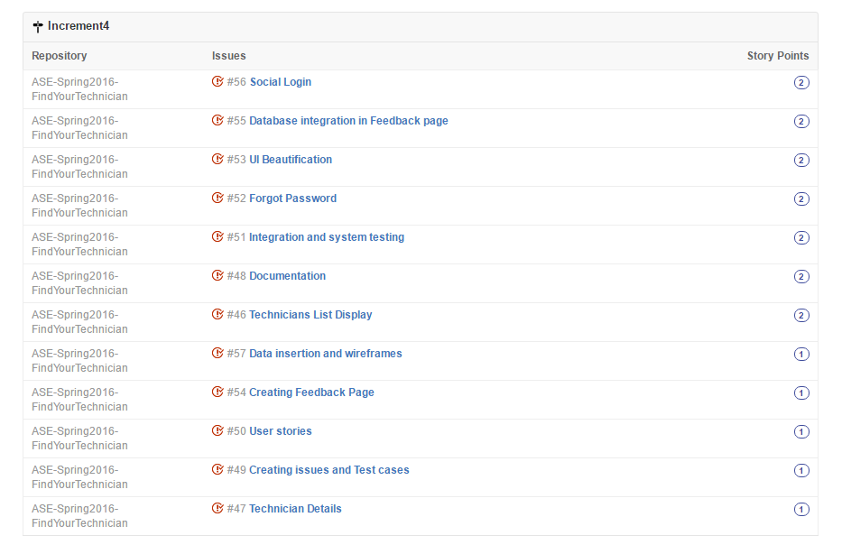

**Bibliography:**

* <http://ziffi.com>
* <http://developer.android.com>
* <http://draw.io>
* <http://creatly.com>

**Presentation Slides:**

[**https://github.com/SCE-UMKC/ASESP16\_FindYourTechnician\_Team6/tree/master/Final%20Presentation**](https://github.com/SCE-UMKC/ASESP16_FindYourTechnician_Team6/tree/master/Final%20Presentation)

**Github Url:**

[**https://github.com/SCE-UMKC/ASESP16\_FindYourTechnician\_Team6**](https://github.com/SCE-UMKC/ASESP16_FindYourTechnician_Team6)

**Video Url:**

<https://youtu.be/mFv6HwEneEU>