

Techno Commercial Proposal



Document Reference #: 2021-11-00015

Document Date: 20-11-2021

Document Version: V1

Document Revision: R1

Customer Name: UKB Electronics

Proposal Description: RFID Asset management System

Intent To:

Sales Person: Rajat Verma

Email:

Mobile:

Web: https://satoasiapacific.com/india/

SATO Argox India is a pioneer and leading global provider of integrated Automatic Identification and Data Collection (AIDC) solutions that leverage barcode and RFID technologies to provide real-time visibility into organisations’ assets, people, and transactions.

SATO manufactures innovative, reliable auto-identification systems and offers complete solutions to businesses by integrating hardware, software, media supplies and maintenance services.

We empower those on the front-line in manufacturing, retail, healthcare, transportation and logistics, and other industries to achieve a performance edge and enhanced profitability.

Our products, software, services, analytics, and solutions are designed to connect people, assets, and data. We design with front-line users and their work environment in mind, enabling them to adopt best practices to optimize operations and make critical decisions intelligently.

SATO Argox India offers a wide range of marking, tracking, and computer printing technologies designed for manufacturing supply chain, retail, healthcare, and government industries. Products include thermal barcode label and receipt printers, RFID smart label printers, fixed and handheld readers, that are used for barcode labelling, personal identification, and specialty printing.

SATO provides quality repair and maintenance services that will ensure customers are operating SATO products at the optimal level.

Document No#: S00001 Ver:1.0 Rev:1.0 Last Updated on:23-03-2021.

Contents

**1.** **Disclaimer** 2

2. **Version Control** 3

**3.** **Introduction** 3

4. **Objectives and Expectations:** 3

**5.** **Proposed Solution** 3

5.1 Asset management System 3

5.2 Master Modules 4

5.2.1 Physical Division 4

5.2.2 Material Setup 4

5.2.2 Authorisation Setup 4

5.3 Transaction Modules 4

5.4 Other Modules 5

5.5 Reports 6

**6.** **Solution Components** 6

**7.** **Technology & Environment** 6

7.1 Technology 6

7.2 Development Environment 7

7.3 Database 7

**8.** **Third party Interfaces** 7

**9.** **Deployment Environment** 9

9.1 WMS Server Configuration 9

**10.** **Implementation Plan** 10

**11.** **Assumptions and Risk** 11

11.1 Assumptions 11

**12.** **Commercial Proposal (WMS s ONE time Licence cost)** 12

**13.** **Commercial Proposal (Hardware)** 12

• **WI-FI & Cloud cost is not included in above commercials, That cost will be extra.** 12

**14 TERMS and Conditions** 12

# **Disclaimer**

Information in this document is provided to communicate the possible solution against the defined requirement by customer. This document is only for sharing information which will help both the party’s customer and supplier to make an informative decision to move ahead and take a final decision.

SATO Argox India Pvt. Ltd have all the right to make changes to this document at any time, without any notice. Creator of this document assumes no responsibility for any errors that can appear in the document, nor does it make a commitment to update the information contained herein in future.

This document contains information, which is the proprietary property of SATO Argox India Pvt Ltd. This document is shared in confidence and its contents cannot be disclosed or copied without the prior written consent of SATO Argox India Pvt. Ltd.

**Copyright**

Copyright © SATO Argox India Pvt. Ltd 2021. All rights reserved.

**Trademarks**

Information and Images may be trademarks of other organisation and the intent of use for explanation and to the owners' benefit, without intent to infringe.

# **Version Control**

|  |  |  |  |  |  |
| --- | --- | --- | --- | --- | --- |
| SL No. | Description | Release Version | Release Date | Created By/On | Approved By/On |
| 1 | Techno Commercial Proposal | R1 | 20-11-2021 | Mayank Nasa | Ramesh Jain |
| 2 |  |  |  |  |  |
| 3 |  |  |  |  |  |

# **Introduction**

Customer: UKB Electronics

Implementation Site: Noida

# **Objectives and Expectations:**

* Implementation of Asset management
* Monitor Asset Location
* Faster Stock take
* RFID Technology for faster and accurate data capture.

# **Proposed Solution**

## 5.1 Asset management System

Asset Management solution from SATO for Asset tracking across the business Unit using RFID, Enterprise Mobility”.

SWAG – OMM benefits

* Operator
  + Improves Efficiency
  + focus on work rather than systems.
  + Accurate and faster data capture.
* Manager
  + Asset visibility
  + Information availability on the go
* Management
  + Higher visibility for better planning
  + Control on processes for optimization
  + System driver operations rather than people driven.

Followings are the modules and their workflow.

## 5.2 Master Modules

Following are major master setup details mentioned here required to implement the WMS.

### Physical Division

* Business Unit – [Plant]
  + Fields: Code, Name, Address etc.
* Warehouse – Storage Location
  + Fields: Code, Name, Address etc.

### 5.2.2 Material Setup

* Material Category
  + Fields: Code, Name, Address etc.
* Material Variant
  + Fields: Code, Name, variant properties (Grade, Size, Color etc.)
* Material Models
  + Fields: Code, Name etc.
* Material Master
  + Fields: Code, Name, Base UOM, Purchase configurations, Sales Configurations, Quality Check, Physical properties (Size, Weight), Lot management, Serialization, FIFO, Picking Indicator
* Stock Control
  + Fields: Material, Warehouse, Reorder Quantity etc.
* Material Tag – label Design
  + Fields: Material, Tag Design, no of labels etc.

### Authorisation Setup

* User Role
  + Fields: Code, Name, Form name.
* User Master
  + Fields: Code, Name, Role etc.

## Transaction Modules

The WMS transaction modules cater to all the material movement between supplier, warehouse, customer etc.

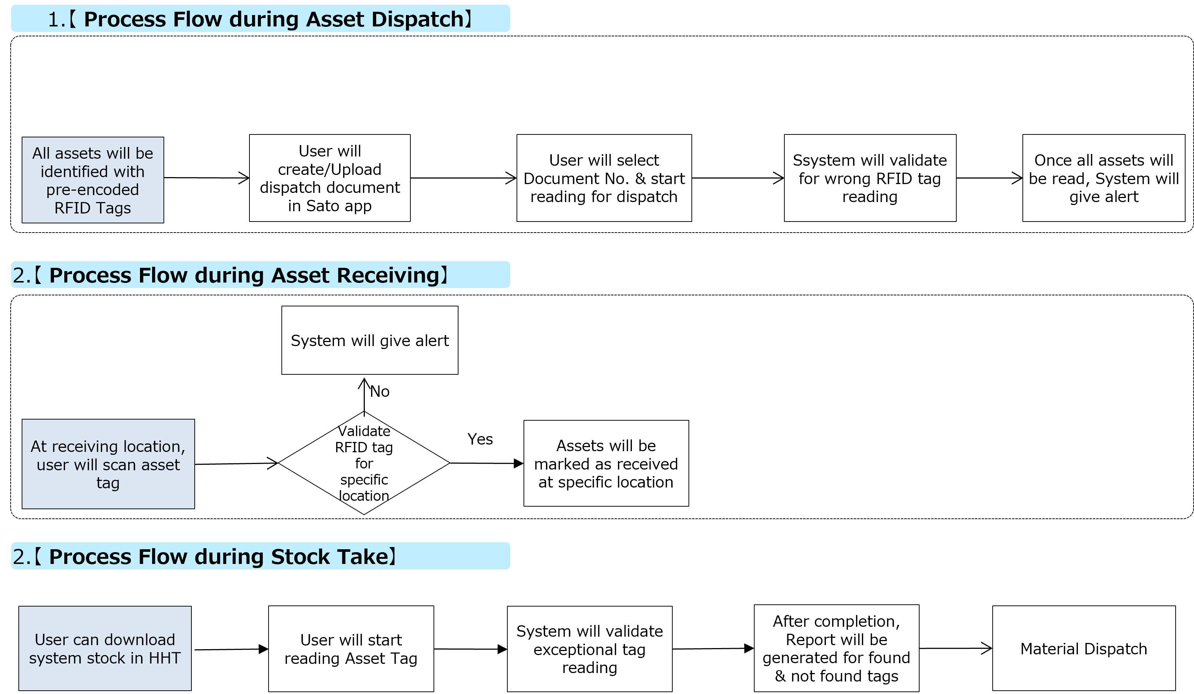

The defined flows may change depends on the implement scenario and ERP configurations.

Major modules are mentioned in document are.

* Dispatch
* Receiving
* Stock take

## Other Modules

* Exception handling related to quantity at Receiving, Picking, Sorting etc.
* Reversal of transactions.
* Etc.

## Reports

The reports are in tabular form and can be exported to Excel.

* Location wise Asset Report
* Asset Dispatch Report
* Location wise Stock take report
* Exception report

# **Solution Components**

* Software
  + Windows Server OS
  + Microsoft SQL Database
  + Asset management Software
* Hardware
  + Server to Host the WMS
  + PC for user
  + Printer for label printing
  + HHT [ mobile device]
  + Wireless Infrastructure
* Others
  + Consumables
  + LAN Infrastructure

# **Technology & Environment**

### 7.1 Technology

* AIDC – Auto Identification technology – RFID will be used to implement AMS transactions.
* Enterprise mobility

### 7.2 Development Environment

* Microsoft .Net 4.8 Framework
* Programming C#

### 7.3 Database

* Microsoft SQL server
* Version should be decided by customer IT team; however, we would provide guidance.

# **Third party Interfaces**

* ERP Interface
  + While standard interface of web API is preferred but open to have integration using flat file, IDocs, or any other ERP API
  + To be finalized after discussion with customer ERP team.
  + The ERP side customization will be responsibility of customer.

ERP

WMS

SOAP Web Services

REST API

Idocs, CSV files, FTP

# **Deployment Environment**

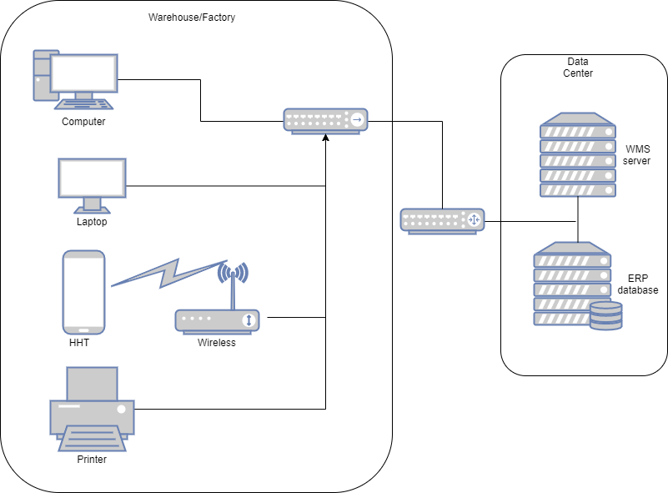

### 9.1 WMS Server Configuration

* Intel Xeon E5-2690 2.60 GHz. (2 vCPUs) or Higher
* Microsoft Windows 2012 or higher version Server operating system with IIS
* MS SQL Data Server 2012 Enterprise Edition or higher version.
* RAM: Minimum 32 GB RAM
* 1 GB or high-speed redundant LAN card.
* Hard Disk: 50 GB Space for database and Application

# **Implementation Plan**

|  |  |  |  |  |
| --- | --- | --- | --- | --- |
| SL. No. | Milestones | Estimated Time (Days) | Responsibility | Remark |
| 1 | Resource Allocation | 5 | Sato Argox |  |
| 2 | Business Blueprint | 5 | Customer/ Sato Argox |  |
| 3 | System Design | 5 | Sato Argox |  |
| 4 | Development | 21 | Sato Argox |  |
| 5 | Quality Testing | 5 | Sato Argox |  |
| Total | | 41 days |  |  |

*The implementation timeline will be around 3 months having few activities in parallel.

# **Assumptions and Risk**

## 11.1 Assumptions

* Required infrastructure to run WMS will be provided by Customer.
* ERP side customization will be responsibility of customer.
* Any process related changes will be taken up by customer.
* Any change during implementation will be taken up after completion with extra effort and cost.

# **14 TERMS and Conditions**

1. Tax: On actual. Presently it is 18%
2. Payment: 100% advance
3. Delivery: 5-6 weeks.
4. Proposal Validity: 30 days
5. Copyright: The design, source and all other intellectual property is owned by SATO only. Customer owns the sold product/solution and cannot re-create or manufacture the copy of it.
6. In case of subscription model, the hardware and consumable should be procured from SATO Argox.