
A Course Project Report
on
COMPARATIVE ANALYSIS OF TRADITIONAL AND MODERN MEMORY TRANSLATION ARCHITECTURES
Submitted in partial fulfilment of the requirements of the course
Operating Systems (B2 + TB2)
Submitted by
Akhilesh Regmi | 24BCE2934
Swayam Raj Pandey | 24BCE2933
Aamarsh Raj Shakya | 24BDS0449

Under the guidance of
Prof. Manivannan P
Vellore Institute of Technology
October 2026

Abstract
Address translation is a significant hidden cost in modern systems: every miss in the translation lookaside buffer (TLB) requires a walk of the page table in memory. This report presents a simulator that implements four page-table organizations (single-level, multi-level, hashed and inverted) behind a common translation interface, replays an identical seeded memory trace through a shared TLB, and performs a real walk of each data structure on every TLB miss. One-factor sweeps over page size, TLB size, memory size, access pattern and process count show a consistent trade-off between table memory and memory references: at the baseline configuration the single-level table achieves the lowest modelled latency (62.0 cycles per access) but occupies 32 MiB, whereas the multi-level table occupies 60 KiB at a latency of 245.2 cycles. A study of Windows, Linux, macOS and Android establishes that all of them employ a multi-level (radix) table, because the x86-64 and Arm processors walk that structure in hardware; the decision available to the operating system is the page size. IBM POWER9 is identified as the exception, permitting Linux to select either a radix tree or a hashed table at boot. A what-if analysis indicates that replacing the radix tree with a hashed table on a 4 KB x86-64 system would reduce modelled latency by 72% at 70 times the table memory, a change not realisable without new hardware. Published measurements on real hardware report a gain of only 1% to 27%, which indicates that the simulator's latency gains should be interpreted as upper bounds.
Keywords: virtual memory, page tables, translation lookaside buffer, radix tree, hashed page table, inverted page table, huge pages

Table of Contents
Abstract 2
1. Introduction 4
1.1 Background 4
1.2 Objectives 4
1.3 Scope 4
1.4 Work Completed 4
2. Page-Table Organizations 5
3. Methodology 5
3.1 Simulator Design 5
3.2 Workload and TLB 5
3.3 Cost Model 6
3.4 Experimental Parameters 6
4. Results and Discussion 6
4.1 Baseline Comparison 6
4.2 Effect of Page Size 7
4.3 Effect of TLB Size 7
4.4 Effect of Memory Size 8
4.5 Effect of Access Pattern 8
4.6 Effect of Process Count 9
5. Study of Operating System Techniques 9
5.1 Organization Is Determined by Hardware 9
5.2 Rationale, Advantages and Disadvantages 10
5.3 IBM POWER9: A Platform Permitting a Change of Organization 10
6. What-If Analysis 11
6.1 Method 11
6.2 Change of Organization 11
6.3 Change of Page Size 12
6.4 POWER9 and Validation Against Published Measurements 12
7. Conclusion and Future Work 13
7.1 Conclusion 13
7.2 Limitations 13
7.3 Future Work 13
References 13

1. Introduction

1.1 Background
Every memory access issued by a program uses a virtual address that must be translated into a physical address. The translation lookaside buffer caches recently used translations; when it misses, the page table must be walked in memory. On the x86-64 architecture this walk reads four levels of a radix tree, and up to 24 entries under virtualization; such walks have been reported to account for between 5% and 90% of runtime in the workloads examined by Yaniv and Tsafrir [1]. The organization of the page table therefore determines both the cost of each TLB miss and the memory occupied by the table itself.

1.2 Objectives
The project addresses three questions:
- To determine which of four page-table organizations (single-level, multi-level, hashed and inverted) performs best, and how the result depends on page size, TLB size, memory size, access pattern and number of processes.
- To establish which technique is used by Windows, Linux, macOS and Android, the reasons for that choice, and its advantages and disadvantages.
- To estimate what each operating system would gain or lose by adopting a different technique, and whether such a change is feasible.

1.3 Scope
The contribution of this work is comparative analysis. The design of a new translation mechanism and the modification of a production kernel are outside its scope. All latencies reported are derived from a stated cost model and are not hardware measurements.

1.4 Work Completed
- A Python simulator implementing the four page-table organizations as real data structures behind a shared TLB, with every translation cross-checked between organizations.
- Five one-factor parameter sweeps from a fixed baseline configuration (Section 4).
- A documentary study of six platforms: Windows x64, Linux x86-64, macOS on Apple Silicon, Android, Linux on Arm servers and Linux on IBM POWER9 (Section 5).
- 60 what-if simulations comparing each operating system's configuration with every alternative, at 1 and 16 processes (Section 6).
- An interactive front end built with Streamlit and a suite of 65 automated tests.

2. Page-Table Organizations
Four organizations are compared in this study. Their mechanisms and principal trade-offs are summarised in Table 1.
Table 1: Summary of the page-table organizations under comparison
Organization | Mechanism | Advantage | Disadvantage
Single-level | One flat array per process, indexed by virtual page number | A single memory reference per TLB miss | Size proportional to the entire address span, incurred per process
Multi-level (radix) | A tree in which only the branches in use are allocated | Compact for sparse address spaces; natural support for huge pages | One memory reference per level: four on x86-64
Hashed | A hash of (process, page) selects a bucket chain | Approximately one reference per miss; size follows mapped pages | Poor cache locality; huge pages are difficult to support
Inverted | One entry per physical frame, located through a hash anchor table | A single table per machine, sized by physical memory | Anchor read plus chain search; shared pages are awkward to represent

The TLB is not a separate organization: it is a cache placed in front of each of the four, and its hit rate depends only on the access pattern and its own capacity. Hashed and inverted tables have historically been used on architectures whose hardware supports them, such as PowerPC, UltraSPARC and IA-64 [2].

3. Methodology

3.1 Simulator Design
The simulator is implemented as a Python package with a common translation interface. A workload generator produces a seeded trace of byte addresses, which passes through a single shared TLB. Each TLB miss is presented to every organization, which walks its data structure and reports the physical frame located and the number of memory references made. The frames returned by all four organizations are verified to agree on every run.

3.2 Workload and TLB
Each run consists of 100,000 accesses over a working set of 16 MiB per process, divided into eight regions distributed across the address span. Four access patterns are generated: sequential, strided (a stride of 4 KiB plus 64 bytes), uniformly random, and skewed (a Zipf distribution with s = 1 over 4 KiB blocks). Processes are scheduled round-robin with 1,000 accesses per time slice. The TLB is fully associative with least-recently-used replacement and is flushed on every context switch.

3.3 Cost Model
Average translation latency is computed from three constants, each configurable in the interactive application: one cycle per access for the TLB lookup, 100 cycles per memory reference made by a page-table walk, and 10 cycles for a hash computation on each TLB miss in the hashed and inverted organizations.

3.4 Experimental Parameters
Each experiment varies a single parameter while the remainder are held at the baseline values listed in Table 2.
Table 2: Experimental parameters and baseline configuration
Parameter | Values examined | Baseline
Page size | 4 KB, 16 KB, 64 KB, 2 MB | 4 KB
TLB size | Disabled, 16, 64, 256, 1024 entries | 64 entries
Memory size | Small, medium, large: 1, 16, 256 GiB address span with 0.5, 4, 16 GiB physical memory | Medium
Access pattern | Sequential, strided, random, skewed | Skewed
Processes | 1, 2, 4, 8, 16 | 1

4. Results and Discussion

4.1 Baseline Comparison
Table 3: Performance of the four organizations at the baseline configuration, ranked by latency
Organization | Latency (cycles) | References per access | TLB hit rate | Table memory
Single-level | 62.0 | 0.61 | 0.39 | 32 MiB
Hashed | 68.3 | 0.61 | 0.39 | 4.1 MiB
Inverted | 129.5 | 1.22 | 0.39 | 20 MiB
Multi-level | 245.2 | 2.44 | 0.39 | 60 KiB

The results in Table 3 show that the fastest organization is not the most compact. The single-level table requires 546 times the memory of the multi-level table, while the multi-level table makes 4 times as many memory references. The hashed table attains a latency within 10% of the single-level table using approximately one eighth of its memory. The TLB hit rate is identical across organizations, as expected, since the TLB observes the same trace in every case.

4.2 Effect of Page Size
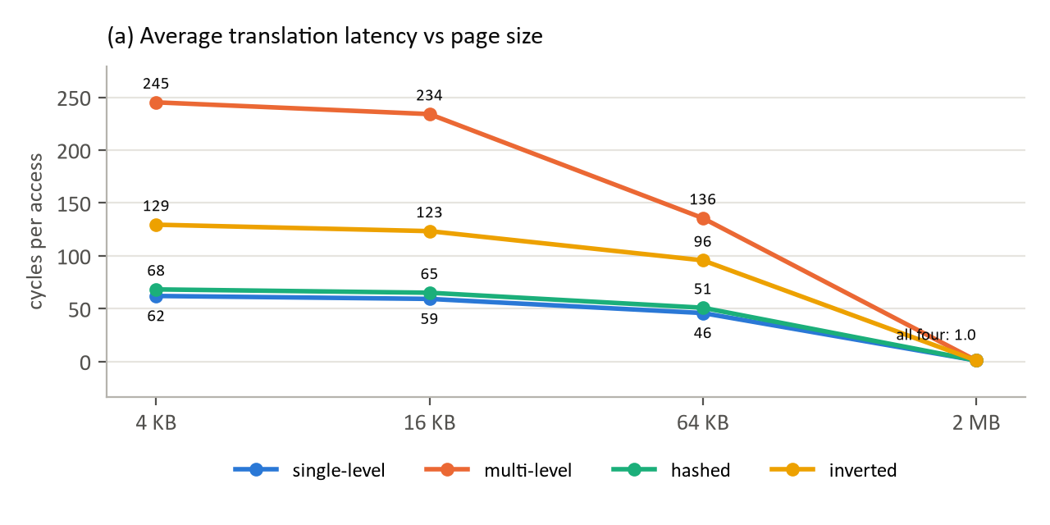
Figure 1: Average translation latency as a function of page size
Larger pages increase the memory covered by each TLB entry and thereby reduce the miss rate (Figure 1). The latency of the multi-level table falls from 245.2 cycles at 4 KB to 135.7 cycles at 64 KB. At 2 MB the entire 16 MiB working set is covered by eight TLB entries, and every organization approaches one cycle per access. The cost of larger pages is internal fragmentation: in the worst case each allocation wastes one page less one byte.

4.3 Effect of TLB Size
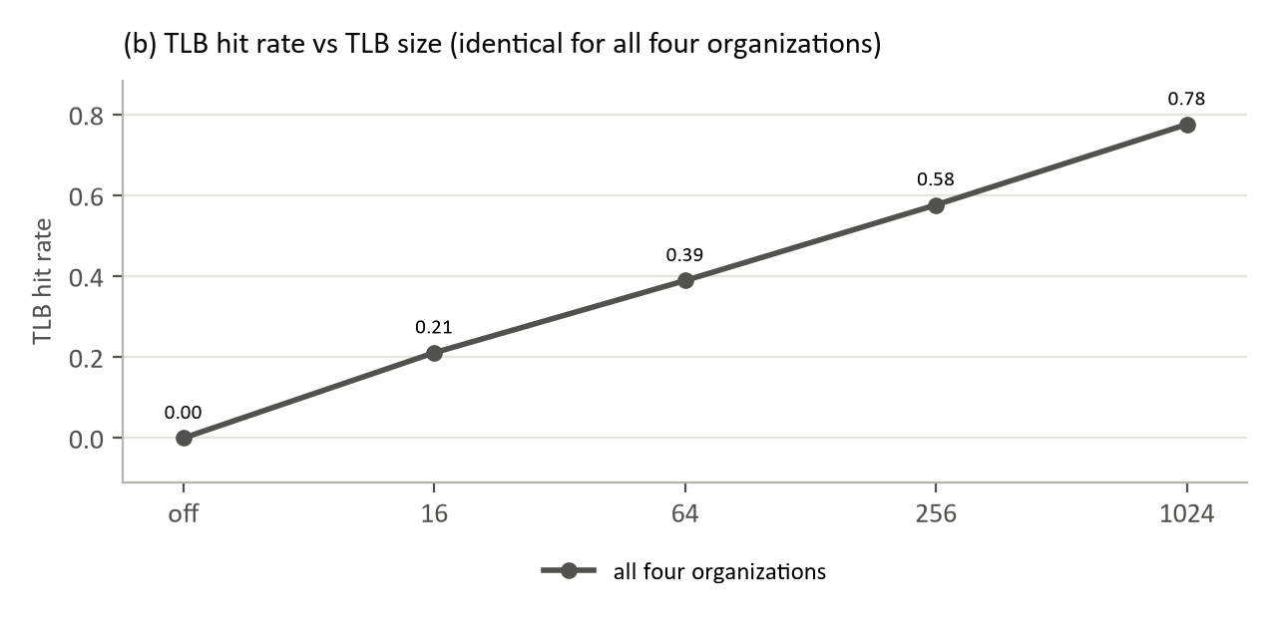
Figure 2: TLB hit rate as a function of TLB size, identical for all four organizations
The hit rate increases from zero with the TLB disabled to 0.78 at 1,024 entries, independently of the organization (Figure 2). The organization determines only the cost of each miss: with the TLB disabled, the multi-level table costs 401.0 cycles per access against 101.0 cycles for the single-level table.

4.4 Effect of Memory Size
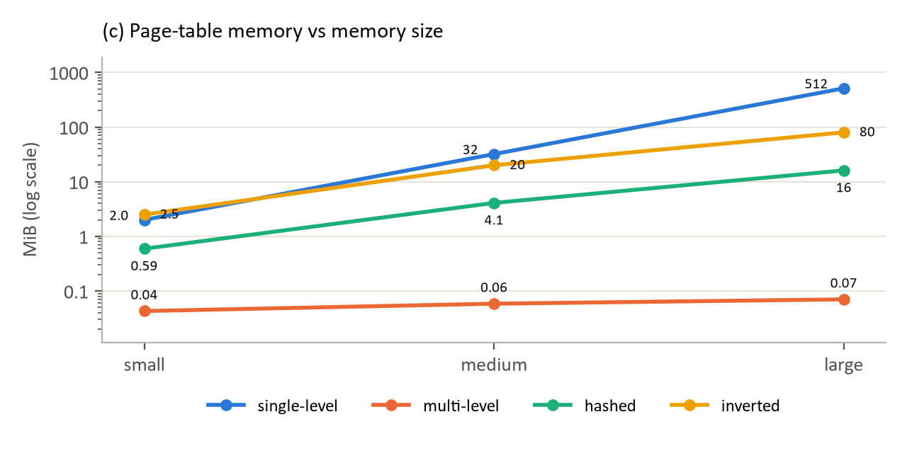
Figure 3: Page-table memory as a function of memory size (logarithmic scale)
Each organization's size is governed by a different quantity (Figure 3). The single-level table scales with the virtual address span, from 2.0 MiB to 512 MiB; the inverted table scales with physical memory, from 2.5 MiB to 80 MiB; and the multi-level table scales only with the mapped pages, remaining below 72 KiB.

4.5 Effect of Access Pattern
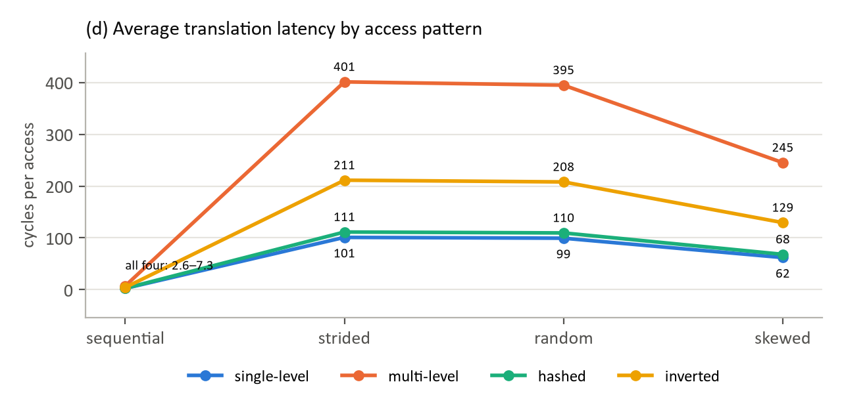
Figure 4: Average translation latency by access pattern
The access pattern alters latency by two orders of magnitude, a larger effect than the choice of organization (Figure 4). Sequential access achieves a TLB hit rate of 98%, and every organization costs fewer than eight cycles per access. Strided and random access almost never hit the TLB, so the multi-level table incurs 401.0 cycles per access under the strided pattern.

4.6 Effect of Process Count
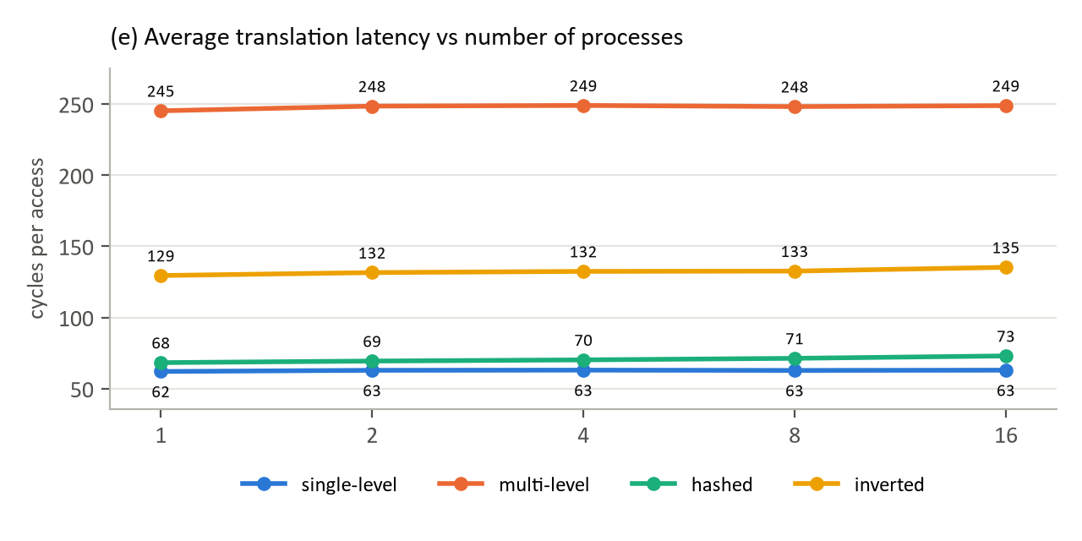
Figure 5: Average translation latency as a function of the number of processes
Per-process tables maintain constant latency as processes are added (Figure 5). The shared tables degrade slightly as their chains lengthen: the hashed table rises from 68.3 to 73.0 cycles and the inverted table from 129.5 to 135.2 cycles. A process-tagged TLB was also evaluated and produced the same hit rate as a flushed TLB, since working sets of 16 MiB evict one another's entries between time slices.

5. Study of Operating System Techniques

5.1 Organization Is Determined by Hardware
Every mainstream operating system examined employs a multi-level page table. This is a consequence of hardware design rather than a free choice: on x86-64 and Arm, the memory-management unit walks a radix tree in hardware, and the operating system must therefore populate that structure [3], [4], [5]. The decision that remains with the operating system is the page size, as summarised in Table 4.
Table 4: Page-table organization and page size by operating system
Operating system | Processor | Page table (fixed by hardware) | Page size (chosen by OS)
Windows x64 | x86-64 | Multi-level, 4 levels | 4 KB; 2 MB large pages on request
Linux x86-64 | x86-64 | Multi-level, 4 or 5 levels | 4 KB; transparent 2 MB huge pages
macOS (Apple Silicon) | Arm | Multi-level | 16 KB
Android | Arm | Multi-level | 4 KB; 16 KB from Android 15
Linux ARM64 (servers) | Arm | Multi-level | 4 KB or 64 KB, fixed at build time
Linux on IBM POWER9 | POWER | Radix by default, or hashed | 64 KB

5.2 Rationale, Advantages and Disadvantages
Table 5: Rationale for each operating system's page size, with its advantages and disadvantages
Operating system | Rationale | Advantage | Disadvantage
Windows x64 | Fine-grained memory for many desktop processes | Low waste; pages are paged individually | Limited TLB reach; large pages require a privilege and contiguous memory
Linux x86-64 | Low waste by default, with reach where beneficial | Huge pages without application changes (THP) | THP can introduce latency spikes and memory bloat
macOS | Apple controls both processor and operating system | Four times the TLB reach of 4 KB pages | Greater rounding waste; software assuming 4 KB pages required changes
Android | Application ecosystem built on 4 KB pages | With 16 KB: app launch 3.16% and boot 8% faster | With 16 KB: slightly higher memory use; libraries must be rebuilt
Linux ARM64 | Arm provides 4, 16 and 64 KB granules | With 64 KB: fewer levels and sixteen times the reach | Up to 64 KB waste per allocation; fixed per kernel build

The entries in Table 5 are drawn from the following sources. Windows large pages are opt-in, non-pageable and require contiguous physical memory [6]. Linux transparent huge pages may be enabled system-wide, restricted to designated regions, or disabled [7]. Apple identifies page size as a difference between Intel-based and Apple Silicon Macs [8]. Google reports the Android 16 KB performance gains together with a slight increase in memory use [9]. The arm64 kernel documents its 4 KB and 64 KB configurations [5].

5.3 IBM POWER9: A Platform Permitting a Change of Organization
POWER servers have traditionally used a hashed page table. Power ISA 3.0, implemented in POWER9, introduced radix tree translation, in which the hardware operates directly on the Linux page tables [10]. Linux now selects the radix tree with 64 KB pages by default, while the hashed mode remains available through the disable_radix boot parameter [11]. IBM attributes the change to cache behaviour: the hashed table "does not cache well" because each entry tends to occupy its own cache line, whereas radix translation "is expected to be more efficient than HPT translation for workloads with high locality of references" [12].

6. What-If Analysis

6.1 Method
The current configuration of each operating system was simulated on the baseline trace, together with the three alternative organizations at the same page size and the current organization at the operating system's alternative page size, at 1 and 16 processes. Changes of organization on x86-64 and Arm are hypothetical, since the hardware walks only radix tables; changes of page size, and the hashed mode on POWER9, are realisable.

6.2 Change of Organization
Table 6: Effect of changing organization on a 4 KB x86-64 or Arm system
Configuration | Latency (cycles) | Change | Memory, 1 process | Memory, 16 processes
Multi-level (current) | 245.2 | — | 60 KiB | 1.0 MiB
Single-level | 62.0 | −75% | 32 MiB | 512 MiB
Hashed | 68.3 | −72% | 4.1 MiB | 5.5 MiB
Inverted | 129.5 | −47% | 20 MiB | 20 MiB

Windows x64, Linux x86-64, Linux ARM64 and Android share the same configuration (multi-level, 4 KB) and therefore produce identical results.
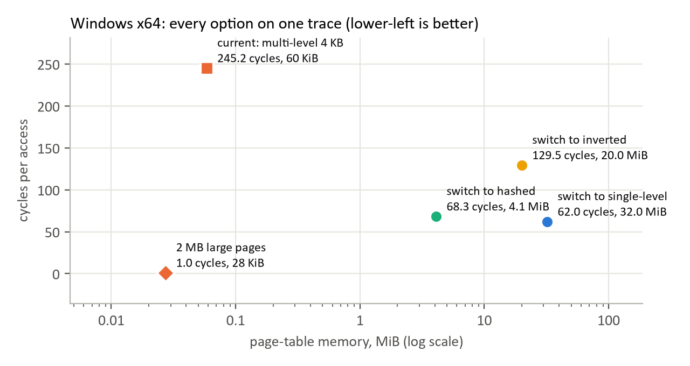
Figure 6: Latency against page-table memory for every option on a 4 KB x86-64 system
Every alternative organization reduces modelled latency, because the multi-level table incurs four references per miss; every alternative also increases table memory substantially. The hashed table requires 70 times the memory of the radix tree, and the single-level table reaches 512 MiB at 16 processes. Figure 6 further shows that the largest improvement is obtained not from a different organization but from 2 MB pages within the existing radix tree.

6.3 Change of Page Size
Table 7: Effect of changing page size (one process)
Operating system | Change | Latency | Table memory | Worst-case waste (1,000 allocations)
Windows x64 | 4 KB to 2 MB | −99.6% | 60 KiB to 28 KiB | 3.9 MiB to 2000 MiB
Linux x86-64 | 4 KB to 2 MB | −99.6% | 60 KiB to 28 KiB | 3.9 MiB to 2000 MiB
macOS | 16 KB to 4 KB | +5% | 176 KiB to 60 KiB | 16 MiB to 3.9 MiB
Android | 4 KB to 16 KB | −5% | 60 KiB to 176 KiB | 3.9 MiB to 16 MiB
Linux ARM64 | 4 KB to 64 KB | −45% | 60 KiB to 512 KiB | 3.9 MiB to 62 MiB
Linux POWER9 | 64 KB to 4 KB | +81% | 512 KiB to 60 KiB | 62 MiB to 3.9 MiB

Larger pages reduce latency at the cost of greater internal fragmentation, and smaller pages do the reverse. This is consistent with Google's findings for Android's adoption of 16 KB pages, and it explains why 2 MB pages remain opt-in on Windows and Linux.

6.4 POWER9 and Validation Against Published Measurements
Table 8: Radix tree against hashed page table on POWER9 with 64 KB pages (simulated)
Scenario | Radix latency | Hashed latency | Radix memory | Hashed memory
1 process | 135.7 | 50.9 | 512 KiB | 262 KiB
16 processes | 142.9 | 56.0 | 9.1 MiB | 352 KiB

The simulator favours the hashed table on POWER9 in both latency and memory, yet IBM adopted the radix tree on account of cache behaviour that the simulator does not model. The same discrepancy appears on x86-64: the simulator predicts a 72% reduction in latency from adopting a hashed table, whereas Yaniv and Tsafrir measured runtimes only 1% to 27% shorter for an optimized hashed table on real hardware [1]. Real processors cache the upper levels of the radix tree, so most misses require one or two memory references rather than four. The direction of the effect is therefore confirmed, but its magnitude is overstated; the latency gains reported in this section should be regarded as upper bounds, and the memory costs as the more reliable result.

7. Conclusion and Future Work

7.1 Conclusion
Each page-table organization trades table memory against memory references. The single-level table is the fastest but the largest; the multi-level table is the most compact but reads every level on a miss; the hashed table offers the best balance; and the inverted table is sized by physical memory alone. Locality of reference and page size affect latency more strongly than the choice of organization.
Windows, Linux, macOS and Android all use the radix tree that their processors walk in hardware, and their effective design decision is the page size. POWER9 is the only platform examined on which the operating system may choose its organization, and there the radix tree was adopted.
Alternative organizations would reduce modelled latency at a substantial cost in memory and would require new hardware on x86-64 and Arm. Page size is the parameter an operating system can practically adjust, and Android's adoption of 16 KB pages illustrates that trade-off in practice.

7.2 Limitations
Latency is derived from fixed cost constants rather than measurement; data caches and page-walk caches are not modelled; workloads are synthetic and generated from a single seed; and operating system configurations are simplified to a 48-bit address space.

7.3 Future Work
Future work comprises the addition of a page-walk cache to the cost model followed by a repetition of the what-if analysis, the implementation of the modern structures proposed in the first review (Elastic Cuckoo or Flattened page tables), and the replay of real application traces.

References
- I. Yaniv and D. Tsafrir, “Hash, don't cache (the page table),” in Proc. ACM SIGMETRICS, Antibes Juan-les-Pins, France, 2016. doi: 10.1145/2896377.2901456. (Abstract consulted.)
- Wikipedia, “Page table.” [Online]. Available: https://en.wikipedia.org/wiki/Page_table
- Microsoft, “Converting virtual addresses to physical addresses,” Microsoft Learn. [Online]. Available: https://learn.microsoft.com/en-us/windows-hardware/drivers/debugger/converting-virtual-addresses-to-physical-addresses
- The Linux Kernel Documentation, “5-level paging.” [Online]. Available: https://www.kernel.org/doc/html/latest/arch/x86/x86_64/5level-paging.html
- The Linux Kernel Documentation, “Memory layout on AArch64 Linux.” [Online]. Available: https://docs.kernel.org/arch/arm64/memory.html
- Microsoft, “Large-page support,” Microsoft Learn. [Online]. Available: https://learn.microsoft.com/en-us/windows/win32/memory/large-page-support
- The Linux Kernel Documentation, “Transparent hugepage support.” [Online]. Available: https://www.kernel.org/doc/html/latest/admin-guide/mm/transhuge.html
- Apple Inc., “Explore the new system architecture of Apple silicon Macs,” WWDC20, session 10686. [Online]. Available: https://developer.apple.com/videos/play/wwdc2020/10686/
- Android Developers, “Support 16 KB page sizes.” [Online]. Available: https://developer.android.com/guide/practices/page-sizes
- A. K. V. Kumar, “powerpc/mm: Use big endian Linux page tables for book3s 64,” Linux kernel commit, 2016. [Online]. Available: https://android-kvm.googlesource.com/linux/+/ee3caed37d763ab28f8ac55563f38fb7530c6252%5E
- TU Berlin DIMA, “POWER9 guide,” fast-interconnects repository, GitHub. [Online]. Available: https://github.com/TU-Berlin-DIMA/fast-interconnects/blob/master/guides/power9.md
- IBM, “IBM POWER9 system software,” IBM J. Res. Dev. Quoted in “Performance of HPT vs Radix?”, RaptorCS forum. [Online]. Available: https://forums.raptorcs.com/index.php/topic,589.0.html
All online sources were accessed in October 2026.

