Capstone Project Description:
- Text to different language translation.
- Text to Speed translation.
Solution:
LLM Model
Backend Logic
Web User Interface
(Using Stream lit)

Step1:

Step:1: Create a Python Virtual Environment and activate the virtual environment using activate.bat file created under my environment (myenv). : This is used to segregate each project work independently and to avoid package dependency issues.
python -m venv myenv
goto /myenv/Scripts/activate.bat
Step2: Install Required libraries as mentioned below:
pip install streamlit
pip install python-dotenv
pip install google-generativeai langchain PyPDF2 chromadb gtts
Pip install openpyxl – for reading xlsx format files.
Step3: Get the Gemini API Key from Google
To download API key, go to https://aistudio.google.com/api-keys and generate a key
Create a Project
Create a key
Copy the key.
Step4: Creating a simple Gemini Translation application using streamlit and can be run using command: streamlit run gemini_translation.py

Final Code Solution below:
- Designed User interface:
  - Given User an option to either enter text or select Csv, XLS, PDF, txt files to upload as shown in image below:

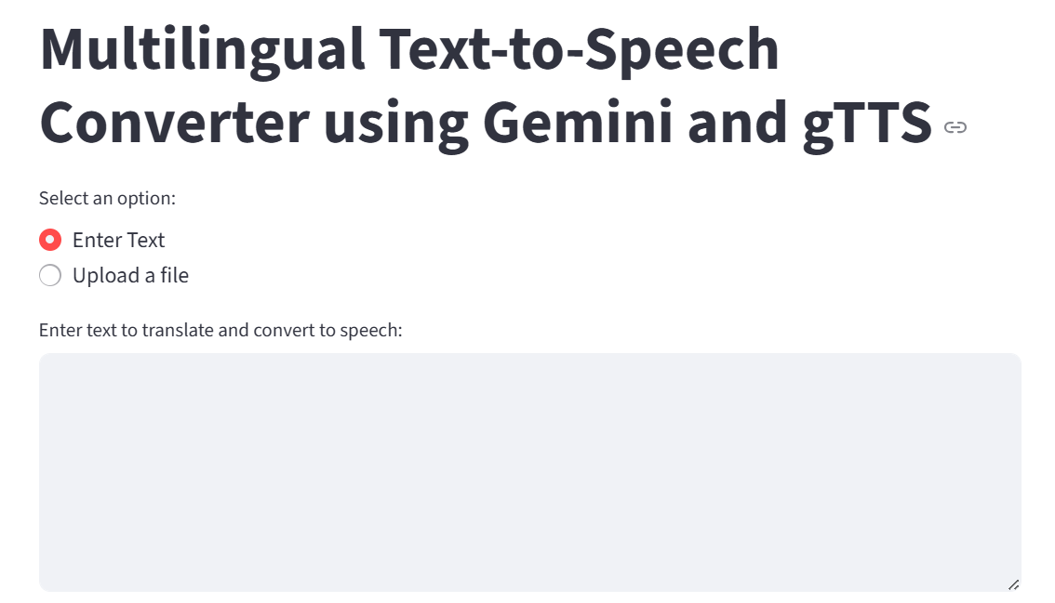

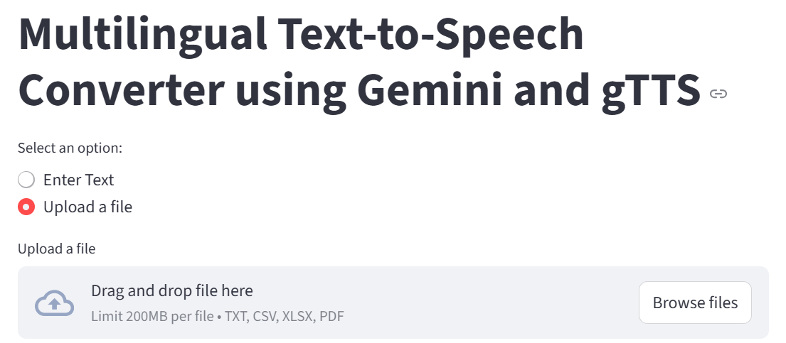

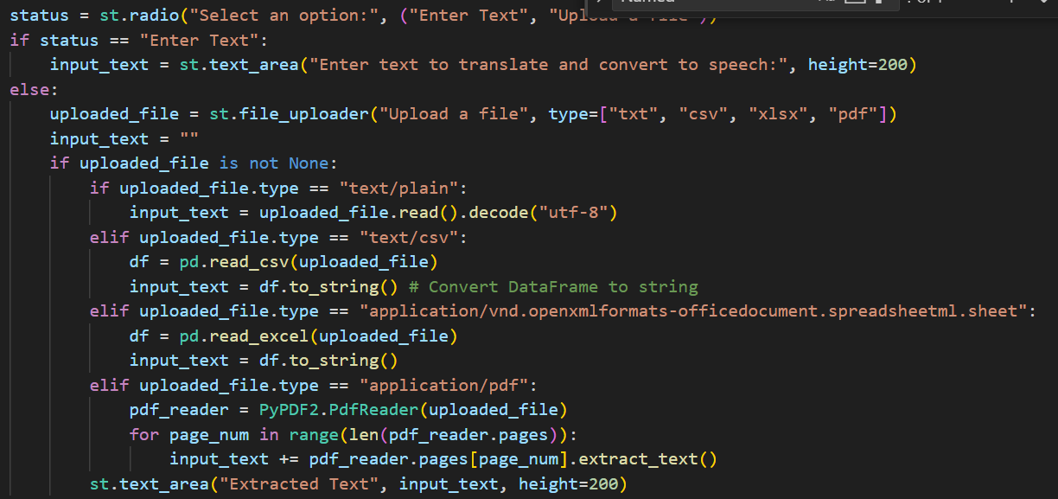

  - Once a file is uploaded, before moving to next step, they can visually see the extracted text from the file as shown below:
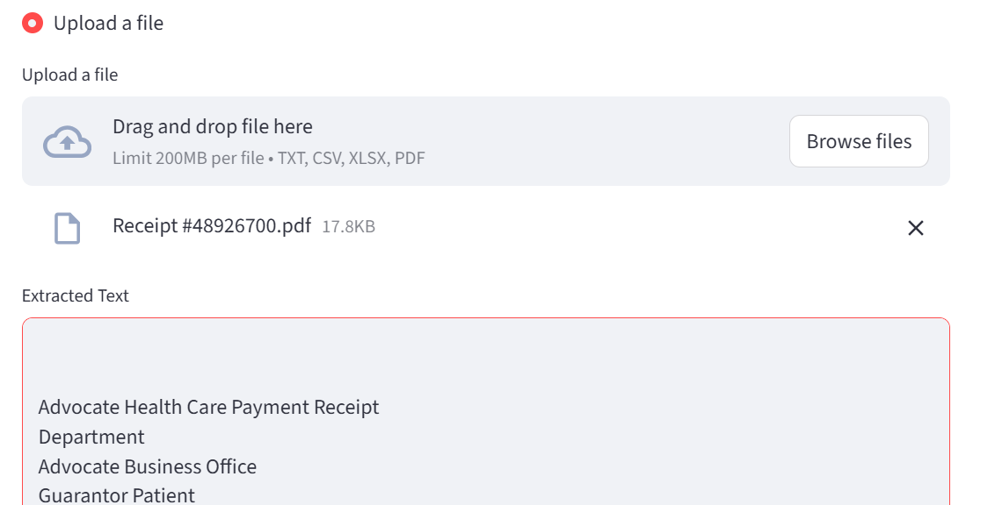

- Allowed user to select language in which they want to translate and convert their speech into using Gemini Translation Interface and GTTS Speech Interface as shown below:
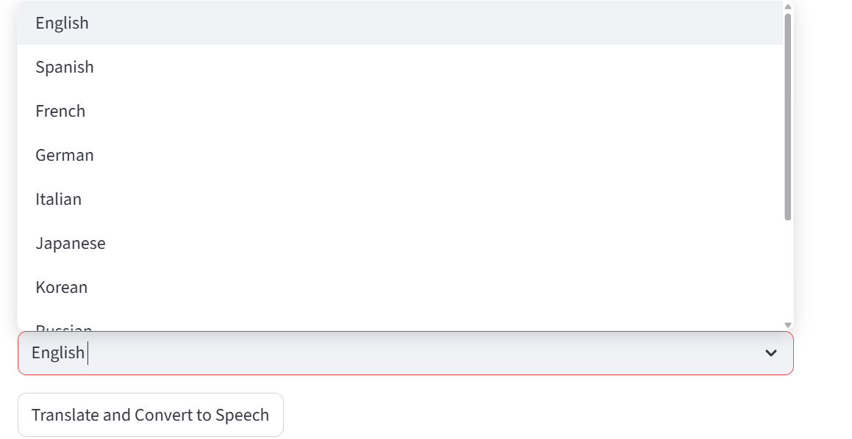
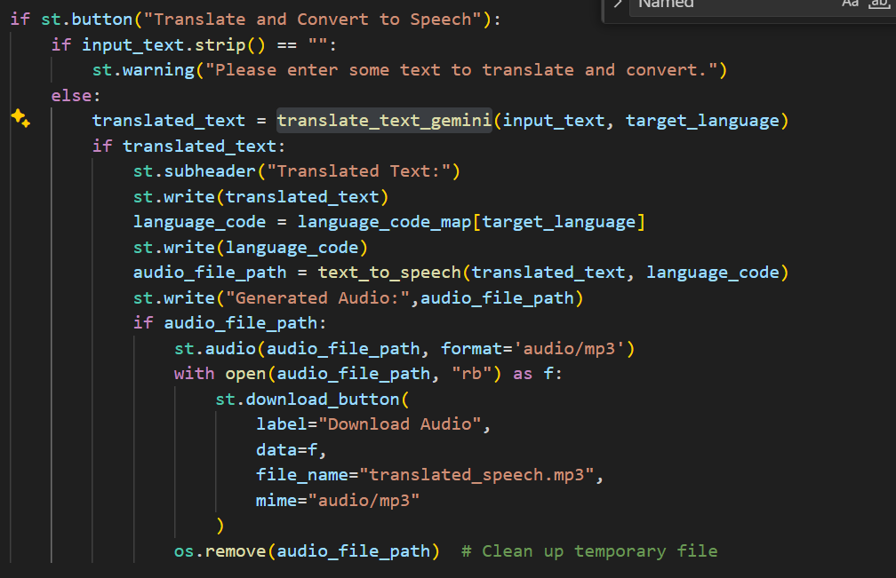

- Added Error Handling:
  - Was getting: 429 (Too Many Requests) from TTS API. Probable cause: Unknown. So, to catch exceptions, try/catch was implemented in the definitions.

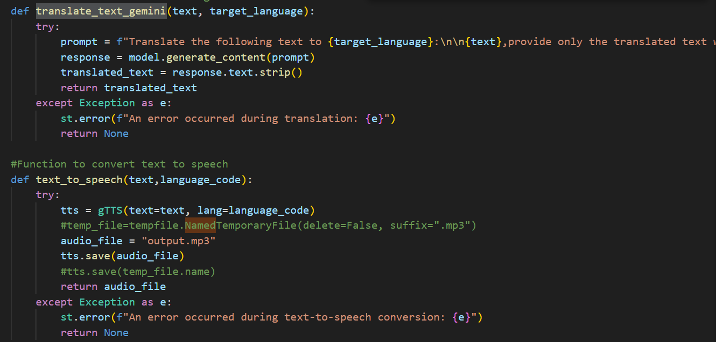

- Challenges during testing & debugging the application: Multiple issues occurring during development, testing & implementation mentioned as below:
  - What Gemini Model should be used for the program and so small code utility was written to extract the models and then tested few using steps below:
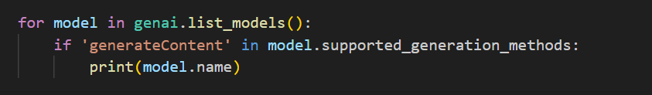
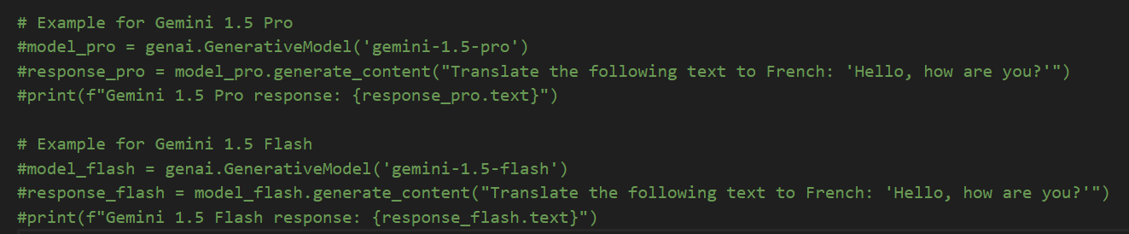
  - Getting 429 Error:
Audio downloading was working earlier but later starting getting GTTS 429 error: Too many requests.
Solution: Need to buy licensed keys now as there was a limitation of100 request.

- Application Deployment

