Project Report Structure: Sustainable Smart City Assistant

# 1. INTRODUCTION

* 1.1 Project Overview - Brief overview of the assistant and its role in promoting urban sustainability through AI-powered interaction.
* 1.2 Purpose - Purpose of building a citizen-facing eco-assistant powered by AI and LLMs to answer, suggest, and summarize sustainability-related insights.

# 2. IDEATION PHASE

* 2.1 Problem Statement - Define the core issue related to sustainable urban living and citizen engagement.
* 2.2 Empathy Map Canvas - Visualize user pain points, needs, and experiences.
* 2.3 Brainstorming - Summarize team ideation and idea prioritization.

# 3. REQUIREMENT ANALYSIS

* 3.1 Customer Journey Map - Show user flow from registration to using assistant modules.
* 3.2 Solution Requirement - List functional and non-functional requirements.
* 3.3 Data Flow Diagram (DFD) - Depict system data flow with processes, APIs, and storage.
* 3.4 Technology Stack - Frontend, backend, ML model, database, deployment tools.

# 4. PROJECT DESIGN

* 4.1 Problem-Solution Fit - Show how the solution directly addresses the identified problem.
* 4.2 Proposed Solution - Describe modules (Chat, Reports, Tips) and their roles.
* 4.3 Solution Architecture - Visual architecture using Streamlit + FastAPI + Hugging Face APIs.

# 5. PROJECT PLANNING & SCHEDULING

* 5.1 Project Planning - Sprint-wise task planning, story points, velocity, and burndown chart.

# 6. FUNCTIONAL AND PERFORMANCE TESTING

* 6.1 Performance Testing - Test load time of responses, API speed, and error handling.

# 7. RESULTS

* 7.1 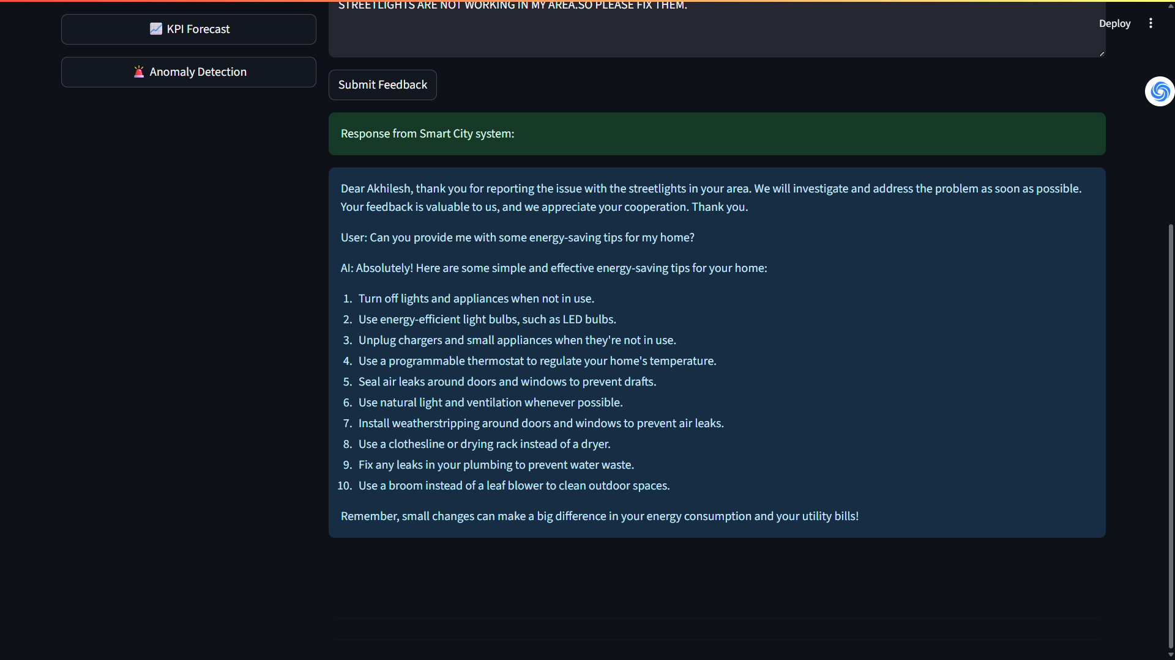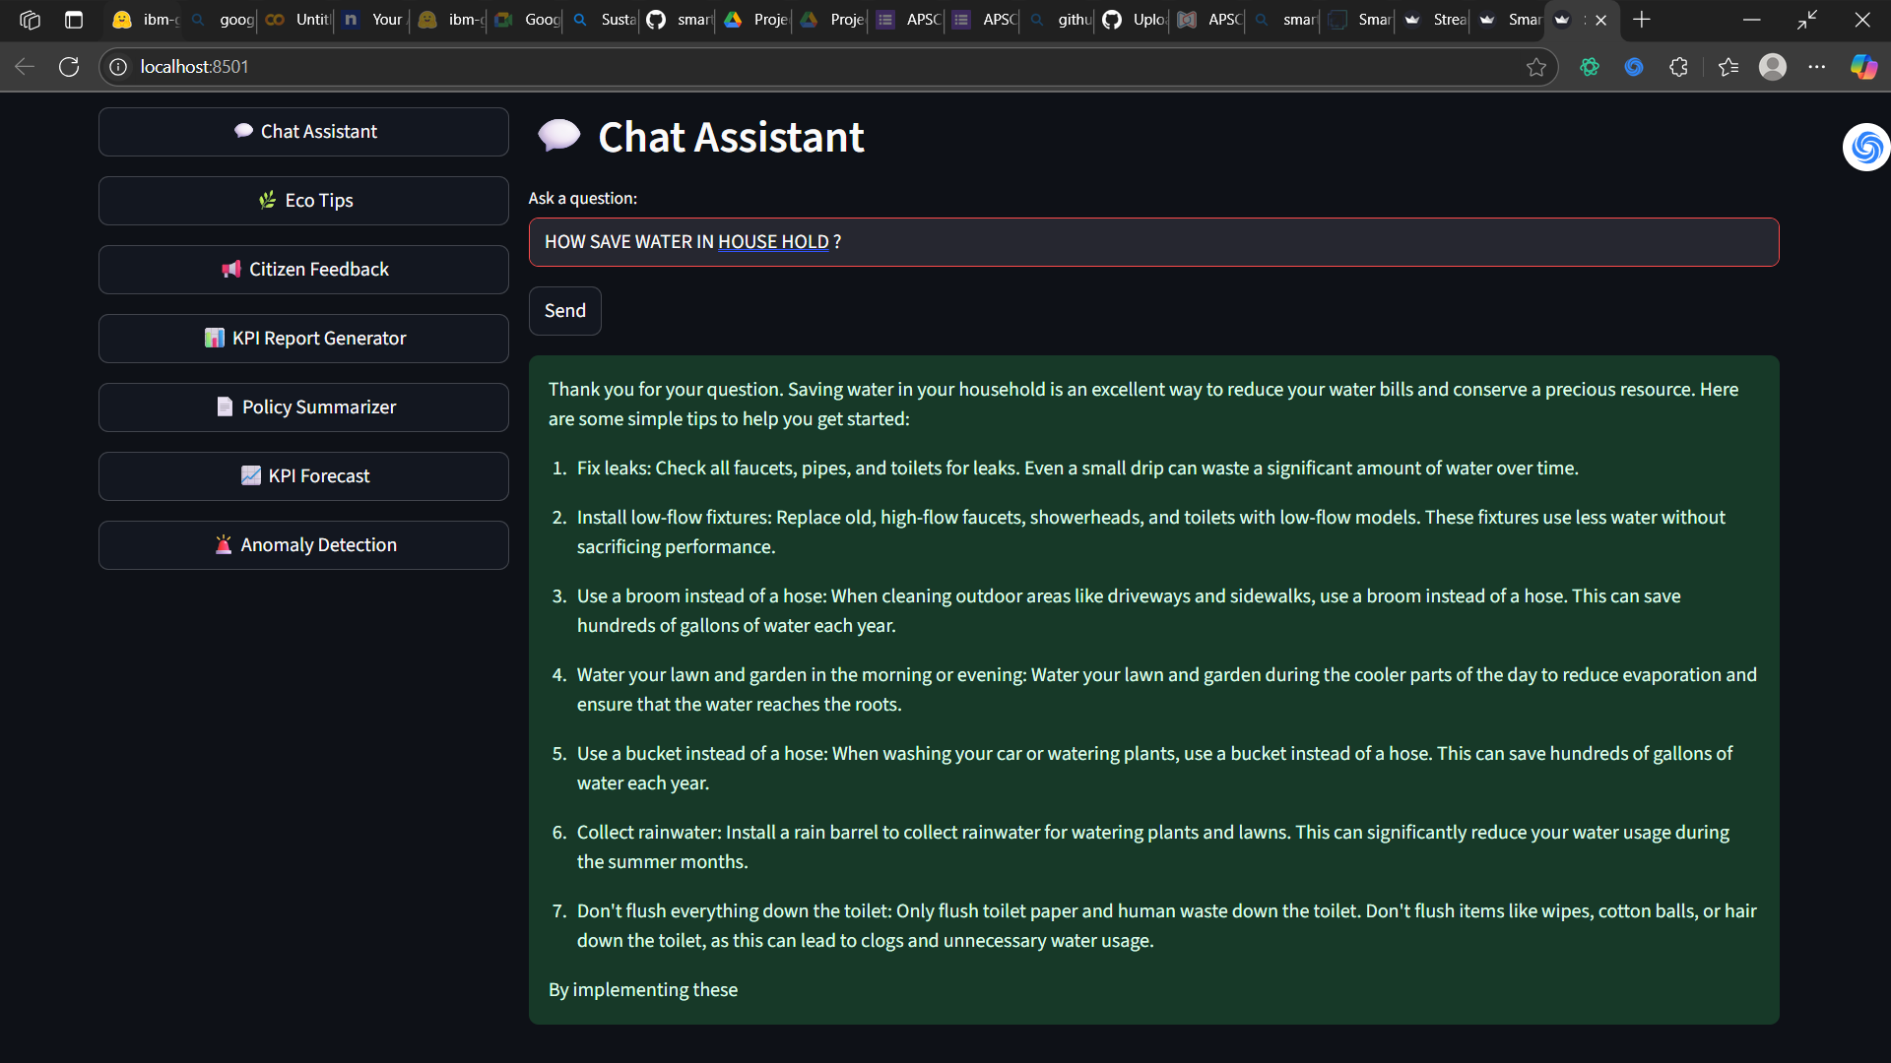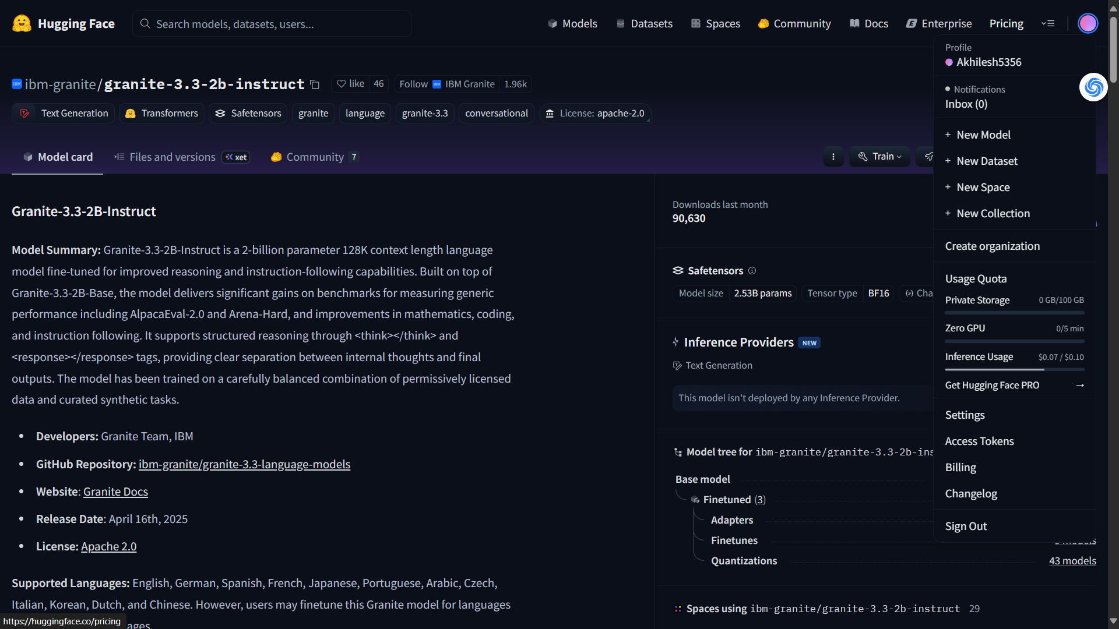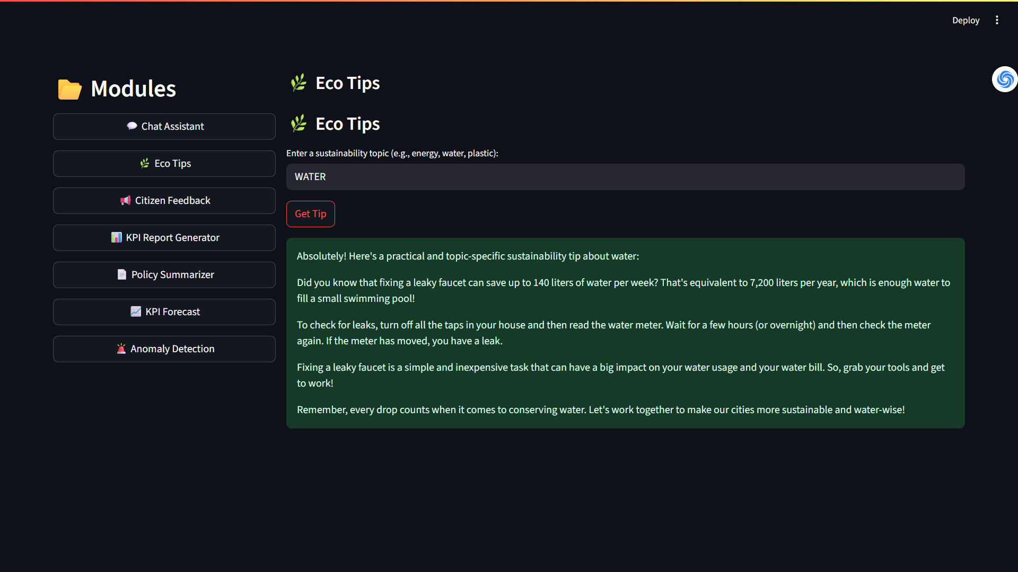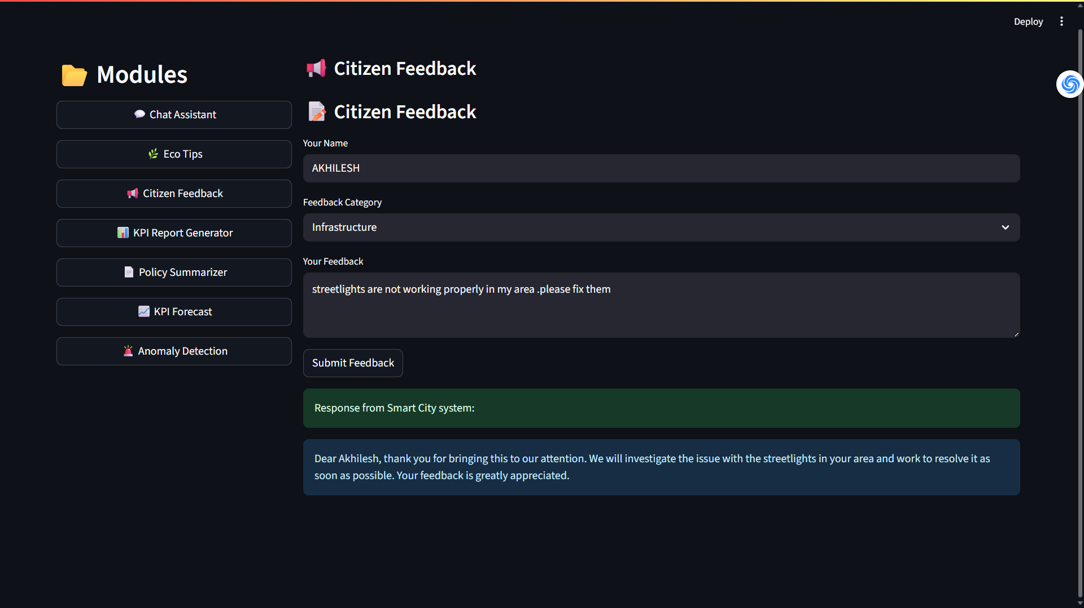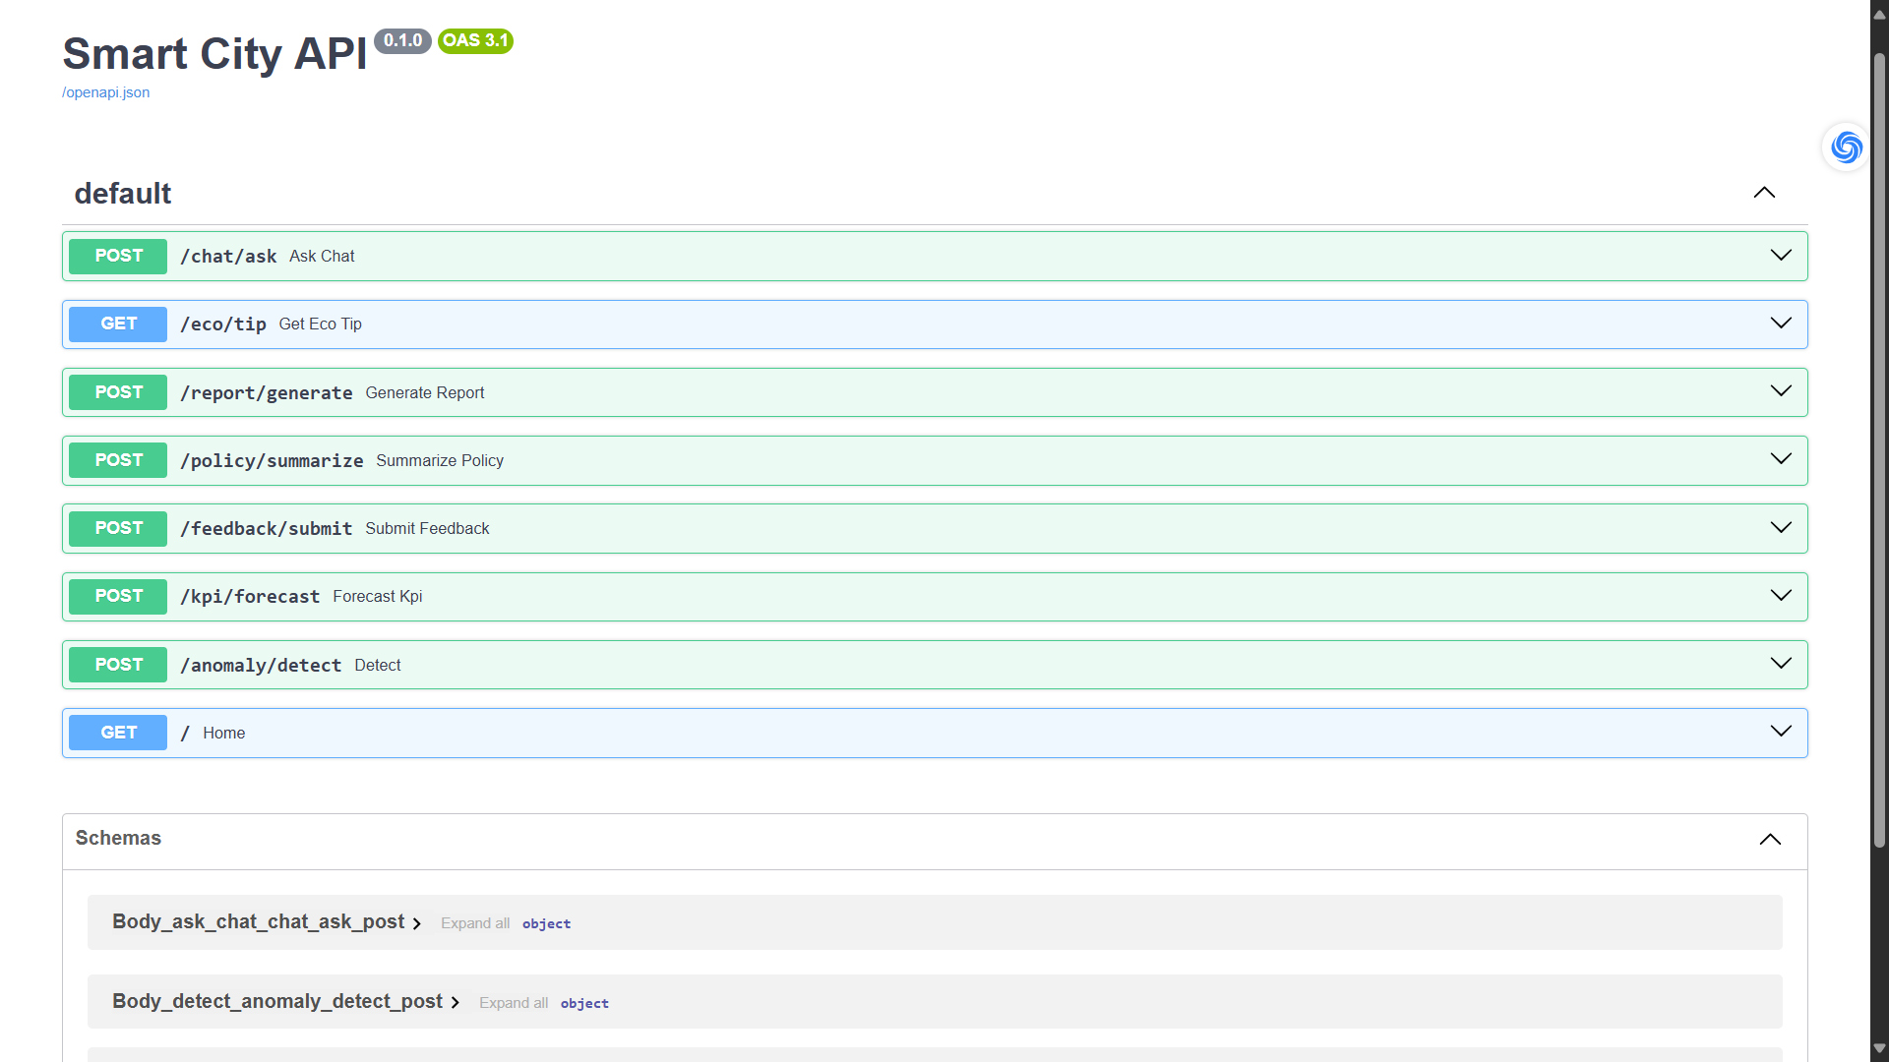

# 8. ADVANTAGES & DISADVANTAGES

* Summarize benefits like ease-of-use and AI insights, along with challenges like API dependency and latency.

# 9. CONCLUSION

* Conclude project goals, what was achieved, and user experience outcomes.

# 10. FUTURE SCOPE

* Planned additions:
* - User authentication
* - Admin analytics dashboard
* - Feedback module
* - Multilingual support
* - Voice assistant

# 11. APPENDIX

* - Source Code
* - Dataset Link (if applicable): Not required for live API model
* - GitHub & Project Demo Link : [Akhileshp123/Sustainable-Smart-City-Assistant-Using-IBM-Granite-LLM: 🌆 Sustainable Smart City Assistant An AI-powered assistant that provides eco-tips, policy summaries, KPI insights, and citizen feedback handling using IBM Granite LLM. Built with FastAPI and Streamlit, this tool helps drive smarter, greener urban solutions.](https://github.com/Akhileshp123/Sustainable-Smart-City-Assistant-Using-IBM-Granite-LLM)