24CS283: DBMS LAB (IV Semester) Reg. No.
Task 4
Database, Users and Roles
Date of the Session: Time of the Session:
Pre Lab-Tasks: Answer the following questions before entering into lab.

- What is a tablespace in Oracle, and why is it required to create a database user?

- What is the difference between a database user and a schema in Oracle?

- What are system privileges and object privileges? Give one example of each.

- What is a role in Oracle? Why are roles preferred over granting privileges directly to users?

- What is the purpose of the GRANT and REVOKE commands in database security?

In Lab Task:

Program 1: Installation of Oracle Database Server.
Aim
To create a tablespace for the COMPANY database, create a new database user, assign default/temporary tablespaces, grant required privileges, and finally drop (delete) the user.
Description
In Oracle, a separate “database” is not created using SQL commands like in MySQL. Instead, we typically create a tablespace to store database objects (tables, indexes, etc.).
A user in Oracle is a schema owner. Creating a user means creating a new schema where tables can be created and data can be stored.
To allow a user to log in and create objects, the DBA must grant privileges such as:
- CREATE SESSION (login)
- CREATE TABLE, CREATE VIEW, etc. (object creation)
- UNLIMITED TABLESPACE or a quota on a tablespace (space usage)
Users can be removed using DROP USER … CASCADE, which deletes the user and all objects owned by that user.
SQL Commands / Programs
A) Create a Tablespace for COMPANY
-- Create tablespace (Run as SYS / SYSTEM)
CREATE TABLESPACE company_ts329
DATAFILE 'company_ts01.dbf'
SIZE 100M
AUTOEXTEND ON NEXT 10M MAXSIZE 500M;

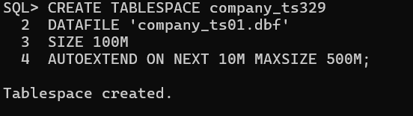

B) Create a New User for COMPANY Database

CREATE USER C##company_user IDENTIFIED BY company123
DEFAULT TABLESPACE company_ts329
TEMPORARY TABLESPACE temp
QUOTA UNLIMITED ON company_ts329;

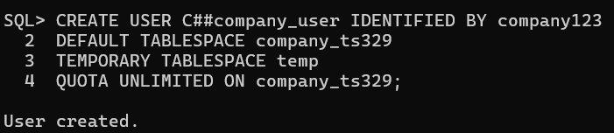

C) Grant Required Privileges to User

-- Allow user to login
GRANT CREATE SESSION TO C##company_user;

-- Allow object creation privileges
GRANT CREATE TABLE,
CREATE VIEW,
CREATE SEQUENCE,
CREATE PROCEDURE
TO C##company_user;

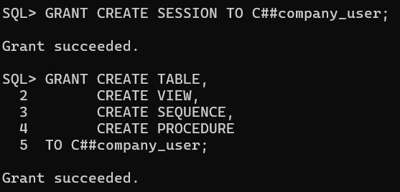

D) Connect as the New User and Create a Sample COMPANY Table

1) Connect as the common user

-- In SQL*Plus / SQL Developer worksheet:

CONNECT C##company_user/company123;

2) Create all COMPANY tables (run in this exact order)
/* =========================
COMPANY DATABASE TABLES
========================= */

/* 1) DEPARTMENT329 */
CREATE TABLE DEPARTMENT 329(
Dname VARCHAR2(15) NOT NULL,
Dnumber NUMBER(2) PRIMARY KEY,
Mgr_ssn CHAR(9),
Mgr_start_date DATE,
CONSTRAINT dept_name_uk UNIQUE (Dname)
);

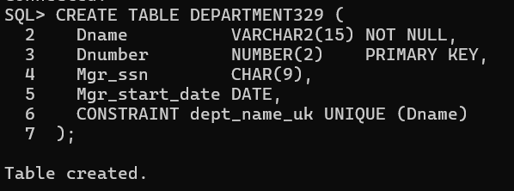

/* 2) EMPLOYEE329 */

CREATE TABLE EMPLOYEE329 (
Fname VARCHAR2(15) NOT NULL,
Minit CHAR(1),
Lname VARCHAR2(15) NOT NULL,
Ssn CHAR(9) PRIMARY KEY,
Bdate DATE,
Address VARCHAR2(80),
Sex CHAR(1) CHECK (Sex IN ('M','F')),
Salary NUMBER(10,2) CHECK (Salary >= 0),
Super_ssn CHAR(9),
Dno NUMBER(2) NOT NULL,
CONSTRAINT emp_super_fk FOREIGN KEY (Super_ssn)
REFERENCES EMPLOYEE329(Ssn),
CONSTRAINT emp_dept_fk FOREIGN KEY (Dno)
REFERENCES DEPARTMENT329(Dnumber)
);

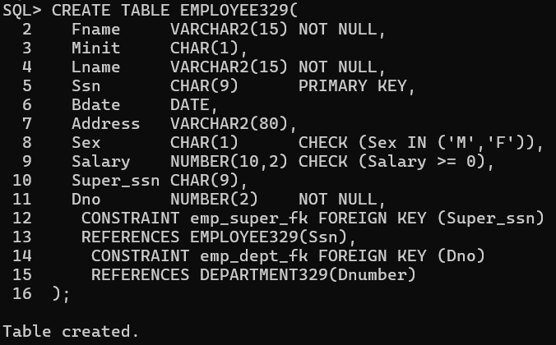

/* 3) DEPT_LOCATIONS329 */

CREATE TABLE DEPT_LOCATIONS329 (
Dnumber NUMBER(2) NOT NULL,
Dlocation VARCHAR2(15) NOT NULL,
CONSTRAINT dept_loc_pk PRIMARY KEY (Dnumber, Dlocation),
CONSTRAINT dept_loc_fk FOREIGN KEY (Dnumber)
REFERENCES DEPARTMENT329(Dnumber)
);

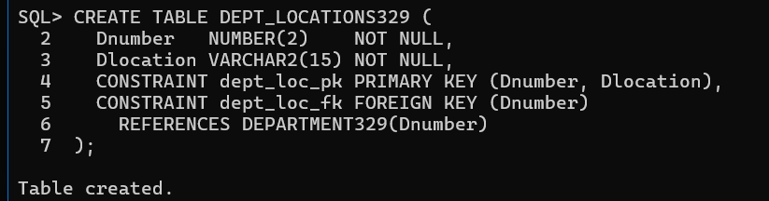

/* 4) PROJECT329 */

CREATE TABLE PROJECT329 (
Pname VARCHAR2(20) NOT NULL,
Pnumber NUMBER(4) PRIMARY KEY,
P_location VARCHAR2(15),
Dnum NUMBER(2) NOT NULL,
CONSTRAINT proj_name_uk UNIQUE (Pname),
CONSTRAINT proj_dept_fk FOREIGN KEY (Dnum)
REFERENCES DEPARTMENT329(Dnumber)
);

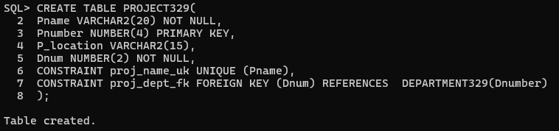

/* 5) WORKS_ON329 */

CREATE TABLE WORKS_ON329 (
Essn CHAR(9) NOT NULL,
Pno NUMBER(4) NOT NULL,
Hours NUMBER(4,1),
CONSTRAINT works_on_pk PRIMARY KEY (Essn, Pno),
CONSTRAINT works_emp_fk FOREIGN KEY (Essn)
REFERENCES EMPLOYEE329(Ssn),
CONSTRAINT works_proj_fk FOREIGN KEY (Pno)
REFERENCES PROJECT329(Pnumber)
);

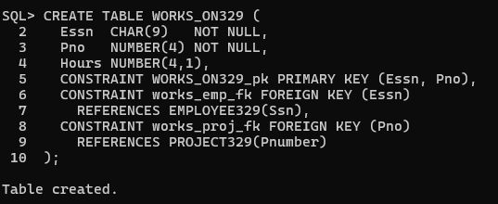

/* 6) DEPENDENT329 */

CREATE TABLE DEPENDENT329 (
Essn CHAR(9) NOT NULL,
Dependent_name VARCHAR2(15) NOT NULL,
Sex CHAR(1) CHECK (Sex IN ('M','F')),
Bdate DATE,
Relationship VARCHAR2(12),
CONSTRAINT dependent_pk PRIMARY KEY (Essn, Dependent_name),
CONSTRAINT dep_emp_fk FOREIGN KEY (Essn)
REFERENCES EMPLOYEE329(Ssn)
);

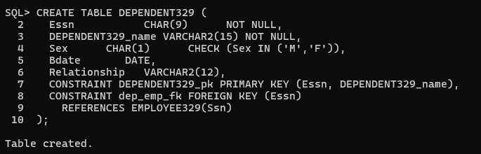

/* 7) Add DEPARTMENT329 manager FK AFTER EMPLOYEE329 is created */

ALTER TABLE DEPARTMENT329
ADD CONSTRAINT dept_mgr_fk FOREIGN KEY (Mgr_ssn)
REFERENCES EMPLOYEE329(Ssn);

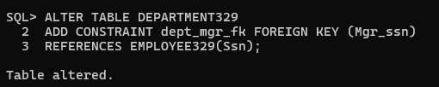

8) Verify Tables Created Under C##company_user
SELECT table_name
FROM user_tables
ORDER BY table_name;

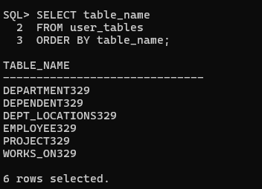

Program 2: Manage privileges and roles using GRANT and REVOKE.

Aim

To manage user access in Oracle by assigning and removing system privileges and roles using the GRANT and REVOKE commands.

Theory

In Oracle, privileges control what operations a user can perform.

Types of Privileges:
- System Privileges
Allow users to perform database-level operations
Examples: CREATE SESSION, CREATE TABLE, CREATE VIEW
- Object Privileges
Allow access to specific database objects
Examples: SELECT, INSERT, UPDATE on tables
Roles:

A role is a collection of privileges that can be granted or revoked as a group, simplifying privilege management.

Important Rule:
Only users with DBA privileges (SYS/SYSTEM) can grant or revoke system privileges.

Pre-condition

Login as a privileged user:

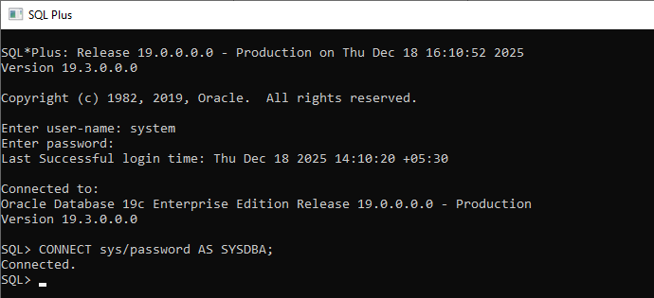

SQL Commands / Programs

- Connect as SYS (Mandatory)

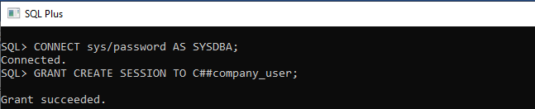

- Grant System Privileges to User

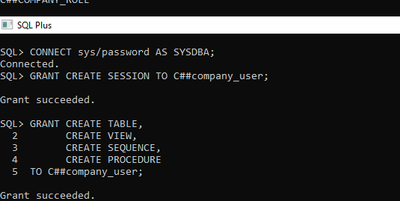

- Create Role (If Not Already Exists)

CREATE ROLE C##company_role;

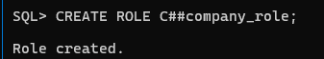

- Grant Privileges to Role

GRANT SELECT, INSERT, UPDATE, DELETE
ON C##company_user.EMPLOYEE329

TO C##company_role;

GRANT SELECT
ON C##company_user.DEPARTMENT329
TO C##company_role

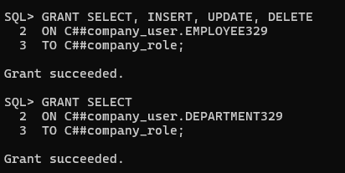

- Assign Role to User

GRANT C##company_role TO C##company_user;

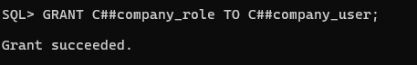

- Verify Granted Privileges

SELECT * FROM dba_tab_privs
WHERE grantee='C##COMPANY_ROLE';

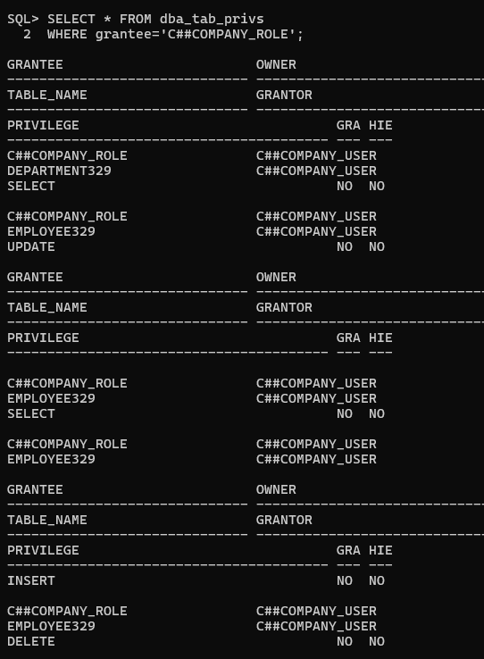

- Revoke Privileges

REVOKE INSERT, UPDATE
ON C##company_user.EMPLOYEE
FROM C##company_role;

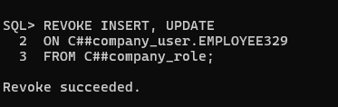

- Revoke Role from User

REVOKE C##company_role FROM C##company_user;

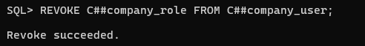

System privileges and object privileges were successfully granted and revoked using GRANT and REVOKE commands. Roles were used to efficiently manage access control in the COMPANY database.

Post-Lab Task: Case Study

Case Study Title:

"User and Role Management for COMPANY Database"

Scenario:

An organization maintains its enterprise data using the COMPANY database. To ensure security and controlled access, the database administrator is required to create database users, define roles, assign privileges, and revoke permissions when necessary. You are assigned the role of a DBA to manage users and roles for the COMPANY database.

Tasks:

Task-1: User and Role Management

- Create a new database user for the COMPANY database and assign an appropriate tablespace and quota.
- Create a role for COMPANY database operations and grant required system privileges to the role.

Task-2: Privilege Assignment and Revocation

- Grant the created role and necessary object privileges on COMPANY tables to the user.
- Revoke one privilege from the role or user and observe the effect.

Note: Paste all query results as screenshots.

Student’s Signature

(For Evaluator’s use only)
Marks Secured: out of _______

Faculty Signature

