Planning

1️⃣ High-Level Idea
This is a Google-map based real-estate listing platform where:

- The real estate prices of Major landmarks are shown on a city map
- Projects/layouts and individual plots ( in future ) of the city are listed
- A buyer (user) can:
  - Explore the real estate market of their city
  - Get details ( like price, next 5 years growth, upcoming developments, nearby amenities, nearby layouts) about some ( around 30 ) landmarks of their city
  - Explore layouts of their city
  - See layouts projects details + documents
  - Book a site visit
  - Request a legal call with a lawyer
  - Set price alerts for specific city/locality
  - Blogs and videos about their city real estate
- A Developer can list their layout / projects and manages inventory, prices, docs, sales team and get leads as site visits
- A Lawyer verifies documents of the listed layouts and review the documents of the projects to buyers
- A Super Admin / Admin / Manager / Marketing team controls the whole system, permissions, and reports.
Think of it as:
99acres UI + Google Maps + in-built Lawyer + Pre-verified docs + full visit workflow.

2️⃣ User Portal – End-to-End Journey
This is exactly what your screenshots show.

2.1 City / Landmarks Overview - real estate market analyser 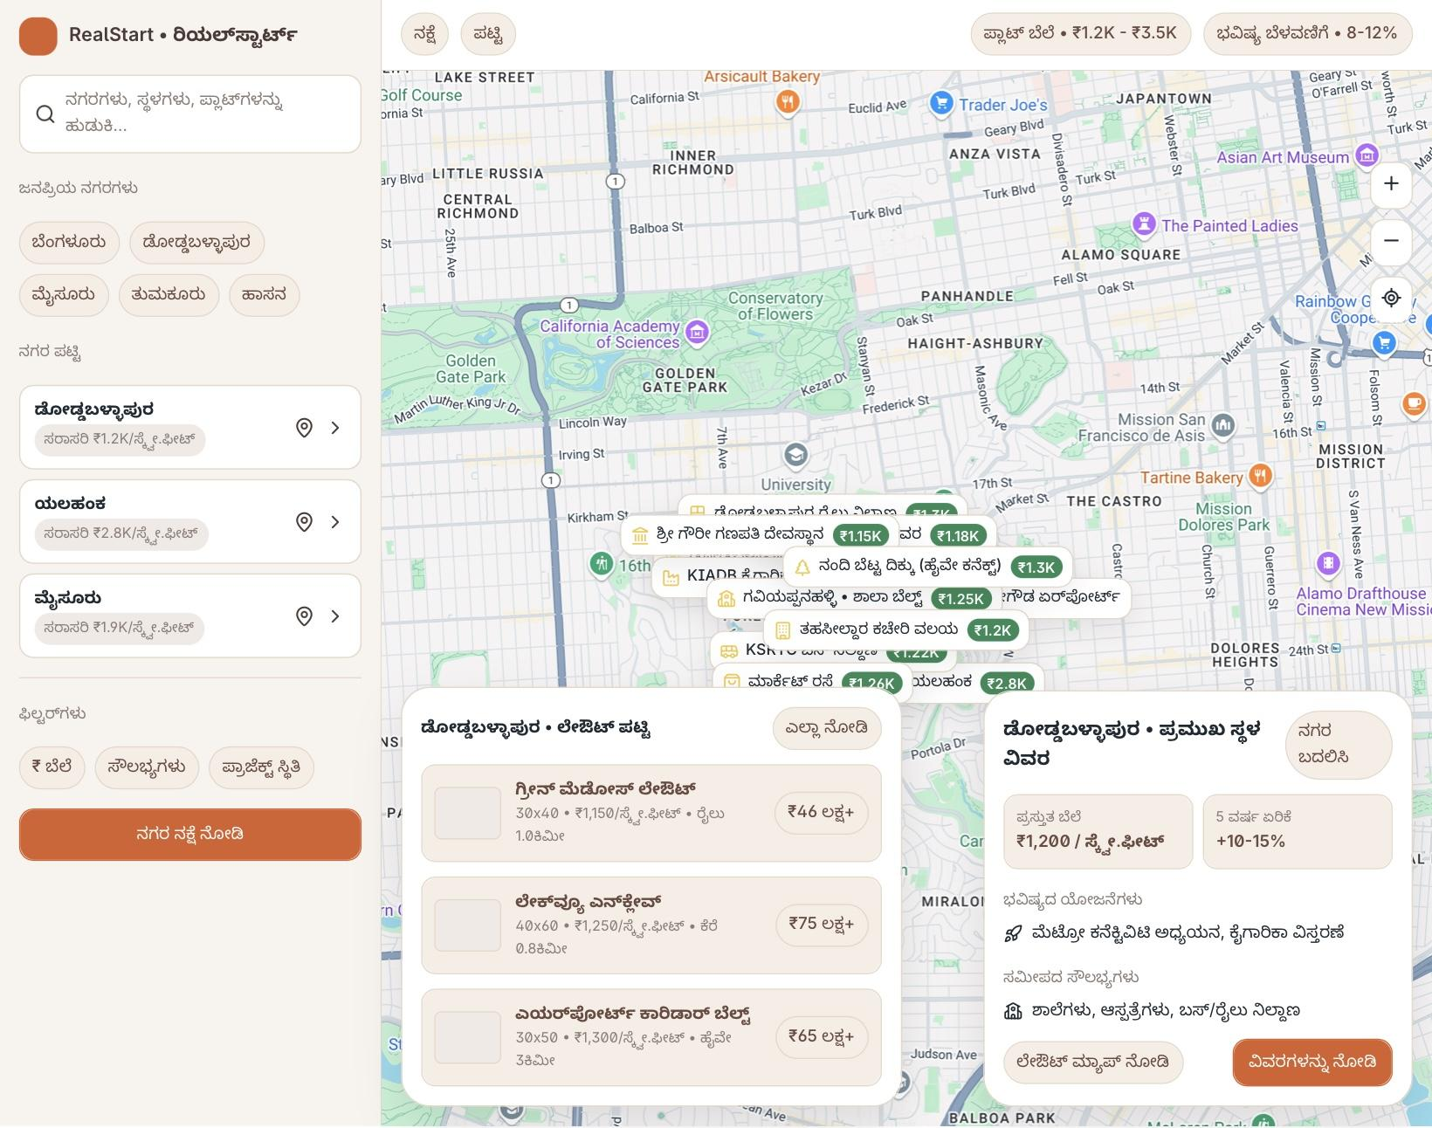
Screen: “Doddaballapur City Map, Top Landmarks in Doddaballapur ”
User can:
- Select City (e.g., Doddaballapur)
- See a city map with:
  - Major landmark of the city and their real estate prices
  - The details of each landmarks (selected)
If buyer select a landmark, a popup tab will open and show details of that landmark
  - Get details of Price, growth in next 5 years and nearby amenities of the landmark. Layout zones, schools, hospitals, connectivity (tabs)
  - List of nearest layouts to that landmark
  - Important price metrics (median price, 3-month trend, active layouts, RERA projects)
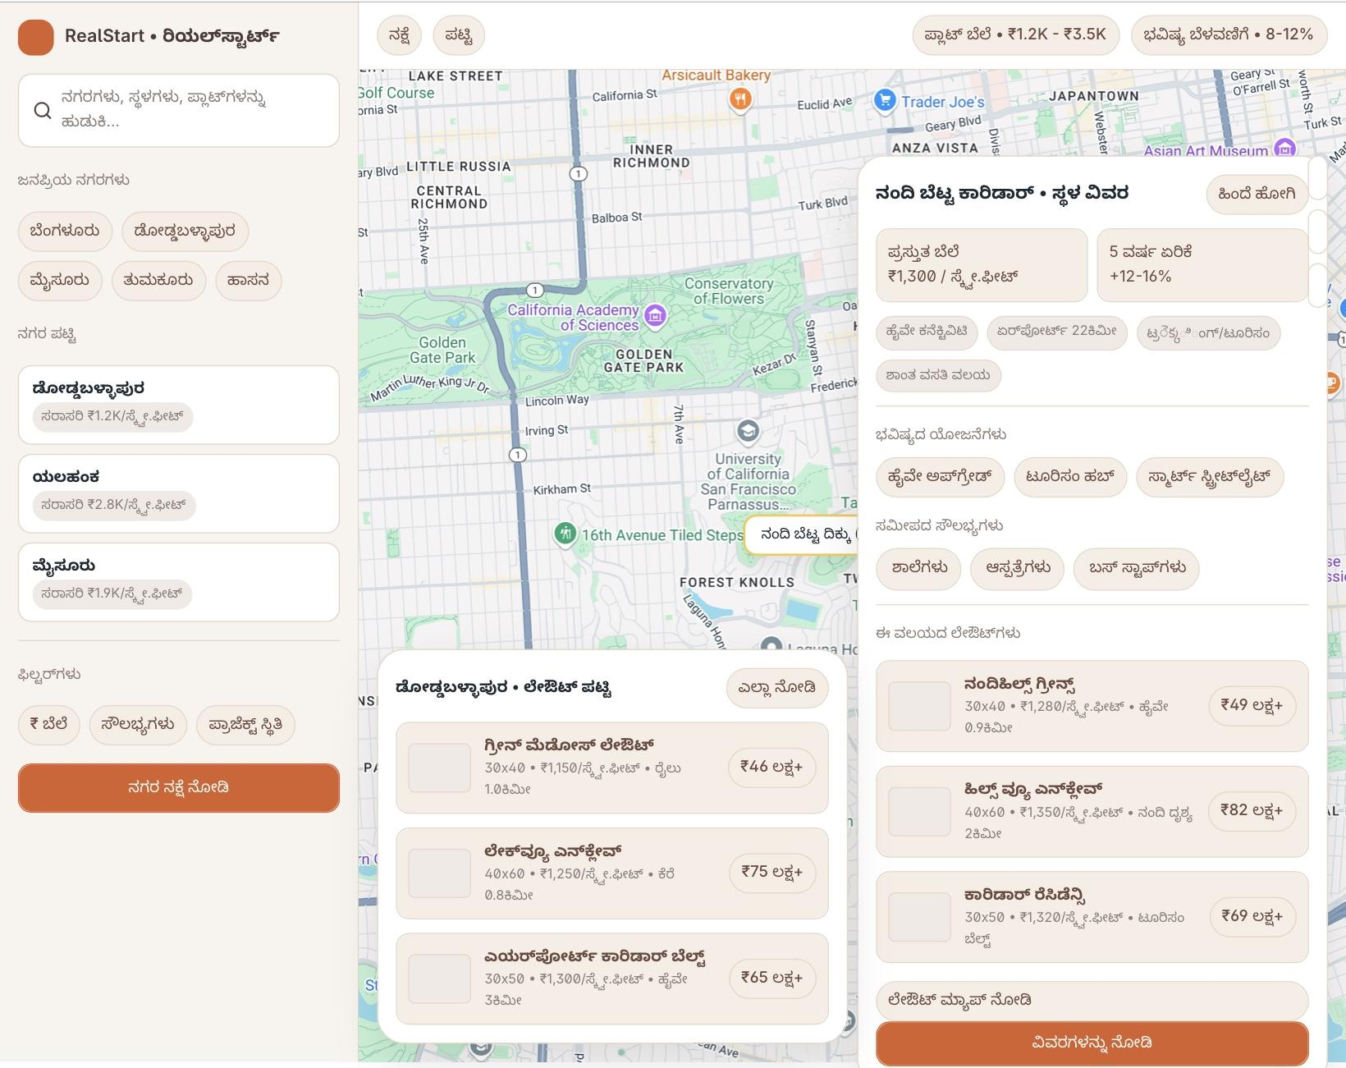
- Right side: Top layouts list
  - Each layout: name,photos, price range, area, locality
  - Button “Get More Details ” – opens specific layout / project.
This page is to help user to know about real estate market of their selected city and landmarks and decide which layout to open.

2.2 Project / Plot Details Page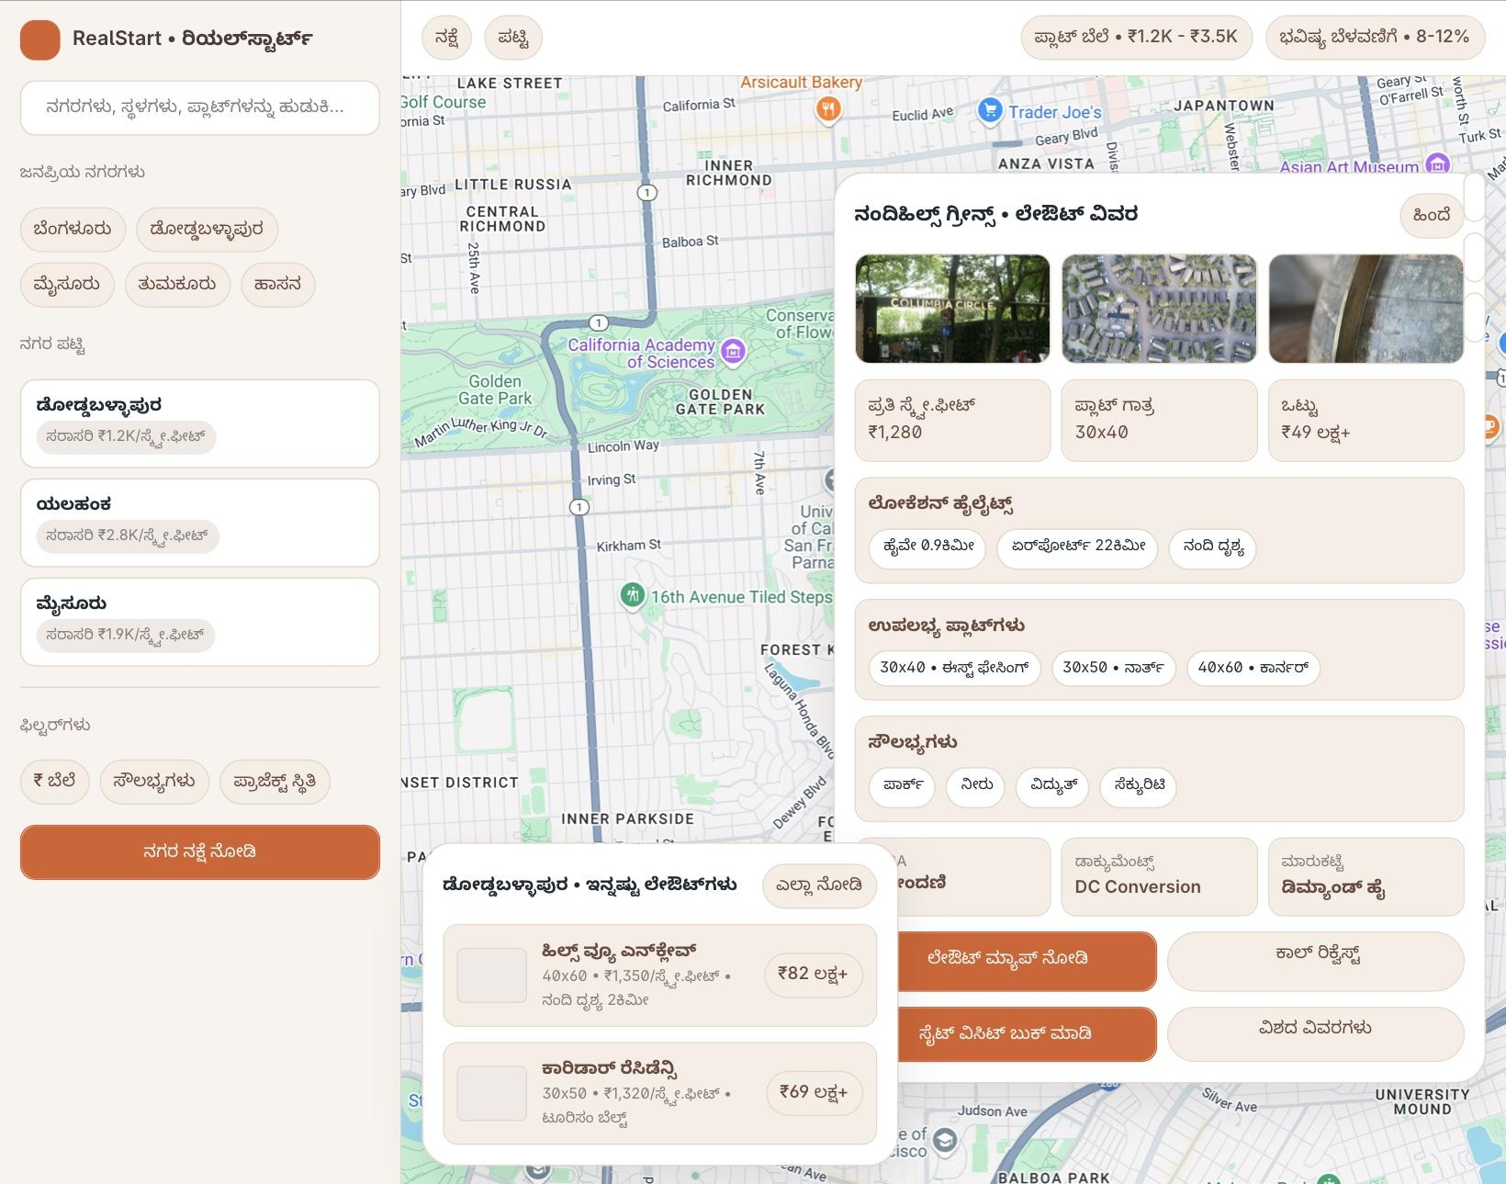
Screen: “ವಿವರಗಳು – Plot A-203”
Here user sees everything about one layout :
- Basic plot info
  - Starting / Average prices of the plots( /sqft)
  - Plots size (e.g., 30x40)
  - Facing (East/West…)
  - Location Highlights
  - Amenities
  - And details as shown in above image
- Location & connectivity
  - Map center on this project
  - Distance & ETA to key points (Airport, Metro, Schools, etc.)
- Important documents summary
  - RTC/ಕತ (EC up to date, 10 years)
  - DC Conversion
  - Layout Approval
  - Each item has status: Ready / Verified / 4 files etc.
- User actions
  - Request details from Call (for this project)
  - From visual of layout
  - Site Visit ( booking )
  - Preferred Day + People for visit
  - View Documents
  - Legal Review ( Lawyer consultation)
  - Interested + Save
  - Share Details
So this screen is the central hub from which:
- Call to get more details starts
- Visit booking starts
- Legal document exploration starts
- Legal call request starts
- Saving/wishlisting the plot starts

2.3 Site Visit Booking
Screen: “Schedule Visit – NandiHills Greens”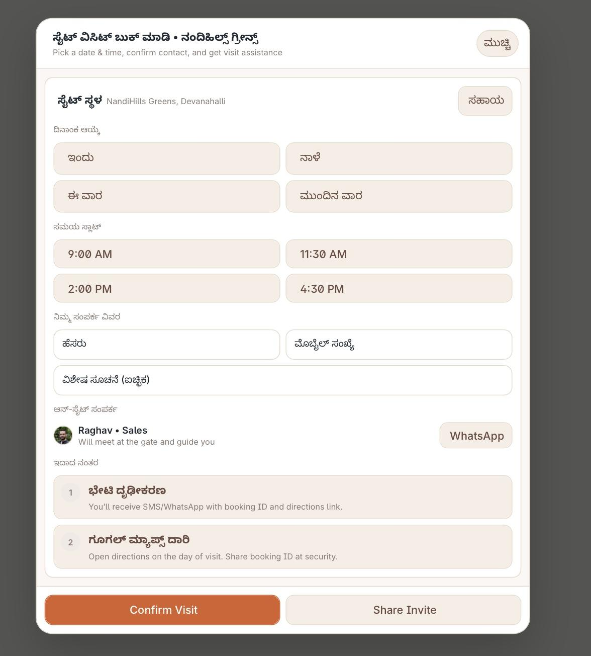
User flow:
- Choose day: Today / Tomorrow / This weekend / Custom.
- Choose time slot (9am, 11:30am, 2pm, 4:30pm).
- Enter Name and Mobile number.
- See Assigned Sales Contact – e.g., “Raghav • Sales, will meet at gate”.
- Click Confirm Visit.
System does:
- Creates a Booking record with:
  - Booking ID
  - Project + Plot info
  - Time slot
  - Assigned sales person
  - Status: Booked

2.4 Visit Confirmation Screen
Screen: “Visit confirmed – Booking ID RS-7842”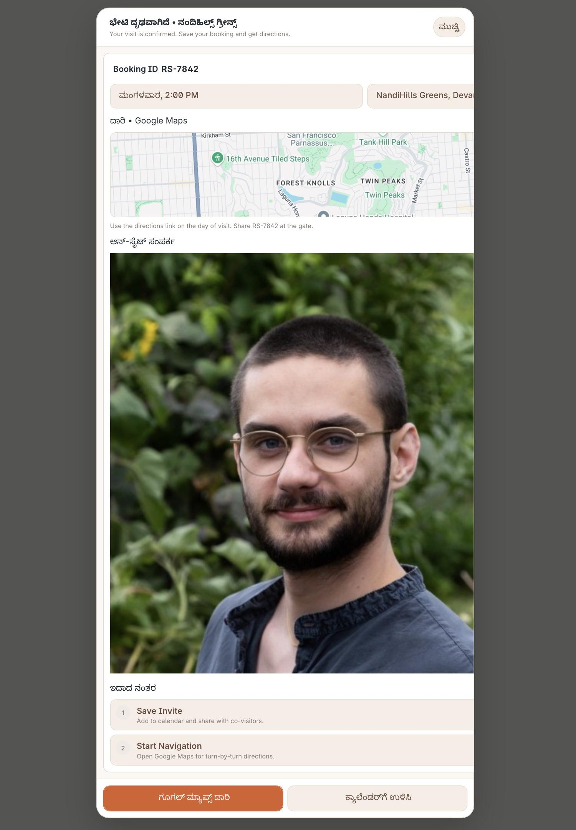
User sees:
- Booking ID & time
- Map with Directions link (Google Maps)
- Sales person photo + name (“Raghav – Sales”)
- Two main actions:
  - Save Invite → add to calendar / share with co-visitors
  - Start Navigation → open Google Maps on visit day
Purpose: User feels confident; knows who meets them, where, when.

2.5 Legal Documents Section
Screen: “ದಾಖಲೆಗಳು – Project legal set”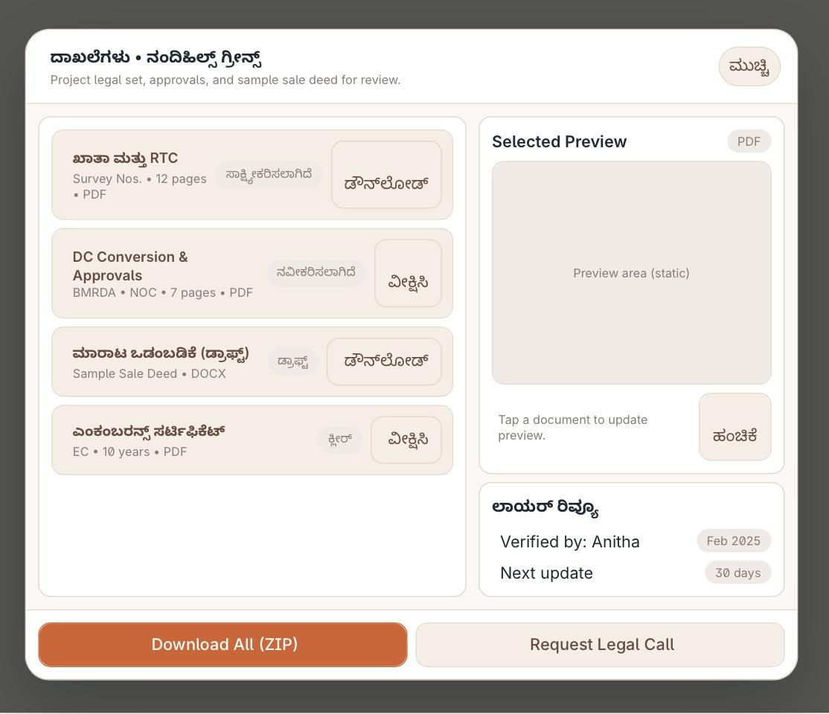
User sees list of pre-uploaded documents from developer:
- RTC/ಕತ (12 pages PDF)
- DC Conversion & Approvals (7 pages PDF)
- Sample Sale Deed Draft (DOCX)
- Encumbrance Certificate (10 years PDF)
Each line has:
- File meta (pages, type)
- Action buttons:
  - Download single
  - Preview (right static viewer)
Bottom actions:
- Download All (ZIP) – zip of all docs.
- Request Legal Call – goes to legal call form.
This gives the assurance: “Documents are already ready & verified”.

2.6 Legal Call Request Form
Screen: “Request Legal Call”
User can:
- Fill Name and Phone
- Choose Preferred Date
- Choose Time Window (e.g., 10:00–13:00)
- Select Topics for call (RTC, DC Conversion, Encumbrance, Sale Deed draft)
- Add Notes for the lawyer
Bottom panel Assignee shows:
- Which Document set
- Which Project
- SLA (e.g., “Within 24 hours”)
- Assigned team: “Anitha – Lawyer”
When clicking Confirm Request:
- System creates a LegalCallRequest object with:
  - User details
  - Project, plot
  - Selected topics
  - Document set reference
  - SLA time

2.7 Legal Call Confirmation Screen
Screen: “Request Confirmed – Legal Call”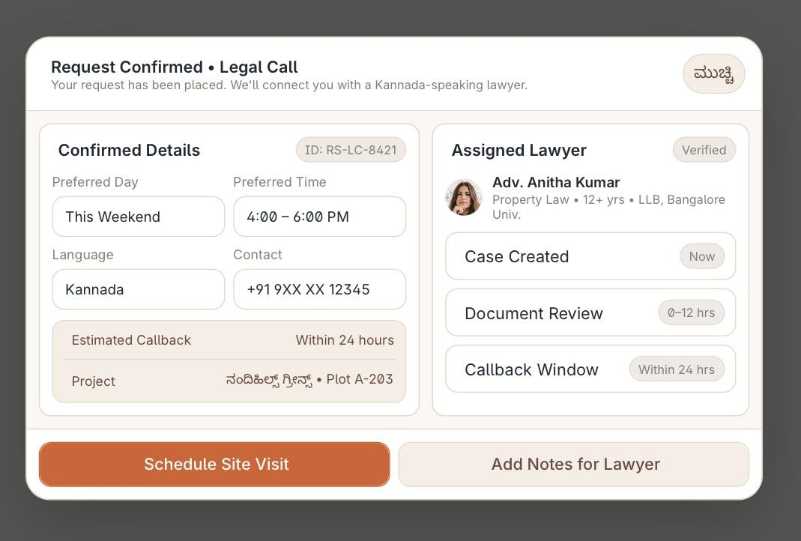
User sees:
- Confirmed details:
  - Preferred Day (This Weekend)
  - Preferred Time (4–6pm)
  - Language (Kannada)
  - Contact number
  - Estimated Callback (Within 24 hours)
  - Project name + plot
- On right: Assigned Lawyer card
  - Lawyer name, photo, experience
  - Steps:
    - Case Created
    - Document Review (0–12 hrs)
    - Callback Window (within 24 hrs)
Actions:
- Schedule Site Visit (cross-link back to visit booking)
- Add Notes for Lawyer (append in the same case)
So from user side, the lawyer workflow is transparent — not a black box.

2.8 Price Alerts
Screen: “ಬೆಲೆ ಎಚ್ಚರಿಕೆಗಳು – Mysuru”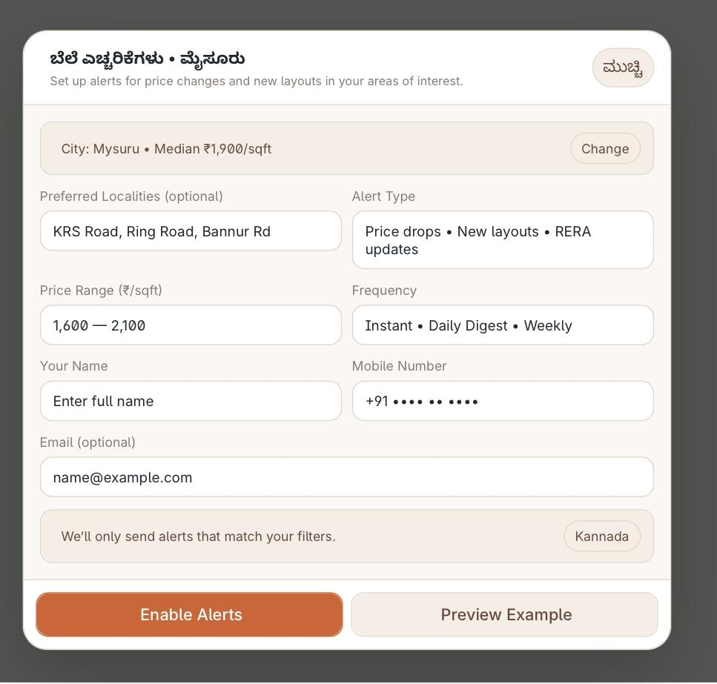
User can:
- Select City and see median ₹/sqft
- Add Preferred Localities (KRS Road, Ring Road etc.)
- Choose Price Range
- Choose Alert Type:
  - Price drops
  - New layouts
  - RERA updates
- Choose Frequency:
  - Instant
  - Daily Digest
  - Weekly
- Enter Name, Mobile, Email
- Choose app language (Kannada/English)
- Click Enable Alerts.
This creates a PriceAlert subscription which is used when:
- Developer / Admin changes prices,
- New layout launches,
- RERA status updates.

3️⃣ Developer Portal – What They Do
Developer has Admin and Marketing roles.

3.1 Developer Admin
Core responsibilities:
- Project Setup
  - Register project/layout (name, photos, location, city, developer company).
  - Upload base map / layout drawing.
  - Mark plots on Google Maps or internal layout grid.
- Plot Inventory
  - For all plot:( starting )
    - Size (e.g., 30x40)
    - Facing
    - Status
    - Rate per sq.ft
    - Base price, all-inclusive price
  - Update availability as sales happen.
- Document Upload
  - Upload RTC, EC, DC conversion docs, approvals, sample sale deed draft.
  - Tag them to a DocumentSet.
  - Send to Lawyer portal for verification.
- Visit Handling
  - See list of Visit bookings from users.
  - Assign/Change Sales person (Raghav etc.).
  - Mark status: Booked → Visited → Follow up → Closed.
  - Ensure the sales person details are reflected in user screens.
- Legal Coordination
  - Receive comments from lawyers (e.g., missing page, new NOC needed).
  - Upload corrected documents.
  - Once lawyer marks “Verified”, status appears in user view as Verified / Ready.

3.2 Developer Marketing Team
- Creates offers (festival discounts, pre-launch price).
- Coordinates with Super Admin/Marketing to:
  - Highlight certain layouts in Top Layouts list.
  - Push special offers to leads and price alert users via WhatsApp/SMS/email.

4️⃣ Super Admin / Admin / Manager / Marketing
This is the platform owner’s control panel.

4.1 Super Admin
- Creates cities, defines zones, add zones details, configures map settings.
- Onboards Developer accounts and sets their access for each project.
- Onboards Law firms / Lawyers with SLAs and pricing (if paid service).
- Sets global rules:
  - Visit slot durations and timings (9:00, 11:30, etc.).
  - Max visits per slot per project.
  - Legal call SLAs (within 24 hours, etc.).

4.2 Admin / Manager
- Monitors lead funnel:
  - Projects → Plot views → Site visits → Legal calls → Bookings.
- Assigns internal managers to projects.
- Manages support team who may help users via call/WhatsApp.

4.3 Marketing
- Creates campaigns:
  - City-level (e.g., “Mysuru layouts sale”).
  - Project-level.
- Controls carousels like:
  - “Top layouts in Mysuru”
  - “Newly launched projects”
- Uses analytics:
  - Most viewed plots
  - Conversion from alert → visit
  - Impact of price change

5️⃣ Lawyer Portal – Workflow
Lawyer side is usually handled by external / internal legal team.

5.1 Incoming Items
- Document sets sent by Developer for verification.
- Legal call requests sent by users.

5.2 Document Review
For each project:
- See latest DocumentSet:
  - RTC, EC, DC conversion order, layout approval, sale deed draft, etc.
- Check validity:
  - Duration (EC 10 years etc.)
  - Names/titles
  - Survey numbers match layout
- Add notes, status:
  - Verified
  - Needs Update (specify why)
  - Pending
Their decisions are:
- Visible to Super Admin & Developer
- Summarised on User project page (e.g., “EC – Verified, 10 years up to date”).

5.3 Legal Calls
For each LegalCallRequest:
- See user details, call window, topics selected.
- Review relevant documents first.
- Call user within SLA (e.g., 24 hours).
- After call:
  - Add summary / opinion.
  - Mark status: Completed.
  - Optionally upload a one-page opinion PDF.
This flows back to:
- Super Admin / Developer: for records.
- User: status updates (“Document review done”, “Call_completed”).

6️⃣ Data Flow & Entities (Conceptual)
To help you later with DB design:
- City
- Locality / Zone
- Project (Layout)
- Plot
- Developer (company + users)
- User (buyer)
- VisitBooking
- SalesPerson
- DocumentSet
- DocumentFile
- Lawyer (user)
- LegalCallRequest
- PriceAlert
- Campaign
- ActivityLog (for audit)
Relationships:
- One Project → many Plots.
- One Project → many DocumentSets (versions).
- One User → many VisitBookings, PriceAlerts, LegalCallRequests.
- One Developer → many Projects.
- One Lawyer → many DocumentSets & LegalCallRequests.

7️⃣ Automations Already Implied
From the designs + flowchart, the system should auto-do:
- Visit booking
  - When user books visit:
    - Notify Developer Sales Person (WhatsApp/SMS/app).
    - Send confirmation message to user.
- Visit day
  - Quick link to Start Navigation using stored Google Maps link.
- Legal call request
  - Create case for Lawyer.
  - Start SLA countdown.
  - Notify user if:
    - Lawyer is assigned.
    - Document review completed.
- Price changes
  - When Developer/Admin updates price:
    - Trigger alerts to users who created PriceAlert in that locality/range.
- Document updates
  - When Developer uploads new DocumentSet:
    - Notify Lawyer for review.
    - After verification, update status on user screens (Ready/Verified).

8️⃣ Permissions – Who Can See / Edit What?
- Super Admin
  - Everything, including platform configuration.
- Admin/Manager
  - Per-city or per-project overview, leads, visits, reports.
- Marketing
  - No legal docs; only campaigns, promotions, public content.
- Developer Admin
  - Manage their own projects, plots, docs, sales team.
- Developer Marketing
  - Leads for their projects; campaigns for their own layouts.
- Lawyer
  - Only legal docs + user requests for projects assigned to them.
- User
  - Public data + their personal bookings, alerts, requests.

This is the full in-depth picture of what we have defined right now.

Next step – your part
Now you can tell me:
- Which extra options / flows you want to add:
  - Booking token / advance payment?
  - Multiple users in one visit?
  - Broker/Channel partner portal?
  - More AI features (price prediction, risk score, etc.)?
  - Multi-language content handling?
Can I get
- AI centric price prediction for each zone or landmark?
- QR code for developers and if we scan, it shows separate window of details of the layout
- Payment Gateway while developers add their projects and user get lawyer consultation
- Multiple language content ( Kannada and English )
- One AI chat box ( users can chat with us )
- Push notifications
- Ad column in pages

figma link and others
Figma link : Figma

Client side needs :

Here’s a clean, professional explanation you can send directly to your client about:
- Developer Onboarding (Registration Form Requirements)
- Project/Plot Entry Requirements
- What information the client must give you
- How you will send the document to the client
I’ll give this in a client-ready format so you can copy-paste into WhatsApp/Email.

✅ CLIENT DOCUMENT – Developer Registration & Project Entry Requirements
Dear Sir/Madam,
To onboard your real-estate projects into our platform, we need the following details from your side. This helps us set up your Developer Profile, Project Details, Plot Inventory, and Marketing Visibility.

⭐ 1. Developer Registration Details
(Required to create your Developer Admin account on the portal)

A. Logo
- Upload high-resolution PNG/JPG
- Minimum size: 500×500px
- Transparent background preferred

B. Developer Name
(E.g., ABC Developers Pvt. Ltd.)

C. Company Information
- Registered Company Name
- Owner/Director Name
- GST Number (optional)
- RERA Registration Number (if applicable)
- Office Address
- Contact Email
- Contact Mobile Number
- Corporate Phone (optional)

D. About the Developer
Short description (150–300 words) covering:
- Company background
- Years of experience
- Completed projects
- Ongoing projects
- Core strengths

E. Documentation for Verification
(Uploads in PDF)
- RERA Registration Certificate
- GST Certificate (optional)
- Company PAN (optional)

F. Social Media Links
Provide links for:
- Facebook Page
- Instagram
- LinkedIn
- YouTube Channel
- Website URL
These will be shown on your public developer profile.

⭐ 2. Project Registration Details
(Required for adding each layout/project to the map)

A. Project Basic Info
- Project Name
- Location (City, Zone, Nearby Landmark)
- Exact Google Map Coordinates / Google Pin
- Launch Year
- Approval Type (BIAAPA / BMRDA / MUDA / Panchayat etc.)
- RERA Number (if applicable)

B. Project Documents
(Uploads – PDF format)
- RTC (10 years)
- EC (10 years)
- DC Conversion Order
- Layout Approval Document
- Tax Paid Receipt
- Sample Sale Deed Draft

C. Amenities & Highlights
(E.g. Roads, Electricity, Water, Parks, Security)

D. Contact for Site Visit
- Sales Manager Name
- Mobile Number
- WhatsApp Number
- Email ID
- Profile Photo (optional)

⭐ 3. Plot & Pricing Details

A. Plot Master List
Upload in Excel or provide manually:
- Plot Number
- Plot Size (e.g., 30×40, 40×60)
- Facing (East/West/North/South)
- Status (Available / Sold / Hold)

B. Plot Pricing
Two options:

Option 1 – Fixed Pricing
- Rate per sq.ft
- Base Price
- All-inclusive price (approx)

Option 2 – Area-wise Pricing
(If the cost varies based on sections inside layout)
- North Block rate
- South Block rate
- Park-facing rate
- Corner plot rate
- Road-facing rate
- Any premium charges

C. Additional Charges (Optional)
- Maintenance
- Clubhouse
- Registration fees
- Taxes

⭐ 4. Marketing Assets
To showcase your project beautifully:

Provide:
- Layout Map (HD Image)
- Project Brochure PDF
- Gallery Images (10–20 preferred)
- Promotional Video (optional)
These will be displayed on your project page.

MVP

🚀 MVP — Real-Estate Platform (Google-Maps Based)
The MVP will launch with 3 portals:
Portal | Purpose
User Portal | Explore layouts → Check plot → Book visit → Request legal call
Developer Portal | Upload project & inventory → Handle visits & documents
Super Admin Portal | Manage platform → Onboard developers → Assign cities

1️⃣ MVP – User Portal (Buyer Experience)
✔ City selection → List of layouts/projects
✔ Google-map view for a selected layout
✔ Click a plot → View plot details

Must-have actions for user
Action | Status
Book site visit | ✔ MVP
Request legal call | ✔ MVP
Save plot to wishlist | ❌ (Post-MVP)
Price alerts | ❌ (Post-MVP)

Mandatory plot details included in MVP
- Size (30×40 etc.)
- Facing
- Status (Available / Hold / Sold)
- Rate per sq.ft + base price
- Contact info for sales
- Quick access to Documents (Preview + Download)

2️⃣ MVP – Developer Portal (Project Owner / Sales Team)
Developer can:
Feature | Status
Register developer account | ✔ MVP
Add project(s) | ✔ MVP
Add plots & pricing | ✔ MVP
Upload legal documents | ✔ MVP
Receive site visit bookings | ✔ MVP
Assign sales person | ✔ MVP
Update plot availability | ✔ MVP
NOT included in MVP (but future phase):
- Marketing campaign tools
- Analytics dashboard
- Festival pricing automation

3️⃣ MVP – Super Admin Panel (Platform Owner)
Super Admin can:
Capability | Status
Create & manage cities | ✔ MVP
Onboard developers | ✔ MVP
View all projects & bookings | ✔ MVP
Assign lawyers to projects | ✔ MVP

4️⃣ MVP – Document & Lawyer Workflow
Task | Status
Developer uploads docs | ✔ MVP
Lawyer reviews docs | ✔ MVP
Status visible on User screen | ✔ MVP
Legal call request | ✔ MVP
Lawyer calls and updates request status | ✔ MVP
📌 Opinion PDF upload by lawyer → Post-MVP

5️⃣ MVP – Automations
Automation | Status
SMS/WhatsApp/Email to user after visit booking | ✔ MVP
Notify assigned sales person | ✔ MVP
Notify lawyer on legal call request | ✔ MVP
⏳ Post-MVP automations:
- Price alert push notifications
- Visit day reminder
- Offer broadcast campaigns

6️⃣ MVP Database Entities
- City
- Zones / Landmarks
- Developer
- Project
- Plot
- DocumentSet + DocumentFile
- VisitBooking
- Lawyer
- LegalCallRequest
- SalesPerson
- SuperAdmin
(PriceAlert, Campaign, Wishlist → NOT needed in MVP)

🟢 What MVP Delivers
Buyer | Developer | Admin
Explore landmarks& plots | Add projects | City mgmt
View legal docs | Update status & docs | Developer onboarding
Book site visit | Handle bookings | Assign lawyers
Request legal call | Handle legal doc updates | Full activity visibility
This ensures real business outcomes from day 1:
💰 Site visits = real leads
📞 Legal calls = high-trust conversion
📄 Verified documentation = instant credibility

🔥 Phase-2 upgrades (after MVP success)
These can be added once traffic grows:
Feature | Phase
Price Alert System | Phase 2
Wishlist / Save plots | Phase 2
Multi-language content | Phase 2
Broker / Channel Partner portal | Phase 3
Token payment / Advance booking | Phase 3
AI price prediction | Phase 4
Investment risk rating | Phase 4

🎯 MVP Timeline Breakdown (for client expectation)
Module | Est. Time
User Portal | 25–35 days
Developer Portal | 20–25 days
Admin Panel | 15–20 days
Maps integration | 10–15 days
Lawyer module | 12–15 days
QA + Deployment | 15–20 days
Total realistic timeline: 90–120 days (for full stable MVP)

🔧 1. Recommended Tech Stack (Fast, Scalable & Low-Maintenance)
Layer | Suggested Technology | Reason
Frontend | Next.js + Tailwind + Mapbox/Google Maps | SEO + fast UI + best for dashboards
Mobile App (future) | Flutter | Single codebase for Android + iOS
Backend | Node.js (NestJS) / FastAPI Python | High request volume + modular services
Database | PostgreSQL | Spatial support, ACID & reporting
Object Storage | AWS S3 | Secure document storage
Authentication | JWT + OTP (Twilio/MSG91) | Smooth onboarding
Hosting | AWS / DigitalOcean | Scalable
Realtime Notifications | Firebase / OneSignal | App/web push
📌 Maps API — recommended: Mapbox (cheaper than Google)

🧱 2. ER Diagram (Text Format)
City ───< Project ───< Plot
| |
| > VisitBooking > SalesPerson
|
> DocumentSet ───< DocumentFile
|
> LegalCallRequest ── Lawyer

Developer ───< Project
User ───< VisitBooking
User ───< LegalCallRequest
SuperAdmin (full access)

🗄 3. Database Schema (MVP Required Tables Only)

1️⃣ City
Field | Type
id | UUID
name | Text
state | Text
active | Boolean

2️⃣ Developer
Field | Type
id | UUID
company_name | Text
owner_name | Text
email | Text
phone | Text
office_address | Text
logo_url | Text

3️⃣ Project
Field | Type
id | UUID
developer_id | FK
city_id | FK
name | Text
location | Text
google_map_lat | Decimal
google_map_lng | Decimal
approval_type | Text
rera_no | Text (nullable)
status | Enum (Active/Inactive)

4️⃣ Plot
Field | Type
id | UUID
project_id | FK
plot_no | Text
size | Text (30×40)
facing | Text
rate_per_sqft | Decimal
base_price | Decimal
all_inclusive_price | Decimal
status | Enum (Available/Hold/Sold)

5️⃣ DocumentSet & Files
Table | Field
DocumentSet | id, project_id, version, status
DocumentFile | id, document_set_id, name, type, file_url, pages

6️⃣ VisitBooking
Field | Type
id | UUID
user_id | FK
project_id | FK
plot_id | FK
visit_date | DateTime
assigned_sales | FK(SalesPerson)
status | Booked / Completed / Cancelled

7️⃣ LegalCallRequest
Field | Type
id | UUID
user_id | FK
project_id | FK
plot_id | FK
topics | JSON
preferred_date | Date
preferred_time_slot | Text
lawyer_id | FK
status | Open / Assigned / Completed

🌐 4. API Architecture + Endpoints (MVP Only)

🔑 Authentication
POST /auth/register
POST /auth/login
POST /auth/send-otp
POST /auth/verify-otp

👤 User Portal
GET /cities
GET /projects?city={city_id}
GET /project/{project_id}
GET /plots?project={id}
GET /plot/{plot_id}

POST /visit/book
POST /legal/request

🧱 Developer Portal
POST /developer/register
GET /developer/projects
POST /developer/project/create
POST /developer/project/upload-documents
PUT /developer/plot/update-status
PUT /developer/visit/assign-sales-person

🛡 Lawyer Portal
GET /lawyer/document-sets
PUT /lawyer/document-set/update-status
GET /lawyer/legal-calls
PUT /lawyer/legal-call/complete

🔧 Admin Portal
POST /admin/create-city
POST /admin/onboard-developer
POST /admin/assign-lawyer
GET /admin/dashboard

📘 5. SRS (Software Requirement Specification – MVP Version)

Product Purpose
A platform where buyers can explore layouts on a map, check verified plot information, book visits, and request legal calls while developers & lawyers manage inventory and documents in real time.

Primary Actors
- Buyer (User)
- Developer
- Sales Person
- Lawyer
- Super Admin

Functional Requirements
Module | Requirement
User | Explore layouts, view plot info, view documents, book site visit, request legal call
Developer | Add project, add plots & pricing, upload legal docs, manage visits
Lawyer | Review document set, handle legal calls
Super Admin | Create cities, onboard developers, assign lawyers, view reports

Non-Functional Requirements
Category | Requirement
Security | JWT + OTP, role-based access control
Performance | 200ms API avg, caching for repeated reads
Scalability | Microservice-ready, S3 file storage
Data Protection | Encrypted docs, signed URL downloads
Localization | English + future Kannada support

💰 6. Project Milestones + Payment Plan (Client-Ready)
Phase | Deliverables | Time | Payment
Phase 1 | UI/UX + Data models + ERD | 2–3 weeks | 10%
Phase 2 | User Portal | 4–6 weeks | 25%
Phase 3 | Developer Portal | 4–5 weeks | 25%
Phase 4 | Lawyer + Admin Portal | 4–5 weeks | 20%
Phase 5 | QA + Maps + Notifications + Deployment | 3–4 weeks | 15%
Phase 6 | AMC / Support | — | 5%
Total Development Duration: 90–120 days

