Deep Kernel Learning Bayesian Optimization for 2D-Materials Discovery: Search Efficiency Is Not Regression Accuracy
Adapting the DKL-BO framework of Kiyohara & Kumagai (2025) to the Computational 2D Materials Database (C2DB), with a 30-seed statistical benchmark against a descriptor-based Gaussian process and random search.
[Author list and affiliations — TODO]

Abstract
Discovering two-dimensional (2D) materials with targeted electronic properties is limited by the cost of density-functional-theory (DFT) evaluations. We adapt the deep-kernel-learning Bayesian-optimization (DKL-BO) framework of Kiyohara and Kumagai — a CGCNN encoder with attention pooling feeding an exact Matérn-5/2 Gaussian process (GP) — to a local instance of the Computational 2D Materials Database (C2DB), adding 2D-aware vacuum-cutoff graph construction, prototype-aware data splitting, and a strict offline/online evaluation protocol. On a 2,667-material benchmark (766-material held-out pool; 30 seeds; 100 evaluations per run) we compare DKL-BO against a standard GP on 43 hand-crafted descriptors (Std-GP) and random search. Std-GP is the more accurate regressor (band-gap R² = 0.60 vs 0.55), yet DKL is the more efficient search engine: frozen pre-trained DKL retrieves 31.5 of the 50 highest-gap materials versus 22.0 for Std-GP (p ≈ 2×10⁻⁶), and in constrained band-window searches live fine-tuned DKL harvests 16.1 vs 9.9 (window-min) and 11.6 vs 8.3 (window-max) of the top-50 (p < 0.001), overtaking Std-GP within 6–37 cycles. The advantage reproduces on a second, 10,359-crystal 3D dataset. Search efficiency and regression accuracy are distinct axes of merit: DKL wins the search even where it loses on accuracy.

1. Introduction
A single hybrid-functional DFT evaluation of a candidate 2D material costs hours to days of compute; exhaustive screening of thousands of candidates is therefore impractical. Bayesian optimization (BO) addresses this by fitting a cheap probabilistic surrogate to the labels acquired so far and using its predictions and uncertainties to choose the single most promising candidate to evaluate next. The figure of merit for such a campaign is discovery efficiency — how few evaluations are needed to find the top materials — which is not the same quantity as the surrogate's regression accuracy (R²/RMSE). Keeping these two axes separate is the central theme of this report.
The classical surrogate for materials BO is a Gaussian process on hand-crafted descriptors (composition statistics, geometry features). Its ceiling is set by the descriptor list: if no hand-crafted feature resolves the property of interest, the search stalls. Deep kernel learning (DKL) removes this ceiling by learning the representation itself: a crystal graph convolutional neural network (CGCNN) encodes the raw atomic structure into an embedding that is trained jointly with the GP by maximizing the marginal log-likelihood, so the network produces exactly the features that make the GP predict — and quantify uncertainty — best. Kiyohara and Kumagai [1] demonstrated this DKL-BO design on 922 bulk oxides and reported that DKL can locate target materials efficiently even when its pointwise accuracy is poor (their minimum-effective-mass task): “search ≠ accuracy” in their own data.
This work adapts that framework — the method itself is theirs — to 2D materials from C2DB [2] and asks where the learned representation actually pays off. Our contributions are an adaptation and an evaluation, not a new method: (i) 2D-aware crystal-graph construction with a vacuum cutoff that blocks spurious bonds across the vacuum layer of slab geometries; (ii) a single shared “intersection” benchmark dataset with prototype-aware, leakage-checked splits so that all methods and all studies are directly comparable; (iii) a statistically rigorous contest (30 seeds, paired Wilcoxon tests, bootstrap confidence intervals) between DKL-BO, a descriptor Std-GP, and random search, in both unconstrained and band-window-constrained searches; (iv) a pre-training ablation (frozen / fine-tuned / cold-start encoders); and (v) engineering layers on top of the reference implementation — a src/ package with Hydra configuration, a swappable sparse variational GP (SVGP) fallback for out-of-memory regimes (concept following Mamun and Yue [5]), and offline/online evaluation separation. A transfer-learning extension following Lyu et al. [6] is designed but not yet run (Section 7).

2. Methods

2.1 Dataset and filtering
The source is a local ASE-database instance of C2DB (data/raw/c2db.db; ~17,000 materials of which ~8,000 carry band-gap labels — figures quoted from the parent database documentation [TODO: raw counts not re-verified for this rebuild]). Materials were kept if they have a valid HSE06 band gap (gap_hse) above the semiconductor filter min_gap = 0.01 eV, which removes the zero-gap metallic spike; 3,351 materials pass. The benchmark then uses the intersection of gap-labelled and effective-mass-labelled materials so that every search task runs on one shared universe: 2,667 materials (band gap 0.010–10.792 eV; effective mass 0.001–136.2 [TODO: confirm emass units, assumed conduction-band effective mass in units of the electron mass]).
The 2,667 materials are split once into 1,901 training materials and a 766-material held-out pool. The split is prototype-aware — materials sharing a structural prototype are kept on the same side, verified by an explicit no-leakage check — and stratified by band gap so that rare high-gap materials appear in the pool (the pool contains the extreme tails of all four search targets, e.g. 7 of the 1.5% highest-gap materials). The pool is the “exam”: BO campaigns search only the pool, and prediction accuracy is measured only on the pool. No decision about any model ever uses pool information (offline/online separation).
Table 1. Benchmark dataset summary (from data/cache/master.parquet and Phase-1 build log).
Quantity | Value
C2DB raw size (parent DB, claimed) | ~17,000 (~8,000 gap-labelled) [TODO verify]
After gap_hse > 0.01 eV filter | 3,351
Intersection dataset (gap ∩ emass) | 2,667
Train / pool split (prototype-aware) | 1,901 / 766
Pool band-gap range | 0.0197 – 8.681 eV
Pool in window 0.7–3.0 eV | 496 of 766 (64.8%); 214 above 3.0 eV
Hand-crafted descriptors (Std-GP) | 43 (35 composition + 8 structural)
gap_max top-50 / top-10% thresholds | ≥ 5.347 eV / ≥ 4.940 eV (76 materials)

2.2 2D-aware crystal-graph construction
Each material is converted once to a crystal graph and cached (LMDB). Nodes are atoms with one-hot element features (dimension 90, elements H–Th); edges connect atoms within a neighbour-search radius of 8.0 Å, capped at the 12 nearest neighbours per atom, with bond distances expanded in a 10-dimensional Gaussian basis. Because C2DB structures are slabs embedded in vacuum, a periodic neighbour search would create spurious bonds between an atom and the periodic image of the layer across the vacuum region; a vacuum cutoff of 4.0 Å on the z-displacement of any candidate bond blocks these cross-vacuum edges. This is the only structural change relative to the 3D graph construction of the reference implementation.

2.3 DKL surrogate
The DKL surrogate follows [1]: a CGCNN encoder (3 gated graph-convolution layers, hidden dimension 32, LayerNorm and residual connections; 18,593 parameters) with attention pooling — chosen over mean pooling to handle the widely varying unit-cell sizes in C2DB — maps each graph to a 32-dimensional crystal embedding (N_FEA = 32). The embedding, standardized to zero mean and unit variance on the labelled set, is the input to an exact GP with a Matérn-5/2 kernel (initial noise 0.01). Encoder and GP are trained jointly by maximizing the exact GP marginal log-likelihood with Adam (GP hyperparameters lr = 0.01, encoder lr = 10⁻³, no weight decay; 100 epochs with early-stopping patience 20 for offline pre-training). The exact GP is the default at this pool size; a sparse variational GP (SVGP) surrogate is implemented as a configuration-swappable fallback for datasets too large for the O(N³) exact GP (configs/surrogate/gp_svgp.yaml), following the scaling concept of [5] — it is an engineering option, not used for any result in this report.

2.4 BO loop and acquisition
Every campaign starts from n_init = 10 randomly labelled pool materials (identical initial sets across methods for each seed) and runs 100 acquisition cycles; acquiring a material reveals its pre-computed DFT label (simulated-DFT lookup), so campaigns are exactly reproducible. For the unconstrained tasks the acquisition is Expected Improvement (EI, ξ = 0.01), chosen over the reference paper's UCB because it is parameter-free and therefore a fairer three-way contest [note: UCB with β = 0.2 is retained in the configuration (configs/bo/ucb.yaml) and was used in earlier, pre-rebuild experiments]. During a campaign the live DKL variants perform a full joint encoder+GP retrain every 5 cycles (50 joint epochs, 20 GP warm-up epochs) with GP-only refits (50 epochs) in between. For the band-window tasks (Section 3.2) the acquisition is the posterior partial expectation of the in-window reward: window-max scores E[g·1{lo ≤ g ≤ hi}] and window-min scores E[(hi − g)·1{lo ≤ g ≤ hi}], computed in closed form from the GP posterior mean and variance. These score a candidate by how much in-window value the model expects, discounting any posterior mass that leaks outside the window; as σ → 0 they collapse to the true constrained optimum.

2.5 Methods compared and evaluation protocol
Five methods share the same GP back-end, the same acquisition rule, and identical per-seed initial samples; they differ only in how a material is represented. Std-GP: exact GP with ARD on the 43 hand-crafted descriptors (one lengthscale per feature, 100 fitting epochs). DKL (frozen): 32-d embeddings from an encoder pre-trained on the 1,901 training materials, locked during the campaign. DKL (fine-tuned, live): same pre-trained encoder, continually fine-tuned on the acquired labels. DKL (cold, live): no pre-training; the encoder trains only on acquired labels. Random: uniform sampling floor. The window experiments omit the cold variant. Main and window contests use 30 seeds; the SNUMAT generalization study (Section 3.3) uses 10. Discovery metrics: best value found vs cycle, cumulative top-50 and top-10% pool materials found, normalized regret AUC, and cycles-to-target; significance is assessed with paired two-sided Wilcoxon signed-rank tests against Std-GP and bootstrap 95% confidence intervals. Following [1], no validation set is used inside the BO loop; GP hyperparameters are fit by marginal likelihood on acquired data only. Regression accuracy (MAE, RMSE, R², 95% coverage) is evaluated separately, offline: train on the 1,901 training materials, predict the 766-material pool. Runs used an NVIDIA RTX A4000 (16 GB).

3. Results
We report discovery efficiency first — it is the primary metric — then regression accuracy, and finally the connection between the two. Throughout, ★ marks a paired Wilcoxon p < 0.05 versus Std-GP over 30 seeds; all values are means over seeds as recorded in results/rebuild/*.csv.

3.1 Unconstrained discovery efficiency (four tasks)
Four unconstrained tasks were run on the shared pool: maximize/minimize the HSE06 band gap (gap_max, gap_min) and maximize/minimize the effective mass (emass_max, emass_min; searched in log10 space). Table 2 summarizes the final state after 100 cycles for all five methods.
Table 2. Unconstrained BO contest on C2DB, mean over 30 seeds after 100 cycles (source: results/rebuild/summary_stats.csv, significance from stats_pairs.csv). Best = best target value found (gap tasks in eV; emass tasks in log10 units). Top-50 / top-10% = number of the pool's 50 best / 10% best materials acquired. ★ = Wilcoxon p < 0.05 vs Std-GP (direction noted); bold = best method per column.
Task | Method | Best found | Top-50 found | Top-10% found
gap_max (opt. 8.68 eV) | Std-GP | 8.68 | 22.0 | 29.8
 | DKL (frozen) | 8.57 ★(−) | 31.5 ★(+) | 42.7 ★(+)
 | DKL (fine-tuned) | 8.40 ★(−) | 25.3 ★(+) | 35.4 ★(+)
 | DKL (cold) | 7.85 ★(−) | 20.3 | 30.2
 | Random | 7.50 ★(−) | 6.8 ★(−) | 10.0 ★(−)
gap_min (opt. 0.020 eV) | Std-GP | 0.024 | 19.1 | 27.8
 | DKL (frozen) | 0.025 | 20.6 | 28.4
 | DKL (fine-tuned) | 0.028 | 17.0 ★(−) | 26.1
 | DKL (cold) | 0.032 ★(−) | 15.5 ★(−) | 24.8
 | Random | 0.054 ★(−) | 6.6 ★(−) | 10.3 ★(−)
emass_max (opt. 2.13, log10) | Std-GP | 1.66 | 14.6 | 19.5
 | DKL (frozen) | 1.50 | 13.3 | 18.0
 | DKL (fine-tuned) | 1.54 | 13.9 | 18.7
 | DKL (cold) | 1.49 ★(−) | 11.4 | 15.9 ★(−)
 | Random | 1.47 | 6.3 ★(−) | 9.7 ★(−)
emass_min (opt. −2.80, log10) | Std-GP | −1.97 | 15.9 | 21.2
 | DKL (frozen) | −1.74 | 15.7 | 21.0
 | DKL (fine-tuned) | −2.10 | 16.7 | 21.5
 | DKL (cold) | −1.99 | 14.7 | 19.3
 | Random | −1.42 ★(−) | 7.2 ★(−) | 10.4 ★(−)
★(+)/★(−): significantly better/worse than Std-GP (paired Wilcoxon, p < 0.05, n = 30 seeds). Emass tasks are searched and reported in log10(emass).

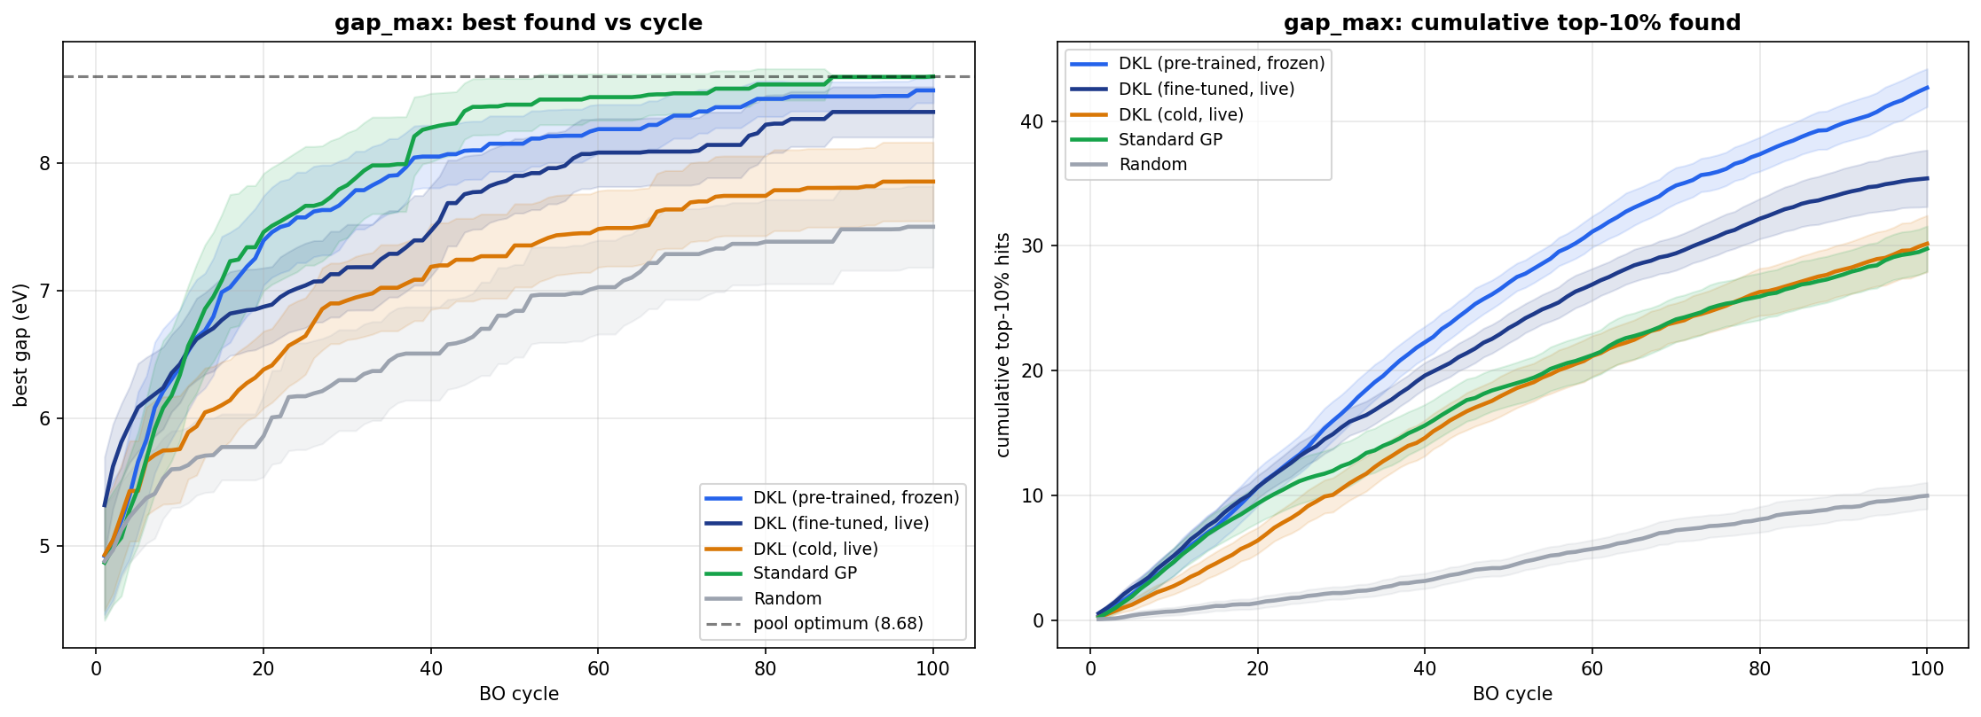
Figure 1. Unconstrained gap_max search on the 766-material C2DB pool (30 seeds; shaded bands = 95% CI). Left: best band gap found vs BO cycle; the dashed line is the pool optimum (8.68 eV), which Std-GP (green) reaches fastest. Right: cumulative top-10% hits; frozen pre-trained DKL (light blue) harvests the most top materials (42.7 vs 29.8 for Std-GP after 100 cycles), overtaking Std-GP from roughly cycle 25 onward. Random (gray) trails all model-based methods. Source: results/rebuild/plots_30seed/gap_max_curves.png.
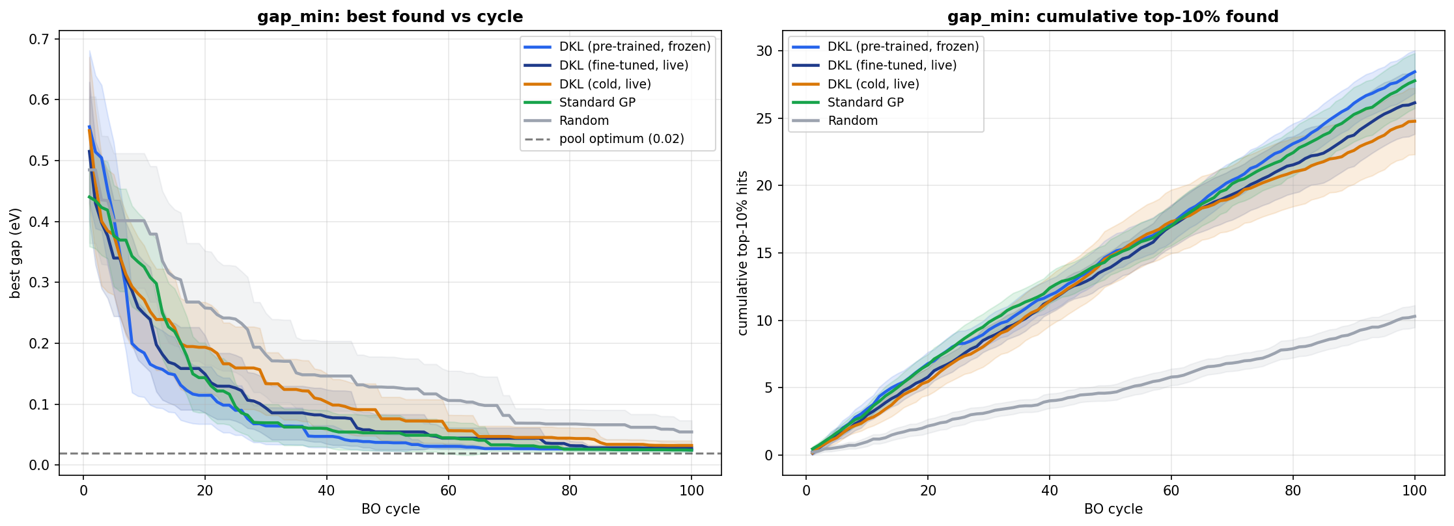
Figure 2. Unconstrained gap_min search (30 seeds, mean ± 95% CI). Left: best (lowest) gap found; every model-based method saturates near the pool optimum (0.020 eV) — final means 0.024–0.032 eV — so the task does not discriminate between surrogates. Right: cumulative top-10% hits; DKL (frozen) 28.4 and Std-GP 27.8 are statistically tied, and all model-based methods clearly beat Random. Source: results/rebuild/plots_30seed/gap_min_curves.png.
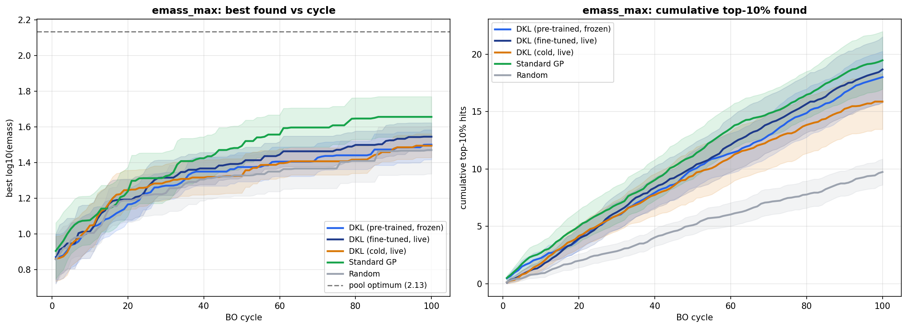
Figure 3. Unconstrained emass_max search in log10(emass) (30 seeds, mean ± 95% CI). Left: best log10(emass) found; Std-GP (green, final 1.66) holds a modest edge over all DKL variants (1.49–1.54); no method reaches the pool optimum (2.13). Right: cumulative top-10% hits; Std-GP 19.5 vs DKL variants 15.9–18.7 — differences mostly within CIs. Source: results/rebuild/plots_30seed/emass_max_curves.png.
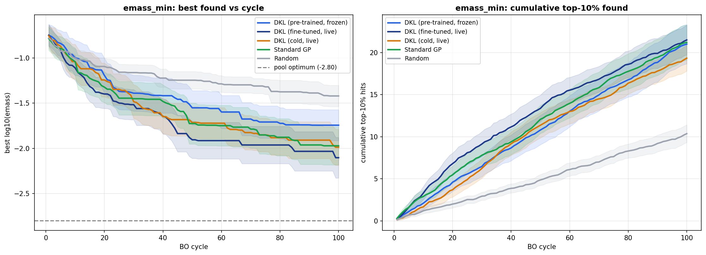
Figure 4. Unconstrained emass_min search in log10(emass) (30 seeds, mean ± 95% CI). Left: best (lowest) log10(emass); fine-tuned DKL reaches −2.10 vs Std-GP −1.97, far above the pool optimum of −2.80 — no method solves this task, and no pairwise difference vs Std-GP is significant. Right: cumulative top-10% hits; all model-based methods cluster at 19–22 vs Random 10.4. Source: results/rebuild/plots_30seed/emass_min_curves.png.
Two patterns matter. First, on the flagship gap_max task the single best point and the harvest dissociate: Std-GP finds the one global optimum faster (it reached the 8.68 eV optimum in all 30 seeds; Table 3), but frozen DKL retrieves half again as many of the pool's 50 best materials (31.5 vs 22.0, p = 2.3×10⁻⁶, per-seed win rate 93%; top-10% win rate 100%). A campaign whose goal is a shortlist of candidates, not a single record-holder, is better served by DKL. Second, the easy extremes do not discriminate: gap_min saturates for every model-based method, and both emass tasks — where neither surrogate achieves useful accuracy (Section 3.4) — end in ties or a slight Std-GP edge.
Table 3. Cycles to reach ≥ 95% of the gap_max pool optimum (8.68 eV), computed from the raw per-cycle run files (results/rebuild/runs*/gap_max__*.csv). Median is over the seeds that reached the target within 100 cycles.
Method | Median cycles (IQR) | Seeds reaching target
Std-GP | 27.5 (15–40) | 30 / 30
DKL (frozen) | 34 (18–66) | 28 / 30
DKL (fine-tuned) | 42 (31–66) | 23 / 30
Random | 48 (23–66) | 9 / 30
Medians for methods with unreached seeds are conditional on reaching the target and therefore flatter the weaker methods; the “seeds reaching” column carries the main signal.

3.2 Constrained band-window discovery — the headline result
Real design problems are constrained: one rarely wants the largest gap, but the largest gap that still satisfies a device rule. We therefore ran two constrained searches inside the band window 0.7–3.0 eV (496 of the 766 pool materials lie inside; anything outside scores zero). Window-max seeks the highest in-window gap (pool best 2.997 eV, just under the ceiling); window-min seeks the lowest in-window gap (pool best 0.701 eV, just above the floor — the 270 out-of-window materials, including the abundant near-metals below 0.7 eV, become traps rather than prizes). Both use the partial-expectation acquisitions of Section 2.4; 30 seeds, 100 cycles, four methods.
Table 4. Window-MAX search (0.7–3.0 eV), final means over 30 seeds (source: results/rebuild/winmax_stats.csv, winmax_crossover.csv). best_inwin = highest in-window gap found (eV; higher better, pool best 2.997); top-50 = number of the 50 highest in-window gaps found. Crossover = first cycle after which the DKL mean stays ahead of Std-GP.
Metric | Method | Mean | Δ vs Std-GP | Wilcoxon p | Win rate | Crossover
best_inwin (eV) | Std-GP | 2.957 | — | — | — | —
 | DKL (fine-tuned) | 2.950 | −0.007 | 0.078 | 27% | —
 | DKL (frozen) | 2.917 | −0.040 ★ | 0.029 | 23% | —
 | Random | 2.948 | −0.009 | 0.112 | 23% | —
top-50 found | DKL (fine-tuned) | 11.6 | +3.30 ★ | 5.5×10⁻⁴ | 70% | cycle 37
 | Std-GP | 8.3 | — | — | — | —
 | DKL (frozen) | 7.4 | −0.90 | 0.277 | 47% | —
 | Random | 7.0 | −1.37 | 0.084 | 27% | —

Table 5. Window-MIN search (0.7–3.0 eV), final means over 30 seeds (source: results/rebuild/winmin_stats.csv, winmin_crossover.csv). best_inwin = lowest in-window gap found (eV; LOWER better, pool best 0.701).
Metric | Method | Mean | Δ vs Std-GP | Wilcoxon p | Win rate | Crossover
best_inwin (eV) | DKL (fine-tuned) | 0.710 | −0.028 ★ | 0.0017 | 60% | cycle 1
 | DKL (frozen) | 0.718 | −0.020 ★ | 0.031 | 57% | cycle 26
 | Random | 0.730 | −0.009 | 0.232 | 53% | —
 | Std-GP | 0.739 | — | — | — | —
top-50 found | DKL (fine-tuned) | 16.1 | +6.20 ★ | 2.1×10⁻⁵ | 87% | cycle 6
 | DKL (frozen) | 12.4 | +2.47 ★ | 0.016 | 67% | cycle 8
 | Std-GP | 9.9 | — | — | — | —
 | Random | 6.4 | −3.57 ★ | 0.0026 | 33% | —

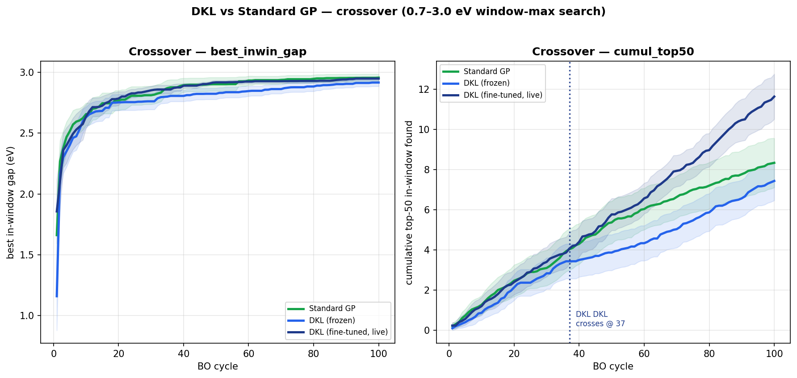
Figure 5. Window-MAX (0.7–3.0 eV) crossover analysis, 30 seeds (mean ± 95% CI). Left: best in-window gap vs cycle — all methods climb to ≈2.95 eV and effectively tie; finding one near-ceiling material is easy. Right: cumulative top-50 in-window materials found — live fine-tuned DKL (navy) overtakes Std-GP (green) at cycle 37 (dotted line) and finishes at 11.6 vs 8.3 (p = 5.5×10⁻⁴); frozen DKL under-performs on this constrained task. Source: results/rebuild/plots/winmax_crossover.png.
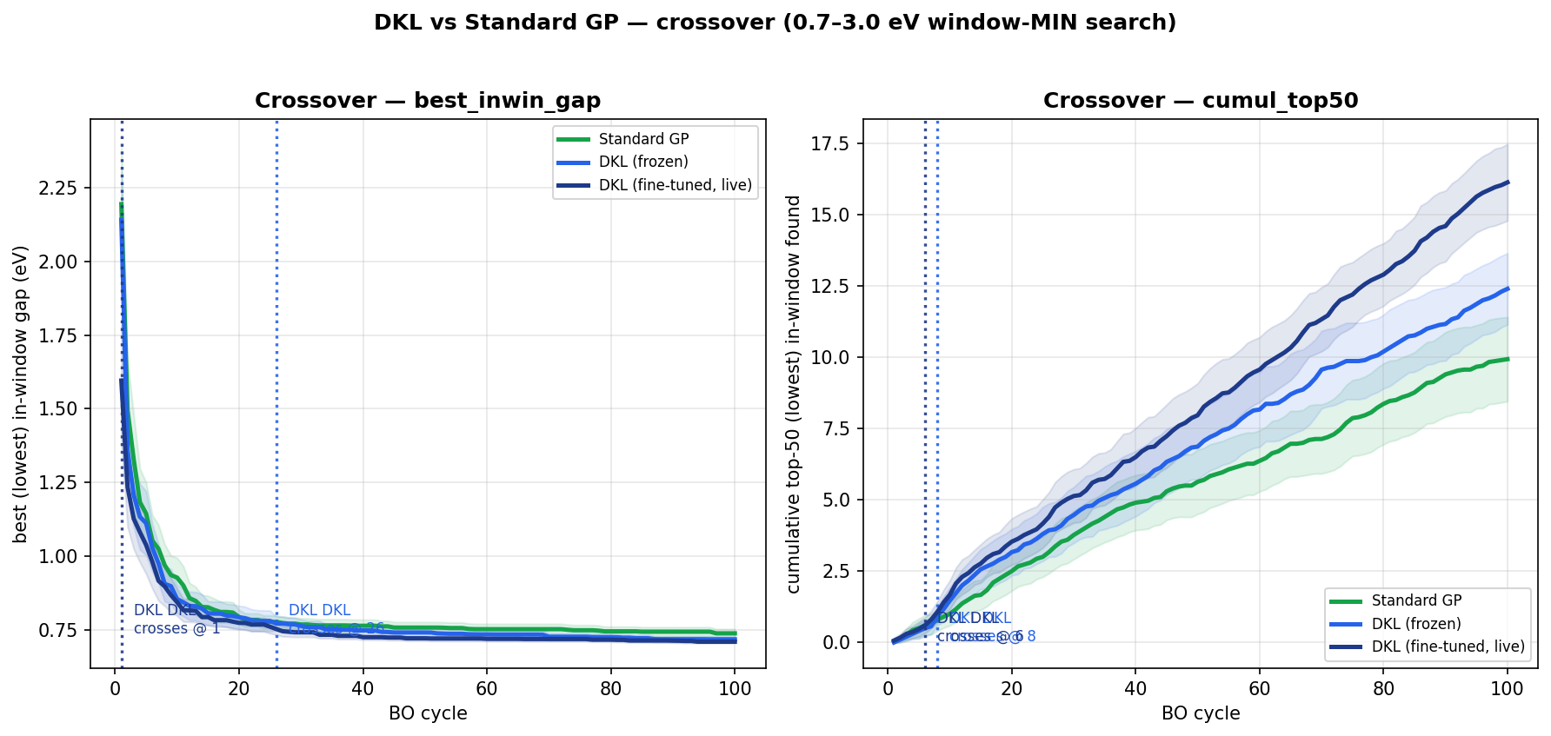
Figure 6. Window-MIN (0.7–3.0 eV) crossover analysis, 30 seeds (mean ± 95% CI). Left: best (lowest) in-window gap vs cycle — fine-tuned DKL is ahead from cycle 1 and finishes at 0.710 eV vs Std-GP 0.739 eV (p = 0.0017), closest to the 0.701 eV pool floor. Right: cumulative top-50 (lowest in-window) found — fine-tuned DKL crosses Std-GP at cycle 6 and finishes at 16.1 vs 9.9 (p = 2.1×10⁻⁵, per-seed win rate 87%); frozen DKL also beats Std-GP (12.4, p = 0.016). Source: results/rebuild/plots/winmin_crossover.png.
These are the strongest results in the project. In window-min, live fine-tuned DKL wins on both metrics — the single best point and the harvest — overtaking Std-GP within the first handful of cycles. In window-max, all methods tie on the single best point but fine-tuned DKL harvests significantly more of the top-50. The interpretation (Section 4) is that band-targeting demands fine discrimination of gap values in the interior of the distribution, which is exactly what the gap-pre-trained learned embedding provides and what 43 generic descriptors do not. Note also the reversal between task types: frozen DKL wins the unconstrained gap_max harvest, but the constrained tasks need the live fine-tuned variant — the encoder must keep learning to resolve the window edges.

3.3 Generalization to a second dataset (SNUMAT, 3D crystals)
To test whether the DKL advantage is a C2DB artifact, the identical pipeline (band gap only, no vacuum cutoff — the crystals are 3D bulk) was re-run on SNUMAT, an ICSD-derived database of HSE band gaps [7; TODO confirm citation]: 10,359 materials, split 7,228 train / 3,131 pool, 10 seeds. Frozen pre-trained DKL dominates the gap_max task: it found the pool optimum (20.30 eV) in 10/10 seeds with a median of 22 cycles, versus 5/10 seeds (median 60 cycles among those that reached it) for Std-GP and 0/10 for Random; final best 20.30 vs 14.94 eV; top-50 found 20.5 vs 17.0; regret AUC 2.81 vs 8.55 (source: snumat_generalization/results/summary_stats.csv and raw runs). On this dataset DKL is also the slightly more accurate regressor (MAE 0.57 vs 0.67 eV, R² 0.64 vs 0.63) — accuracy and search wins can coincide; Section 3.5 shows they need not. The SNUMAT window experiments (10 seeds) are underpowered and largely non-significant; only the window-min fine-tuned top-50 trend (6.0 vs 4.6) points the same way as C2DB.
Table 6. SNUMAT gap_max generalization study, mean over 10 seeds (source: snumat_generalization/results/summary_stats.csv; cycles-to-optimum computed from raw run files).
Method | Regret AUC ↓ | Best found (eV) | Top-50 found | Top-10% found | Seeds finding optimum | Median cycles to optimum
DKL (frozen) | 2.81 | 20.30 | 20.5 | 44.5 | 10 / 10 | 22
DKL (fine-tuned) | 3.62 | 20.24 | 9.3 | 25.3 | 9 / 10 | 36
DKL (cold) | 4.24 | 19.14 | 8.5 | 23.7 | 8 / 10 | 45.5
Std-GP | 8.55 | 14.94 | 17.0 | 39.0 | 5 / 10 | 60
Random | 11.50 | 10.22 | 1.9 | 10.6 | 0 / 10 | —

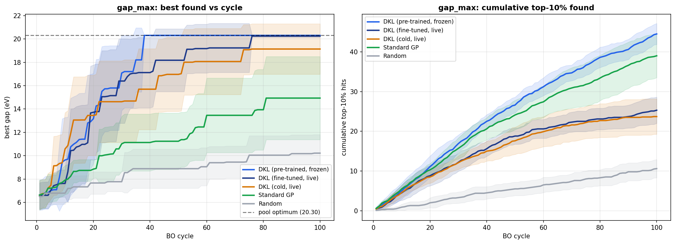
Figure 7. SNUMAT (3D bulk crystals, 3,131-material pool, 10 seeds, mean ± 95% CI) gap_max search. Left: best gap found vs cycle — frozen pre-trained DKL (light blue) reaches the pool optimum (20.30 eV, dashed) by ≈ cycle 38 in every seed, while Std-GP (green) plateaus near 15 eV. Right: cumulative top-10% hits — frozen DKL leads (44.5 final) with Std-GP second (39.0). The C2DB discovery-efficiency win generalizes to a structurally different database. Source: snumat_generalization/results/plots/gap_max_curves.png.

3.4 Regression accuracy — a separate axis
Offline accuracy (train on 1,901, predict the 766-material pool) is reported in Table 6 and Figure 8. On the band gap, Std-GP is the better regressor on every pointwise metric: MAE 0.74 vs 0.76 eV, RMSE 0.99 vs 1.07 eV, R² 0.60 vs 0.55; it is also better calibrated (95% coverage 0.95 vs 0.90). On the effective mass both surrogates fail outright (R² ≤ 0: −0.10 for Std-GP, −0.05 for DKL; log-scaling the target lifts R² only to ≈0.13 for both, results/rebuild/emass_scale_compare.csv) — the pool's five-order-of-magnitude emass range with heavy tails defeats pointwise regression.
Table 7. Offline prediction accuracy on the held-out pool (766 materials; source: results/rebuild/accuracy.csv). Coverage@95 = fraction of pool labels inside the model's 95% predictive interval.
Target | Method | MAE | RMSE | R² | Coverage@95
Band gap (eV) | Std-GP | 0.745 | 0.995 | 0.604 | 0.948
 | DKL | 0.759 | 1.065 | 0.546 | 0.898
Effective mass | Std-GP | 1.861 | 6.167 | −0.099 | 0.967
 | DKL | 1.962 | 6.029 | −0.050 | 0.943

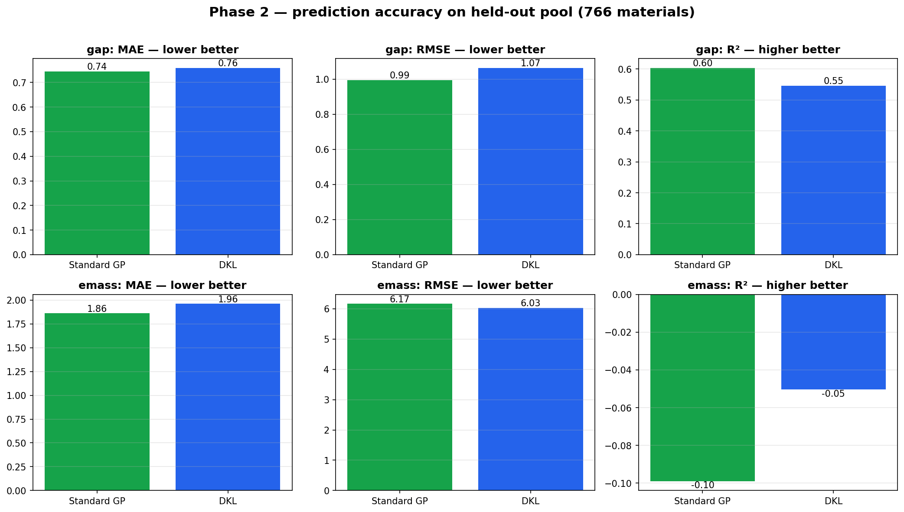
Figure 8. Offline prediction accuracy on the held-out pool (766 materials). Top row: band gap — Std-GP (green) beats DKL (blue) on MAE (0.74 vs 0.76 eV), RMSE (0.99 vs 1.07 eV) and R² (0.60 vs 0.55). Bottom row: effective mass — both models have negative R² (−0.10 / −0.05); neither is a usable pointwise regressor for this target. Source: results/rebuild/plots/accuracy.png.

3.5 Search ≠ Accuracy
Placing Sections 3.1–3.2 beside Section 3.4 gives the central finding. On the C2DB band gap, the more accurate model loses the search that matters: Std-GP holds the better R² (0.60 vs 0.55) and RMSE, yet frozen DKL retrieves 43% more of the top-50 in gap_max (31.5 vs 22.0, p ≈ 2×10⁻⁶) and fine-tuned DKL wins both window-constrained searches outright (p ≤ 0.0017). The reason is that BO does not consume global pointwise accuracy; it consumes the ranking of candidates near the current search frontier, together with usable uncertainty. A 32-dimensional embedding pre-trained to organize materials by gap orders the relevant region of chemistry space well even while its absolute predictions carry a slightly larger RMSE than the descriptor GP. The converse also appears in our data: on emass, where both models are equally (in)accurate, no search advantage emerges — a reminder that a representation must encode at least local structure of the target to convert into search efficiency. This reproduces, on an independent 2D dataset, the lesson of [1], whose DKL found minimum-effective-mass oxides in ≈50 cycles versus 371 for Std-GP despite poor pointwise R²: discovery efficiency and regression accuracy are different quantities and must be evaluated separately.

4. Discussion

4.1 When DKL wins, and when Std-GP would
The pattern across all seven searches (four unconstrained, two windowed, one external) is consistent: DKL's advantage appears on hard, localized targeting problems and on harvesting breadth, and disappears on easy extremes. Unconstrained gap_min is easy — low-gap materials are abundant, every surrogate saturates at the pool floor, and there is no headroom for a better representation to matter. The band-window tasks are hard — the desirable region is squeezed between a rejection zone (the abundant sub-0.7 eV near-metals become traps) and a suboptimal zone, so the surrogate must resolve gap values finely near specific thresholds; this is where the gap-pre-trained embedding decisively beats 43 generic descriptors. Conversely, per [1], Std-GP should win whenever a single hand-crafted descriptor correlates strongly with the target (their Curie-temperature/cobalt-content case) — the descriptor then is the answer and a learned representation adds nothing; our emass results, where Std-GP holds a slight edge, are consistent with descriptors already capturing what little signal pointwise models can use. Practically: choose DKL when no trusted descriptor exists, when the goal is a shortlist rather than a single optimum, or when the target region is a narrow band; choose Std-GP when a known strong descriptor exists and the goal is a single extreme.

4.2 Pre-training ablation
The frozen / fine-tuned / cold comparison shows that pre-training is where DKL's power comes from, and that the best deployment mode is task-dependent. Cold-start DKL — training the encoder only on the ≤110 labels acquired during a campaign — is the weakest DKL variant everywhere (e.g. gap_max best 7.85 eV, significantly below Std-GP), confirming that a 18.6k-parameter encoder cannot be learned from scratch inside a 100-cycle budget. Frozen embeddings win the unconstrained harvest (gap_max top-50 31.5); live fine-tuning wins the constrained windows (top-50 +6.2 in window-min). The window tasks change the reward landscape relative to the pre-training objective, so the representation benefits from adapting; the unconstrained gap tasks are aligned with pre-training, so adaptation only adds variance.

4.3 Robustness and limitations
Three honest caveats, each de-emphasized deliberately because none changes the headline conclusions. (i) Encoder training length: a controlled sweep (25–400 pre-training epochs, 5 seeds; Figure 9) shows pool MAE improving only up to ≈50 epochs and then flat (0.736 at 50 vs 0.728 at 300 — within noise), while train MAE keeps falling (0.117 → 0.074): a classic early-overfitting signature without test-error degradation within 400 epochs. The production setting (100 epochs) sits comfortably on the plateau; results are not sensitive to this choice. (ii) In-band search is a tie: when the task is merely “acquire materials anywhere inside 0.7–3.0 eV” — 64.8% of the pool qualifies — Std-GP (93.1/100 in-window) and frozen DKL (92.3) tie (p = 0.20), Random lands at the 63.9% base rate exactly as expected, and live fine-tuning actually hurts (82.5, p < 0.001): on crowded, easy targets fine-tuning on a handful of live labels distorts a good pre-trained map (Figure 10). The discriminating wide-window variant (3.0–4.5 eV) was stopped early and has no DKL data yet [TODO]. (iii) Single-best-point searches slightly favor Std-GP on C2DB gap_max (8.68 vs 8.57 eV, p = 0.0018) — DKL's wins are on harvesting and constrained targeting, and we report both sides.
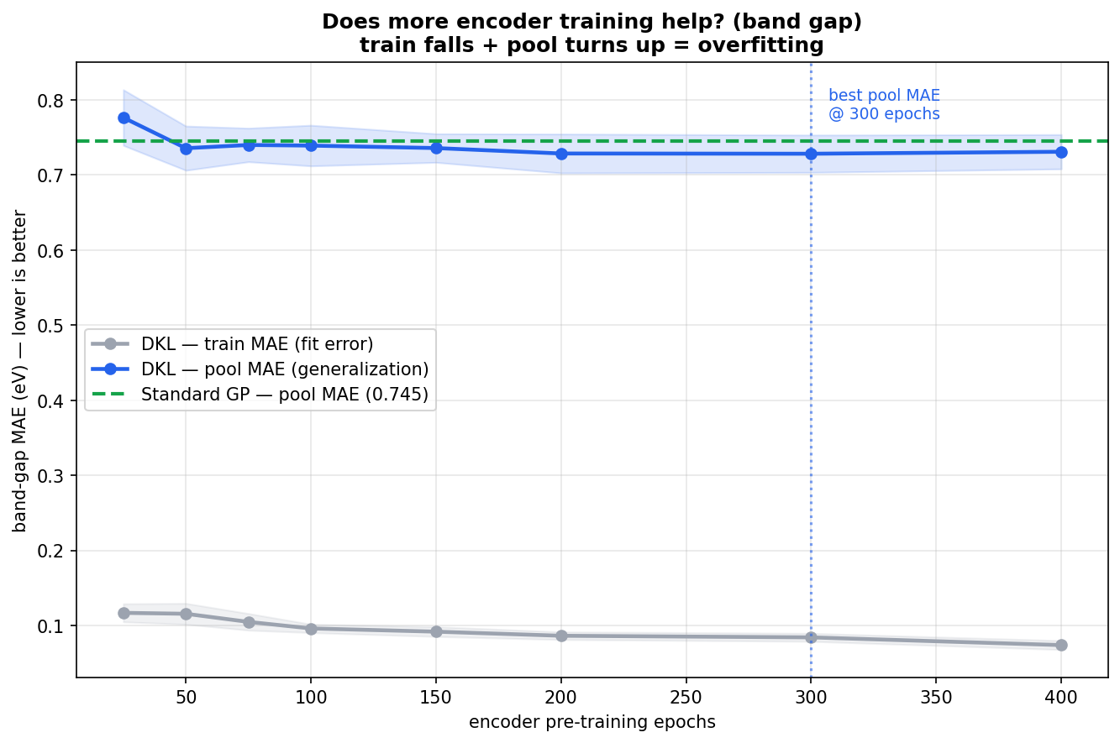
Figure 9. Encoder pre-training length vs band-gap MAE (5 seeds, mean ± 95% CI; source: results/rebuild/epoch_sweep.csv). Pool MAE (blue) drops to ≈0.74 eV by 50 epochs and stays flat through 400 (best 0.728 at 300 — within noise of 50); train MAE (gray) keeps falling (0.117 → 0.074), the widening gap being an early overfitting signature that never degrades pool error in this range. Dashed green line: Std-GP reference (0.745). Source: results/rebuild/plots/epoch_sweep_gap.png.
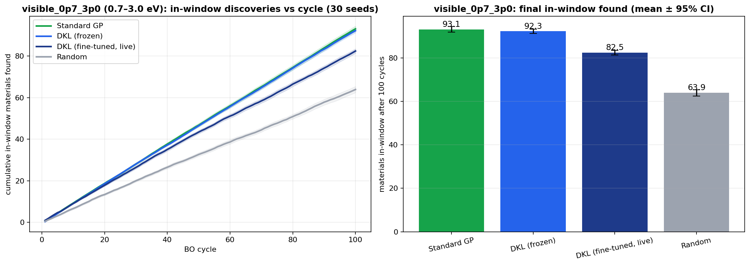
Figure 10. In-band acquisition task (“find materials anywhere in 0.7–3.0 eV”), 30 seeds, regenerated from the raw run files (results/rebuild/window_runs/). Left: cumulative in-window materials vs cycle. Right: final counts after 100 cycles (mean ± 95% CI) — Std-GP 93.1 and frozen DKL 92.3 tie (p = 0.20); live fine-tuning hurts (82.5, p < 0.001); Random (63.9) matches the 64.8% pool base rate, validating the metric. With 64.8% of the pool in-window, the task is too easy to discriminate between informed surrogates.

5. Conclusion and future work
We adapted the DKL-BO framework of Kiyohara and Kumagai to 2D materials and subjected it to a 30-seed, significance-tested benchmark against a descriptor Gaussian process and random search. The learned CGCNN representation converts into discovery efficiency exactly where representation quality matters: harvesting the top candidates (gap_max top-50: 31.5 vs 22.0, p ≈ 2×10⁻⁶) and constrained band-window targeting (window-min: better best point, p = 0.0017, and +62% top-50 harvest, p ≈ 2×10⁻⁵, overtaking Std-GP by cycle 6) — while the descriptor GP remains the more accurate regressor. Search efficiency and regression accuracy are distinct axes, and surrogate models for materials discovery should be selected and reported on both.
Future work — designed but NOT yet run; no results exist for any of the following. (a) SVGP scaling: the sparse variational GP surrogate is implemented as a config swap and would allow pools of 10⁵+ materials; it has not been exercised in the rebuilt benchmark. (b) Transfer learning from formation energy: pre-train the encoder on the abundant Eform labels and adapt to the gap, following the strategy of Lyu et al. [6] and the pre-training study in [1]. (c) Multi-objective / Pareto BO, e.g. jointly optimizing gap and effective mass on the shared intersection dataset. (d) On-the-fly DFT validation: replacing the simulated-DFT lookup with live GPAW/VASP calls to discover materials outside the labelled set. (e) Completing the wide-window (3.0–4.5 eV) experiment, the discriminating variant of the in-band task.

6. Reproducibility appendix
All code lives in src/dklbo (package) and scripts/ (entry points), configured via Hydra YAML in configs/. Every run script is idempotent and resumable (completed per-seed CSVs are skipped). The full rebuild sequence:
- python scripts/01_build_dataset.py — intersection dataset, descriptors, graph-cache verification
- python scripts/02_pretrain_encoder.py — CGCNN pre-training + embedding export
- python scripts/03_eval_accuracy.py — offline Std-GP vs DKL accuracy (Table 6)
- python scripts/04_run_bo.py — main contest, frozen DKL / Std-GP / Random (10 seeds default; 30 used)
- python scripts/05_run_bo_finetune.py — fine-tuned + cold-start DKL variants
- python scripts/06_stats.py — bootstrap CIs + paired Wilcoxon (Tables 2–5)
- python scripts/07_plot.py — all main-contest figures
- python scripts/exp_window_max_bo.py / exp_window_min_bo.py — constrained window searches (30 seeds)
- python scripts/exp_epoch_sweep.py — encoder-epoch sweep (Figure 9)
- python scripts/exp_window_bo.py — in-band window task (Figure 10; wide window incomplete)
- python snumat_generalization/scripts/01..07 — full SNUMAT replication
Table 8. Exact hyperparameters as configured and run (sources: configs/config.yaml and defaults in the run scripts).
Parameter | Value | Config file / source
Target | gap_hse (HSE06 band gap); emass (log10) | configs/data/c2db_gap.yaml
Semiconductor filter min_gap | 0.01 eV | configs/data/c2db_gap.yaml
Neighbour radius / vacuum cutoff / max neighbours | 8.0 Å / 4.0 Å / 12 | configs/data/c2db_gap.yaml
Atom / bond feature dims | 90 (one-hot H–Th) / 10 (Gaussian basis) | configs/model/cgcnn.yaml
Encoder | 3 conv layers, hidden 32, attention pooling, 18,593 params | configs/model/cgcnn.yaml
Embedding (N_FEA) | 32, standardized (zero mean, unit var) | configs/model/cgcnn.yaml
Kernel / surrogate | Matérn-5/2, exact GP (SVGP fallback unused) | configs/surrogate/gp_exact.yaml
GP lr / noise init / pretrain epochs / patience | 0.01 / 0.01 / 100 / 20 | configs/surrogate/gp_exact.yaml
Encoder lr / weight decay | 10⁻³ / none | configs/model/cgcnn.yaml; no weight_decay in src/
Acquisition (main contest) | EI, ξ = 0.01 | scripts/04_run_bo.py
Acquisition (window tasks) | window_max / window_min partial expectation | src/dklbo/bo/acquisition.py
UCB β (configured, unused in rebuild) | 0.2 | configs/bo/ucb.yaml
n_init / n_cycles | 10 / 100 | configs/bo/ucb.yaml; run scripts
Live retrain cadence | full joint retrain every 5 cycles (50 epochs; 20 GP warm-up); GP refit 50 epochs between | configs/bo/ucb.yaml
Std-GP features | 43 descriptors (35 composition + 8 structural), ARD, 100 epochs | configs/benchmark/bench.yaml
Seeds | 30 (C2DB main + windows), 10 (SNUMAT), 5 (epoch sweep) | run scripts
Hardware | NVIDIA RTX A4000, 16 GB, CUDA | run logs (docs/information.md)
Spectral norm (tested, disabled) | sn_coeff 1.0 and 3.0 hurt test metrics → off | configs/model/cgcnn.yaml

References
[1] S. Kiyohara and Y. Kumagai, “Bayesian Optimization with Gaussian Processes Assisted by Deep Learning for Material Designs,” J. Phys. Chem. Lett. 2025, 16, 5244–5251. (Method template; code: github.com/skiyohara/dklbo.)
[2] S. Haastrup et al., “The Computational 2D Materials Database: high-throughput modeling and discovery of atomically thin crystals,” 2D Mater. 5, 042002 (2018). (C2DB.)
[3] T. Xie and J. C. Grossman, “Crystal Graph Convolutional Neural Networks for an Accurate and Interpretable Prediction of Material Properties,” Phys. Rev. Lett. 120, 145301 (2018). (CGCNN.)
[4] A. G. Wilson, Z. Hu, R. Salakhutdinov, and E. P. Xing, “Deep Kernel Learning,” Proc. AISTATS 2016, PMLR 51:370–378.
[5] Mamun and Yue (2026), deep-grid/distributional kernel learning with calibration and SVGP scaling — concept reference for the SVGP fallback and calibration metrics only. [TODO: full citation]
[6] Lyu et al. (2023), transfer-learning strategy for materials property models — concept reference for the planned Eform → gap transfer extension only. [TODO: full citation]
[7] SNUMAT band-gap database (HSE, ICSD-derived; used for the generalization study). [TODO: confirm citation — likely S. Kim et al., Sci. Data 7, 387 (2020)]

Open items / TODO for professor
- Raw C2DB counts (~17,000 total / ~8,000 gap-labelled) are quoted from the old pipeline's README and were NOT re-verified against the local c2db.db for this rebuild — confirm before publication. The rebuilt benchmark's own counts (3,351 / 2,667 / 1,901 / 766) are verified.
- Wide-window experiment (3.0–4.5 eV) is incomplete: only Std-GP (25/30 seeds) ran; no DKL data exists, so no comparison is reported. Resume with: python scripts/exp_window_bo.py (completed files are skipped).
- results/rebuild/window_summary.csv and window_stats.csv on disk are stale 2-seed smoke-test outputs; the in-band numbers in this report (93.1 / 92.3 / 82.5 / 63.9) were recomputed from the full 30-seed raw runs in results/rebuild/window_runs/ and match docs/rebuild/rebuild_phase6_extensions_explanation.md. Regenerate the two CSVs by re-running scripts/exp_window_bo.py's summary step.
- Figure 10 was regenerated for this report from the raw 30-seed runs (saved as results/rebuild/plots/window_visible_0p7_3p0_30seed.png) because the repository's window_visible_0p7_3p0.png plots the 2-seed smoke test (x-axis stops at cycle 8). Consider regenerating via the project's own plotting code.
- All embedded figures are 160-dpi PNGs (1,200–2,400 px wide) — adequate on screen; regenerate at 300+ dpi vector/PNG for journal submission.
- Full citations needed: Mamun & Yue 2026 [ref 5]; Lyu et al. 2023 [ref 6]; SNUMAT database paper [ref 7].
- Confirm effective-mass units and definition (assumed conduction-band effective mass, emass_cbm, in units of the electron mass; the BO tasks search log10(emass)).
- The rebuild's main contest uses EI (ξ = 0.01), not the reference paper's UCB (β = 0.2). UCB β = 0.2 remains configured and was used in earlier pre-rebuild experiments (beta sweep, recalibration), whose outputs were removed from the working tree — decide whether to cite or re-run any of them.
- SVGP fallback is implemented but unexercised in the rebuild; the only SVGP-vs-exact comparison (SVGP 2.8× slower at small N) predates the rebuild and is not reported here.
- Author list, affiliations, and acknowledgements are placeholders.

