# **“PIZZA ORDERING SYSTEM”**

### A Project report submitted

**In the partial fulfillment the award of degree of**

**BACHELOR OF TECHNOLOGY**

**IN**

**COMPUTER SCIENCE AND ENGINEERING (2022-2023)**

**BY**

**U. AKHIL VARMA REG NO:211801391001**

**Under the esteemed Guidance of**

**Mrs. G. Rama Devi, M.Tech,(Ph.d),Asst. Professor**

**CENTURION UNIVERSITY SCHOOL OF ENGINEERING AND TECHNOLOGY**

**Rollavaka village, Tekkali mandal 535003**

**(2022-2023)**

##### **CENTURION UNIVERSITY OF TECHNOLOGY AND MANAGEMENT**

**ANDHRA PRADESH**

**(2019-2023)**

##### DEPARTMENT OF COMPUTER SCIENCE AND ENGINEERING

BONAFIDE CERTIFICATE

This is to certify that the project work entitled “PIZZA ORDERIING SYSTEM” is a full fillment of project work done U.AKHIL VARMA REG NO:211801391001, for the award the degree of BACHELOR OF TECHNOLOGY in COMPUTER SCIENCE AND ENGINEERING,CENTURION UNIVERSITY OF TECHNOLOGY AND MANAGEMENT, during the academic year 2022-2023.

##### INTERNALGUIDE HEAD OF THE DEPARTMENT

##### Mrs .G. Rama Devi Mr.R. Lakshmana Rao

**Asst. Professor**

**Dept. of CSE Dept. of CSE**

**EXTERNAL EXAMINER**

**ACKNOWLEDGEMENT**

It is with at most pleasure and excitement we submit our project partial fulfillment of the requirement for the award of Bachelor of Technology.

The project is a result to the cumulate efforts, support, guidance, encouragement and inspiration from many of those for whom we have to give our truthful honor and express gratitude through bringing out this project at the outset as per our knowledge.

I convey my special thanks to our project **Guide Mrs. G. Rama Devi(Asst. Professor)** who has guided, encouraged and tremendously supported me to enhance my knowledge with present working of this project to bring out enriching the quality of project.

I express my appreciativeness to **Mr. R.LAKSHMAN RAO(Asst. Professor) and Head of the Department,** who facilitated us to providing the friendly environment which helped to enhance my skills in present project.

I would also like to extend my gratitude to **Dr. K. V. G. KRISHNA MURTHY, Dean-School of Engineering And Technology, Centurion University of Technology and Management** who has helped us to attain all the requirements of the project.

I convey my sincere thanks to **Dr. RAMANA RAO, Ph. D Registrar of Centurion University of Technology and Management** who provided us with an opportunity to take on project work in well-equipped laboratories of Computer Science Department in our college.

At the outset, we thank to **Sri. G.S.N.RAJU**, beloved **Vice Chancellor of Centurion University of Technology and Management** who is the back bone by providing for completion of this project, Thank you sir.

**DECLA****RATION**

I hereby declare that the project entitled **“PIZZA ORDERING SYSTEM”** submitted to the fulfillment of award the degree of **B.TECH (CSE)** in **CENTURION UNIVERSITY OF TECHNOLOGY AND MANAGEMENT**, **ANDHRA PRADESH.**

U.AKHIL VARMA REG NO:211801391001

**ABSTRACT**

Pizza Management is the famous website application has developed in C# Programming in Visual Studio. Now a day’s most of the people are ordering pizza through online instead of going to shop. The selection procedure of the pizza over the net is very simple. After selecting the pizza the Pizza delivery boy will bring pizza directly to the customer’s house in short time. In this we have to select items what we want and finally it will all the selected items in the list. In this web application we have different items like pizzas, burgers, pastes etc.. After selecting items if we go to shopping cart there we can select quantity according to our items price will changes. There is another module named Admin, in this module we can update items and delete unwanted items. You must have ordered your pizzas on phone for home delivery. The process seems easy to use but at times there is miscommunication. As there is no visual menu shown during a phone call, the employees have to repeat a lot of things again and again to the customers. It’s a time consuming process which at times irritates customers. It would be great for me as I don’t need to wait for my pizza. I need to reach there only when my pizza is ready. In a nutshell, we can say that improved and efficient services are provided to the customers by the inclusion of internet in your business. As a business point of view it gives you an edge over your competitors.

**1.INTRODUCTION**

Online Pizza ordering system is a web-based application that enables customers to order their pizzas online for home delivery or pick up from the pizzeria. If you are planning to do some other projects. You can get [computer science final year project help](https://www.lovelycoding.org/computer-science-final-year-project-help/). There are a variety of food items available on this planet. Each country has its own kind of dishes to offer. But if we pick a food item which is loved by all the people on this planet, then pizza will be a clear winner in it. I have listed more than 90 [computer science projects](https://www.lovelycoding.org/computer-science-project-ideas-for-final-year/), Kindly check that. The whole world is in love with pizzas. The billions of dollars earned by different pizzerias across the globe just prove this. The love of pizzas has enabled the rise of large pizza companies like Pizza Hut, Domino’s, Papa John’s, and much more. As the internet users are increasing exponentially, these companies have introduced an Online Pizza ordering system for taking orders from customers. This system not only improves customer’s experience but also eases the workload on the staff of pizzerias. You must have ordered your pizzas by phone for home delivery. The process seems easy to use but at times there is miscommunication. As there is no visual menu shown during a phone call, the employees have to repeat a lot of things again and again to the customers. It’s a time-consuming process that at times irritates customers. Also, it takes a lot of time of the pizzeria staff. It would be much more comfortable for the customers to have an online pizza ordering system. It would be hassle-free for users as they can select the pizzas they want and make payment for it. Also, it will reduce the purchasing time for customers. Let us look at another benefit of using this system. It would be great for me as I don’t need to wait for my pizza. I need to reach there only when my pizza is ready. In a nutshell, we can say that improved and efficient services are provided to the customers by the inclusion of internet in your business. From a business point of view, it gives you an edge over your competitors.

**The main objectives of this ordering system are:**

**Build your own pizza** – This system will help customers in ordering custom pizzas. So, the customer will pick exactly the things which he/she wants in their pizza. This will surely enhance the image of the pizzeria and customer satisfaction will be more.

**Online Payment**– This system will give the option to the customer for online payment. This will make the pizza buying experience cash-free.

**Better Knowledge**– This system will provide the customer all the details of his order before making the order. This confirmation will help customers to check the items ordered with their prices.

**Know Delivery Time**– This system will show the time by which the order will be delivered to the customer. For pick-ups, customers can fix the time by which they will pick their order.

**Reduce Paper Work**– As most of the things will be performed online, it will reduce the usage of paper for the pizzeria.

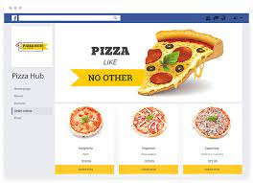

**2. SYSTEM ANALYSIS**

* 1. **Existing System:**

The existing system is a manual system. Here the pizzas needs to save the information in the form of excel sheets or Disk Drives. There is no sharing is possible if the data is in the form of paper or Disk drives. It’s a limited system and fewer users friendly. Searching of particular information is very critical it takes lot of time. It is a tedious job to maintain different customers are asking different service details, normally solve these queries are not possible. Automated system is needed.

* 1. **DIS-ADVANTAGES:**

● The manual system gives us very less security for saving data; some data may be lost due to mismanagement.

● It is very critical to maintain manually call records of customers, because call center receives huge no of calls per a day.

**2.3 PROPOSED SYSTEM:**

The development of this new system contains the following activities, which try to automate the entire process keeping in the view of database integration approach.

* The system makes the overall project management much easier and flexible.
* The user information can be stored in centralized database which can be maintained by the system.
* This can give the good security for user information because data is not in client machine.
* Authentication is provided for this application only registered Users can access.
* There is no risk of data management at any level while the project development is under process.
* The automated system will provide to the customers for reliable services.
  1. **ADVANTAGES:**

● User Friendliness is provided in the application with various controls provided by system Rich User Interface.

● It can be accessed over the Intranet.

● The speed and accuracy of this system will improve more and more.

**2.5** **SYSTEM REQUIREMENTS:**

**2.5.1 SOFTWARE REQUIREMENTS:**

* Operating system : Windows XP/7.
* Coding Language : net, C#.net
* Tool                       : Visual Studio 2010
* Database                : SQL SERVER 2008
* Languages : php, java script, HTML, Bootstrap.

**2.5.2 HARDWARE REQUIREMENTS:**

* System            : Pentium IV 2.4 GHz.
* Hard Disk      : 40 GB.
* Floppy Drive : 44 Mb.
* Monitor          : 15 VGA Colour.
* Mouse             : Logitech
* Ram                 : 512 Mb.

**3. SYSTEM DESIGN**

**3.1 SYSTEM ARCHITECTURE:**

Let us now understand the working of this system. Whenever a customer visits the webpage or mobile application of the pizzeria, he/she will have to select his location so that the order is made to the nearest pizzeria. The menu will be visible to the customer with the pizzas and other non-pizza products on offer. All the ingredients will be shown at their prices.

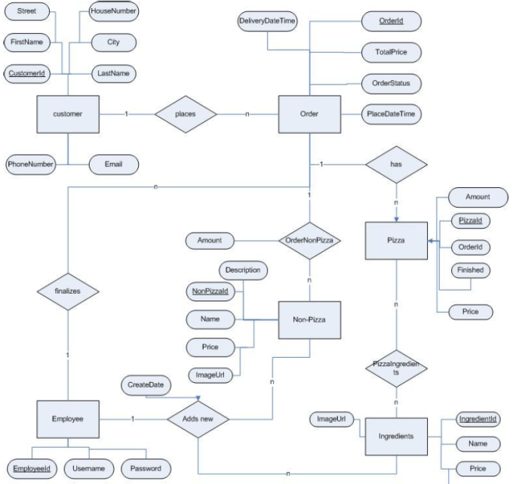**The ER diagram for the online pizza ordering system is shown below:**

**3.2 MODULES DESCRIPTION:**

**HTML:**

HTML (Hypertext Markup Language) forms the backbone of the website, providing the structure and layout for the various elements. It defines the content and organizes the information in a hierarchical manner, enabling effective presentation and accessibility across different devices and browsers.

**CSS:**

CSS (Cascading Style Sheets) complements HTML by providing styling and visual enhancements to the website. It enables the customization of fonts, colors, layouts, and other visual aspects, ensuring a consistent and aesthetically pleasing design. CSS helps in creating responsive and mobile-friendly web pages, ensuring a seamless user experience across devices of different sizes.

**JavaScript:**

JavaScript is a powerful scripting language that adds interactivity and dynamic functionality to the website. It allows for client-side processing, enabling real-time validations, form submissions, and dynamic content updates without the need for server communication. JavaScript is also crucial for implementing animations, sliders, modal pop-ups, and other interactive elements that enhance user engagement and interactivity.

**PHP:**

PHP (Hypertext Preprocessor) is a server-side scripting language that enables the processing and manipulation of data on the server. It is particularly useful for handling form submissions, database operations, and server-side computations. PHP integrates seamlessly with HTML and JavaScript, allowing for dynamic content generation and database connectivity, making it an essential component for developing robust web applications.

**Bootstrap:**

Bootstrap is a popular CSS framework that provides pre-designed responsive components and grid systems. It simplifies the development process by offering a range of ready-to-use UI elements, such as navigation bars, buttons, forms, and modals, that can be easily customized and integrated into the website. Bootstrap ensures a consistent and responsive layout, improving the website's overall appearance and user experience.

**AJAX:**

AJAX (Asynchronous JavaScript and XML) is a technique that enables seamless communication between the web server and the client browser without requiring a page refresh. It facilitates the retrieval and updating of data in the background, providing a smoother and more responsive user experience. AJAX is commonly used for implementing auto-suggest search boxes, real-time updates, and asynchronous form submissions, enhancing the website's interactivity and performance.

The combined use of HTML, CSS, JavaScript, PHP, Bootstrap, and AJAX has empowered the resume screening website to deliver an intuitive user interface, responsive design, real-time interactions, and efficient data processing. This comprehensive technology stack has contributed to the website's success in revolutionizing the resume screening process, providing employers and recruiters with a powerful tool for efficient talent acquisition.

**4.MODULE INTERFACE**

## ****Login/Sign-Up:****

## When a customer visits the online pizza ordering system of any pizzeria, he will be asked to log in or sign up for them for a better experience. The customer has to create a unique username and a password. Then he /she need to enter details like Name, phone number, address. After these steps account of that customer will be created.

## MENU:

* The system will provide customers a menu in which all the pizzas and non-pizza items will be shown with their prices. The pizzas on the menu are created by the professional chefs of the pizzeria.
* The ingredients in this pizza can be changed according to the customer’s interests. The customer can select any pizza from the menu or build a custom pizza.
* Each pizza will be shown with its image and price. The ingredients used in the making of that pizza can also be seen.
* Each of these ingredients can be removed or other new ingredients can be added in the order.
* After each selection or de-selection, the grand total of the order will be updated.

**Build Your Pizza:**

One of the most amazing features of an online pizza ordering system is that you can build your pizzas from the scratch. This system provides the options to create your custom pizzas with everything of your choice. Let me tell you more about making custom pizzas.

* The customer will get an option to select the pizza’s crust size which can be small, medium, or large.
* Then the customer has to choose the sauce to be used on his pizza crust. These can marinara, cheese, ranch, and others.
* Then the system asks the customer whether to add cheese or not. He also has an option to select extra cheese.
* At last, the system shows the customers different types of toppings. Firstly, the customer has to choose between veg. and non-veg. toppings. Suppose you selected veg., then different options like pineapple, mushrooms, olives, etc. are shown.

One important point to be noticed here is after each step, the updated price of your custom-built pizza is shown to the customers. Each item’s price is also reflected below its image.

## ****Add To Cart:****

This feature is useful in a situation where you have to order more than one pizza or other non-pizza items. Suppose you have selected a Margherita pizza and now you want to select another pizza as well. Then you just have to add that pizza to the cart using the Add to cart option. Items added to the cart will be saved so that you can choose other pizzas as well. Finally, when you are ready to order you can check out from the cart to make payment. Payment There will be basically 2 payment options i.e. online payment using Credit/Debit cards and Internet banking or Cash on delivery. Before making payment, your order details are shown and confirmed. This system makes transactions easier as the need to pay with cash is not there. Home Delivery or Pick up. This feature asks the customer if he/she intends to pick up his/her order from the pizzeria or it is needed to be delivered to their address.

## Track your Order:

This is another interesting feature which helps customers to keep a track of his order. The customer is notified at every step of their order completion. After making payment the customer is shown the time by which his order will be delivered to his doorstep.

## Order Processing

In the previous section, I told you all about pizza ordering by customers. But what happens after this. How the pizzeria manages the order made by the customer and delivers it on time. The online pizza ordering system comes to their rescue again. It provides all the features and functionalities for processing orders without any fuss for the staff of the pizzeria.

This module will be used by the employees of the pizzeria for preparing orders and delivering them to their destination. Each employee of the pizzeria will have an account in this ordering system. They will have a username and password provided to them by the system admin. Mainly there are three types of employees using the online pizza ordering system.

They are Kitchen staff, delivery staff, and other employees like the counter staff.

**Let me tell you about each user’s rights and responsibilities:**

## Kitchen Staff:

They have an interface that shows them the list of orders to be prepared. Each order shows its details like ingredients to be used and the quantity of each item. The current status of each order is pending. After a particular order is prepared and ready to be delivered, the kitchen staff updates the status to ‘Prepared’.

The customer is notified at this stage that their order is prepared and soon will be delivered.

## Delivery Staff:

After the order is prepared the available delivery staff is handed over the orders with their address. When the delivery staff leaves for delivery the status of the order is updated again to ‘Out for Delivery’ and the customer is notified. When the delivery staff delivers the order successfully, he updates the order status to ’Delivered’.

If he fails to deliver the order due to any reason, the status is updated to ‘Delivery Failure’.

## Counter Staff:

In case of pick up, the counter staff updates the status of the orders. When the kitchen staff has prepared the order, the counter staff updates the status to ‘Ready to be picked’ and the customer is notified that he can pick up his order now. After the customer picks up his order, the counter staff updates the order status to ‘Received by customer’.

Each kind of employee has its own rights and permissions. The kitchen staff has a right to only check pending orders and update status to ‘Prepared’. He cannot update the order status to ‘Delivered’ as he doesn’t have the right to do so.

**5.IMPLEMENTATION**

<?php session_start() ?>

<div class="container-fluid">

    <form action="" id="login-frm">

        <div class="form-group">

            <label for="" class="control-label">Email</label>

            <input type="email" name="email" required="" class="form-control">

        </div>

        <div class="form-group">

            <label for="" class="control-label">Password</label>

            <input type="password" name="password" required="" class="form-control">

            <small><a href="javascript:void(0)" class="text-dark" id="new_account">Create New Account</a></small>

        </div>

        <button class="button btn btn-dark btn-sm">Login</button>

    </form>

</div>

<style>

    #uni_modal .modal-footer{

        display:none;

    }

</style>

<script>

    $('#new_account').click(**function**(){

        uni_modal("Create an Account",'signup.php?redirect=index.php?page=checkout')

    })

    $('#login-frm').submit(**function**(e){

        e.preventDefault()

        $('#login-frm button[type="submit"]').attr('disabled',true).html('Logging in...');

        if($(this).find('.alert-danger').length > 0 )

            $(this).find('.alert-danger').remove();

        $.ajax({

            url:'admin/ajax.php?action=login2',

            method:'POST',

            data:$(this).serialize(),

            error:err**=>**{

                console.log(err)

        $('#login-frm button[type="submit"]').removeAttr('disabled').html('Login');

            },

            success:**function**(resp){

                if(resp == 1){

                    location.href ='<?php echo isset($_GET['redirect']) ? $_GET['redirect'] : 'index.php?page=home' ?>';

                }else{

                    $('#login-frm').prepend('<div class="alert alert-danger">Email or password is incorrect.</div>')

                    $('#login-frm button[type="submit"]').removeAttr('disabled').html('Login');

                }

            }

        })

    })

</script>

<?php

  include'admin/db_connect.php';

    $qry = $conn->query("SELECT * FROM  product_list where id = ".$_GET['id'])->fetch_array();

?>

<div class="container-fluid">

    <div class="card ">

        <img src="assets/img/<?php echo $qry['img_path'] ?>" class="card-img-top" alt="...">

        <div class="card-body">

          <h5 class="card-title"><?php echo $qry['name'] ?></h5>

          <p class="card-text truncate"><?php echo $qry['description'] ?></p>

          <div class="form-group">

          </div>

          <div class="row">

            <div class="col-md-2"><label class="control-label">Qty</label></div>

            <div class="input-group col-md-7 mb-3">

              <div class="input-group-prepend">

                <button class="btn btn-outline-secondary" type="button" id="qty-minus"><span class="fa fa-minus"></button>

              </div>

              <input type="number" readonly value="1" min = 1 class="form-control text-center" name="qty" >

              <div class="input-group-prepend">

                <button class="btn btn-outline-dark" type="button" id="qty-plus"><span class="fa fa-plus"></span></button>

              </div>

            </div>

          </div>

          <div class="text-center">

            <button class="btn btn-outline-dark btn-sm btn-block" id="add_to_cart_modal"><i class="fa fa-cart-plus"></i> Add to Cart</button>

          </div>

        </div>

      </div>

</div>

<style>

    #uni_modal_right .modal-footer{

        display: none;

    }

</style>

<script>

    $('#qty-minus').click(**function**(){

**var** qty = $('input[name="qty"]').val();

        if(qty == 1){

            return false;

        }else{

            $('input[name="qty"]').val(parseInt(qty) -1);

        }

    })

    $('#qty-plus').click(**function**(){

**var** qty = $('input[name="qty"]').val();

            $('input[name="qty"]').val(parseInt(qty) +1);

    })

    $('#add_to_cart_modal').click(**function**(){

        start_load()

        $.ajax({

            url:'admin/ajax.php?action=add_to_cart',

            method:'POST',

            data:{pid:'<?php echo $_GET['id'] ?>',qty:$('[name="qty"]').val()},

            success:**function**(resp){

                if(resp == 1 )

                    alert_toast("Order successfully added to cart");

                    $('.item_count').html(parseInt($('.item_count').html()) + parseInt($('[name="qty"]').val()))

                    $('.modal').modal('hide')

                    end_load()

            }

        })

    })

</script>

*<!-- Masthead-->*

 <header class="masthead">

            <div class="container h-100">

                <div class="row h-100 align-items-center justify-content-center text-center">

                    <div class="col-lg-10 align-self-center mb-4 page-title">

                        <h1 class="text-white">Shopping Cart</h1>

                        <hr class="divider my-4 bg-dark" />

                    </div>

                </div>

            </div>

        </header>

    <section class="page-section" id="menu">

        <div class="container">

            <div class="row">

            <div class="col-lg-8">

                <div class="sticky">

                    <div class="card">

                        <div class="card-body">

                            <div class="row">

                                <div class="col-md-8"><b>Items</b></div>

                                <div class="col-md-4 text-right"><b>Total</b></div>

                            </div>

                        </div>

                    </div>

                </div>

                <?php

                if(isset($_SESSION['login_user_id'])){

                    $data = "where c.user_id = '".$_SESSION['login_user_id']."' ";

                }else{

                    $ip = isset($_SERVER['HTTP_CLIENT_IP']) ? $_SERVER['HTTP_CLIENT_IP'] : (isset($_SERVER['HTTP_X_FORWARDED_FOR']) ? $_SERVER['HTTP_X_FORWARDED_FOR'] : $_SERVER['REMOTE_ADDR']);

                    $data = "where c.client_ip = '".$ip."' ";

                }

                $total = 0;

                $get = $conn->query("SELECT *,c.id as cid FROM cart c inner join product_list p on p.id = c.product_id ".$data);

                while($row= $get->fetch_assoc()):

                    $total += ($row['qty'] * $row['price']);

                ?>

                <div class="card">

                    <div class="card-body">

                        <div class="row">

                            <div class="col-md-4 d-flex align-items-center" style="text-align: -webkit-center">

                                <div class="col-auto">

                                    <a href="admin/ajax.php?action=delete_cart&id=<?php echo $row['cid'] ?>" class="rem_cart btn btn-sm btn-outline-danger" data-id="<?php echo $row['cid'] ?>"><i class="fa fa-trash"></i></a>

                                </div>

                                <div class="col-auto flex-shrink-1 flex-grow-1 text-center">

                                    <img src="assets/img/<?php echo $row['img_path'] ?>" alt="">

                                </div>

                            </div>

                            <div class="col-md-4">

                                <p><b><large><?php echo $row['name'] ?></large></b></p>

                                <p class='truncate'> <b><small>Desc :<?php echo $row['description'] ?></small></b></p>

                                <p> <b><small>Unit Price :<?php echo number_format($row['price'],2) ?></small></b></p>

                                <p><small>QTY :</small></p>

                                <div class="input-group mb-3">

                                  <div class="input-group-prepend">

                                    <button class="btn btn-outline-secondary qty-minus" type="button"   data-id="<?php echo $row['cid'] ?>"><span class="fa fa-minus"></button>

                                  </div>

                                  <input type="number" readonly value="<?php echo $row['qty'] ?>" min = 1 class="form-control text-center" name="qty" >

                                  <div class="input-group-prepend">

                                    <button class="btn btn-outline-secondary qty-plus" type="button" id=""  data-id="<?php echo $row['cid'] ?>"><span class="fa fa-plus"></span></button>

                                  </div>

                                </div>

                            </div>

                            <div class="col-md-4 text-right">

                                <b><large><?php echo number_format($row['qty'] * $row['price'],2) ?></large></b>

                            </div>

                        </div>

                    </div>

                </div>

            <?php endwhile; ?>

            </div>

            <div class="col-md-4">

                <div class="sticky">

                    <div class="card">

                        <div class="card-body">

                            <p><large>Total Amount</large></p>

                            <hr>

                            <p class="text-right"><b><?php echo number_format($total,2) ?></b></p>

                            <hr>

                            <div class="text-center">

                                <button class="btn btn-block btn-outline-dark" type="button" id="checkout">Proceed to Checkout</button>

                            </div>

                        </div>

                    </div>

                </div>

            </div>

            </div>

        </div>

    </section>

    <style>

        .card p {

            margin: unset

        }

        .card img{

            max-width: calc(100%);

            max-height: calc(59%);

        }

        div.sticky {

          position: -webkit-sticky; */* Safari */*

          position: sticky;

          top: 4.7em;

          z-index: 10;

          background: white

        }

        .rem_cart{

           position: absolute;

           left: 0;

        }

    </style>

    <script>

        $('.view_prod').click(**function**(){

            uni_modal_right('Product','view_prod.php?id='+$(this).attr('data-id'))

        })

        $('.qty-minus').click(**function**(){

**var** qty = $(this).parent().siblings('input[name="qty"]').val();

        update_qty(parseInt(qty) -1,$(this).attr('data-id'))

        if(qty == 1){

            return false;

        }else{

             $(this).parent().siblings('input[name="qty"]').val(parseInt(qty) -1);

        }

        })

        $('.qty-plus').click(**function**(){

**var** qty =  $(this).parent().siblings('input[name="qty"]').val();

                 $(this).parent().siblings('input[name="qty"]').val(parseInt(qty) +1);

        update_qty(parseInt(qty) +1,$(this).attr('data-id'))

        })

**function** update_qty(qty,id){

            start_load()

            $.ajax({

                url:'admin/ajax.php?action=update_cart_qty',

                method:"POST",

                data:{id:id,qty},

                success:**function**(resp){

                    if(resp == 1){

                        load_cart()

                        end_load()

                    }

                }

            })

        }

        $('#checkout').click(**function**(){

            if('<?php echo isset($_SESSION['login_user_id']) ?>' == 1){

                location.replace("index.php?page=checkout")

            }else{

                uni_modal("Checkout","login.php?page=checkout")

            }

        })

    </script>

*-- phpMyAdmin SQL Dump*

*-- version 5.1.3*

*-- https://www.phpmyadmin.net/*

*--*

*-- Host: 127.0.0.1*

*-- Generation Time: Feb 16, 2023 at 08:16 AM*

*-- Server version: 10.4.24-MariaDB*

*-- PHP Version: 8.1.5*

SET SQL_MODE = "NO_AUTO_VALUE_ON_ZERO";

START TRANSACTION;

SET time_zone = "+00:00";

*--*

*-- Database: `opos_db`*

*--*

*-- --------------------------------------------------------*

*--*

*-- Table structure for table `cart`*

*--*

CREATE TABLE `cart` (

  `id` **int**(30) NOT NULL,

  `client_ip` **varchar**(20) NOT NULL,

  `user_id` **int**(30) NOT NULL,

  `product_id` **int**(30) NOT NULL,

  `qty` **int**(30) NOT NULL

) ENGINE=InnoDB **DEFAULT** CHARSET=utf8mb4;

*-- --------------------------------------------------------*

*--*

*-- Table structure for table `category_list`*

*--*

CREATE TABLE `category_list` (

  `id` **int**(30) NOT NULL,

  `name` **text** NOT NULL

) ENGINE=InnoDB **DEFAULT** CHARSET=utf8mb4;

*--*

*-- Dumping data for table `category_list`*

*--*

INSERT INTO `category_list` (`id`, `name`) VALUES

(1, 'Thin Crust Pizza'),

(2, 'Thick Crust Pizza'),

(3, 'Sicilian Pizza'),

(4, 'Beverages');

*-- --------------------------------------------------------*

*--*

*-- Table structure for table `orders`*

*--*

CREATE TABLE `orders` (

  `id` **int**(30) NOT NULL,

  `name` **text** NOT NULL,

  `address` **text** NOT NULL,

  `mobile` **text** NOT NULL,

  `email` **text** NOT NULL,

  `status` **tinyint**(1) NOT NULL **DEFAULT** 0

) ENGINE=InnoDB **DEFAULT** CHARSET=utf8mb4;

*--*

*-- Dumping data for table `orders`*

*--*

INSERT INTO `orders` (`id`, `name`, `address`, `mobile`, `email`, `status`) VALUES

(1, 'Mark Cooper', 'Sample Address', '0912345698', 'mcooper@mail.com', 1);

*-- --------------------------------------------------------*

*--*

*-- Table structure for table `order_list`*

*--*

CREATE TABLE `order_list` (

  `id` **int**(30) NOT NULL,

*--*

CREATE TABLE `system_settings` (

  `id` **int**(30) NOT NULL,

  `name` **text** NOT NULL,

  `email` **varchar**(200) NOT NULL,

  `contact` **varchar**(20) NOT NULL,

  `cover_img` **text** NOT NULL,

  `about_content` **text** NOT NULL

) ENGINE=InnoDB **DEFAULT** CHARSET=utf8mb4;

*--*

*-- Dumping data for table `system_settings`*

*--*

INSERT INTO `system_settings` (`id`, `name`, `email`, `contact`, `cover_img`, `about_content`) VALUES

(1, 'Online Pizza Ordering System - PHP', 'info@abcpizaa.com', '0912654789', '1676509500_pizza-bg.jpg', '&lt;h1 style=&quot;margin-bottom: 0px; padding: 0px; line-height: 90px; color: rgb(0, 0, 0); text-align: center; font-size: 70px; font-family: DauphinPlain;&quot;&gt;About Us&lt;/h1&gt;&lt;h4 style=&quot;margin: 10px 10px 5px; padding: 0px; font-size: 14px; line-height: 18px; text-align: center; font-style: italic; color: rgb(0, 0, 0); font-family: &amp;quot;Open Sans&amp;quot;, Arial, sans-serif;&quot;&gt;&quot;Neque porro quisquam est qui dolorem ipsum quia dolor sit amet, consectetur, adipisci velit...&quot;&lt;/h4&gt;&lt;h5 style=&quot;margin: 5px 10px 20px; padding: 0px; font-size: 12px; line-height: 14px; text-align: center; color: rgb(0, 0, 0); font-family: &amp;quot;Open Sans&amp;quot;, Arial, sans-serif;&quot;&gt;&quot;There is no one who loves pain itself, who seeks after it and wants to have it, simply because it is pain...&quot;&lt;/h5&gt;&lt;hr style=&quot;margin: 0px; padding: 0px; clear: both; border-top: 0px; height: 1px; background-image: linear-gradient(to right, rgba(0, 0, 0, 0), rgba(0, 0, 0, 0.75), rgba(0, 0, 0, 0)); color: rgb(0, 0, 0); font-family: &amp;quot;Open Sans&amp;quot;, Arial, sans-serif; text-align: center;&quot;&gt;&lt;p id=&quot;Content&quot; style=&quot;margin-bottom: 0px; padding: 0px; position: relative; color: rgb(0, 0, 0); font-family: &amp;quot;Open Sans&amp;quot;, Arial, sans-serif; text-align: center;&quot;&gt;&lt;p class=&quot;boxed&quot; style=&quot;margin: 10px 28.7969px; padding: 0px; clear: both;&quot;&gt;&lt;p id=&quot;lipsum&quot; style=&quot;margin-bottom: 0px; padding: 0px; text-align: justify;&quot;&gt;&lt;p style=&quot;margin-bottom: 15px; padding: 0px;&quot;&gt;Lorem ipsum dolor sit amet, consectetur adipiscing elit. Praesent suscipit porttitor dui, a accumsan metus molestie vel. Quisque luctus eros interdum, facilisis lectus at, aliquam lacus. Etiam blandit lectus imperdiet nisi finibus posuere. Quisque in dolor id quam rhoncus sollicitudin sed id nisi. Interdum et malesuada fames ac ante ipsum primis in faucibus. Proin sed odio luctus, tempus dui quis, aliquet arcu. Nunc a sagittis dui, ut lacinia risus. Pellentesque nec leo ut quam varius semper quis ut ligula. Proin feugiat, nisl sed facilisis dignissim, augue mauris cursus elit, at mattis lectus urna in est. Quisque venenatis quam vitae mauris tincidunt, et facilisis purus tincidunt. Sed arcu lacus, maximus quis lorem eget, auctor maximus felis. Cras tristique, ligula eu iaculis feugiat, purus sapien tristique velit, non consequat quam ante sed velit.&lt;/p&gt;&lt;/p&gt;&lt;/p&gt;&lt;/p&gt;&lt;p&gt;&lt;/p&gt;');

*-- --------------------------------------------------------*

*--*

*-- Table structure for table `users`*

*--*

CREATE TABLE `users` (

  `id` **int**(30) NOT NULL,

  `name` **varchar**(200) NOT NULL,

  `username` **text** NOT NULL,

  `password` **varchar**(200) NOT NULL,

  `type` **tinyint**(1) NOT NULL **DEFAULT** 2 COMMENT '1=admin , 2 = staff'

) ENGINE=InnoDB **DEFAULT** CHARSET=utf8mb4;

*--*

*-- Dumping data for table `users`*

*--*

INSERT INTO `users` (`id`, `name`, `username`, `password`, `type`) VALUES

(1, 'Administrator', 'admin', '$2y$10$efDvenHYJ5Fu/xxt1ANbXuRx5/TuzNs/s4k6keUiiFvr2ueE0GmrG', 1),

(2, 'Staff', 'staff', '$2y$10$DJbGDnA6bkOiS0TW08R5FOPruw0wRW4maShgWK8k6FlEfgNjbXsvm', 2);

*-- --------------------------------------------------------*

*--*

*-- Table structure for table `user_info`*

*--*

CREATE TABLE `user_info` (

  `user_id` **int**(10) NOT NULL,

  `first_name` **varchar**(100) NOT NULL,

  `last_name` **varchar**(100) NOT NULL,

  `email` **varchar**(300) NOT NULL,

  `password` **varchar**(300) NOT NULL,

  `mobile` **varchar**(10) NOT NULL,

  `address` **varchar**(300) NOT NULL

) ENGINE=InnoDB **DEFAULT** CHARSET=latin1;

*--*

*-- Dumping data for table `user_info`*

*--*

INSERT INTO `user_info` (`user_id`, `first_name`, `last_name`, `email`, `password`, `mobile`, `address`) VALUES

(1, 'Mark', 'Cooper', 'mcooper@mail.com', '$2y$10$Z.LYi0zrDsrCYIgU1e7yCOkn1lbREGbUcIpSvgkB0OPapDfp7Xc0a', '0912345698', 'Sample Address');

*--*

*-- Indexes for dumped tables*

*--*

*--*

*-- Indexes for table `cart`*

*--*

ALTER TABLE `cart`

  ADD **PRIMARY KEY** (`id`);

*--*

*-- Indexes for table `category_list`*

*--*

ALTER TABLE `category_list`

  ADD **PRIMARY KEY** (`id`);

*--*

*-- Indexes for table `orders`*

*--*

ALTER TABLE `orders`

  ADD **PRIMARY KEY** (`id`);

*--*

*-- Indexes for table `order_list`*

*--*

ALTER TABLE `order_list`

  ADD **PRIMARY KEY** (`id`);

*--*

*-- Indexes for table `product_list`*

*--*

ALTER TABLE `product_list`

  ADD **PRIMARY KEY** (`id`);

*--*

*-- Indexes for table `system_settings`*

*--*

ALTER TABLE `system_settings`

  ADD **PRIMARY KEY** (`id`);

<?php session_start() ?>

<div class="container-fluid">

    <form action="" id="signup-frm">

        <div class="form-group">

            <label for="" class="control-label">Firstname</label>

            <input type="text" name="first_name" required="" class="form-control">

        </div>

        <div class="form-group">

            <label for="" class="control-label">Lastname</label>

            <input type="text" name="last_name" required="" class="form-control">

        </div>

        <div class="form-group">

            <label for="" class="control-label">Contact</label>

            <input type="text" name="mobile" required="" class="form-control">

        </div>

        <div class="form-group">

            <label for="" class="control-label">Address</label>

            <textarea cols="30" rows="3" name="address" required="" class="form-control"></textarea>

        </div>

        <div class="form-group">

            <label for="" class="control-label">Email</label>

            <input type="email" name="email" required="" class="form-control">

        </div>

        <div class="form-group">

            <label for="" class="control-label">Password</label>

            <input type="password" name="password" required="" class="form-control">

        </div>

        <button class="button btn btn-info btn-sm">Create</button>

    </form>

</div>

<style>

    #uni_modal .modal-footer{

        display:none;

    }

</style>

<script>

    $('#signup-frm').submit(**function**(e){

        e.preventDefault()

        $('#signup-frm button[type="submit"]').attr('disabled',true).html('Saving...');

        if($(this).find('.alert-danger').length > 0 )

            $(this).find('.alert-danger').remove();

        $.ajax({

            url:'admin/ajax.php?action=signup',

            method:'POST',

            data:$(this).serialize(),

            error:err**=>**{

                console.log(err)

        $('#signup-frm button[type="submit"]').removeAttr('disabled').html('Create');

            },

            success:**function**(resp){

                if(resp == 1){

                    location.href ='<?php echo isset($_GET['redirect']) ? $_GET['redirect'] : 'index.php?page=home' ?>';

                }else{

                    $('#signup-frm').prepend('<div class="alert alert-danger">Email already exist.</div>')

                    $('#signup-frm button[type="submit"]').removeAttr('disabled').html('Create');

                }

            }

        })

    })

</script>

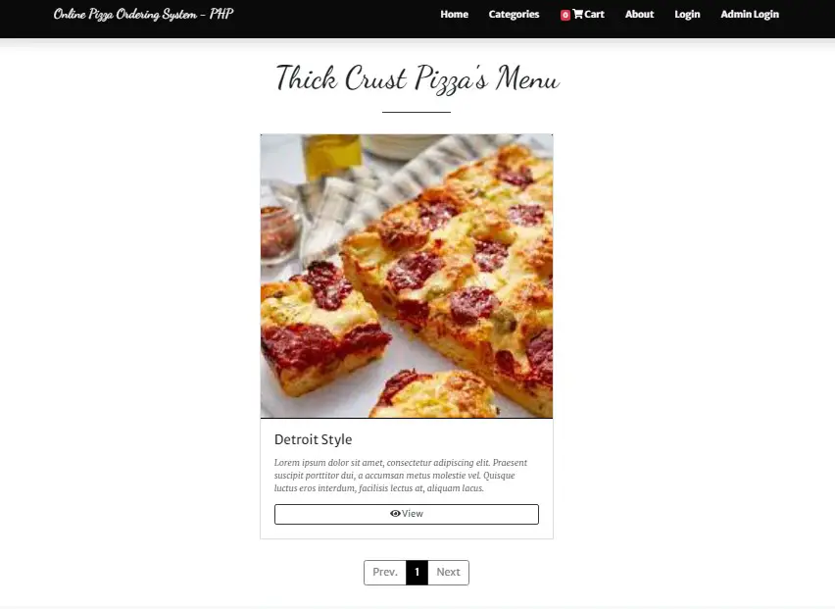**OUTPUT**

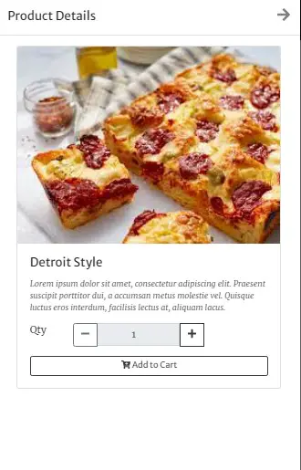

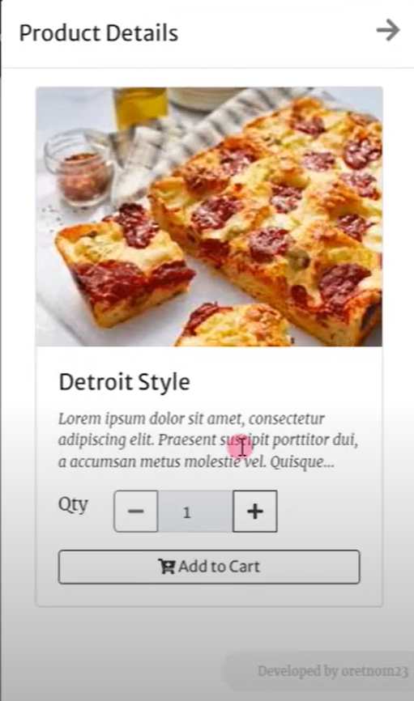

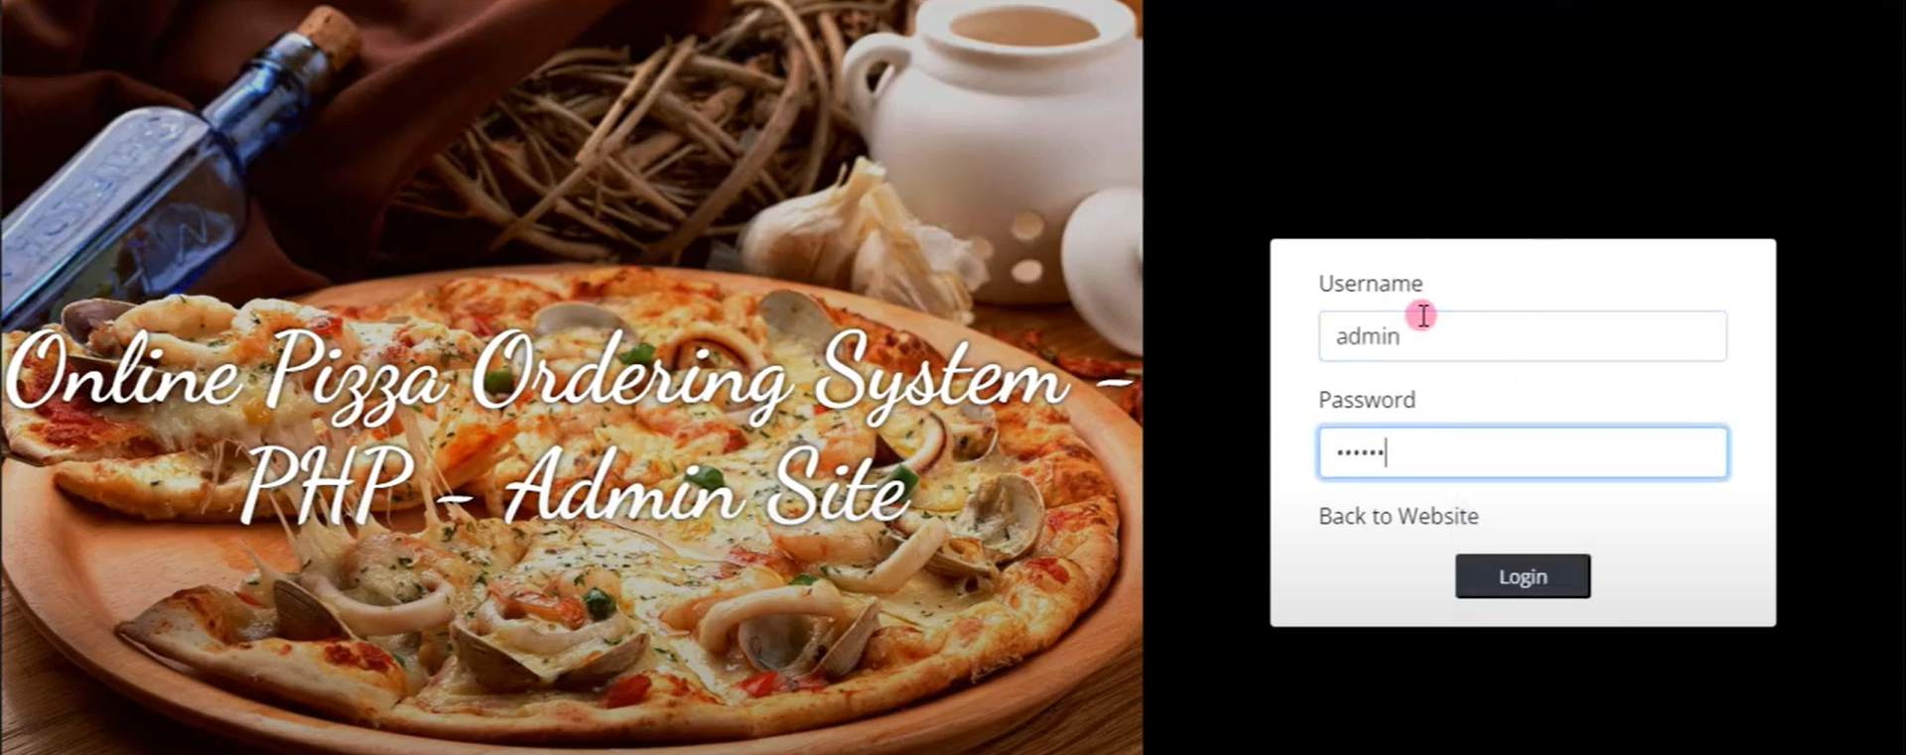

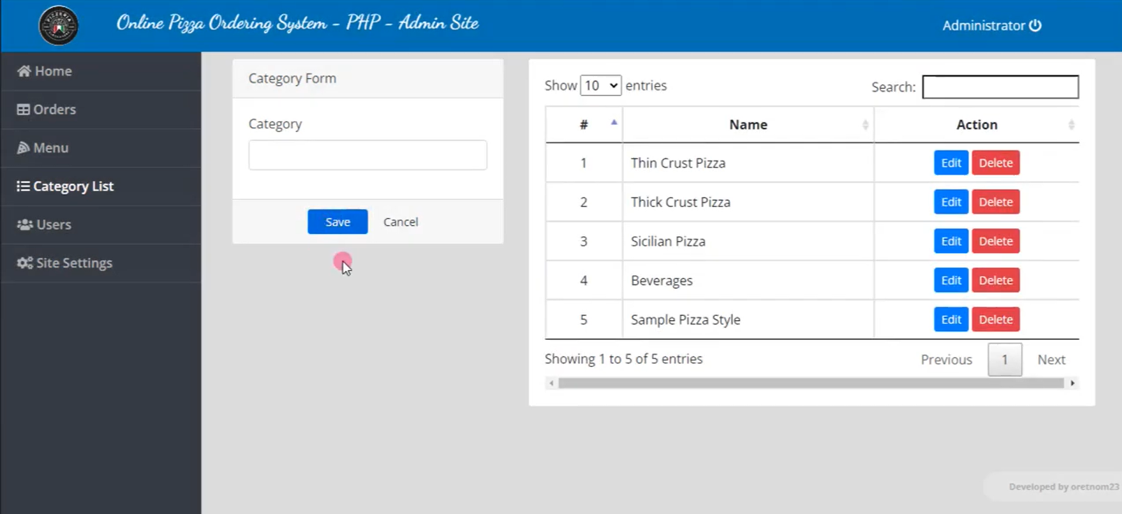**CONCLUSION**

So, friends, this was all about the online pizza ordering system. You know the importance of this system in our day-to-day lives as we all prefer online ordering over-ordering on phone. All these modules can be implemented in the web application or a mobile application ([Android](https://www.lovelycoding.org/android-assignment-help/), iOS, and windows). This project can be developed in any technology or programming language. I must tell you that if you are looking for such an online system for your business then you are at the right place. Feel free to contact me for this project or similar projects like the online ordering system for a Restaurant. If you are a student, you can use my [programming assignment help](https://www.lovelycoding.org/programming-assignment-help/) service to boost your grade. You can also ask me to do your programming project. All your queries and doubts are welcomed. Features such as Editing site content, user management, and site settings are the most essential feature of a site. And these all features have made management of site easier as the user can change the content and setting any time he/she wants rather than opening the whole source code and changing each line of codes. This project made PHP helps in easy management of the site for the company. Design of this project is pretty and responsive so that user won’t find it difficult to understand, use and navigate.

**BIBLIOGRAPHY**

### Sites Referred

<https://www.PHP.org>.

* + - 1. https://github.com/prasadus92/Face-Recognition
      2. [https://www.w3schools.com/java_getting_started.jdkp](https://www.w3schools.com/python/python_ml_getting_started.asp).
      3. [https://www.tutorialspoint.com/java/index.html.](https://www.tutorialspoint.com/machine_learning_with_python/index.htm)
      4. http://searchsecurity.techtarget.com/definitions/biometrics.
      5. https://community.tableau.com/docs/DOC-1236.

### Books Referred

* + - * 1. Learning.https://ieeexplore.ieee.org/document/8735638.
        2. IntelligentSalesPredictionUsingBootStrapTechniques.https://ieeexplore.iee e.org/document/8659115/authors.