- Do not edit/delete any heading or section with red text.
- Type /paste you answers in relevant sections (below Final Answer (in all questions , Approach (wherever required ) and Charts & tables (wherever required)) of the solution
- Link to submission guidelines
- Please note that submission not following the guidelines will not be accepted

OBJECTIVE QUESTIONS

Question 1: What is the total no. of attributes present in the data?

Solution:

Final Answer (if any):
10 attributes (columns) in the Tickets sheet.
06 attributes (columns) in the IT Agents sheet.

Approach (if any):
Used COUNTA function to determine the number of columns in a sheet.

Charts & Tables (if any):
NA

Question 2: Which columns have inconsistent or missing values, and what is the count of such values?

Solution:

Final Answer (if any):
There is no missing values as such— all 97,498 rows are fully filled
However, Following Changes have been made due to inconsistency in Data with the help of Search and Replace (ctrl H)
- ‘Mayor’ spelling changed to “Major” 4,836 rows replaced
- ‘Unassiged’ spelling changed to “Unassigned” 29,410 rows replaced
- ‘Unclasified’ spelling changed to “Unclassified” 356 rows replaced

Approach (if any):
Applied filter option for all columns to check the inconsistent values in a given data

Charts & Tables (if any):
NA

Question 3: What is the average daily ticket volume over time?

Solution:

Final Answer (if any):
I have made a Pivot Table, to calculate total numbers of ticket handled each day.
Through which I calculated average daily ticket volume over time
On an Average, around 53.37 tickets are raised per day.

Approach (if any):
Syntax to find the Average of Daily Ticket Volume is mentioned below:-
=AVERAGE(C14:C1840)

Charts & Tables (if any):
NA

Question 4: What is the distribution of ticket categories (e.g., Login Access, System, Software)?

Solution:

Final Answer (if any):
I have made a Pivot Table, to find total distribution of ticket across different categories.

Hardware has 9,733 Tickets.
Login Access has 29,193 Tickets.
Software has 19,570 Tickets.
System has 39,002 Tickets

Approach (if any):
Used Pivot Table To determine the count for each category
and made a pie chart for better representation.
Charts & Tables (if any):
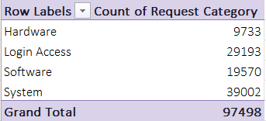
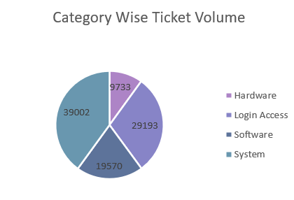

- Description:
It represents the category wise distribution of tickets

Question 5: How many tickets has each agent handled?

Solution:

Final Answer (if any):
I have made a Pivot Table, to calculate total numbers of ticket each Agent handled. On an Average, each Agent Handled 1949 Tickets

Approach (if any):
Syntax to find the Average of Ticket each Agent handled is mentioned below:- =AVERAGE(B14:B63)

Charts & Tables (if any):
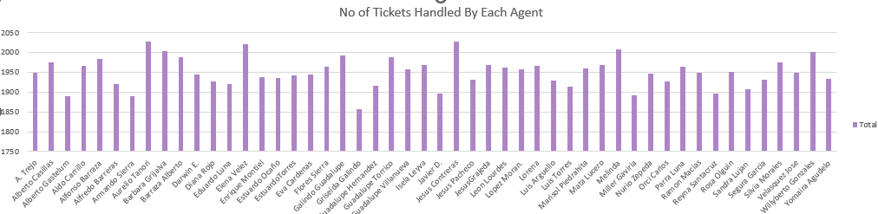
- Description:
It represents the total tickets handled by each agent

Question 6: How can you extract the domain from the email addresses in the IT Agents sheet?

Solution:

Final Answer (if any):
fp20analytics

Approach (if any):
I Extract the domain with the help of ‘RIGHT’,‘LEFT’ ,‘FIND’ and ‘XLOOKUP’ function

Syntax to find the Domain is mentioned below:-

LEFT(RIGHT(XLOOKUP('Cleaned Data'!d2,'IT Agents'!$A$2:$A$51,'IT Agents'!$C$2:$C$51),LEN(XLOOKUP('Cleaned Data'!d2,'IT Agents'!$A$2:$A$51,'IT Agents'!$C$2:$C$51))-FIND("@",XLOOKUP('Cleaned Data'!d2,'IT Agents'!$A$2:$A$51,'IT Agents'!$C$2:$C$51))),FIND(".",RIGHT(XLOOKUP('Cleaned Data'!d2,'IT Agents'!$A$2:$A$51,'IT Agents'!$C$2:$C$51),LEN(XLOOKUP('Cleaned Data'!d2,'IT Agents'!$A$2:$A$51,'IT Agents'!$C$2:$C$51))-FIND("@",XLOOKUP('Cleaned Data'!d2,'IT Agents'!$A$2:$A$51,'IT Agents'!$C$2:$C$51))))-1)

Charts & Tables (if any):
NA

Question 7: How can you find the full name of an agent given their Agent ID?

Solution:

Final Answer (if any):
Full Name of Agent can be find with the help of ‘XLOOKUP’ or ‘VLOOKUP’ function.

Approach (if any):
Syntax to find the Full Name is mentioned below:-

XLOOKUP(D2,'IT Agents'!$A$2:$A$51,'IT Agents'!$B$2:$B$51)

Charts & Tables (if any):
- Table / Chart Name:
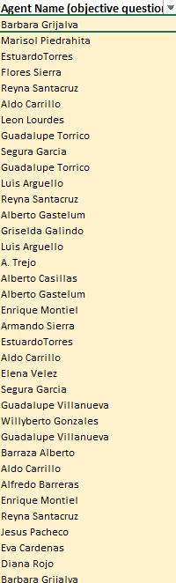
- Description:
Shows the name of Agent with respect to their id

Question 8: What is the count of each issue type (e.g., IT Error, IT Request)?

Solution:

Final Answer (if any):
IT Error has 24,278 Tickets
IT Request has 73,220 Tickets

Approach (if any):
I have made a Pivot Table, to calculate count of ticket as per Issue Type, IT Error and IT Request.

Charts & Tables (if any):
- Table / Chart Name:

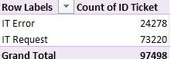

- Description:
It shows the total number of tickets per issue type.

Question 9: What is the average resolution time for tickets?

Solution:

Final Answer (if any):
Daily Average of Resolution Time (Days) is 4.551729662.

Approach (if any):
I have made a Pivot Table, to calculate Daily Average of Resolution Time(Days).

Charts & Tables (if any):
- Table / Chart Name:

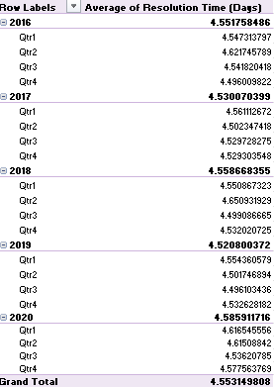
- Description:
This pivot table represents the average of resolution time by year wise and quarter wise.

Question 10: How has the volume of tickets changed over time?

Solution:

Final Answer (if any):
1. Consistent Growth (2016–2018):
- Between 2016 and 2018, ticket numbers went up gradually.
- This indicates a steady increase in IT usage or reported technical issues.
2. Major Spike in 2020:
- The most prominent rise occurred from 2019 to 2020, where tickets jumped by nearly 7,600 cases.
- This surge may be linked to company growth, the shift to remote work, or greater dependency on IT systems.
3. Overall Expansion:
- In the 5-year period, ticket volume more than doubled, moving from 13,051 in 2016 to 29,088 in 2020.
- That’s about a 123% rise, underlining the importance of scaling IT support capacity.

Approach (if any):
I created a Pivot Table to analyze the change in ticket volume over time and represented it with a Line with Markers Chart. This chart clearly highlights that the number of tickets has been rising consistently year by year.

Charts & Tables (if any):
- Table / Chart Name:

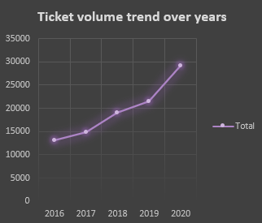
- Description:
It shows the representation of pivot table describing total no. of ticket trend as per each year and quarter.

Question 11: What is the average age of the IT agents?

Solution:

Final Answer (if any):
The result shows that the average age of IT Agents is 41 years.
Approach (if any):
To Determine the Average Age of agents, the first step was I calculate agent DOB of each agent by DATE(D2,E2,F2) later I calculate age of the agent using DATEDIF and Today functions:
=DATEDIF(G2,TODAY(),"Y")
Charts & Tables (if any):
- Table / Chart Name:
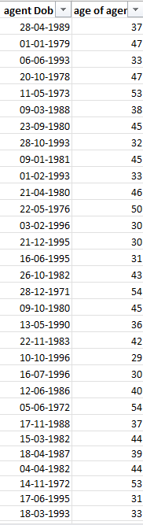
- Description:
It shows the age of every it agent as per their date of birth.

Question 12: Is there a correlation between the severity of issues and the resolution time?

Solution:

Final Answer (if any):
The calculated correlation between severity and resolution time is -0.040536349. meaning there is practically no linear relationship between issue severity and the time required to resolve it. Although a negative correlation would normally suggest that higher severity leads to shorter resolution times, the value here is so close to zero that it implies severity has almost no effect on resolution duration.
Approach (if any):
Formula used: CORREL('Cleaned Data'!G:G,'Cleaned Data'!J:J)

Charts & Tables (if any):
NA

Question 13: How many categorical columns are there in the data? [Search about categorical and continuous data, and try to answer this question]

Solution:

Final Answer (if any):
There are 7 categorical Columns Present in the data.

Approach (if any):
As the categorical data represents the information that can be sorted in groups and labels but doesn’t hold numerical values for direct calculations. We can determine the categorical columns in the workbook.

Charts & Tables (if any): NA

SUBJECTIVE QUESTIONS

Question 1: If there is an investment, should it be used to hire more IT agents, improve training programs, or upgrade ticket management software?

Analysis: Perform a cost-benefit analysis using ticket resolution and satisfaction metrics.

Solution:

Approach:
Compare agent performance and ticket priority using ticket volume, average resolution time and satisfaction rate. Identify workload or resolution-time gaps, review unassigned tickets, and use the results to prioritize improvements based on expected impact and implementation effort.

Charts & Tables:
- Table / Chart Name:
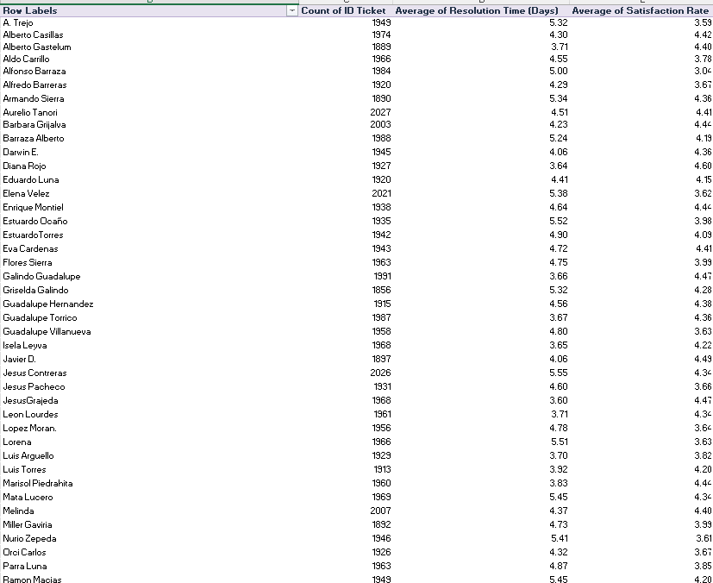
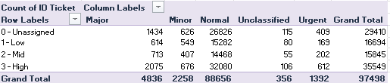

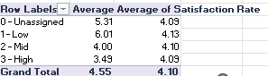

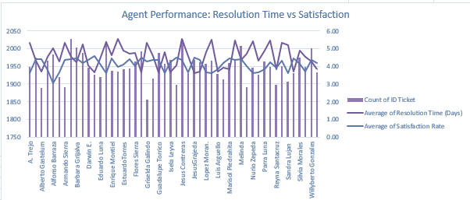

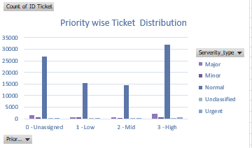

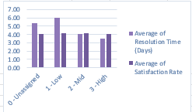

- Description:
The analysis compares agent performance and ticket priorities using ticket volume, average resolution time and satisfaction rate. The charts highlight differences in agent resolution performance, priority-wise ticket distribution, and the relationship between priority, resolution time and satisfaction. These results help identify where process improvements, training and better ticket assignment can have the greatest impact.

Insights:

- Agent performance varies in resolution time and satisfaction, indicating a need for targeted support and workload balancing.
- Low-priority tickets have the highest average resolution time at 6.01 days, while high-priority tickets are resolved faster at 3.43 days.
- 6,288 tickets are unassigned, showing a significant assignment gap that can delay ticket resolution.
Recommendations:

1. Introduce automated ticket assignment and escalation rules to reduce the 6,288 unassigned tickets and improve response speed.

2. Provide targeted training and workload support to agents with higher resolution times, aiming for a 20% reduction within 3 months.

3. Set resolution-time targets for low-priority tickets to reduce the 6.01-day average, while maintaining faster handling of high-priority tickets.

Question 2: Which agents need additional training based on their performance metrics?

Analysis: Identify agents with the lowest satisfaction ratings and longest resolution times.

Solution:

Approach:

I compared each agent using ticket count, average resolution time, average satisfaction rate, and the satisfaction-to-resolution ratio. The ratio was used to normalize performance and identify agents who require targeted training. Agents with mid-range performance gaps were prioritized rather than selecting candidates only on the basis of the lowest satisfaction or longest resolution time.

Charts & Tables:
- Table / Chart Name:

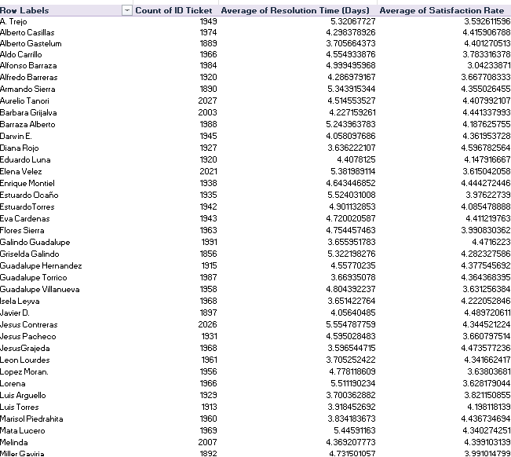

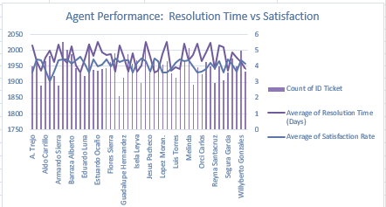

- Description:
The table below shows the comparison of performance of individual agents on the basis of three parameters which are; average satisfaction rate, average resolution time and ticket count.

Insights:
1. Alfonso Barraza has the lowest satisfaction rate at 3.04 with an average resolution time of about 5 days, indicating a clear need for improvement.
2. Lorena has the highest average resolution time at 5.51 days with a satisfaction rate of 3.63, making her another important training candidate.
3. A. Trejo has a satisfaction rate of 3.59 and an average resolution time of 5.32 days, showing both customer-experience and efficiency gaps.

Recommendations:

- Give Alfonso Barraza priority training on customer communication and issue resolution, targeting a 10% improvement in satisfaction within 3 months.
- Provide Lorena and A. Trejo with resolution-efficiency training focused on troubleshooting and faster ticket closure, targeting a 10% reduction in average resolution time within 3 months.
- Review the three agents monthly using satisfaction rate, average resolution time, and satisfaction-to-resolution ratio to measure whether training is improving performance.

Question 3: Do certain categories of requests have longer resolution times?

Analysis: Analyze the resolution times by request category.

Solution:

Approach:
I analyzed the average resolution time in days for Hardware, Login Access, Software, and System requests. I determined Hardware has the highest resolution time followed by the system and software

Charts & Tables:
- Table / Chart Name:

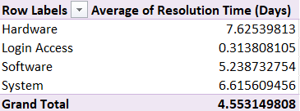

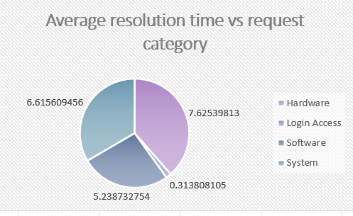
- Description:
The table and chart indicate the average number of days needed to resolve request categories. The overall average resolution time is 4.55 days.

Insights:
From my analysis, I discovered that Hardware requests have an average resolution time of 7.63 days, and System requests take 6.62 days. Software requests require 5.24 days, while Login Access requests are resolved within 0.31 days.

It is clear that Hardware and System request categories have the longest resolution time.

Recommendations:
From this, I would suggest that priority be given to Hardware and System requests. The IT team needs to analyze why there are long resolution times, develop good documentation, and conduct training where necessary.

Question 4: How effective are the current software tools in managing IT tickets?

Analysis: Evaluate performance metrics before and after the implementation of new tools.

Solution:

Approach:

I compared ticket severity with the assigned priority using a pivot table and counted the tickets in each severity-priority combination. I then identified the combinations where the assigned priority does not align with the expected priority for that severity. This helps measure how consistently the ticketing system is applying its prioritization rules.

Charts & Tables:
- Table / Chart Name:

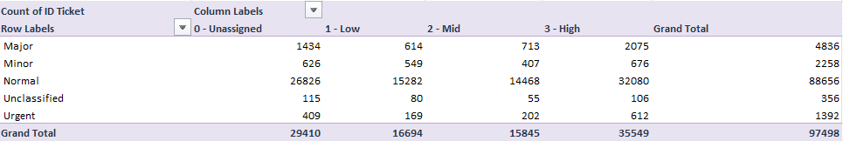

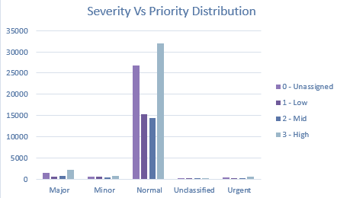

- Description:

The pivot table shows how tickets are distributed across severity and priority levels. It helps identify cases where tickets may be under-prioritized or over-prioritized compared with their severity.
Using the expected mapping of Minor → Low, Normal → Mid, and Major/Urgent → High, the mismatched combinations can be quantified and used to evaluate the current ticket-prioritization settings.
Insights:
- The Normal severity group has the largest number of mismatched tickets, with 74,188 cases. The Major group has 2,761 mismatches, while Minor and Urgent have 1,709 and 780 mismatches respectively.

- Overall, this gives 79,438 mismatched tickets out of 97,498 tickets, showing that the current priority rules need to be reviewed rather than relying only on the existing settings.

- The high number of mismatches, particularly within the Normal category, suggests that the priority rules may be too broad or are not being applied consistently.
Recommendations:
Review and update the severity-priority rules, especially for the Normal category with the highest mismatch count. Automate appropriate priority mapping and monitor mismatch levels for the next 3 months to confirm improvement.

Question 5: How has the performance of the IT support team changed over time (e.g., monthly or quarterly)?

Analysis: Trend analysis using time series charts.

Solution:

Approach:
I examined the changes in resolution time and satisfaction rate of Hardware, Login Access, Software and System requests throughout the quarters and determined whether there was any improvement or decline in the performance of the team.

Charts & Tables:
- Table / Chart Name:

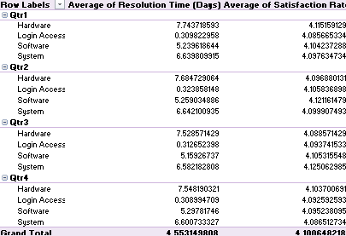

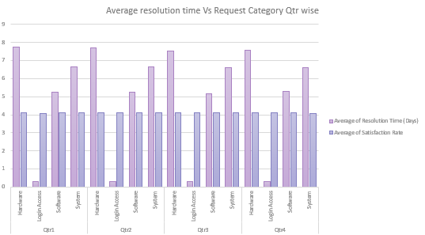
- Description:
This table and chart illustrate the average resolution time and satisfaction rate of each request category during the quarters of Q1, Q2, Q3 and Q4.

Insights:
It can be observed that the performance of IT support team has been fairly consistent throughout all four quarters.

Hardware requests have the highest average resolution time of 7.5–7.7 days.
The second-highest average resolution time is of System requests, which is 6.6 days.
The third-highest average resolution time is 5.2 days for Software requests.
Requests of Login Access type have the lowest resolution time of 0.31 days.
The average satisfaction rate remains almost same in all categories and quarters at 4.1.

No significant increase or decrease in performance is noted in the four quarters, indicating consistency in the performance of the IT support team.

Recommendations:
I suggest improving the performance on Hardware and System requests, since they take much more time than other types of requests.

Question 6: If we invest more on tech (Hardware, software, etc), do you think it will improve the ticket resolution times and employee satisfaction?

Analysis: Use historical data to project potential improvements.

Solution:

Approach:
I compared current resolution times and levels of satisfaction of employees with regard to Hardware, Login Access, Software and System requests. The main attention was paid to request categories which had longer resolution times, where the improvement of technologies can make an effect.

Charts & Tables:
- Table / Chart Name:

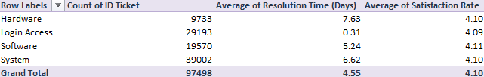
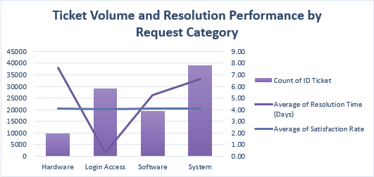

- Description:
The table and chart compare ticket volume, average resolution time, and satisfaction rate across Hardware, Login Access, Software, and System requests. This comparison helps identify categories with high workload, longer resolution times, and areas that require operational improvement.

Insights:
- System requests have the highest ticket volume at 39,002 tickets and an average resolution time of 6.62 days, making System the largest workload area.
- Hardware has the longest average resolution time at 7.63 days across 9,733 tickets, indicating that hardware-related issues take the most time to resolve.
- Software records 19,570 tickets with an average resolution time of 5.24 days, while Login Access handles 29,193 tickets in only 0.84 days, showing much faster resolution for access-related issues.
- Satisfaction remains relatively consistent across all categories at approximately 4.09–4.11, so the main opportunity is to improve resolution speed rather than satisfaction.
Recommendations:

- Reduce Hardware average resolution time from 7.63 days to 5 days within 3 months by improving hardware availability, escalation procedures, and replacement processes.
- Reduce System average resolution time from 6.62 days to 5 days within 3 months by identifying recurring issues and increasing automation or self-service support.
- Review the 39,002 System tickets to identify the most common issues and target the highest-volume problems for process improvement.
- Use the Login Access process (0.84-day resolution time) as a benchmark to identify practices that could help improve slower categories.

Question 7: What are the key performance metrics for IT agents, and how can they be improved, do we need to fire any agents?

Analysis: Define and analyze metrics such as average handling time, satisfaction scores, and number of tickets resolved.

Solution:

Approach:
I compared the three main performance metrics for each agent. I focused on agents with higher resolution times and lower satisfaction scores, while also considering the number of tickets handled. I used these results to identify agents who may need additional training or performance monitoring.

Charts & Tables:
- Table / Chart Name:

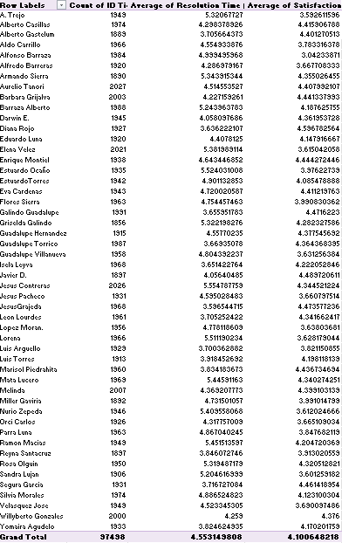

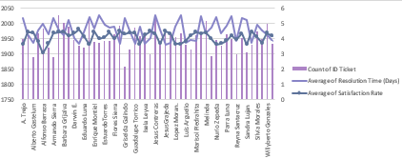
- Description:
The table and chart compare the number of tickets handled, average resolution time, and average satisfaction rate for each IT agent. This helps identify differences in individual performance and areas where improvement may be required.

Insights:
I found that most agents handle a similar number of tickets, generally around 1,850–2,050 tickets. However, their resolution times and satisfaction rates vary.

Some agents show weaker performance. For example, Alfonso Barraza has a low satisfaction rate of approximately 3.04 and a resolution time of about 5 days. A. Trejo also has a relatively low satisfaction rate of 3.59 with a resolution time of approximately 5.32 days. Estuardo Ocano has one of the higher resolution times at approximately 5.52 days, with a satisfaction rate below 4.

These agents should be monitored more closely because their combination of resolution time and satisfaction suggests that their performance can be improved.

Recommendations:
I would not recommend firing any agents immediately. The data only shows performance metrics and does not provide enough information to conclude that an agent should be terminated.

Instead, I would recommend:

Provide additional training to agents with low satisfaction and high resolution times.
Set clear performance targets for resolution time and satisfaction.
Monitor their performance for a specific period after training.
Provide additional support or coaching where required.
If an agent consistently performs below the required standards even after training and performance improvement measures, then management can consider further action.

Question 8: How do employee demographics (e.g., department, seniority) impact satisfaction and ticket outcomes?

Analysis: Segment analysis using filters and pivot tables.

Solution:

Approach:
I grouped employees by age and compared their average resolution time, satisfaction rate, and ticket volume using pivot tables and a combo chart. This helps identify performance differences between age groups and determine whether any group requires closer attention.

Charts & Tables:
- Table / Chart Name:

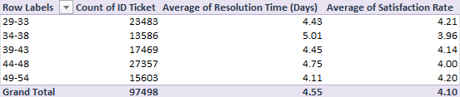

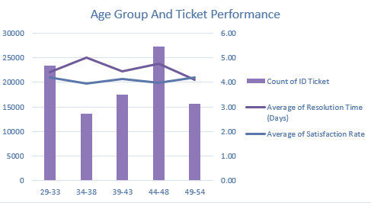

- Description:
The table and chart compare ticket volume, average resolution time, and satisfaction rate across five employee age groups: 29–33, 34–38, 39–43, 44–48, and 49–54.

Insights:
- The 34–38 age group has the highest average resolution time at 5.01 days, while the 49–54 group has the lowest at 4.11 days.
- Satisfaction remains relatively consistent across the groups, ranging from 3.96 to 4.21, with the 29–33 group having the highest rate at 4.21.
- The overall averages are 4.55 days resolution time and 4.10 satisfaction rate, indicating that performance differences across age groups are relatively moderate
Recommendations:
I would not recommend making major changes based only on employee age. Instead, the organization should focus on individual performance, training needs, workload, and ticket type.

I would also recommend using the same support and training opportunities across age groups while providing additional assistance to employees based on their actual performance metrics.

Question 9: Identify the trends for IT support operations based on ticket volumes and satisfaction, and mention the peak and stable times?

Analysis: Use pivot tables and charts to identify peak and off-peak hours.

Solution:

Approach:
I analyzed ticket volume and average satisfaction by month and year using pivot tables and charts to identify peak, low, and stable periods and track changes in support performance over time.

Charts & Tables:
- Table / Chart Name:

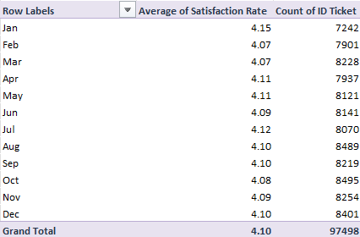

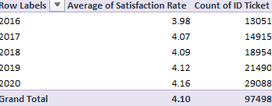

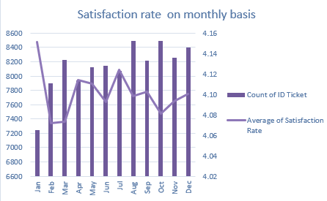
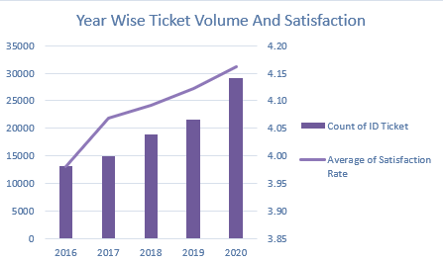

Description:
The table and chart provide monthly ticket amounts and average satisfaction rates from January to December. This information allows us to find out the months of high or low demand of IT support.

Insights:
- October has the highest monthly ticket volume at 8,495, while January has the lowest at 7,242.
- Ticket volume remains relatively stable at around 7,200–8,500 per month, with satisfaction ranging from 4.07–4.15.
- Year-wise, ticket volume increased from 13,051 in 2016 to 29,088 in 2020, while satisfaction improved from 3.98 to 4.16, showing overall improvement in support performance.
Recommendations:
I would recommend planning additional IT support capacity during the higher-volume months, especially August, October, and December, to handle increased demand.

During lower or more stable periods, the organization can focus on agent training, system maintenance, and process improvements without putting additional pressure on the support team.

Question 10: What metrics should be included in the final dashboard to provide a comprehensive view of call center performance and guide investment decisions?

Solution:

Approach:
I decided to put the main performance metrics into my final dashboard, which will allow getting a clear picture about ticket volume, employee satisfaction, efficiency, severity and issues' categories. Such metrics will be necessary for management to understand current performance and find out where they should make investments.

Charts & Tables:
- Table / Chart Name:

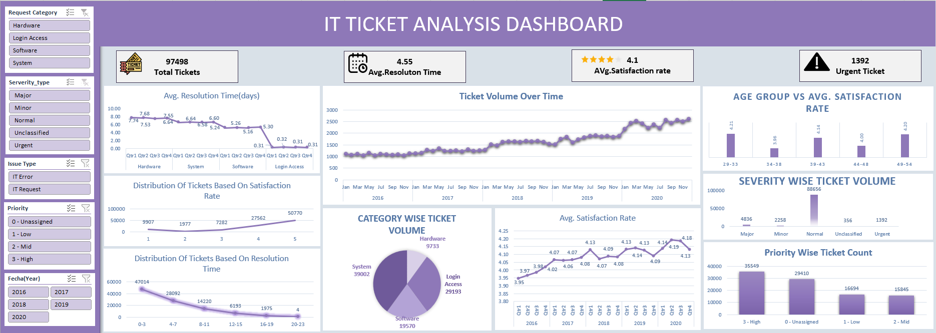

- Description:
This dashboard includes several KPI cards and charts such as:

Total Number of Tickets – 97,498
Average Satisfaction Rate – 4.1
Average Resolution Time – 4.55 days
High Severity Tickets – 1,392
Ticket Volume by Categories
Ticket Volume by Severity
Total Number of Tickets by Issue Type
Categories vs. Average Resolution Time

This dashboard provides the filters such as Request Category, Severity Type, Issue Type, Year, Month, Priority, which will give a possibility to analyze the data from various sides.

Insights:
I found that IT Requests have the highest ticket volume with 73,220 tickets, compared with 24,278 IT Error tickets. Hardware has the highest average resolution time, followed by System requests.

The overall satisfaction rate is 4.1, while the average resolution time is 4.55 days. The dashboard also shows 1,392 high-severity tickets, which indicates an area that requires close monitoring.

These metrics provide a comprehensive view of both workload and service quality and help identify where improvements are needed.

Recommendations:
I would recommend using the dashboard to guide investment decisions in the following areas:

Invest in ticket management software and automation to reduce resolution time.
Focus on Hardware and System requests, as they take longer to resolve.
Provide additional training to agents with lower satisfaction and higher resolution times.
Monitor high-severity tickets and prioritize them for faster resolution.
Use the monthly and yearly filters to plan resources during periods of higher ticket volume.
Continue monitoring satisfaction rate and resolution time to measure whether investments are improving performance.

