SQL : it is used to retrieve the data, insert, update, delete and manage db objects
Types of sql commands:
• DDL – Data Definition Language (Create, Alter(to modify), Drop(entire it deletes) and Truncate(only rows deleted data only))
• DML – Data Manipulation Language (INSERT , update, delete)
• DQL – Data Query Language (SELECT)
• DCL – Data Control Language
• TCL – Transaction Control Language (COMMIT, SAVEPOINT, ROLLBACK)

2. Data Types

Common Data Types
- INT
- FLOAT / DOUBLE
- CHAR(n) upto the space it consumes fixed length char(3) “a” but it takes 3 spaces fix
- VARCHAR(n) upto to data it consumes not fixed (3) “a” only one space takes
- DATE
- TIMESTAMP
- BOOLEAN
3. DDL Commands
CREATE TABLE
CREATE TABLE employee (
emp_id INT PRIMARY KEY,
name VARCHAR(50),
salary DOUBLE,
dept VARCHAR(30)
);
Alter Table (modify)
ALTER TABLE employee ADD age INT;
ALTER TABLE employee MODIFY name VARCHAR(100);
ALTER TABLE employee DROP age;

TRUNCATE
Truncate Table employee (it deletes data)
DROP
DROP table employee(it deletes complete structure)

DML COMMANDS

Insert : insert the data

insert into employee values(1,'robert','it',60000),(2,'vikas','hr',70000),(3,'kilkil','dev',55000),(4,'akhi','tl',90000);

UPDATE

update employee set salary=65000 where emp_id=1;

DELETE

DELETE FROM employee where emp_id=3;

DQL

Select
SELECT * FROM employee;
select * from employee where salary=90000;
select emp_name from employee where department='it';
select emp_name from employee where salary>70000 and department='it';
select distinct department from employee;(removes duplicate values gives only unique values)

-- Select all columns
SELECT * FROM employee;

-- Select specific columns
SELECT emp_id, emp_name FROM employee;

-- Using WHERE condition
SELECT * FROM employee WHERE salary > 50000;

-- Using ORDER BY
SELECT * FROM employee ORDER BY salary DESC;

-- Using GROUP BY
SELECT department, COUNT(*) FROM employee GROUP BY department;

-- Using HAVING
SELECT department, COUNT(*)
FROM employee
GROUP BY department
HAVING COUNT(*) > 5;

6. Aggregate Functions
- COUNT()
- SUM()
- AVG()
- MIN()
- MAX()

- 1. COUNT()
- Q1. Count total employees
- SELECT COUNT(*) FROM employee;
- Q2. Count employees in IT department
- SELECT COUNT(*)
- FROM employee
- WHERE dept = 'IT';
- Q3. Count distinct departments
- SELECT COUNT(DISTINCT dept) FROM employee;

2. SUM() – Salary Based Questions

Q4. Total salary of all employees
SELECT SUM(salary) FROM employee;

Q5. Total salary of IT department
SELECT SUM(salary)
FROM employee
WHERE dept = 'IT';

3. MIN() and MAX()

Q8. Minimum salary
SELECT MIN(salary) FROM employee;

Q9. Maximum salary
SELECT MAX(salary) FROM employee;

Q10. Highest salary in each department
SELECT dept, MAX(salary)
FROM employee
GROUP BY dept;

7. Constraints
- PRIMARY KEY
- FOREIGN KEY
- UNIQUE
- NOT NULL
- CHECK
- DEFAULT

1. PRIMARY KEY
- Uniquely identifies each row
- Cannot be NULL
- No duplicate values
CREATE TABLE employee (
emp_id INT PRIMARY KEY,
emp_name VARCHAR(50)
);

2. FOREIGN KEY
- Creates a link between two tables
- Refers to a PRIMARY KEY in another table
CREATE TABLE department (
dept_id INT PRIMARY KEY,
dept_name VARCHAR(30)
);
CREATE TABLE employee (
emp_id INT PRIMARY KEY,
dept_id INT,
FOREIGN KEY (dept_id) REFERENCES department(dept_id)
);

3. UNIQUE
- Ensures all values in a column are different
- Allows only one NULL
CREATE TABLE employee (
email VARCHAR(50) UNIQUE
);

4. NOT NULL
- Column cannot have NULL values
CREATE TABLE employee (
emp_name VARCHAR(50) NOT NULL
);
Joins
Tables
Department table
create table department(
dept_id int primary key,
dept_name varchar(30)
);
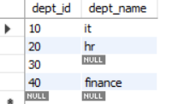
-------------------------------------------------------------------------------------

Employee table
create table employee(
emp_id int primary key,
name varchar(30),
dept_id int ,
foreign key(dept_id)references department(dept_id)
);
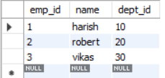
---------------------------------------------------------------
JOINs are used to combine rows from two or more tables based on a related column (usually a primary key–foreign key relationship).
- Inner join: Return matching records from both the tables
select e.name,d.dept_name
from employee e
inner join department d
on e.dept_id=d.dept_id;
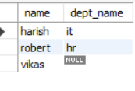
- Left join : return all records from left table and common records from right table
If no match null values
select e.name,d.dept_name
from employee e
left join department d
on e.dept_id=d.dept_id;
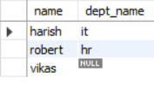
- Right join : returns all records from right table and common records from left tables
If no match null values

select e.name,d.dept_name
from employee e
right join department d
on e.dept_id = d.dept_id;

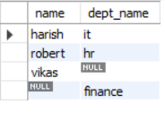

- Full join(full outer join)
Returns all records from both the tables

select e.name,d.dept_name
from employee e
left join department d
on e.dept_id = d.dept_id

Union

select e.name,d.dept_name
from employee e
right join department d
on e.dept_id = d.dept_id;

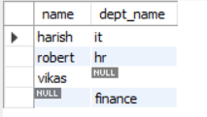

- Self join : this is a join which join itself in the same table
It is used when there is data which is related to other data in same db

create table self(
emp_id int primary key,
emp_name varchar(30),
dept_name int
);
alter table self add manager_id int;
alter table self modify dept_name varchar(30);
insert into self values(1,'akhi','it',null),(2,'robert','hr',1),(3,'vikas','finance',1),
(4,'kilkil','intern',3);

select * from self;
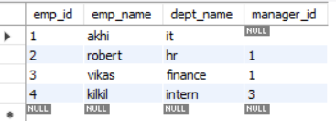

SELECT e.emp_name AS employee,
m.emp_name AS manager
FROM self e
JOIN self m
ON e.manager_id = m.emp_id;
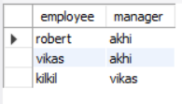

- Cartisian join :Every row in one table is comnboined with every row in another table

select e.name, d.dept_name
from employee e
cross join department d;

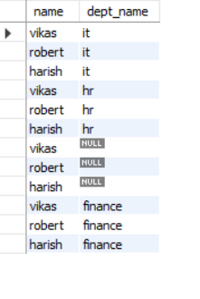
1 create database emp;
Use emp; and create tables
Sample table
CREATE TABLE employees (
emp_id INT,
emp_name VARCHAR(50),
department VARCHAR(30),
salary INT,
joining_date DATE
);
Inserting records
insert into employee values(1,'robert','it',60000),
(2,'vikas','hr',70000),
(3,'kilkil','dev',55000),
(4,'akhi','tl',90000);
select * from employee ;
Table will be displayed

